Fabrication of Ultralow Density Quantum Dots by Droplet Etching Epitaxy
Jiang Wu^{1,*}, Zhiming M. Wang^{2,*}, Xinlei Li³, Yuriy I. Mazur⁴, and Gregory J. Salamo⁴
¹ Department of Electronic and Electrical Engineering, University College London, Torrington Place, London WC1E 7JE, United Kingdom
² Institute of Fundamental and Frontier Sciences, University of Electronic Science and Technology of China, Chengdu 610054, People’s Republic of China
³ MOE Key Laboratory of Laser Life Science & Institute of Laser Life Science, College of Biophotonics, South China Normal University, Guangzhou 510631, P. R. China
⁴ Institute for Nanoscience and Engineering, University of Arkansas, Fayetteville, Arkansas 72701, United States of America
* Jiang.wu@ucl.ac.uk and zhmwang@uestc.edu.cn

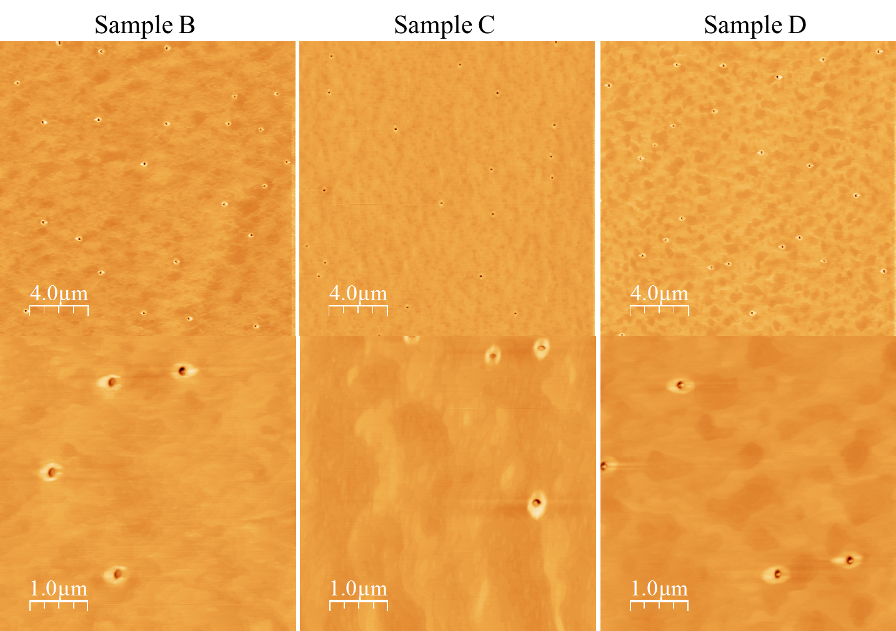
Figure S1. AFM images of sample B (0.9 ML InAs), sample C (1.2 ML InAs), and sample D (1.35 ML InAs). Top row: 20 × 20 µm²; bottom row: 5 × 5 µm².

