SUPPLEMENTARY MATERIAL
for
Synthesis of CuO Nanostructures on Zeolite-Y and Investigation of Their CO₂ Adsorption Properties
Cansu Boruban¹and Emren Nalbant Esenturk^{1,2}*
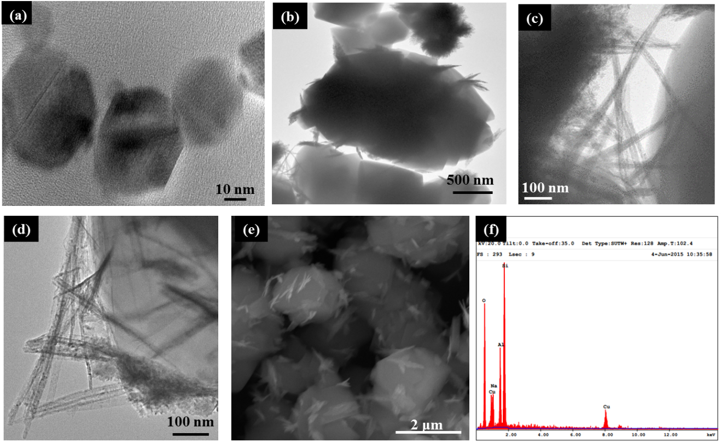
¹ Department of Chemistry, Middle East Technical University, 06800 Ankara, Turkey
² Micro and Nanotechnology Program, Middle East Technical University, 06800 Ankara, Turkey

FIG S1. (a) TEM images of bare zeolite; (b-d) TEM images, (e) SEM image and (f) EDX spectrum of spiky-shaped CuO NPs on zeolite.

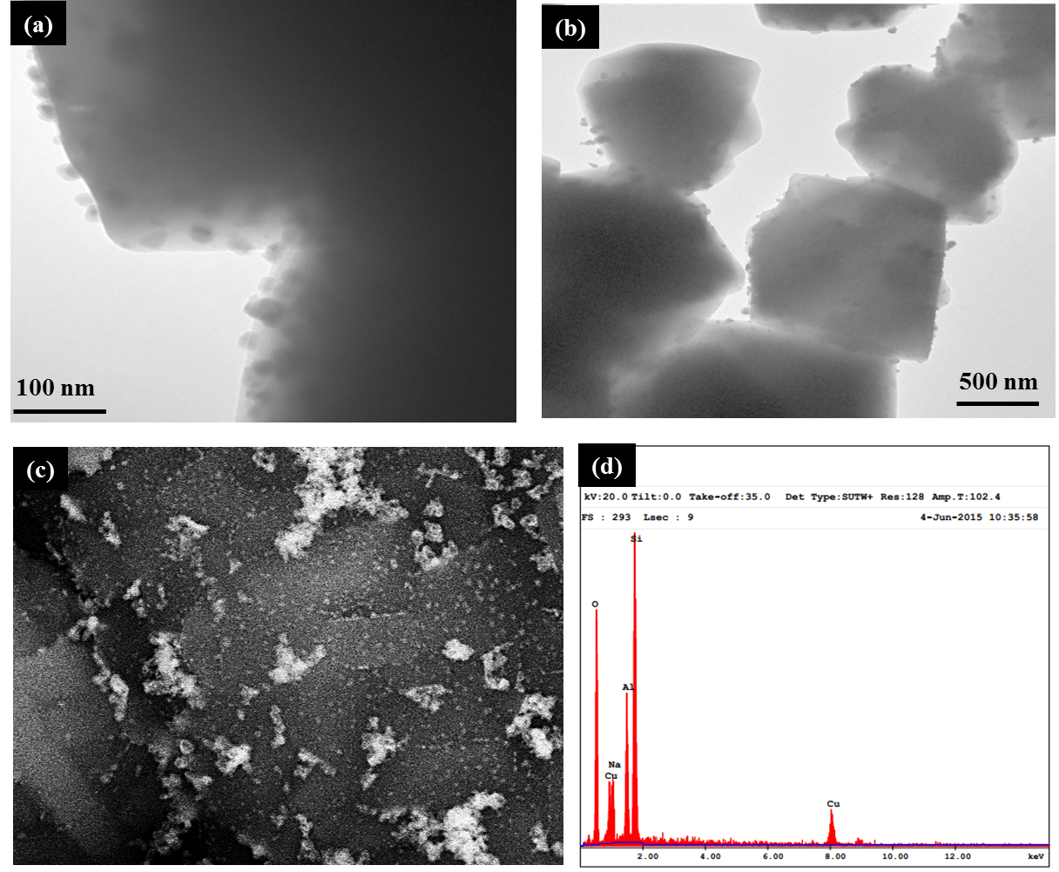
FIG S2. (a-b) TEM images, (c) back-scattered SEM, and (d) EDX spectrum of spherical CuO NPs on zeolite.

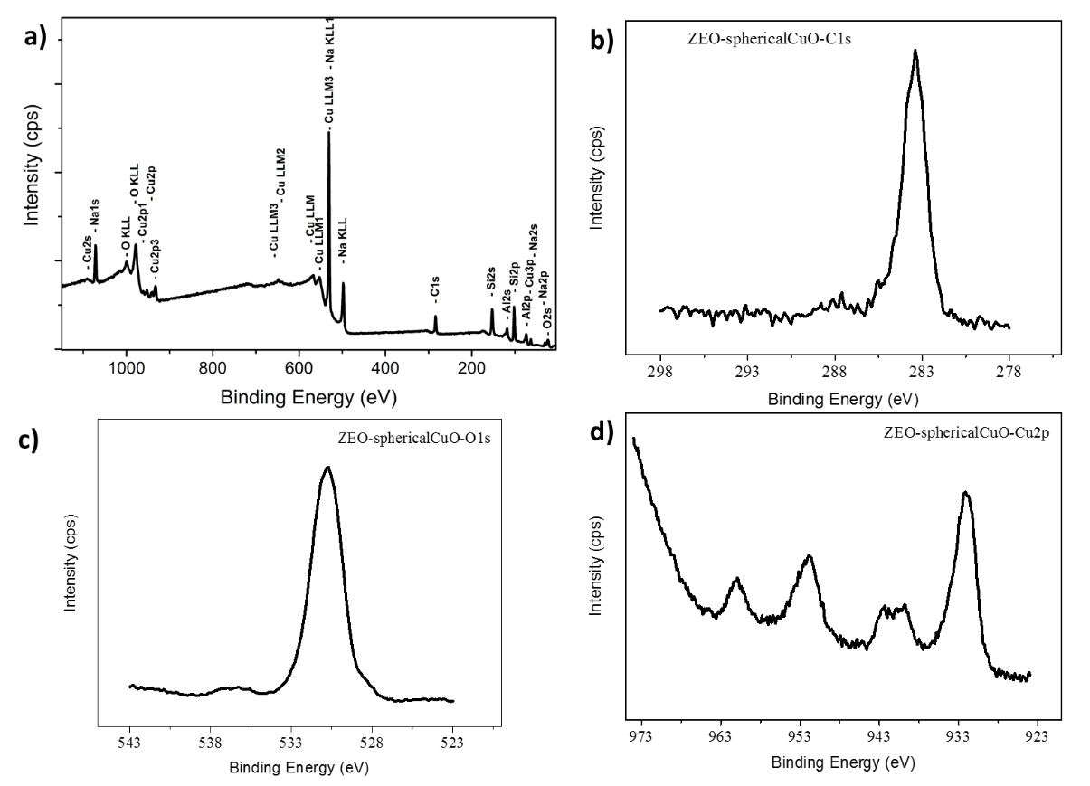
FIG S3. XPS spectra of spherical CuO NPs on zeolite: a) survey, b) C1s, c) O1s, and
d) Cu2p.

FIG. S4. N₂ adsorption isotherms of zeolite-Y (square), zeolite containing spherical (sphere) and spiky CuO NPs (triangle).

FIG. S5. TPD-CO₂ profile of CO₂ desorption behavior of (a) bare zeolite, (b) spherical and (c) spiky CuO NP-zeolite systems.

TABLE SI. The amount of CO₂ adsorbed by physically and chemically on zeolite, zeolite with spiky and spherical CuO NPs. The sample amounts used in measurements are given in parenthesis.
 | Total CO₂ |  |  | Physisorbed CO₂ |  |  |  | Chemisorbed CO₂
 | mg | mmol/g | % wt* |  | mg | mmol/g | % wt* |  | mg | mmol/g
Zeolite (4.926 mg) | 0.916 | 4.226 | 62 |  | 0.568 | 2.620 | 38 |  | 0.348 | 1.606
Zeolite- spherical CuO (5.061 mg) | 1.146 | 5.146 | 42 |  | 0.481 | 2.161 | 58 |  | 0.665 | 2.985
Zeolite- spiky CuO (5.127 mg) | 1.192 | 5.284 | 36 |  | 0.429 | 1.884 | 64 |  | 0.763 | 3.400
*Relative percent weight values obtained from TPD measurements.

 | % weight loss
Fresh | 23.24
1st regeneration | 22.95
2st regeneration | 23.06
3rd regeneration | 23.11
4th regeneration | 22.66
TABLE SII. Regeneration of spiky CuO NP-zeolite system. % weight loss of the system after every adsorption-desorption cycle.

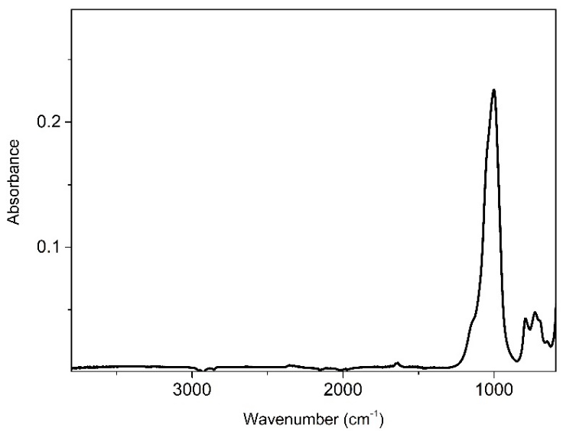
FIG S6. FTIR-ATR spectrum of virgin (without CO₂ treatment) zeolite.

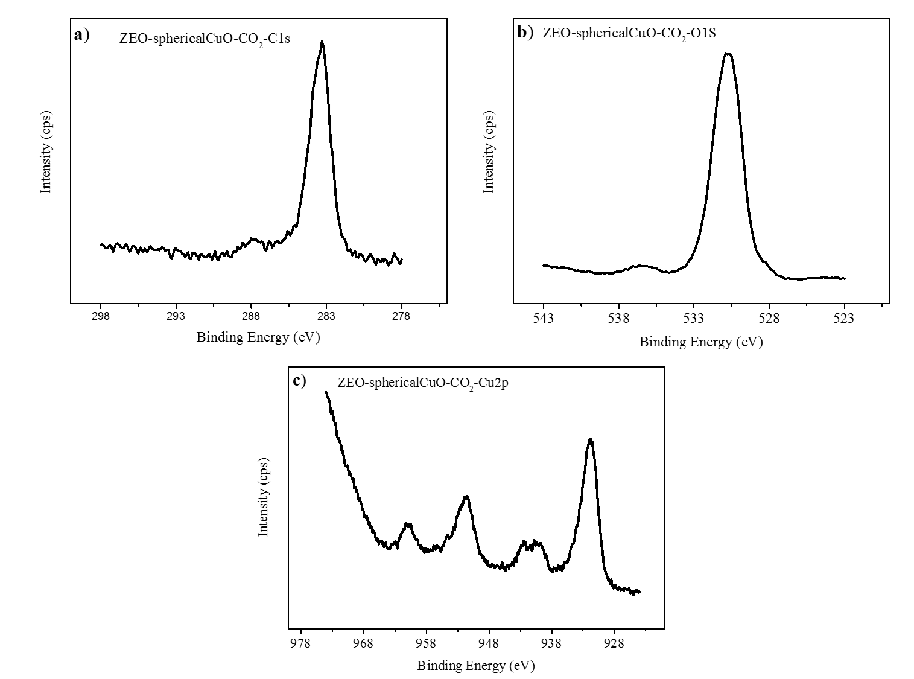
FIG S7. XPS spectra of spherical CuO NPs on zeolite after CO₂ treatment: a) C1s, b) O1s, c) Cu2p.

Quantitative analysis of CO₂ adsorption by FTIR analysis:
The infrared light absorption of CO₂ in gas form is proportional to its concentration in the N₂-CO₂ gas mixture according to the Beer-Lambert Law.
A= Ɛ.l.c
Here A is absorbance, Ɛ is absorptivity, l is the path length and c is the concentration of the CO₂. Thus, a ratio of two absorbance becomes a ratio of the CO₂ concentrations in two different samples while the path length is kept constant:
A₁ / A₂ = c₁ / c_{2,}
Since concentration is proportional to the number of CO₂ molecules:
c = (N/N_{A})/V
The absorbance ratio directly becomes ratio of the number of CO₂ molecules
A₁ / A₂ = N₁/N₂
Thus, the ratio directly shows relative loss of the CO₂ in the sample compartment, which then can be correlated to the absorbed amount of gas at the substrate surfaces when the reference N₂-CO₂ mixture is used. This enables one to calculate the percentages of adsorbed CO₂ per gram of substrate for all samples.

