Supplementary Information
Hardening Mechanisms in Irradiated Cu-W Alloys
Gowtham Sriram Jawaharram, Shen J. Dillon* and Robert S. Averback
Department of Materials Science and Engineering, University of Illinois Urbana-Champaign, Urbana, IL 61801
*Corresponding author. Phone (217) 244-5622; e-mail: sdillon@illinois.edu

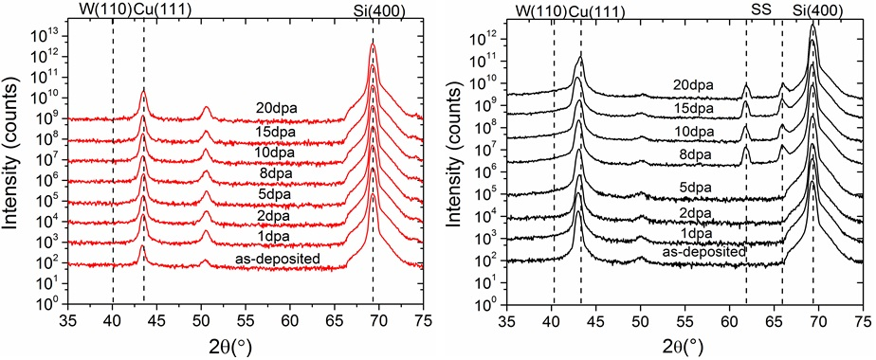
FIG. S1 XRD spectra of Cu₉₉W₁(red) and Cu₉₄W₆ (black) as a function of irradiation dose. Dotted lines correspond to the Bragg peaks of Cu (111), W (110), Stainless steels and Si (400) respectively. The additional peaks observed at 8, 10, 15 and 20 dpa are from stainless steel mounts used to mount these samples on the X-ray diffractometer.

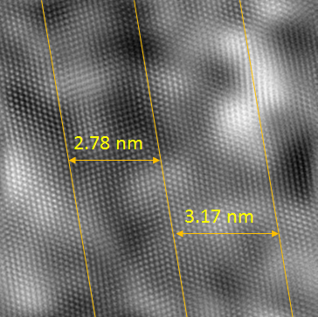
FIG. S2 High resolution HAADF image of Cu₉₄W₆ irradiated to 20dpa showing a twin spacing of approximately 2.9nm

