Supporting Information

**Effects of Second Phases on Thermoelectric Properties in Copper Sulfides with Sn addition**

***Peng Qin1 , Zhen-Hua Ge1*, Jing Feng1***

1. Faculty of Materials Science and Engineering, Kunming University of Science and Technology, Kunming, 650093, China.

**1. Cp**

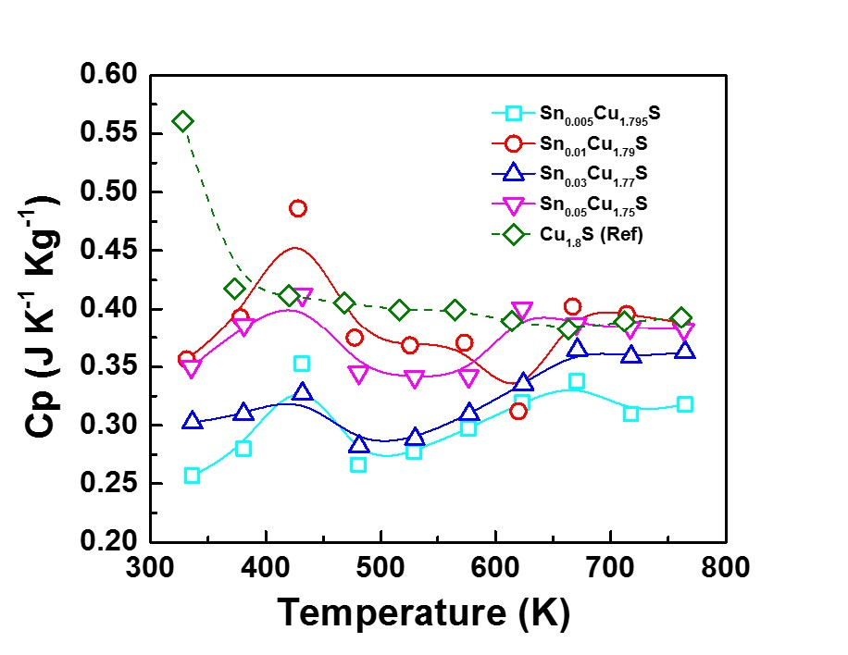

**Fig. S1 temperature dependence of heat specific.**

**2. Lorenz Number**

Reduced Fermi energy was used to calculate Lorenz number (**equ. (1)**) varies as Seebeck value changes (**equ.(2)**) with temperature or composition. The L calculation was estimated in a traditional single parabolic band model (resulting in an L with a deviation of less than 10% as compared with a more rigorous single non-parabolic band and multiple band models calculation) , where the reduced Fermi energy was implicitly determined by the Seebeck values (**equ.(2)**).

(1)

(2)

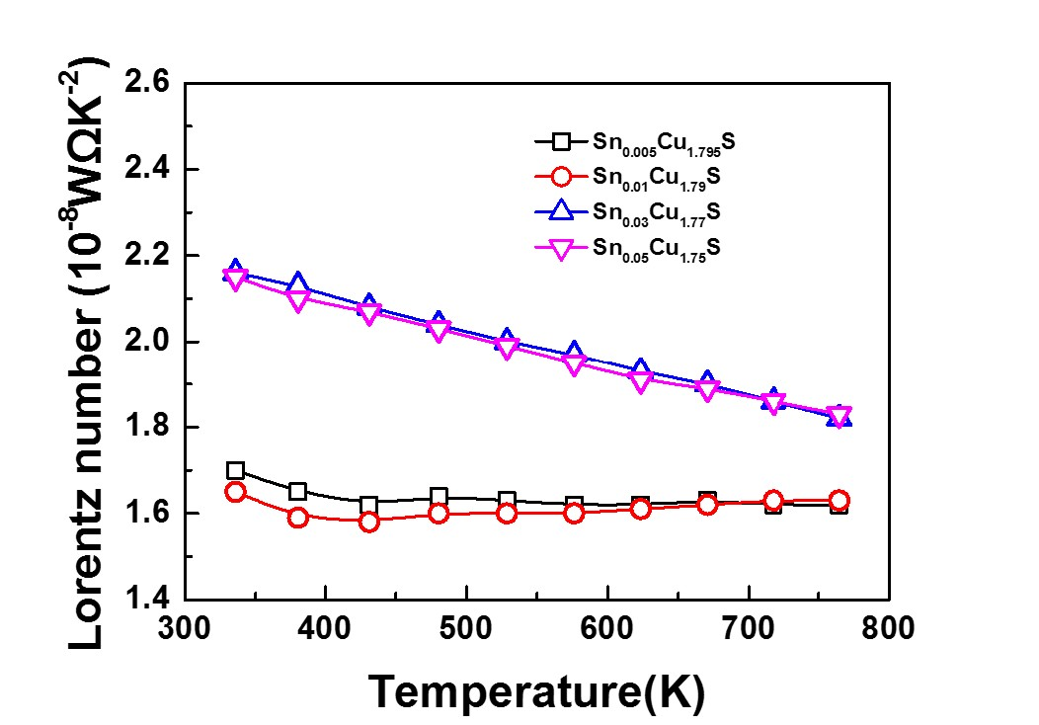

Fig. S2 Temperature dependence of Lorenz Number

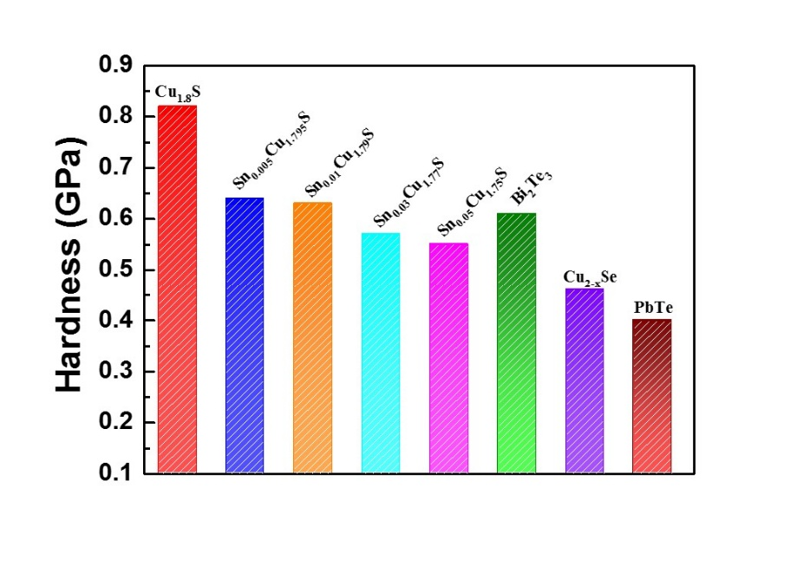

**Fig. S3** Vickers hardness values of the fabricated SnxCu1.8-xS (x = 0.005, 0.01, 0.03, and 0.05).