Supporting Information to

Fabrication and determination of growth regimes of various Pd NPs based on the control of deposition amount and temperature on c-plane GaN

Mao Sui¹, Sundar Kunwar¹, Puran Pandey¹, Quanzhen Zhang¹, Ming-Yu Li¹ and Jihoon Lee^{1,2*}
¹ College of Electronics and Information, Kwangwoon University, Nowon-gu Seoul 01897, South Korea
² Institute of Nanoscale Science and Engineering, University of Arkansas, Fayetteville AR 72701, USA.
*Correspondence author: e-mail: jihoonleenano@gmail.com, Phone: +82 2 940 5297, Fax: 82 2 942 5235

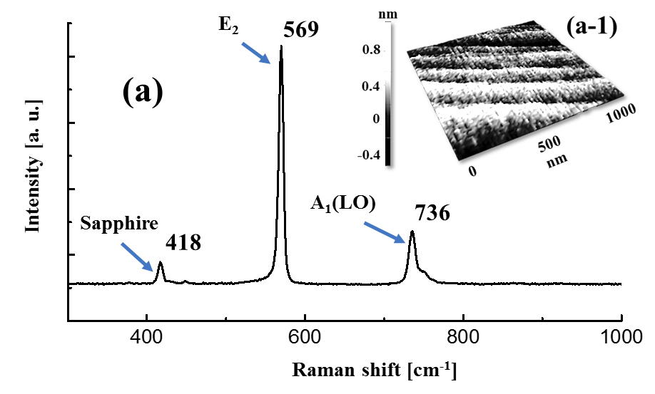
Figure S1 (a) Raman spectrum of bare GaN template on sapphire. The signal is measured with an excitation of 532 nm laser at room temperature. The E₂ peak is observed at 569 cm⁻¹ and A₁ phonon at 736 cm⁻¹. (a-1) AFM side-view of 1 × 1 µm² of bare GaN degassed at 350 °C for 30 min.

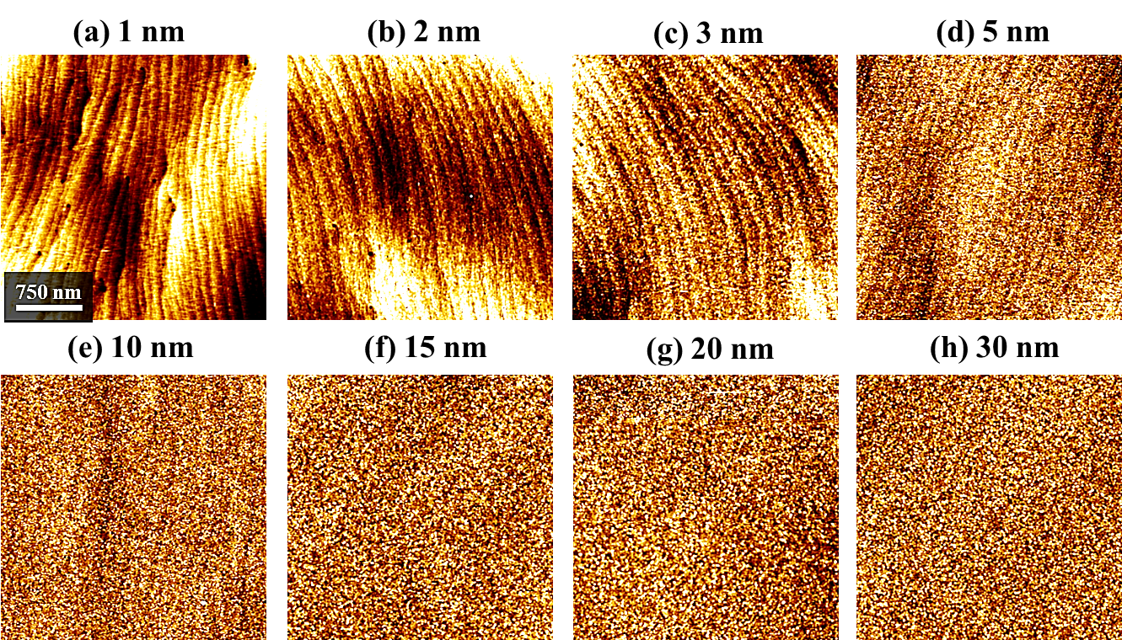
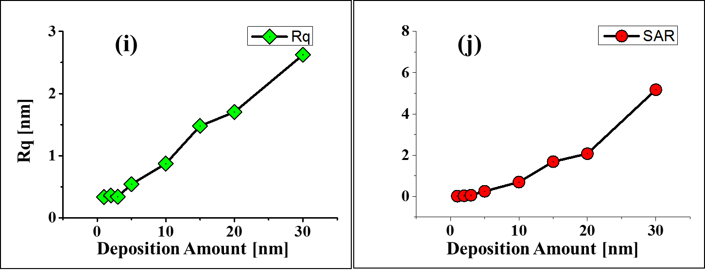
Figure S2 Surface morphologies of the pre-annealed samples deposited with various Pd thickness between 1 and 30 nm. (a) – (h) AFM top-views of 3 × 3 µm². (i) Rq and (j) SAR for the corresponding samples.

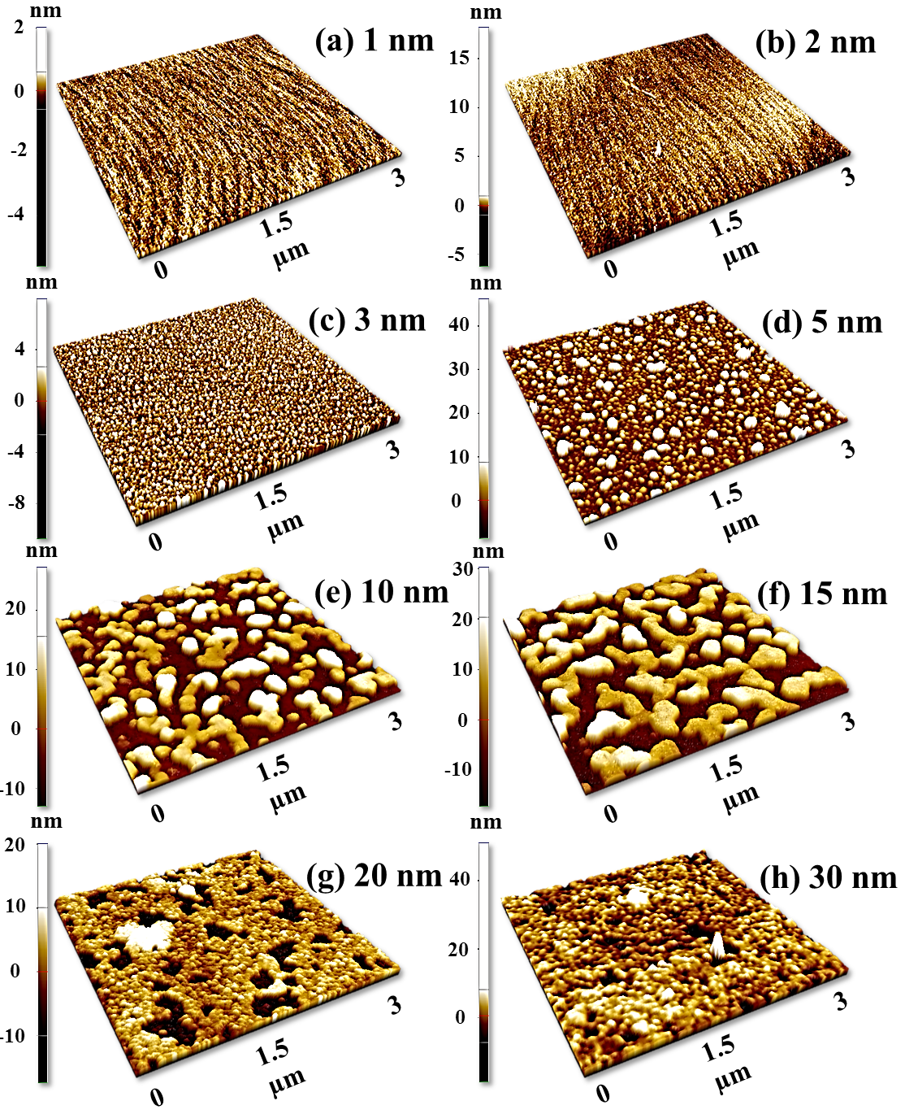
Figure S3 AFM side-views of 3 × 3 µm² for the Pd nanostructures fabricated on GaN with the variation of Pd deposition amounts at 700 °C.

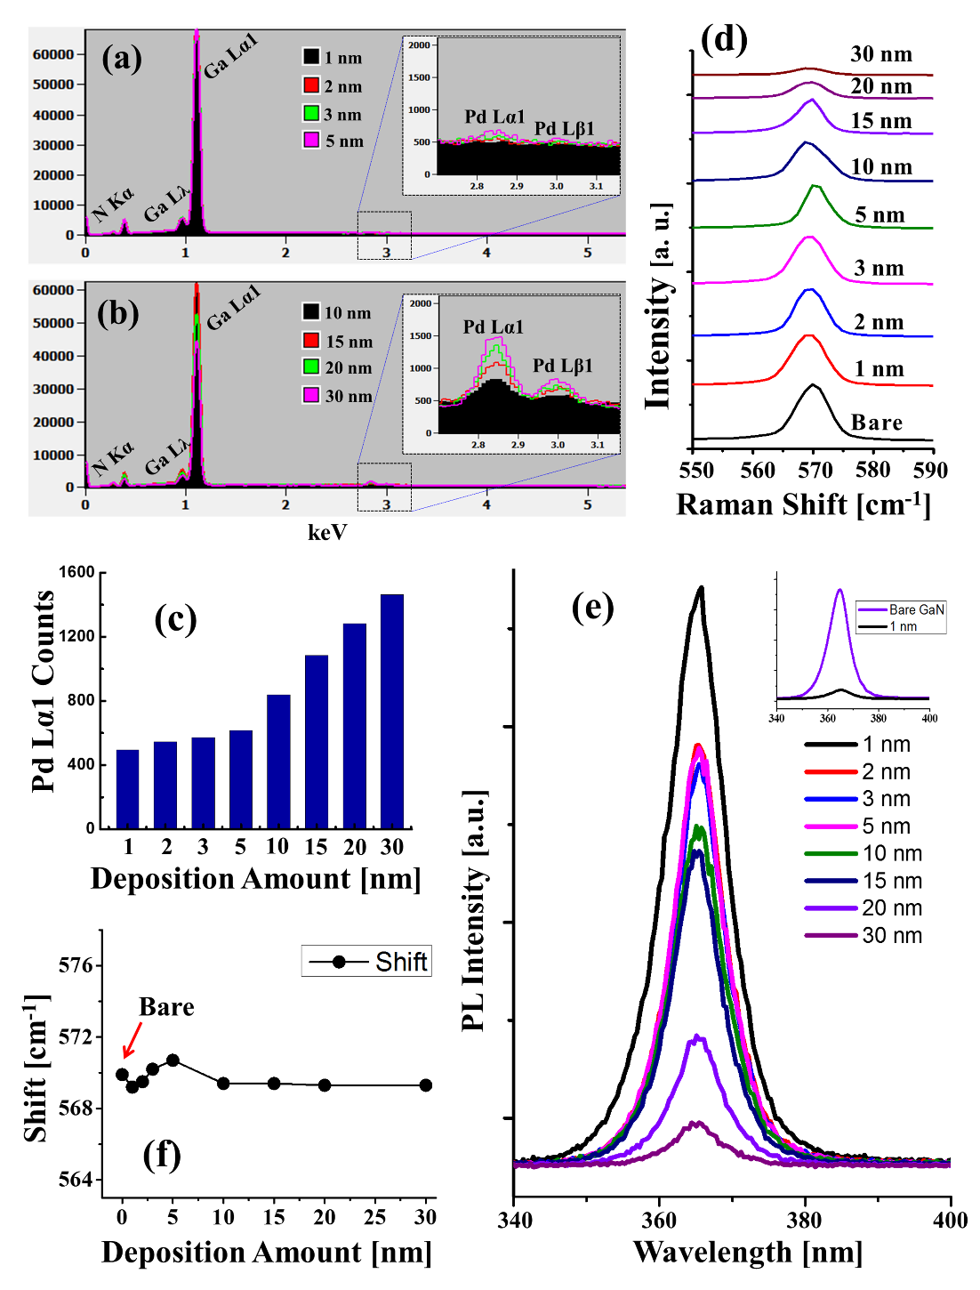
Figure S4 EDS spectra of the samples fabricated with the variation of Pd deposition amount at 700 °C. The energy range between 2.5 to 3.4 keV are enlarged and shown as insets. (c) Summary of peak intensity of Pd Lα1 peaks as a function of Pd deposition amount. (d) Raman spectra between 550 and 590 cm⁻¹. (e) Raman E₂ peak position plotted as a function of the deposition amounts.

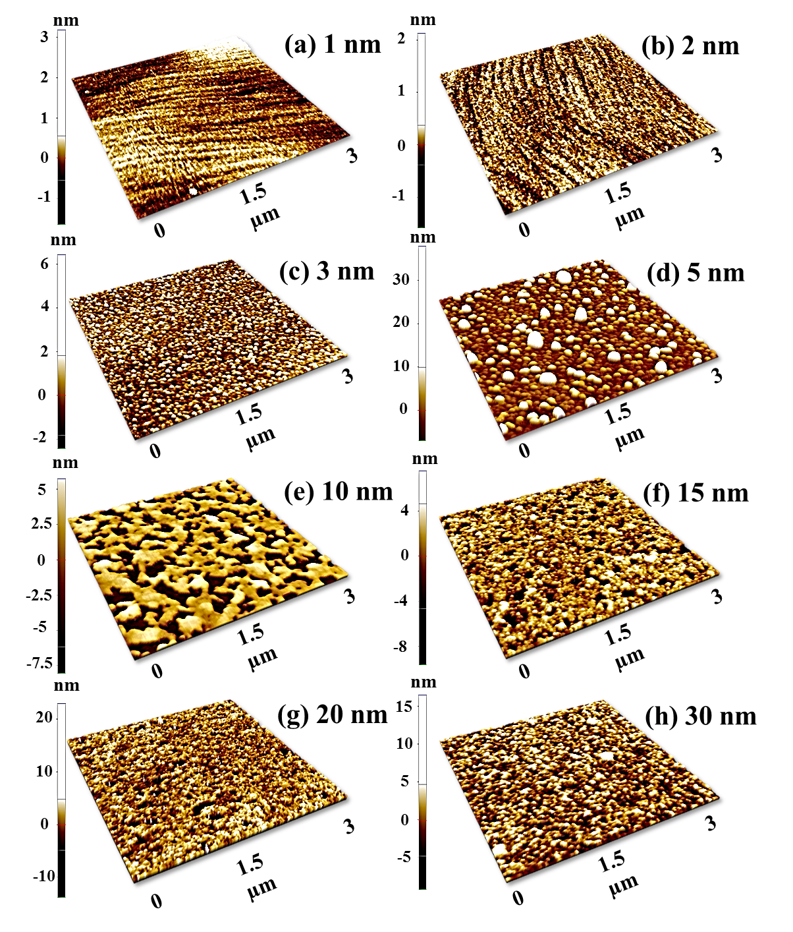
Figure S5 AFM side-views of 3 × 3 µm² of the Pd nanostructures fabricated with variation of Pd deposition amount between 1 and 30 nm at 650 °C.

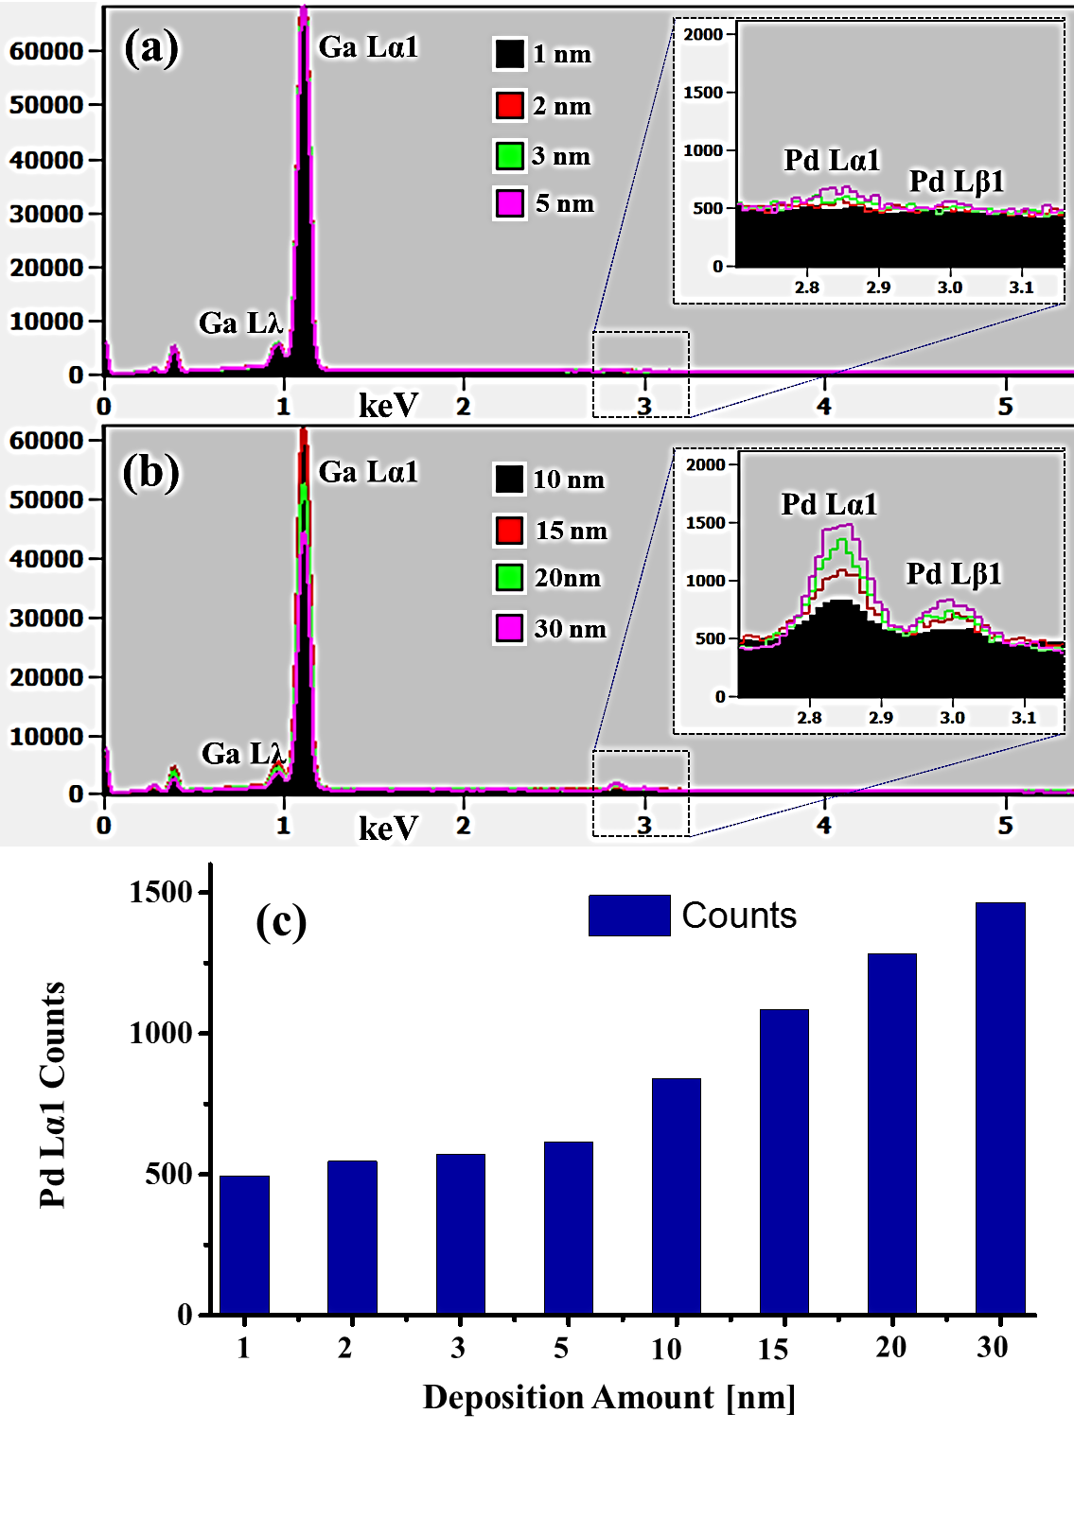
Figure S6 EDS spectra of the samples fabricated with the variation of Pd deposition amount at 650 °C. The energy range between 2.5 to 3.4 keV are enlarged and shown as insets. (c) Summary of peak intensity of Pd Lα1 peaks as a function of Pd deposition amount.

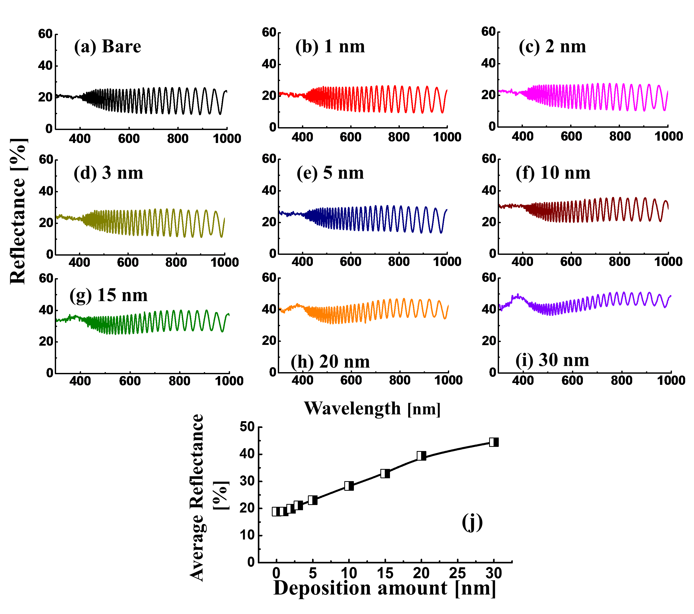
Figure S7 Reflectance spectra of the Pd nanostructures on GaN fabricated with the control of Pd deposition amount between 1 and 30 nm at 650 °C. (a) – (i) Spectra of bare GaN and the corresponding samples. (j) Average reflectance of the set plotted as a function of Pd deposition amounts.
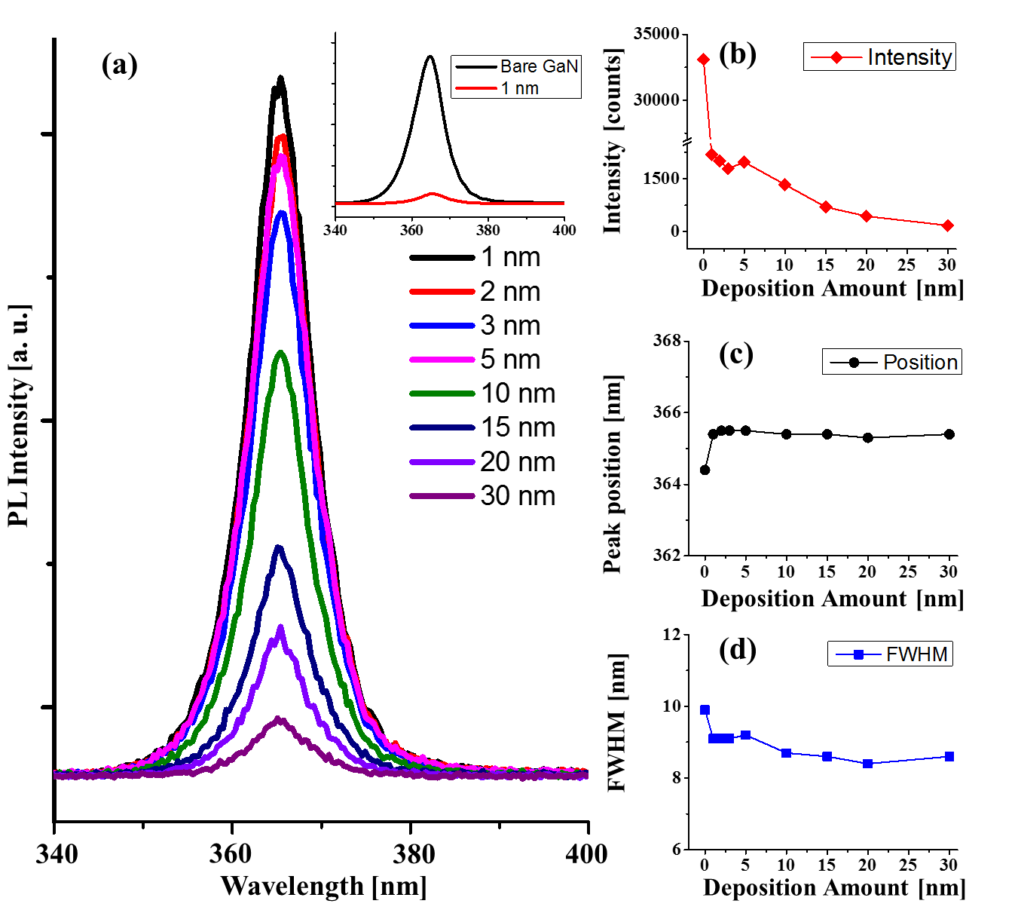
Figure S8 (a) Photoluminescence (PL) spectra of the Pd nanostructures on GaN fabricated at 650 °C with various deposition amount. (b) Intensity, (c) shift, and (d) full width at half maximum (FWHM) of the peaks with respect to the Pd deposition amounts.

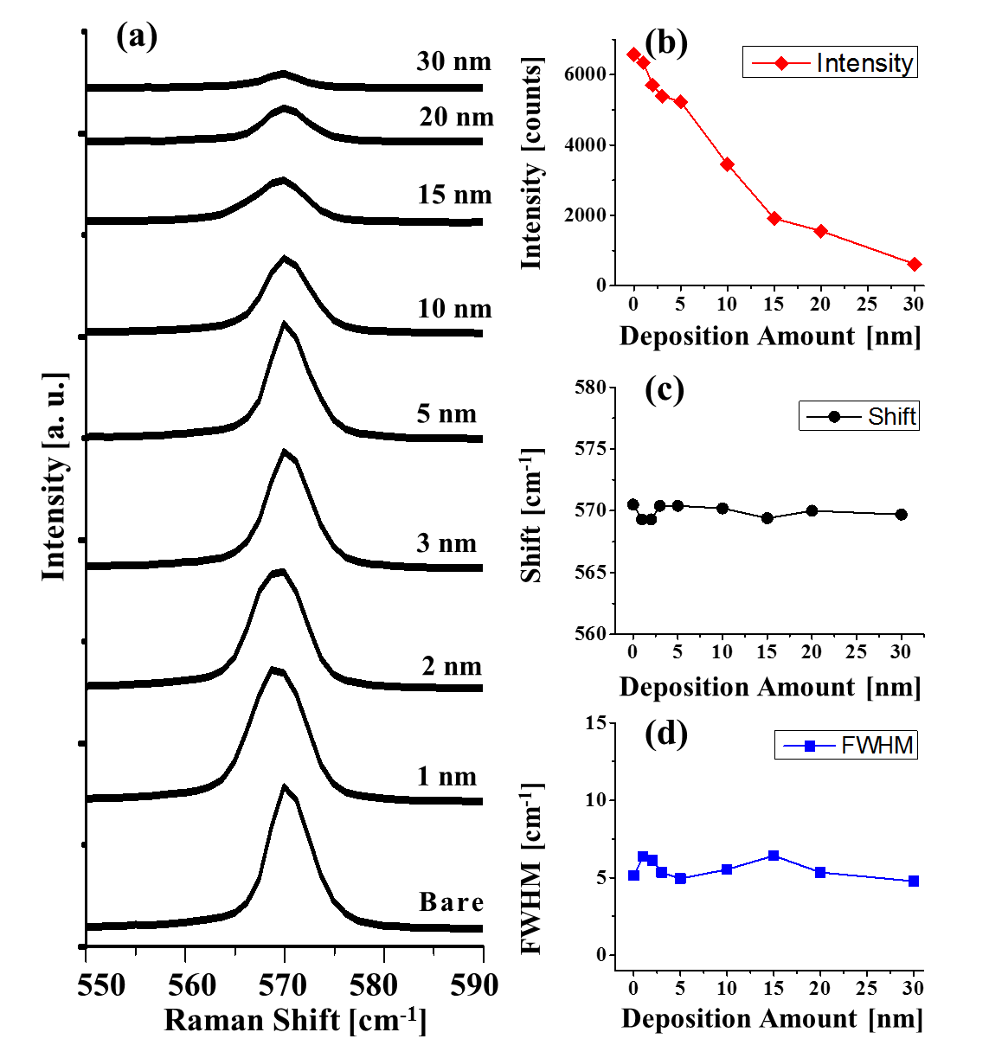
Figure S9 (a) Raman spectra of the Pd nanostructures on GaN fabricated at 650 °C with various thickness of Pd layers. (b) Intensity, (c) shift, and (d) FWHM of the peaks as functions of Pd deposition amount.

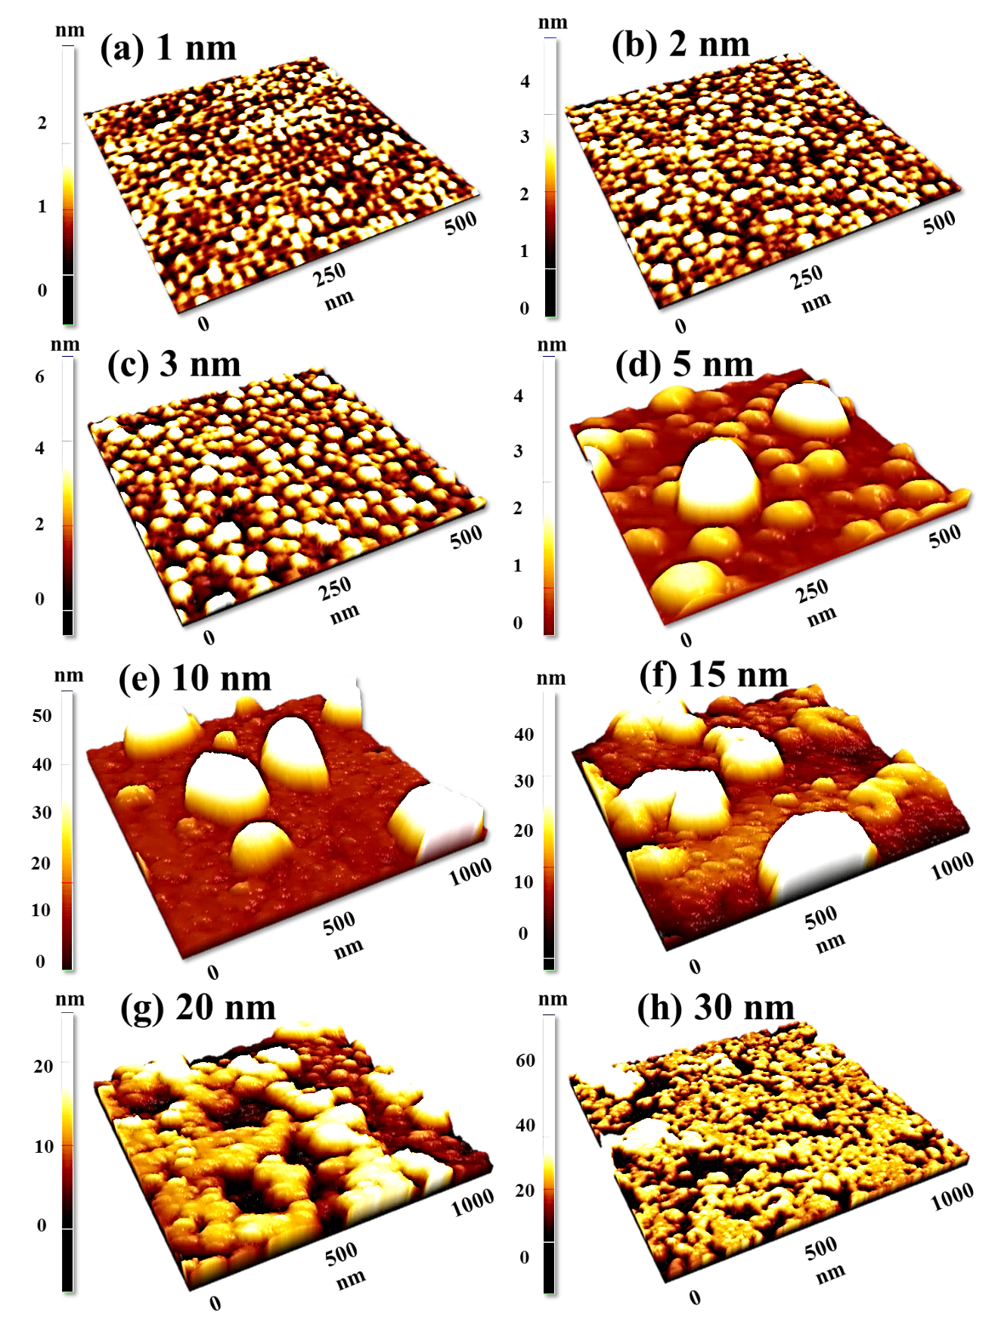
Figure S10 AFM side-views of (a) – (d) 500 × 500 nm² and (e) – (h) 1 × 1 µm² of the Pd nanostructures fabricated on GaN by the variation of Pd deposition amounts at 750 °C.

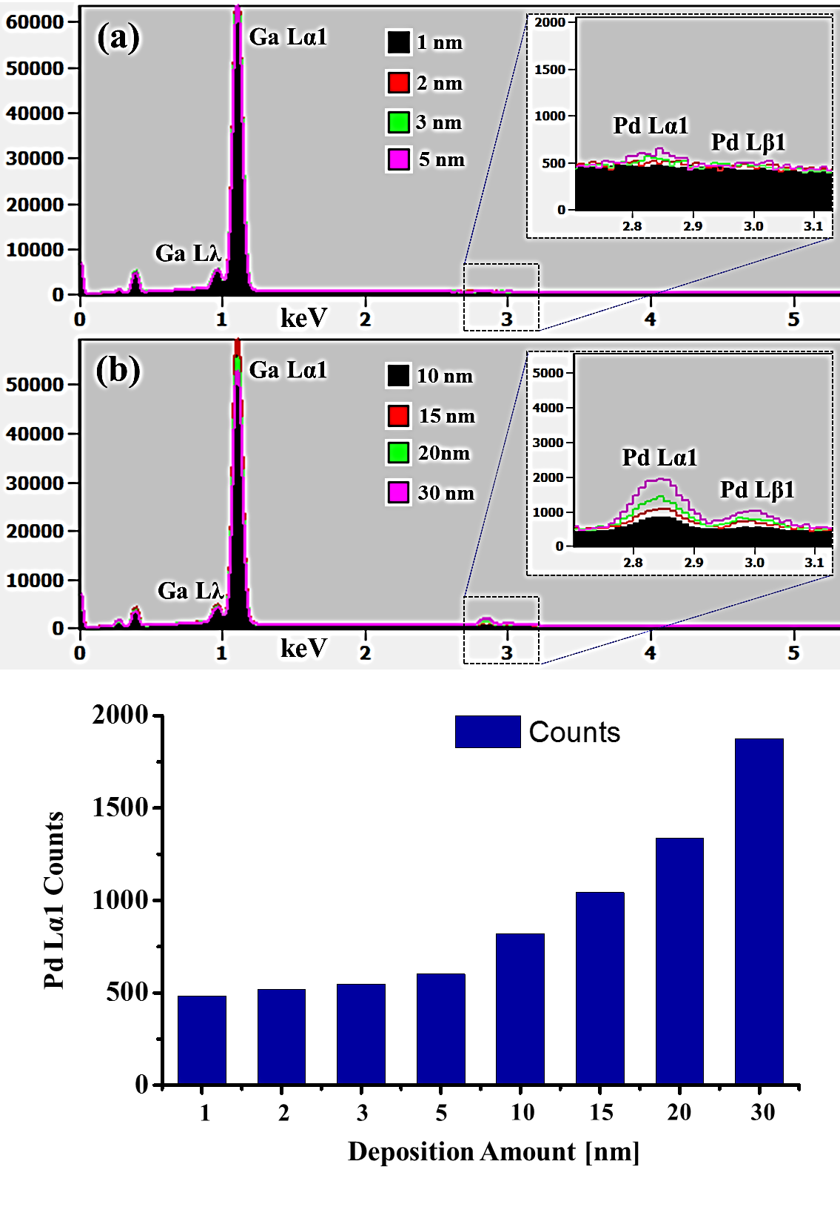
Figure S11 EDS spectra of the Pd nanostructures on GaN fabricated by the variation of Pd deposition amounts at 750 °C. The spectra of energy range between 2.5 to 3.2 keV are enlarged and shown as insets. (c) The peak intensities of Pd Lα1 for the samples with various deposition amount.

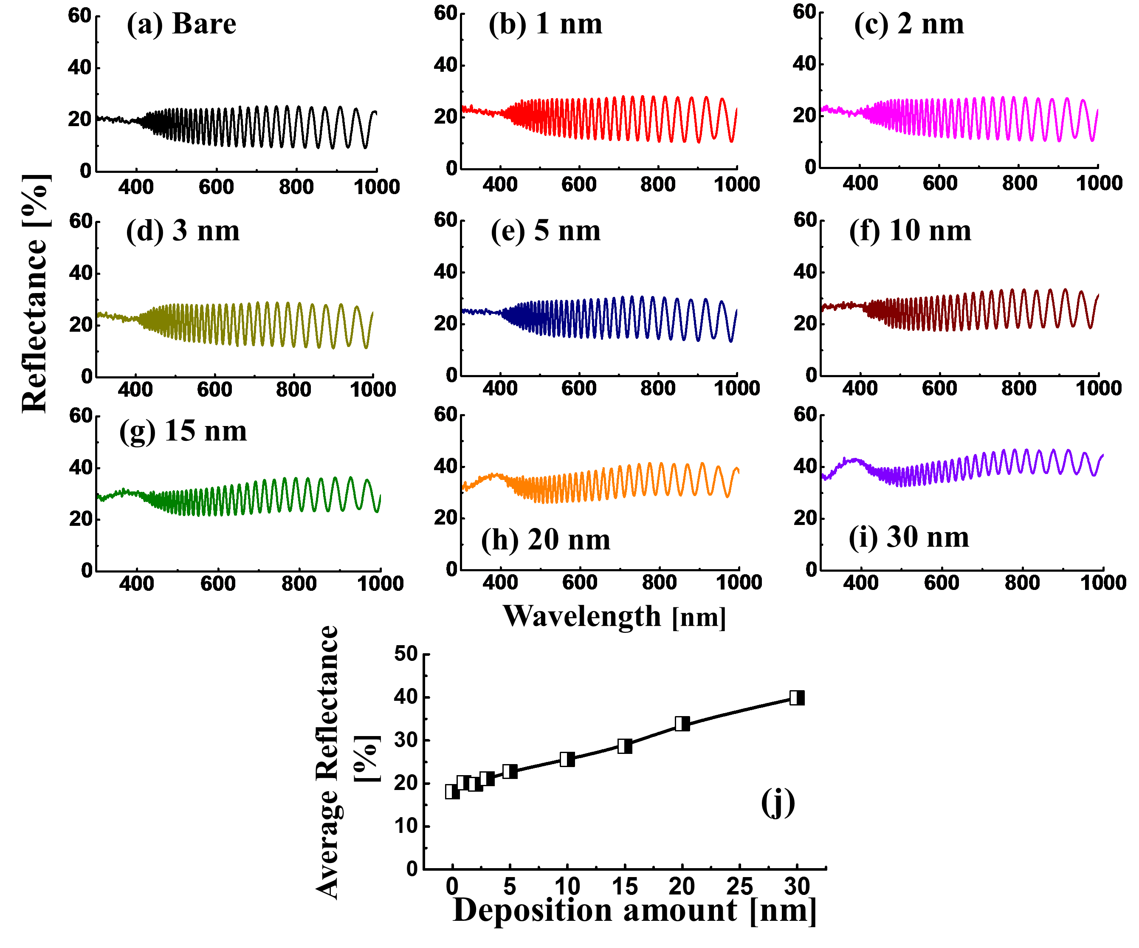
Figure S12 Reflectance spectra of the Pd nanostructures on GaN fabricated at 750 °C with the variation of Pd deposition amount between 1 and 30 nm. (a) – (i) Spectra of bare GaN and the corresponding samples. (j) Average reflectance with respect to the deposition amount.
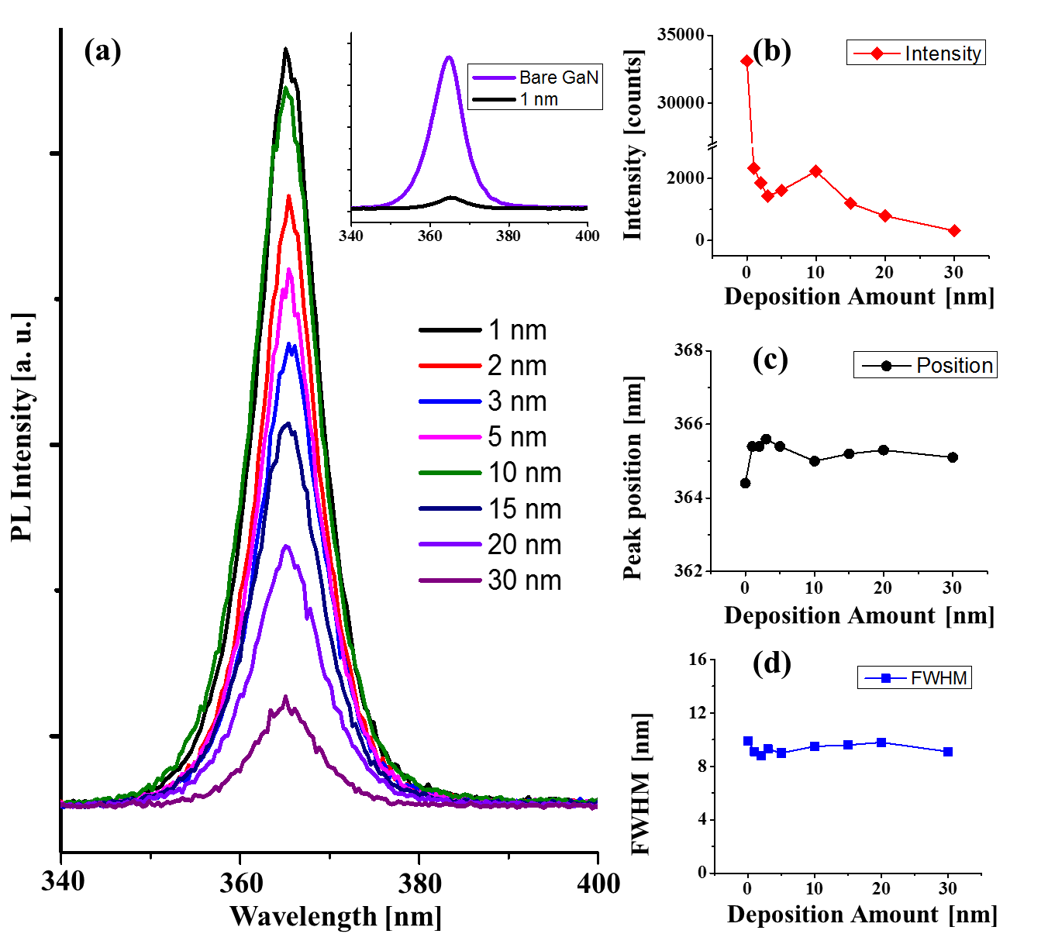
Figure S13 (a) PL spectra of the Pd nanostructures on GaN, annealed at 750 °C with variable Pd film thickness. (b) Intensity, (c) shift and (d) FWHM of the peaks as a function of Pd deposition amount.

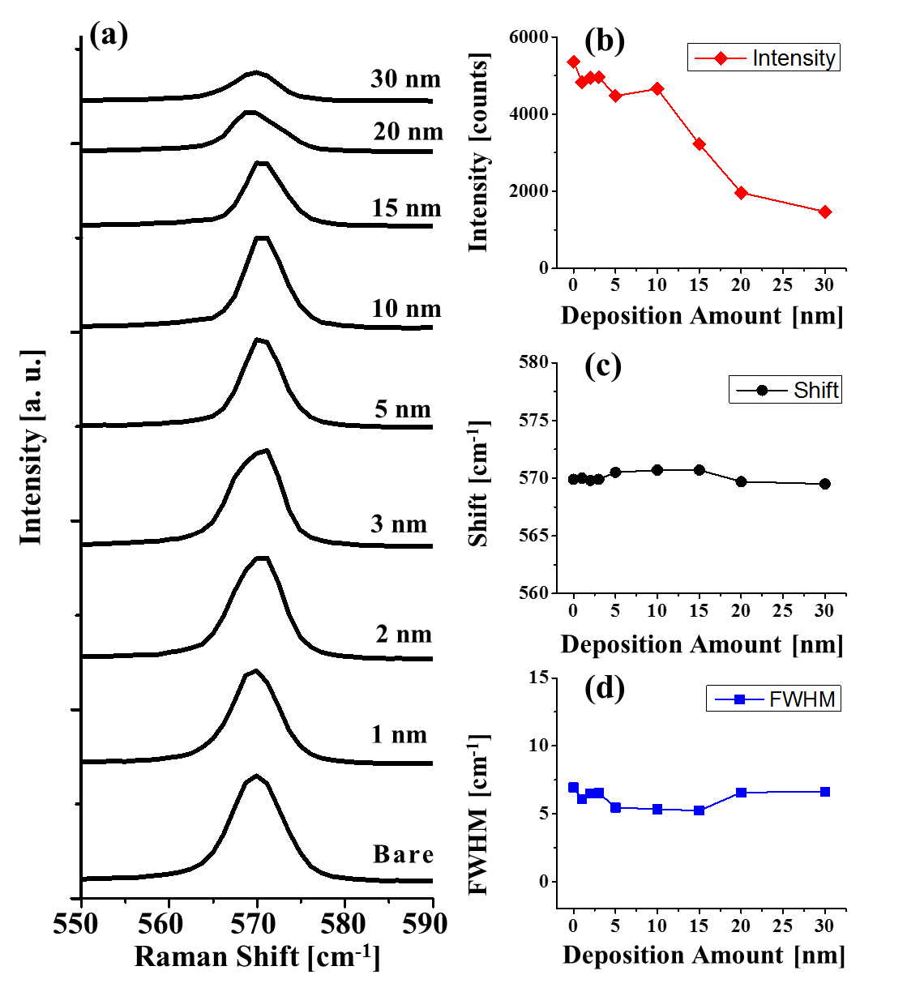
Figure S14 (a) Raman spectra of the samples fabricated at 750 °C with distinct Pd film thickness. (b) Intensity, (c) shift, and (d) FWHM of the peaks as a function of Pd deposition amount.

Table SI Summary of root mean squared roughness (Rq) and surface area ration (SAR) for the Pd nanostructures on GaN fabricated by the variation of Pd deposition amounts (DA) at 700 °C.
DA [nm] | Rq [nm] | SAR [%]
1 | 0.3 | 0.08
2 | 0.5 | 0.16
3 | 1.4 | 1.18
5 | 4.4 | 2.23
10 | 8.0 | 2.68
15 | 10.4 | 2.99
20 | 5.2 | 2.16
30 | 4.1 | 1.12

Table SII Summary of average reflectance [%] of the Pt nanostructures on GaN with the variation of deposition amounts (DA) at 650, 700 and 750 °C.
DA [nm] | 650 °C | 700 °C | 750 °C
0 | 18.84 | 18.66 | 18.08
1 | 18.88 | 18.91 | 20.21
2 | 19.87 | 18.20 | 19.81
3 | 21.11 | 20.05 | 21.10
5 | 23.08 | 22.57 | 22.78
10 | 28.32 | 25.95 | 25.61
15 | 32.86 | 25.28 | 28.67
20 | 39.42 | 35.56 | 33.86
30 | 44.46 | 42.01 | 39.89

Table SIII Summary of photoluminescence (PL) peak intensity, position and FWHM of the Pd nanostructures on GaN fabricated with the variation of deposition amounts (DA) at 700 °C.
DA [nm] | Intensity | Peak Position  [nm] | FWHM  [nm]
0 | 33107 | 364.4 | 9.9
1 | 2662 | 365.0 | 10.5
2 | 1950 | 365.5 | 9.2
3 | 1863 | 365.5 | 9.2
5 | 1943 | 365.4 | 9.2
10 | 1579 | 365.3 | 9.4
15 | 1456 | 365.1 | 9.0
20 | 596 | 365.3 | 8.8
30 | 192 | 365.1 | 8.6

Table SIV Summary of Raman E₂ peak intensity, position and FWHM of the Pd nanostructures on GaN fabricated by the deposition amount (DA) variation at 700 °C.
DA [nm] | Intensity | Peak Position  [/cm] | FWHM  [/cm]
Bare GaN | 6048 | 569.9 | 6.3
1 | 5544 | 569.2 | 6.7
2 | 5305 | 569.5 | 5.9
3 | 5241 | 570.2 | 6.7
5 | 4678 | 570.7 | 5.2
10 | 4145 | 569.4 | 6.8
15 | 3488 | 569.4 | 5.5
20 | 1764 | 569.3 | 6.3
30 | 715 | 569.3 | 6.3

Table SV Summary of root mean squared roughness (Rq) and SAR of the Pd nanostructures on GaN fabricated by variation of Pd deposition amounts (DA) at 650 °C.
DA [nm] | Rq [nm] | SAR [%]
1 | 0.2 | 0.02
2 | 0.2 | 0.02
3 | 0.9 | 0.31
5 | 5.1 | 2.00
10 | 4.5 | 0.70
15 | 3.2 | 0.84
20 | 2.3 | 0.61
30 | 2.2 | 0.48

Table SVI Summary of root mean squared roughness and SAR of the Pd nanostructures on GaN fabricated by variation of Pd deposition amounts (DA) at 750 °C.
DA [nm] | Rq [nm] | SAR [%]
1 | 0.7 | 0.20
2 | 0.7 | 0.42
3 | 1.3 | 1.10
5 | 4.4 | 2.93
10 | 12.9 | 3.82
15 | 10.8 | 4.57
20 | 10.6 | 4.48
30 | 7.8 | 2.58

Table SVII Summary of photoluminescence (PL) peak intensity, position and FWHM of the Pd nanostructures on GaN fabricated by the variation of deposition amounts (DA) at 650 °C.
DA [nm] | Intensity | Peak Position  [nm] | FWHM  [nm]
0 | 33107 | 364.4 | 9.9
1 | 2193 | 365.4 | 9.1
2 | 2006 | 365.5 | 9.1
3 | 1785 | 365.5 | 9.1
5 | 1974 | 365.5 | 9.2
10 | 1335 | 365.4 | 8.7
15 | 697 | 365.4 | 8.6
20 | 436 | 365.3 | 8.4
30 | 172 | 365.4 | 8.6

Table SVIII Summary of the Raman E₂ peak intensity, position and FWHM of the Pd nanostructures on GaN fabricated by the deposition amount (DA) variation at 650 °C.
DA [nm] | Intensity | Peak Position  [/cm] | FWHM  [/cm]
0 | 6565 | 570.5 | 5.2
1 | 6338 | 569.3 | 6.4
2 | 5701 | 569.3 | 6.1
3 | 5389 | 570.4 | 5.3
5 | 5229 | 570.4 | 5.0
10 | 3454 | 570.2 | 5.5
15 | 1915 | 569.4 | 6.4
20 | 1557 | 570.0 | 5.4
30 | 619 | 569.7 | 4.8

Table SIX Summary of the photoluminescence (PL) peak position, intensity and FWHM of the Pd nanostructures on GaN fabricated by the variation of deposition amounts (DA) at 750 °C.
DA [nm] | Intensity | Peak Position  [nm] | FWHM  [nm]
0 | 33107 | 364.4 | 9.9
1 | 2341 | 365.4 | 9.1
2 | 1860 | 365.4 | 8.8
3 | 1436 | 365.6 | 9.3
5 | 1620 | 365.4 | 9.0
10 | 2237 | 365.0 | 9.5
15 | 1200 | 365.2 | 9.6
20 | 795 | 365.3 | 9.8
30 | 318 | 365.1 | 9.1

Table SX Summary of Raman E₂ peak intensity, position and FWHM of the Pd nanostructures on GaN fabricated by the deposition amount (DA) variation at 750 °C.
DA [nm] | Intensity | Peak Position  [/cm] | FWHM  [/cm]
0 | 5360 | 569.9 | 6.9
1 | 4822 | 570.0 | 6.1
2 | 4949 | 569.8 | 6.5
3 | 4961 | 569.9 | 6.5
5 | 4472 | 570.5 | 5.5
10 | 4654 | 570.7 | 5.3
15 | 3226 | 570.7 | 5.2
20 | 1966 | 569.7 | 6.6
30 | 1472 | 569.5 | 6.6

