Supplementary Materials

In-situ preparation of Z-scheme MoO₃/g-C₃N₄ composite with high performance in photocatalytic CO₂ reduction and RhB degradation

¹Zhe Feng, ¹Lin Zeng, ¹Yijin Chen, ¹Yueying Ma, ¹Chunran Zhao, ¹Risheng Jin, ¹Yu Lu, ²Ying Wu, ¹Yiming He*

¹Department of Materials Science and Engineering, Zhejiang Normal University, Jinhua, 321004, China
² Institute of Physical Chemistry, Zhejiang Normal University, Jinhua, 321004, China

Corresponding author: Tel: +86-0579-82291500; E-mail: hym@zjnu.cn

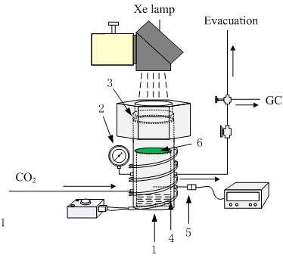
FIG. S1 Schematic diagram of the photocatalytic CO₂ conversion setup: (1) reactor, (2) pressure guage, (3) quartz glass, (4) heating tape, (5) thermocouple, (6) support.

a
b
FIG. S2 N₂ adsorption/desorption isotherms (a) and pore size distribution (b) of g-C₃N₄ and 3wt.% MoO₃/g-C₃N₄ composite

