SUPPLEMENTARY MATERIAL

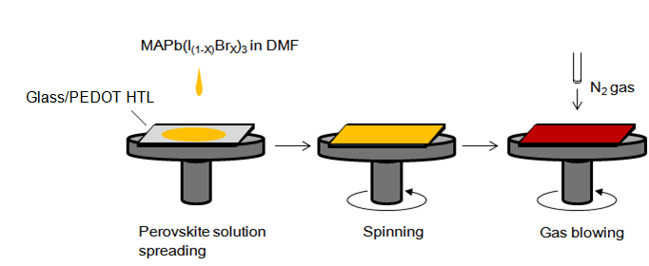

FIG. S1. Schematic illustration of the gas blowing method for fabricating the perovskite layer. Nitrogen gas was blown onto the precursor solution during spin-coating.

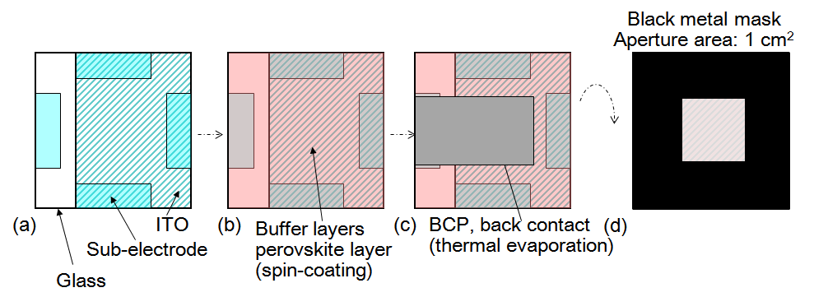

FIG. S2. Substrate design for 1 cm2 cells. (a) Glass substrate consisting of ITO and a sub-electrode (metal contact pads). (b) Glass substrate spin-coated with buffer layers and perovskite layer without masking. (c) BCP and Back contact (Ag electrode) formed by thermal evaporation using a metal mask. (d) Black metal mask with a 1 cm2 aperture applied to the reverse side for measurement of I-V characteristics.

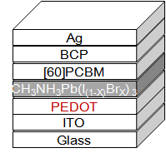

FIG. S3. Schematic illustration of the perovskite solar cells tested in this study (ITO/PEDOT HTL/CH3NH3Pb(I(3-X)BrX)3/[60]PCBM/BCP/Ag).

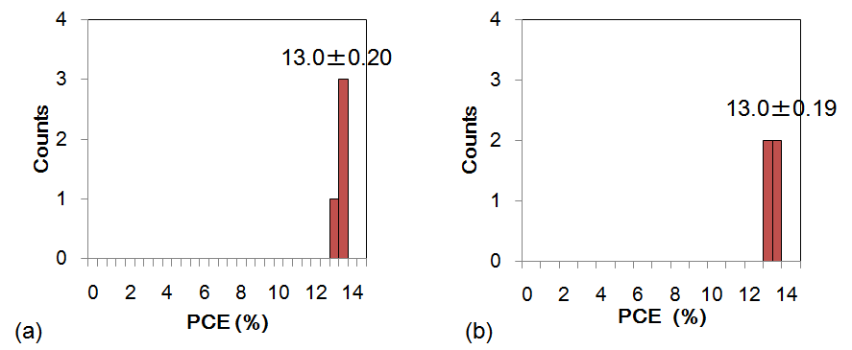

FIG. S4. Histogram of PCE for four cells. PCEs were obtained from scanning in the forward bias (a) and reverse bias (b) directions. Cells had an active area of 1 cm2. PCE was measured with anti-reflective films on the surface of the solar cells.