Stability of shear banding process in bulk metallic glasses and composites
Yusheng Qin ¹, Xiaoliang Han ¹, Kaikai Song ^{1, a)}, Li Wang ^{1,b)}, Yun Cheng ¹, Zequn. Zhang ¹, Qisen Xue ¹, Nianzhen Sun ¹, Jianguo Wang ², Baoan Sun ³, Baran Sarac ⁴, Florian Spieckermann ^{4, 5}, Gang Wang ⁶, Ivan Kaban ⁷, and Jürgen Eckert ^{4, 5}

¹ School of Mechanical, Electrical & Information Engineering, Shandong University (Weihai), Wenhua Xilu 180, 264209 Weihai, P.R. China.

² School of Materials Science and Engineering, Anhui University of Technology, 243002 Ma’anshan, P.R. China.

³ Herbert Gleiter Institute of Nanoscience, Nanjing University of Science and Technology, 210094 Nanjing, P.R. China.

⁴ Erich Schmid Institute of Materials Science, Austrian Academy of Sciences, Jahnstraße 12, A-8700 Leoben, Austria.

⁵ Department Materials Physics, Montanuniversität Leoben, Jahnstraße 12, A-8700 Leoben, Austria.

⁶ Laboratory for Microstructures, Shanghai University, 200444 Shanghai, P.R. China.

⁷ IFW Dresden, Institute for Complex Materials, Helmholtzstraße 20, D-01069 Dresden, Germany.

Contributing Editor:

Address all correspondence to these authors.

^{a)} e-mail: songkaikai8297@gmail.com

^{b)} e-mail: wanglihxf@sdu.edu.cn

This file includes: Supplementary FIGs. S1- S3

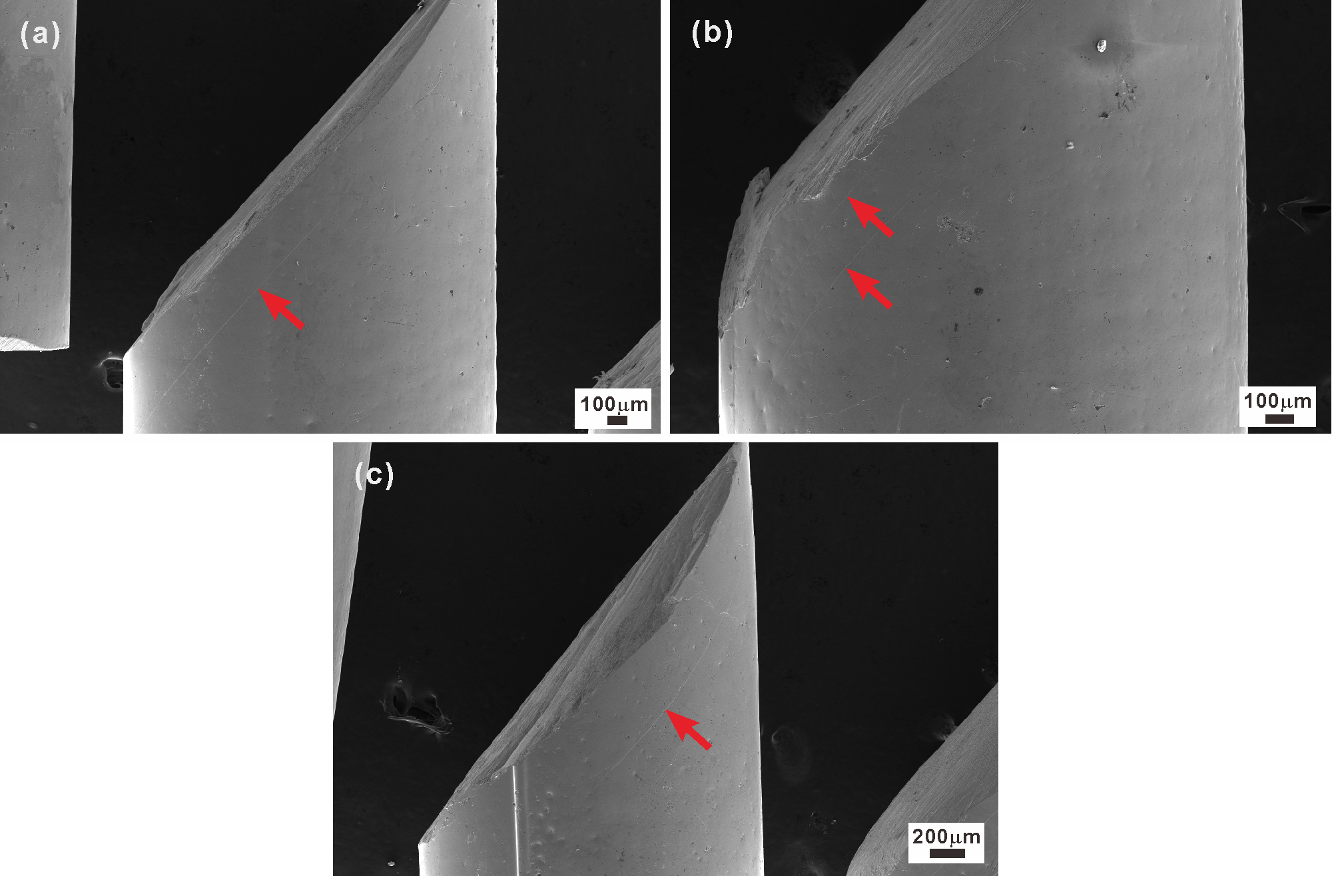
FIG. S1 Fracture morphologies of the Cu₄₆Zr₄₆Al₈ BMG samples after compression. (a), (b), and (c) were obtained from different compressive rods, respectively.

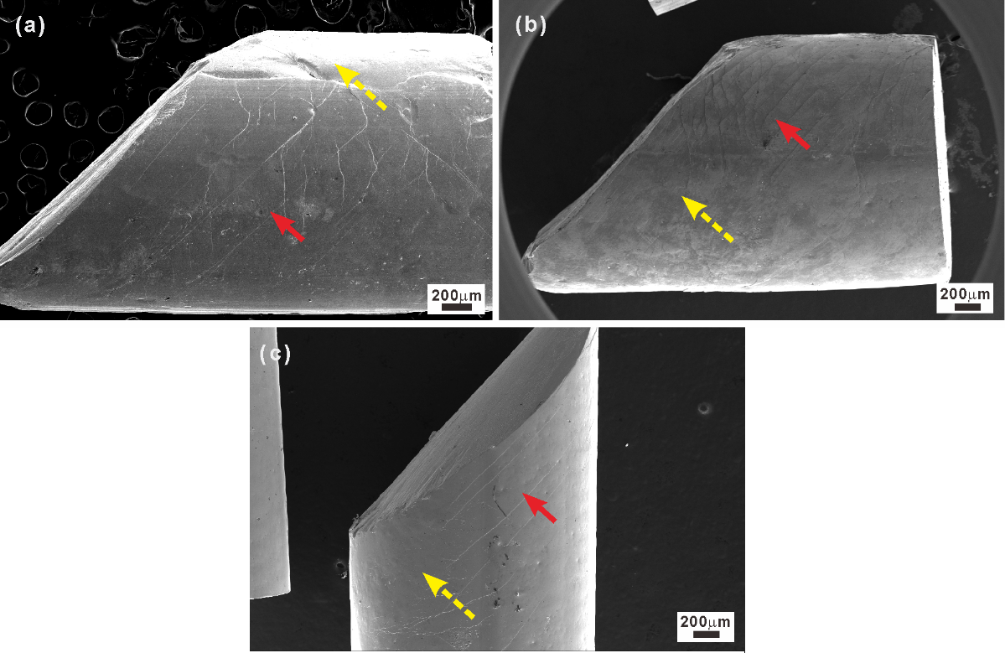
FIG. S2 Fracture morphologies of the in situ prepared Cu₄₆Zr₄₆Al₈ BMG composites after compression. (a), (b), and (c) were obtained from different compressive rods, respectively.

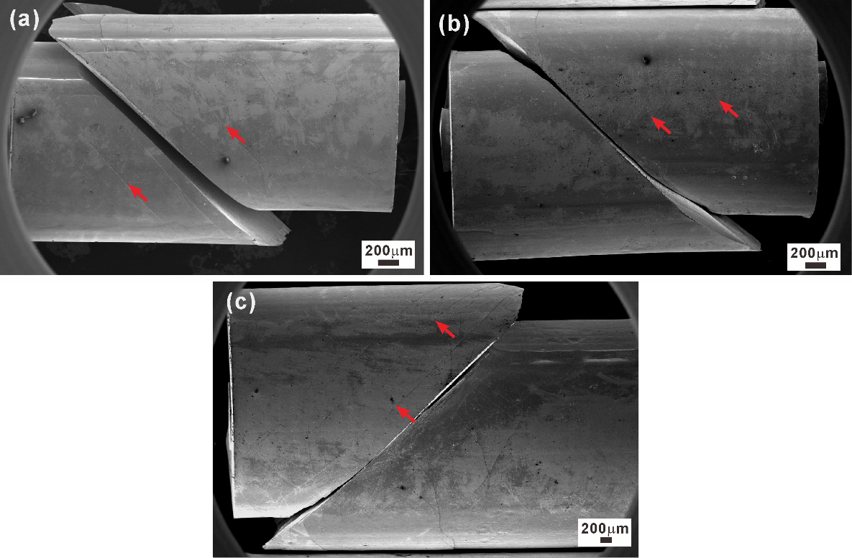
FIG. S3 Fracture morphologies of the ex situ prepared Cu₄₆Zr₄₆Al₈ BMG composites after compression. (a), (b), and (c) were obtained from different compressive rods, respectively.

