**Supplementary information**

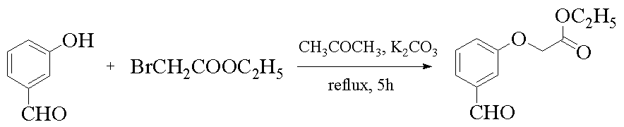

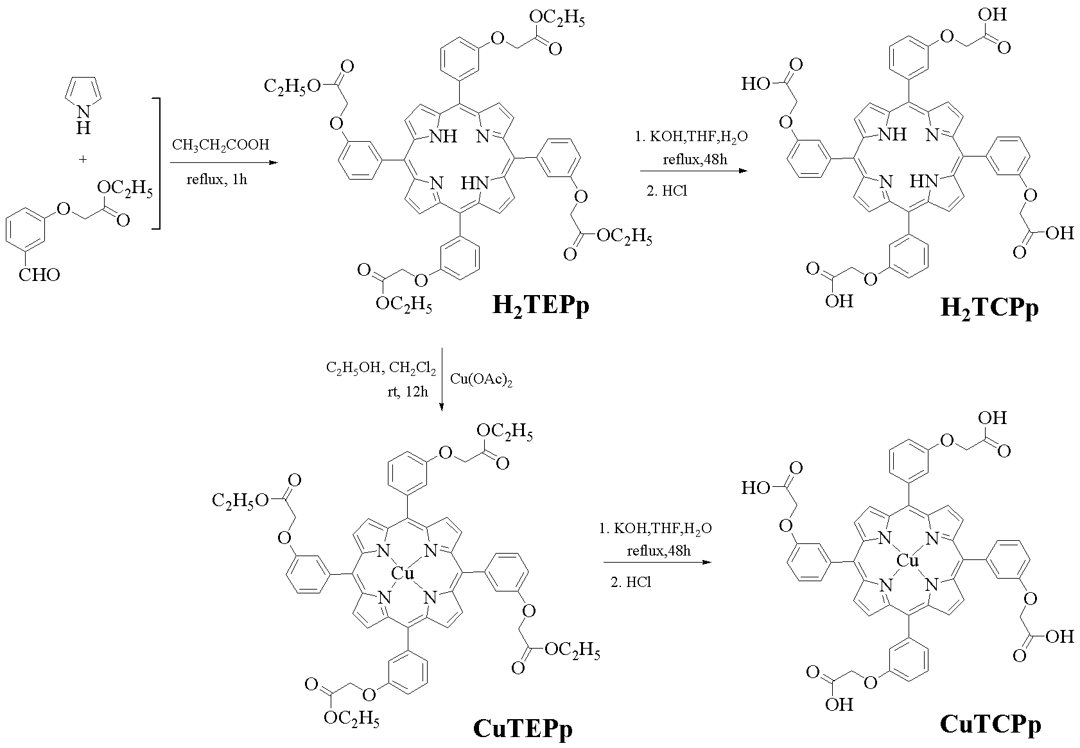

**Scheme S1** The synthesis routes of porphyrins.

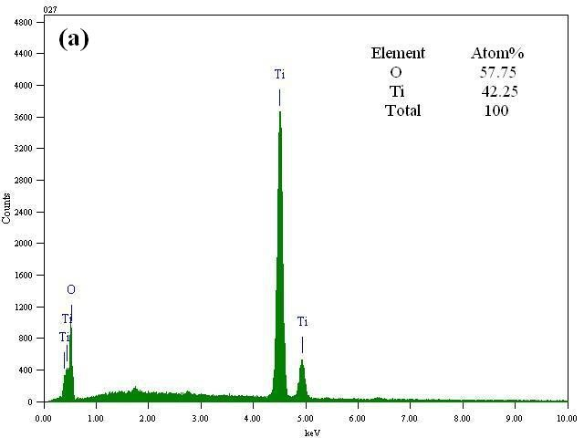

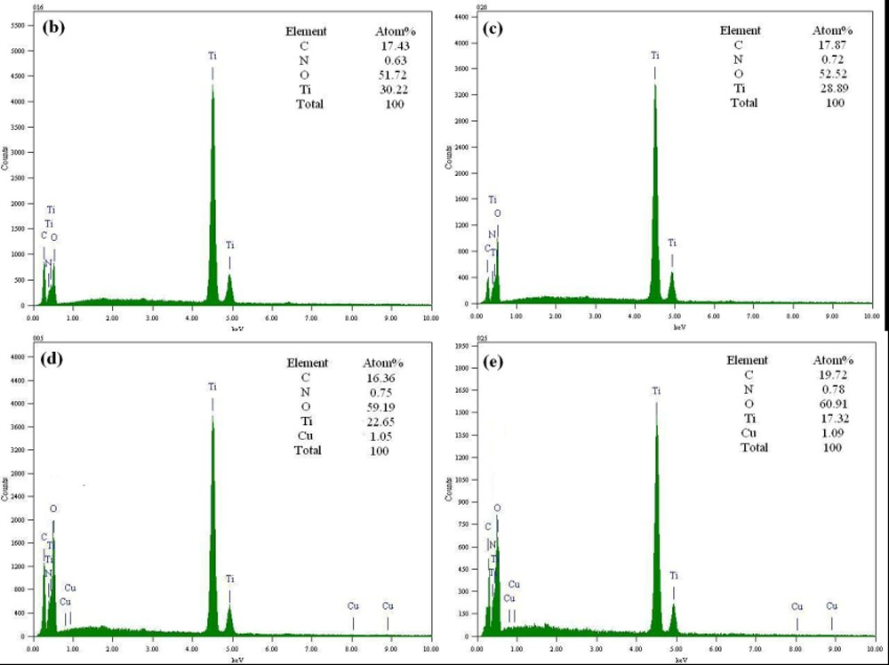

**Fig. S2** EDS images of bare TiO2(a), H2TEP/TiO2 (b), H2TCPp/TiO2 (c), CuTEPp/TiO2 (d) and CuTCPp/TiO2 (e) composites.

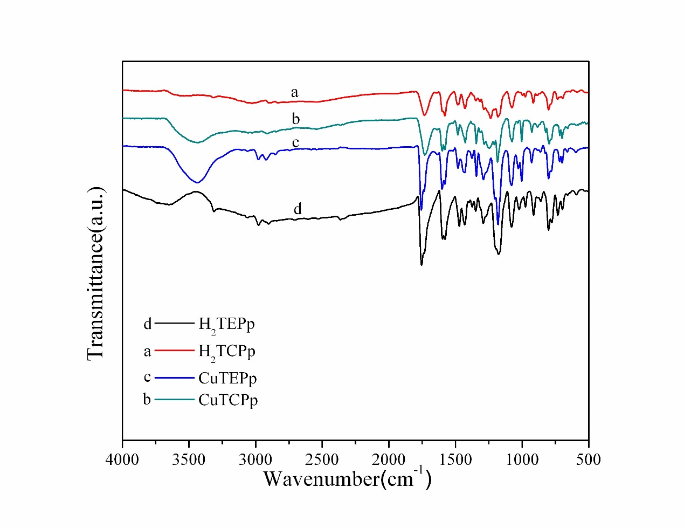

**Fig. S3** FT-IR spectra of synthesized porphyrins.

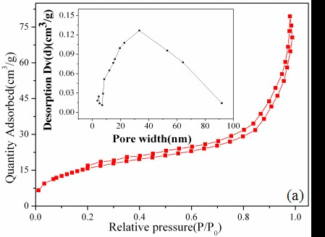

图片1

**Fig. S4** N2 adsorption-desorption isotherms and pore pore size distribution curve of bare TiO2(a), H2TEPp/TiO2(b), H2TCPp/TiO2(c), CuTEPp/TiO2(d)and CuTCPp/TiO2(e)composites.

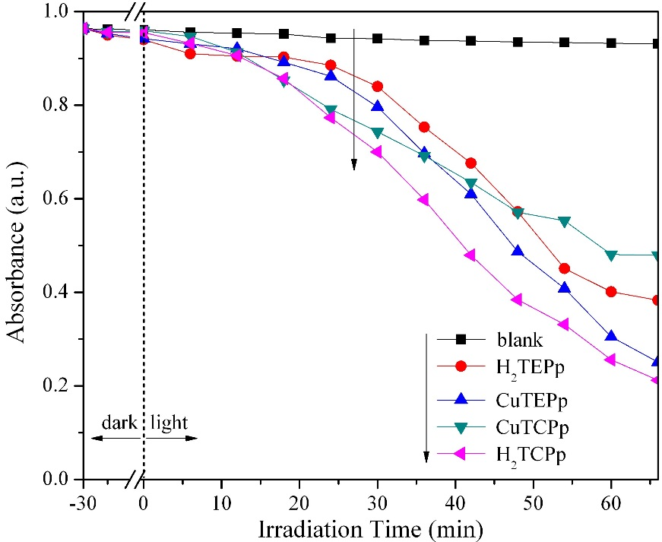

**(a)**

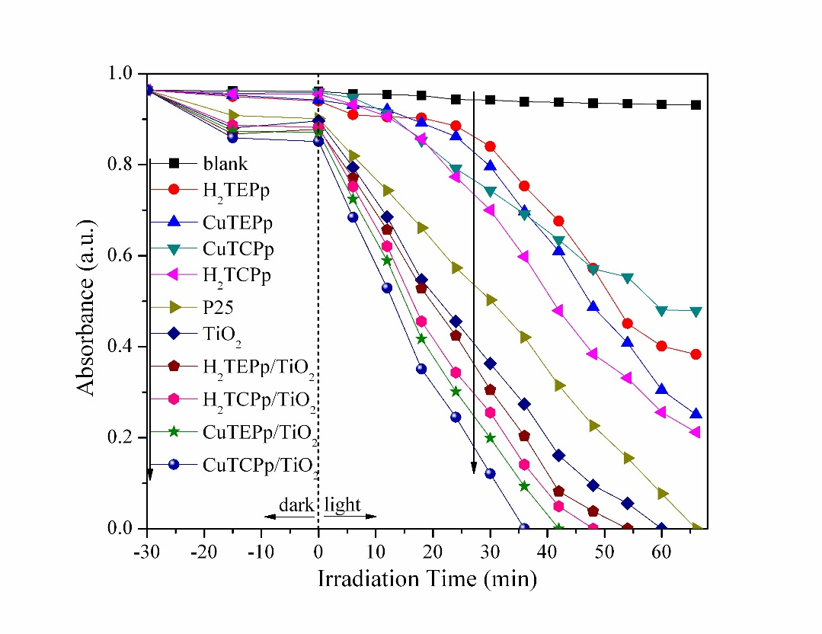

**(b)**

**Fig. S5.** The photocatalytic activities of porphyrins and Cu(II)porphyrins for the 4-NP degradation (a) and all samples (b) for comparison.