Supplementary Materials

Reaction with Organic Halides as a General Method for the Covalent Functionalization of Nanosheets of 2D Chalcogenides and Related Materials

S. Manjunatha, S. Rajesh, Pratap Vishnoi and C. N. R. Rao^{a)}

New Chemistry Unit,
International Centre for Materials Science and Sheikh Saqr Laboratory
Jawaharlal Nehru Centre for Advanced Scientific Research, Jakkur P. O.,
Bangalore-560064 (India)
e-mail: cnrrao@jncasr.ac.in

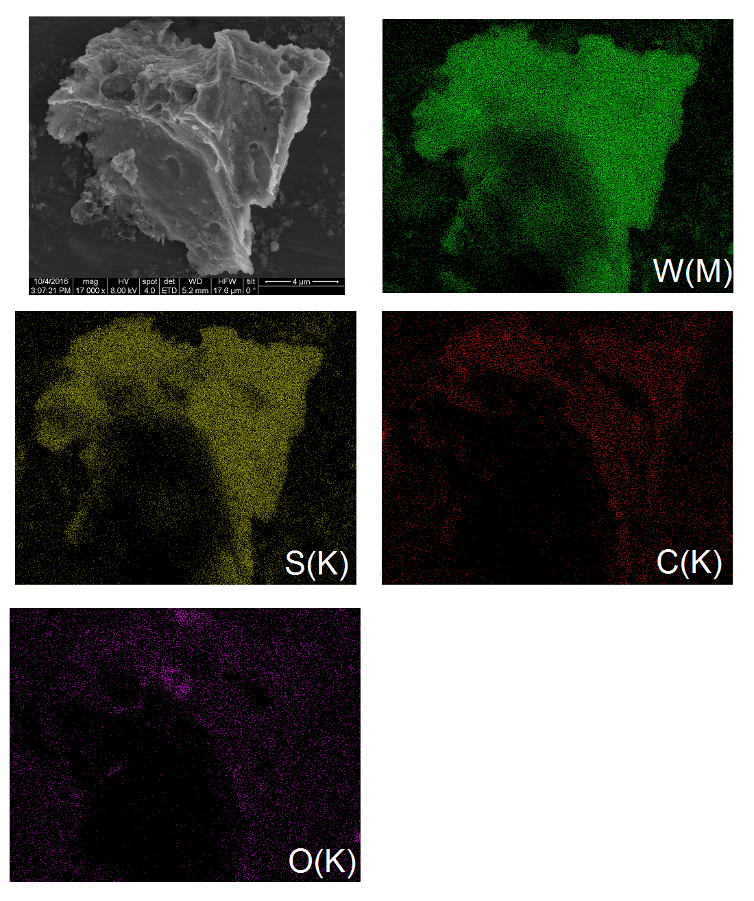
Fig. S1. EDAS elemental maps of WS₂-methoxyphenyl (1).

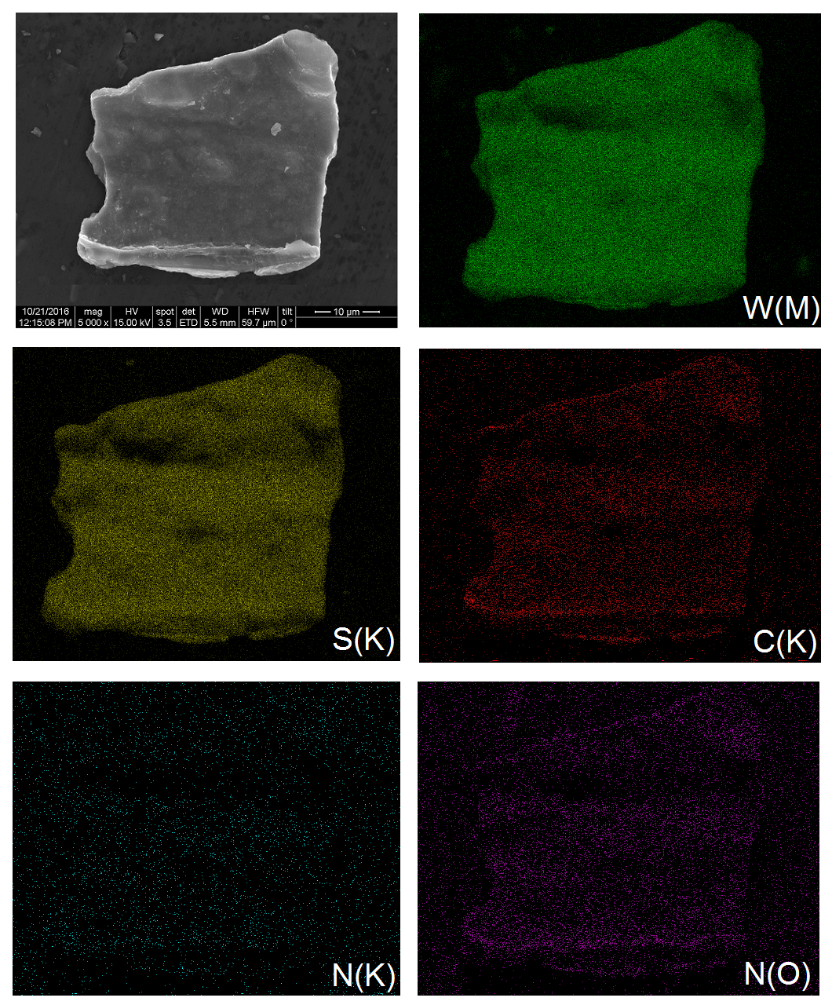
Fig. S2. EDAS elemental maps of WS₂-nitrophenyl (3).

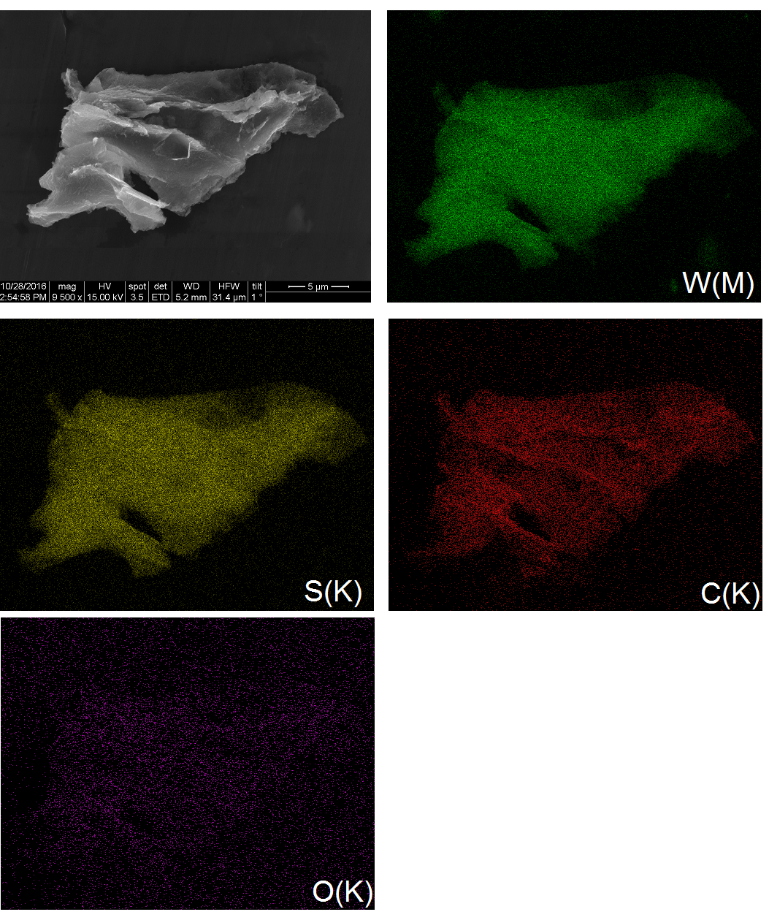
Fig. S3. EDAS elemental maps of WS₂-pyrene (4).

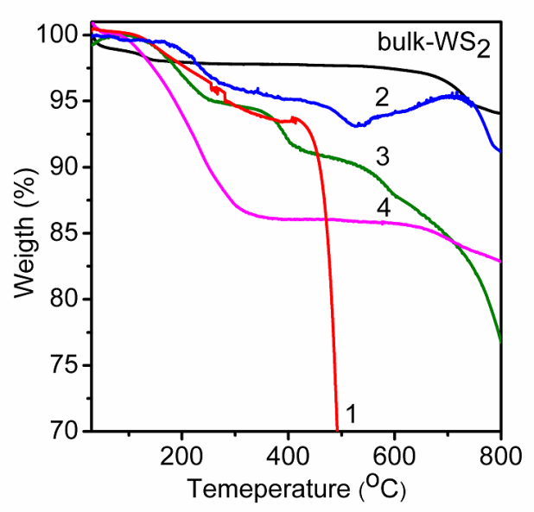
Fig. S4. TGA curves of WS₂-methoxyphenyl (1), WS₂-phenyl (2), WS₂-nitrophenyl (3) and WS₂-pyrene (4) (heating rate 3 ºC/ min, nitrogen atmosphere). The TGA plot of bulk WS₂ is also given.

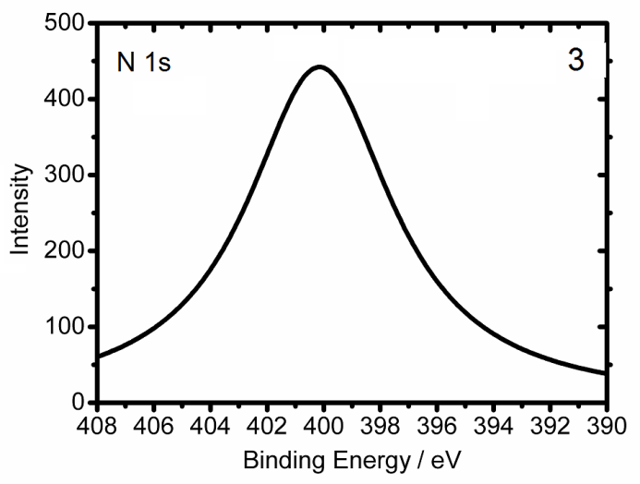
Fig. S5. N 1s core level XP spectrum of WS₂-nitrophenyl (3).

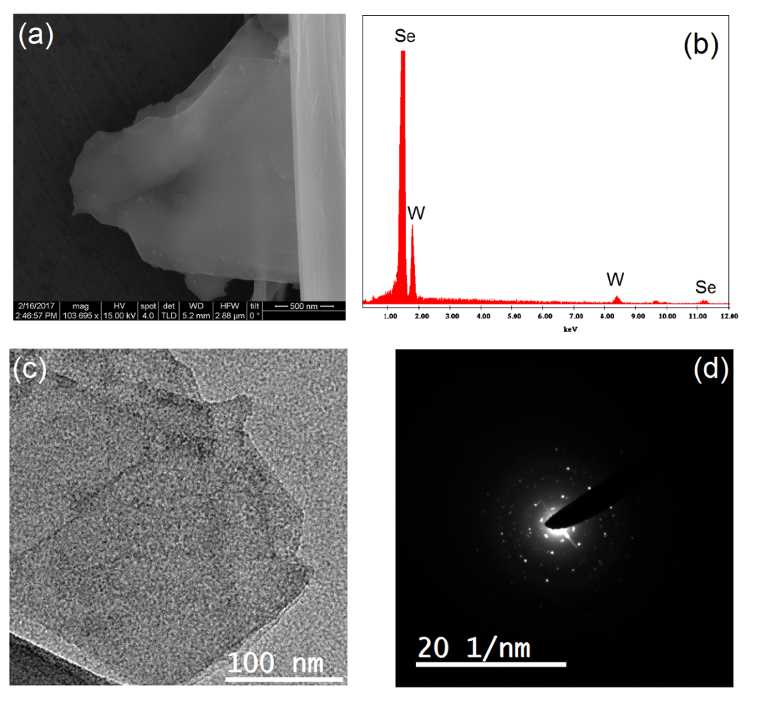
Fig. S6. Electronic microscope images of chemically exfoliated 1T-WSe₂ nanosheets. (a) SEM image, (b) EDAS, (c) HR-TEM image, and (d) SAED pattern.

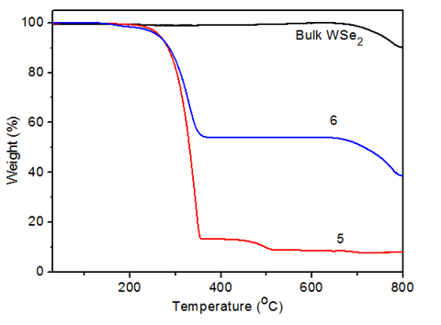
Fig. S7. TGA plots of WSe₂-phenyl (5) and WSe₂-pyrene (6) (heating rate 3 ºC/ min, nitrogen atmosphere). The TGA plot of bulk WSe₂ is also given.

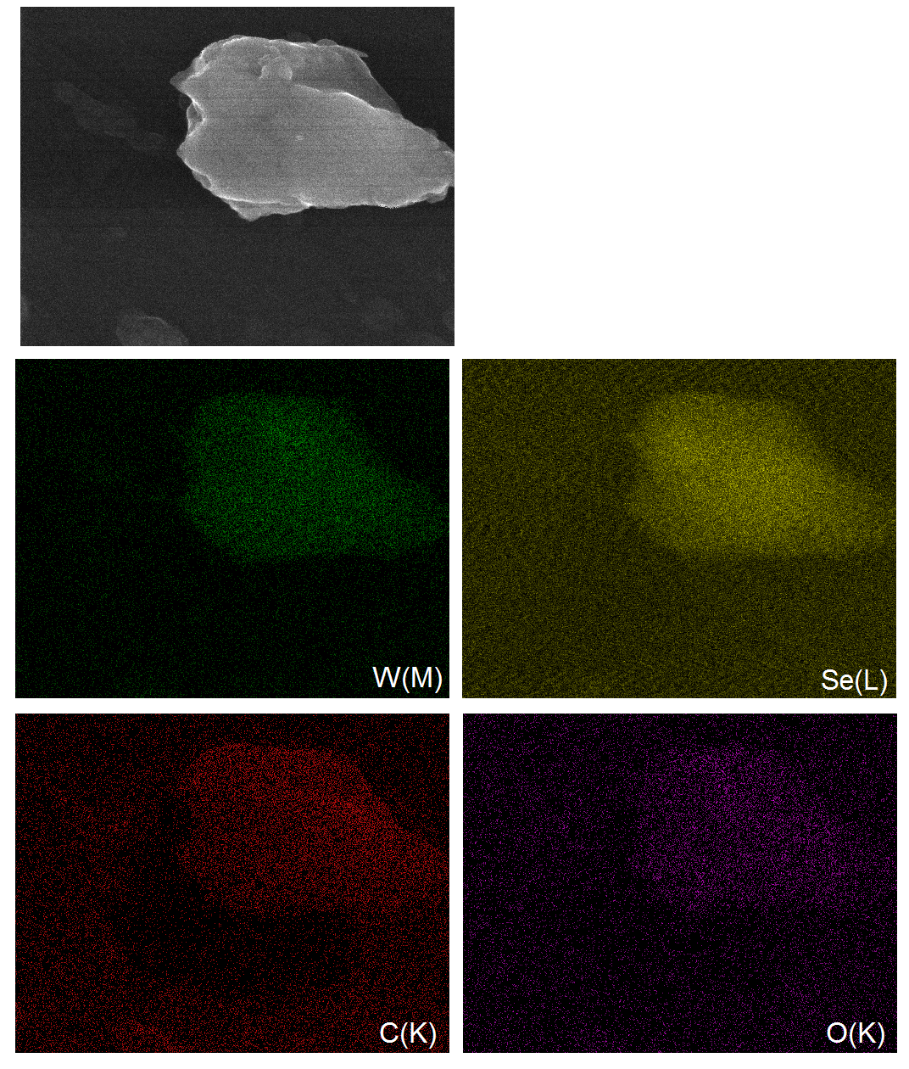
Fig. S8. EDAS elemental maps of WSe₂-pyrene (6).
Fig. S9. Absorption spectra of of WS₂-methoxyphenyl (1), WS₂-phenyl (2), WS₂-nitrophenyl (3) and WS₂-pyrene (4) in N-methyl-2-pyrrolidone (NMP) suspension. The spectra of bulk and chemically exfoliated 1T-WS₂ are also given.

Fig. S10. Absorption spectra of WSe₂-phenyl (5) and WSe₂-pyrene (6) in NMP. The spectra of bulk and chemically exfoliated 1T-WSe₂ are also given.

Fig. S11. Absorption spectra of WS₂-pyrene in NMP. The spectra of 1-(bromoacetyl)pyrene is also given.
Fig. S12. Absorption spectra of 3-acetyl-6-bromocoumarin (80 μM) and a mixture of 1T-WS₂ and coumarin (80 μM and 120 μM respectively) in NMP-water mixture (8/2: v/v).

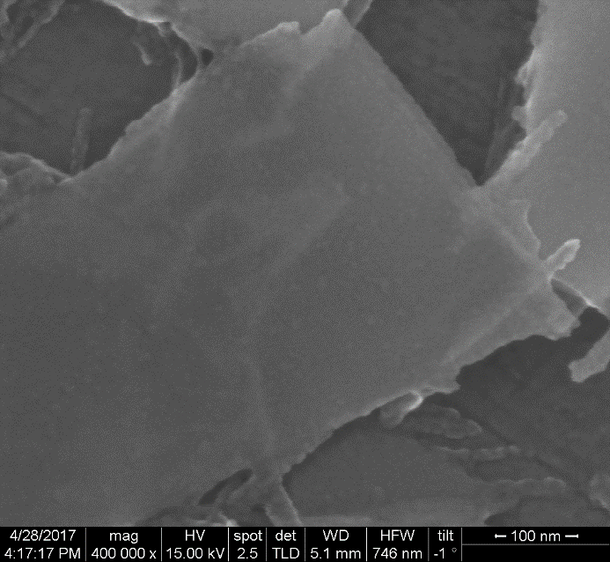
FIG. S13. FE-SEM image of exfoliated 2H-WTe₂.

Fig. S14. TGA curves of WTe₂-phenyl and WTe₂-pyrene (heating rate 3 ºC/ min, nitrogen atmosphere). The TGA plot of bulk WTe₂ is also given.
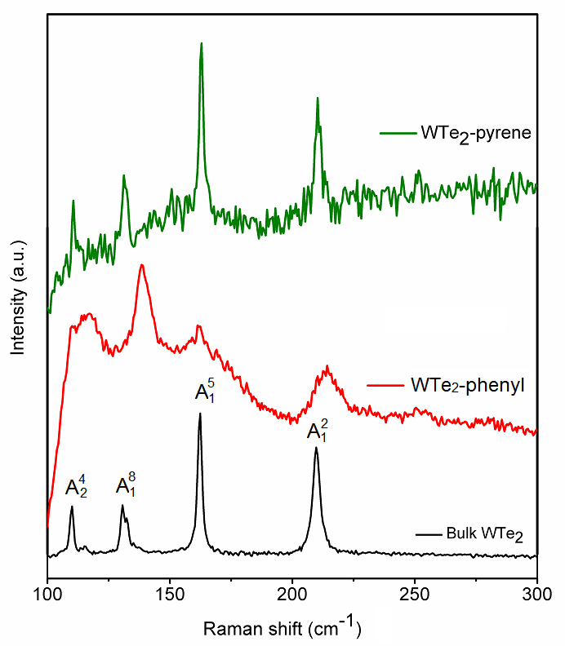
FIG. S15. Raman spectra of WTe₂-phenyl and WTe₂-pyrene. The spectra of bulk WTe₂ is also given (λ = 514.5 nm).

Fig. S16. Absorption spectra of WTe₂-phenyl and WTe₂-pyrene in DMF dispersion. The spectrum of bulk WTe₂ is also given.

Fig. S17. FT-IR spectra of WTe₂-phenyl and WTe₂-pyrene. The spectrum of bulk WTe₂ is also given.

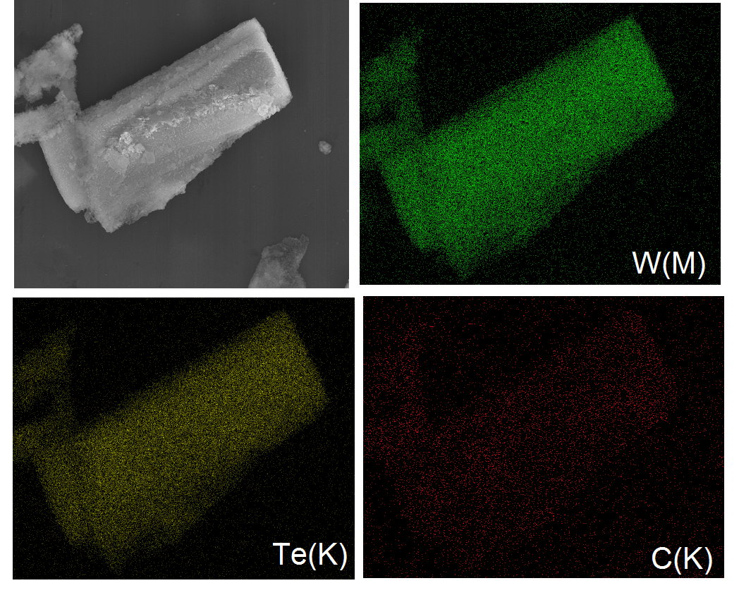
Fig. S18. EDAS elemental maps of WTe₂-phenyl.

