Electronic Supplementary Information (ESI) for
Zinc cobalt bimetallic nanoparticles embedded in porous nitrogen-doped carbon frameworks for the reduction of nitro compounds
Xuejuan Xu, Hui Li, Hongtao Xie, Yuhua Ma, Tingxiang Chen, Jide Wang *

Key Laboratory of Oil and Gas Fine Chemicals, Ministry of Education & Xinjiang Uygur
Autonomous Region, College of Chemistry and Chemical Engineering of Xinjiang University, Urumqi, 830046, China.
E-mail: awangjd@sina.cn(J.D.Wang);
270997380@qq.com(X. J. Xu);
Tel/Fax: +86-991-8582087

FIG.S1. Elemental mapping of Zn_{0.3}Co_{2.7}-ZIF.

FIG.S2. EDS spectrum and Element content of the Zn_{0.3}Co_{2.7}-ZIF.

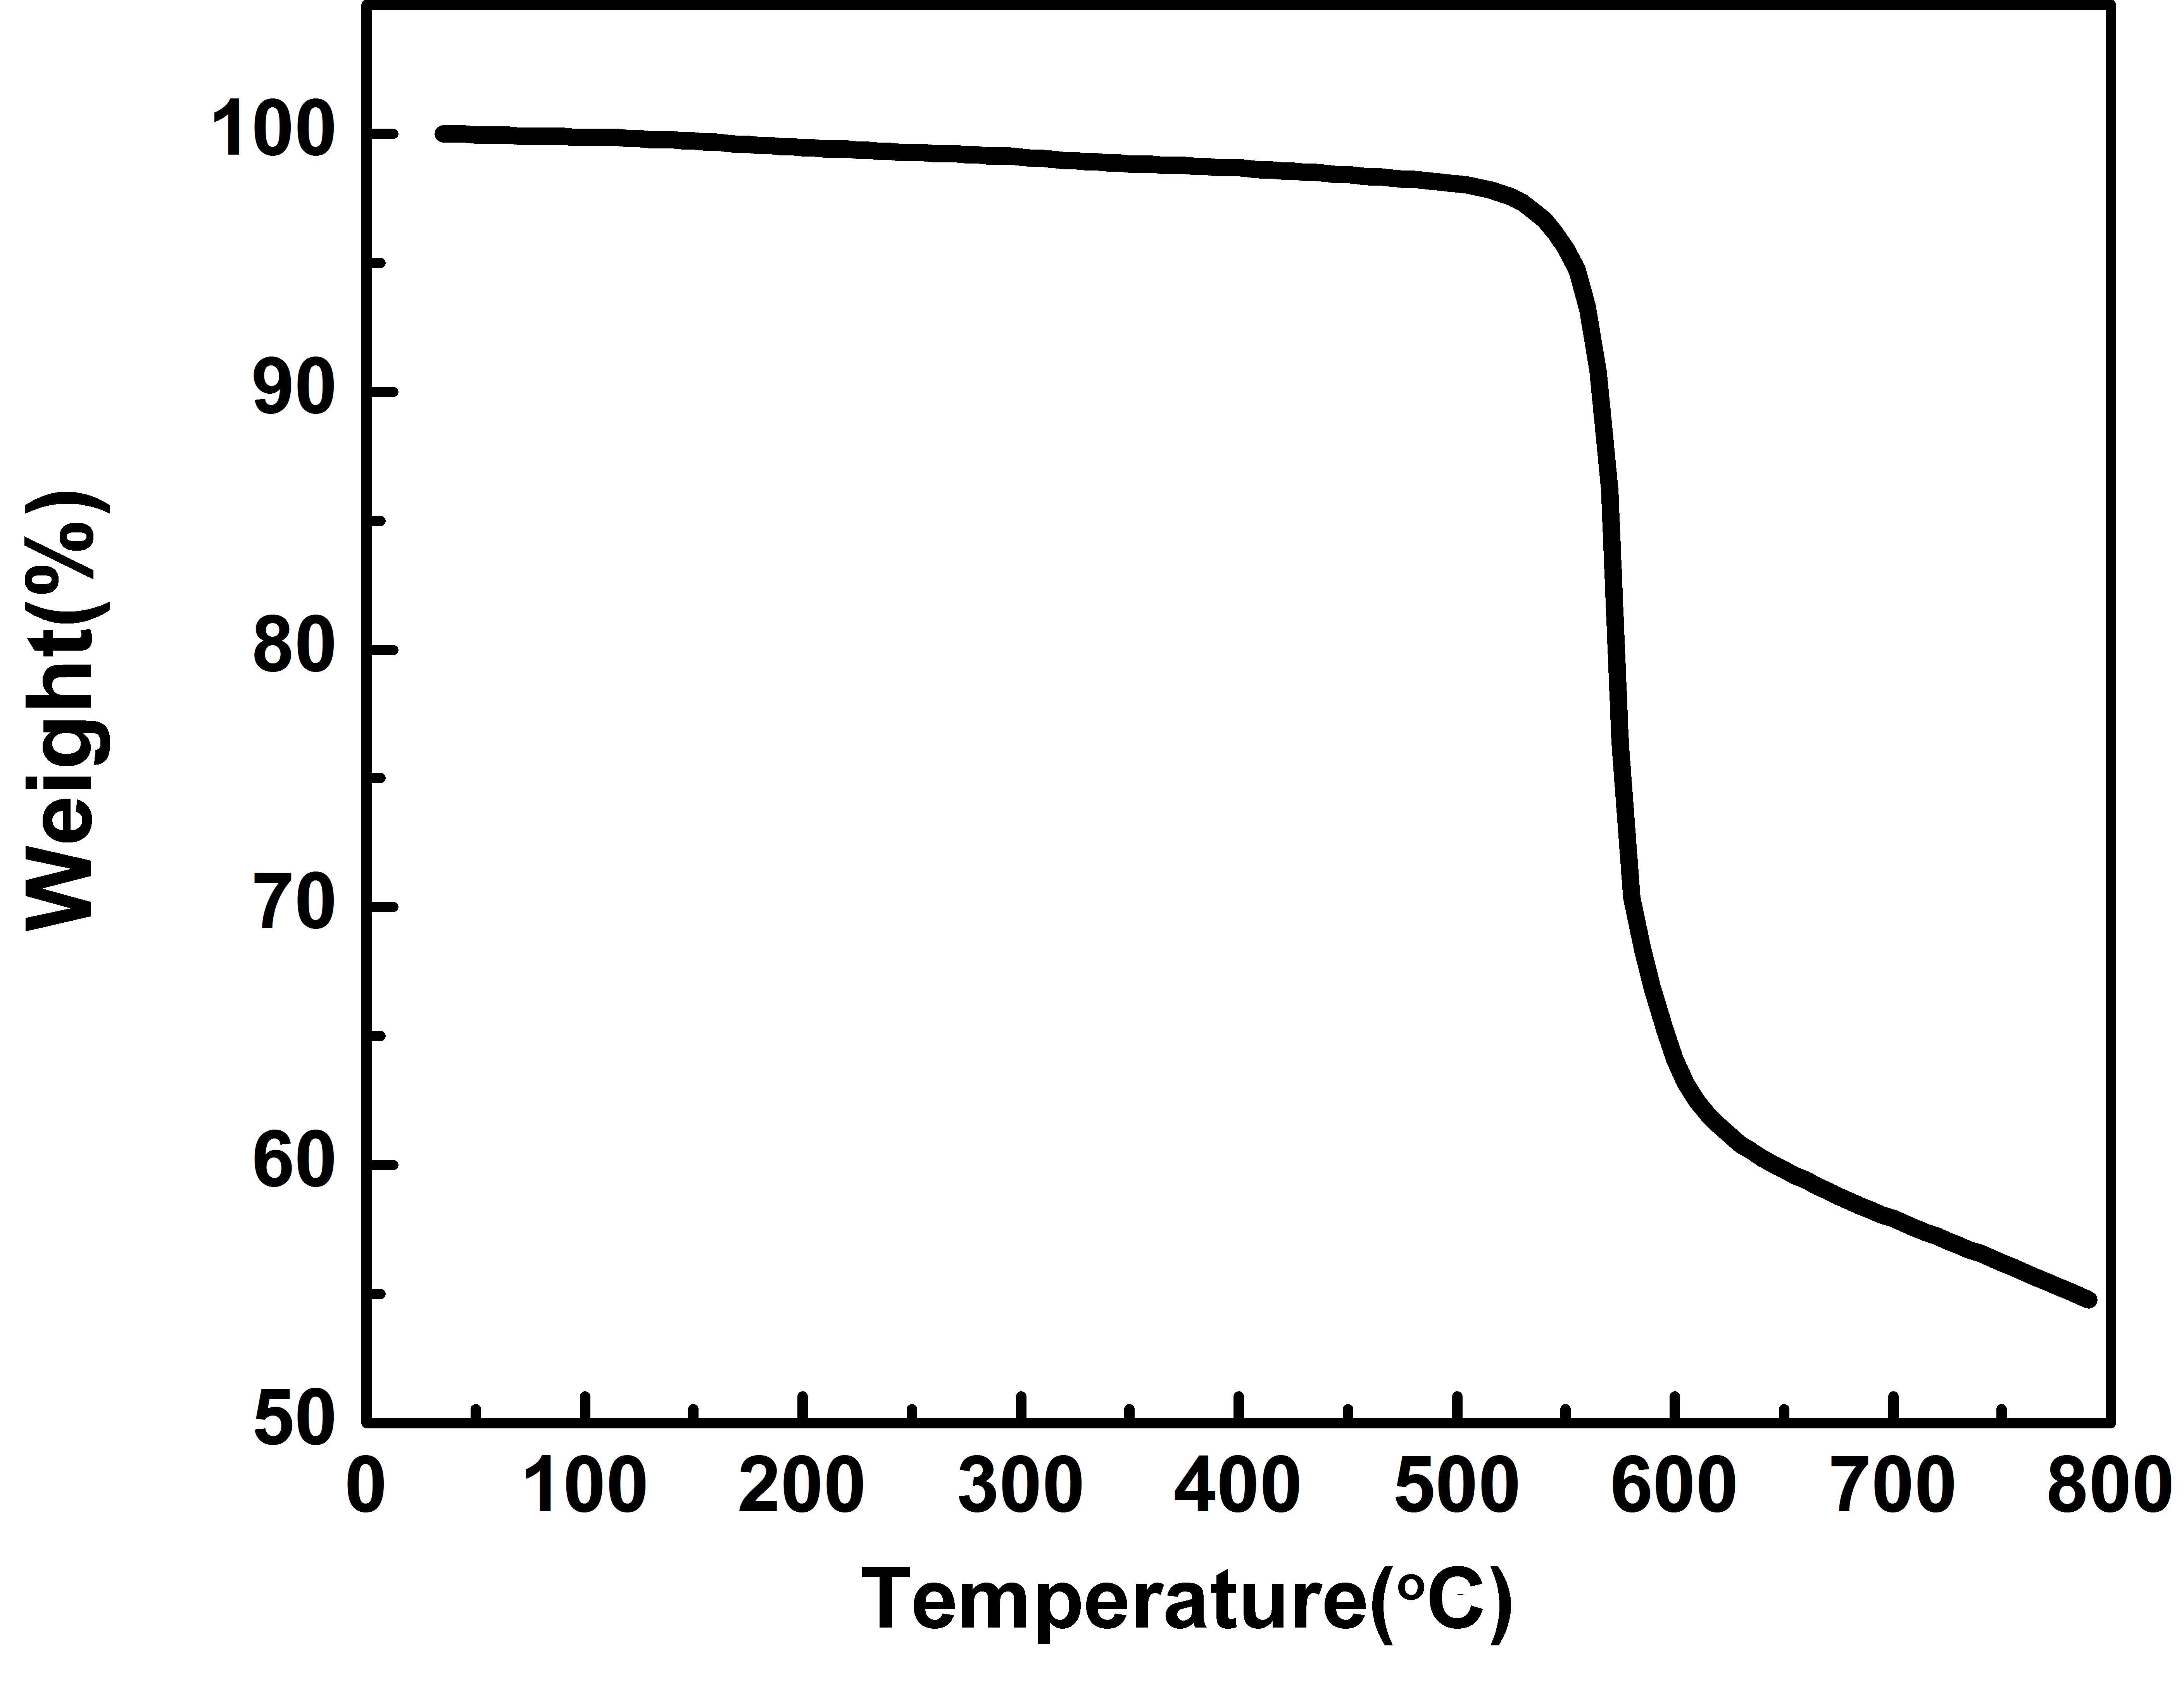
FIG.S3. TG curve under N₂ condition of Zn_{0.3}Co_{2.7}-ZIF.

FIG.S4. Elemental mapping of Zn_{0.3}Co_{2.7}@NC.

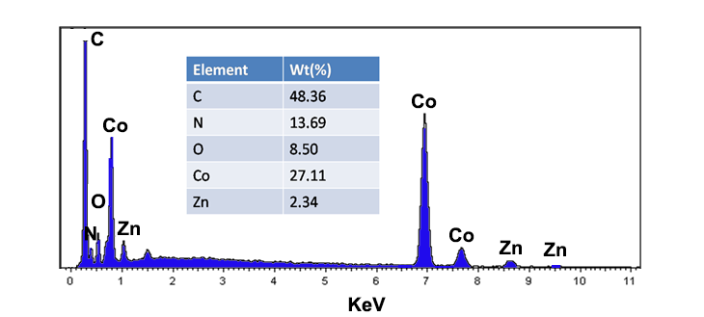
FIG.S5. EDS spectrum and Element content of Zn_{0.3}Co_{2.7}@NC.

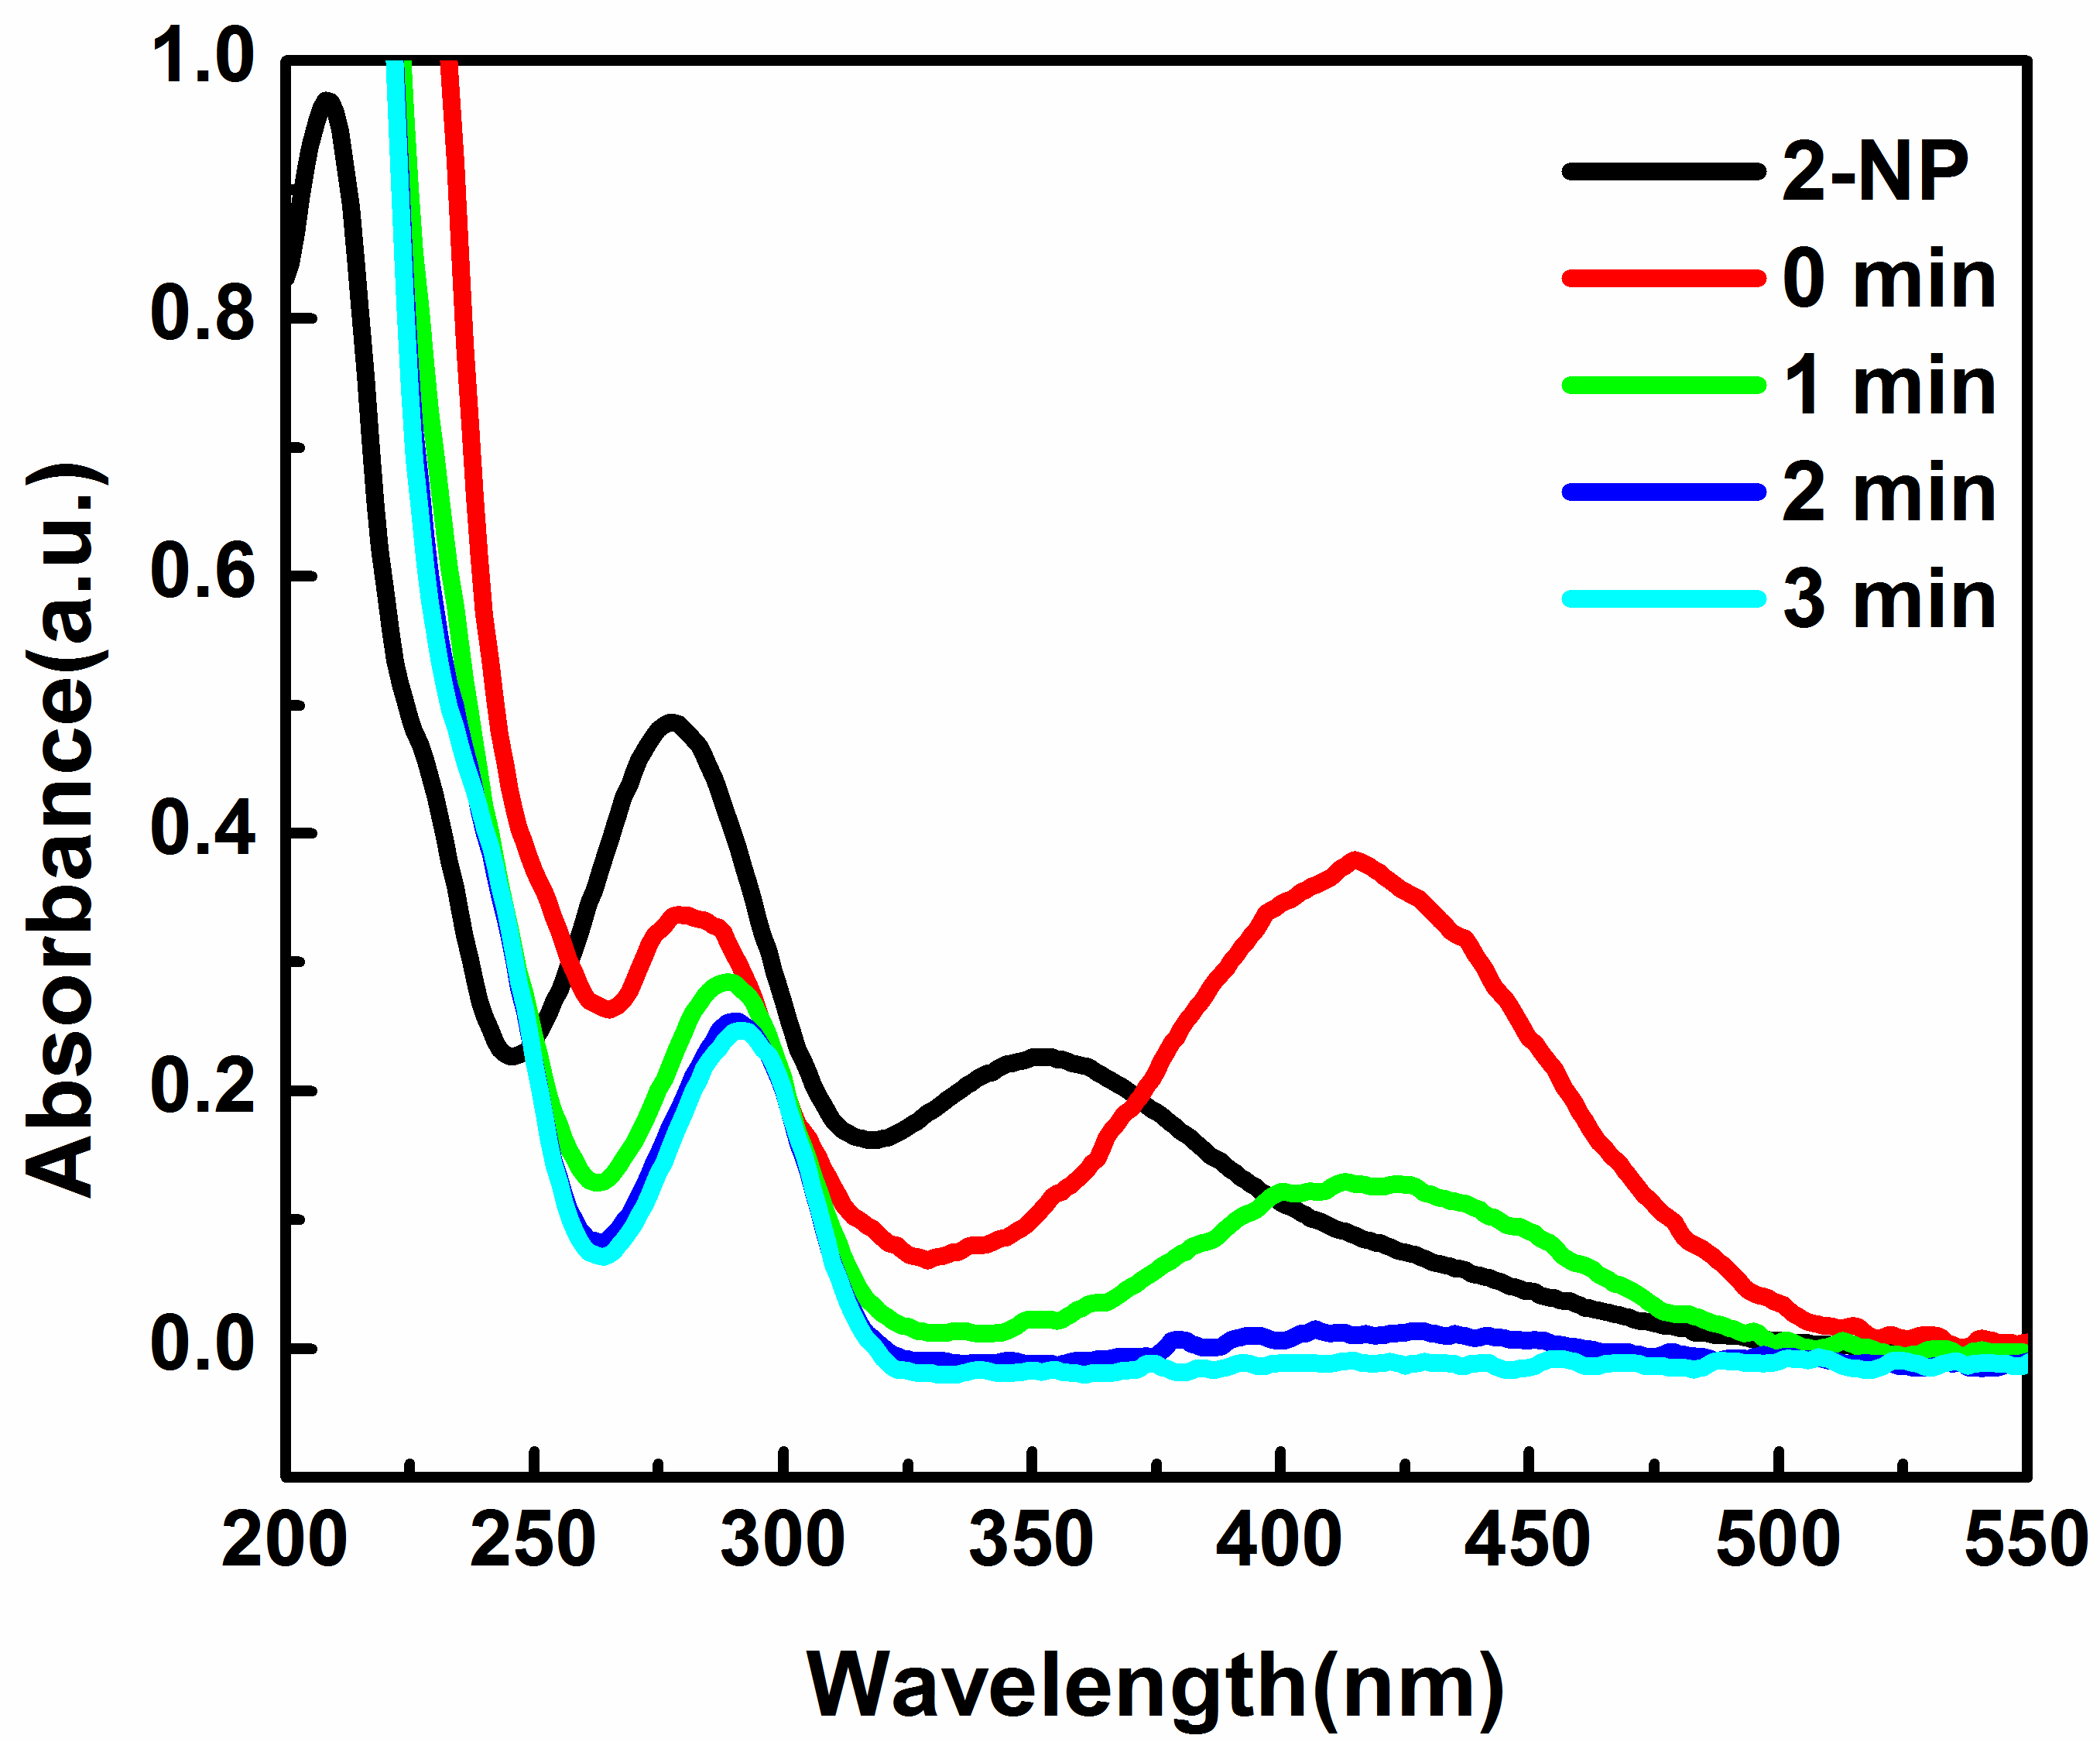
FIG.S6. Spectrogram of the reduction reaction for the conversion of 2-NP catalyzed by Zn_{0.3}Co_{2.7}@NC in the presence of NaBH₄ (T= 25℃, the amount of the catalyst is 0.02 mg/ml).
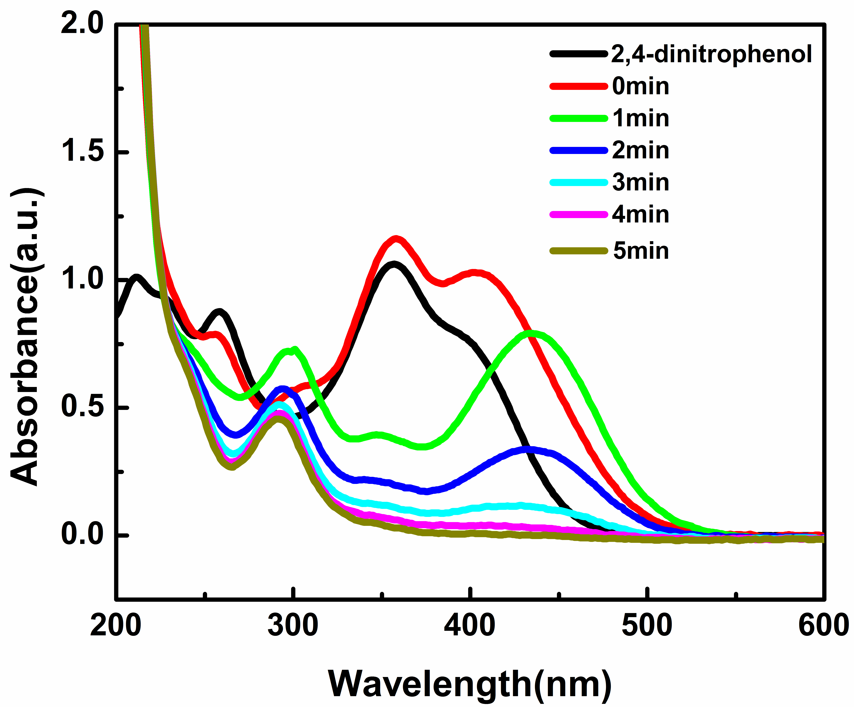
FIG.S7. Spectrogram of the reduction reaction for the conversion of 2, 4-dinitrophenol catalyzed by Zn_{0.3}Co_{2.7}@NC in the presence of NaBH₄ (T= 25℃, the amount of the catalyst is 0.02 mg/ml).
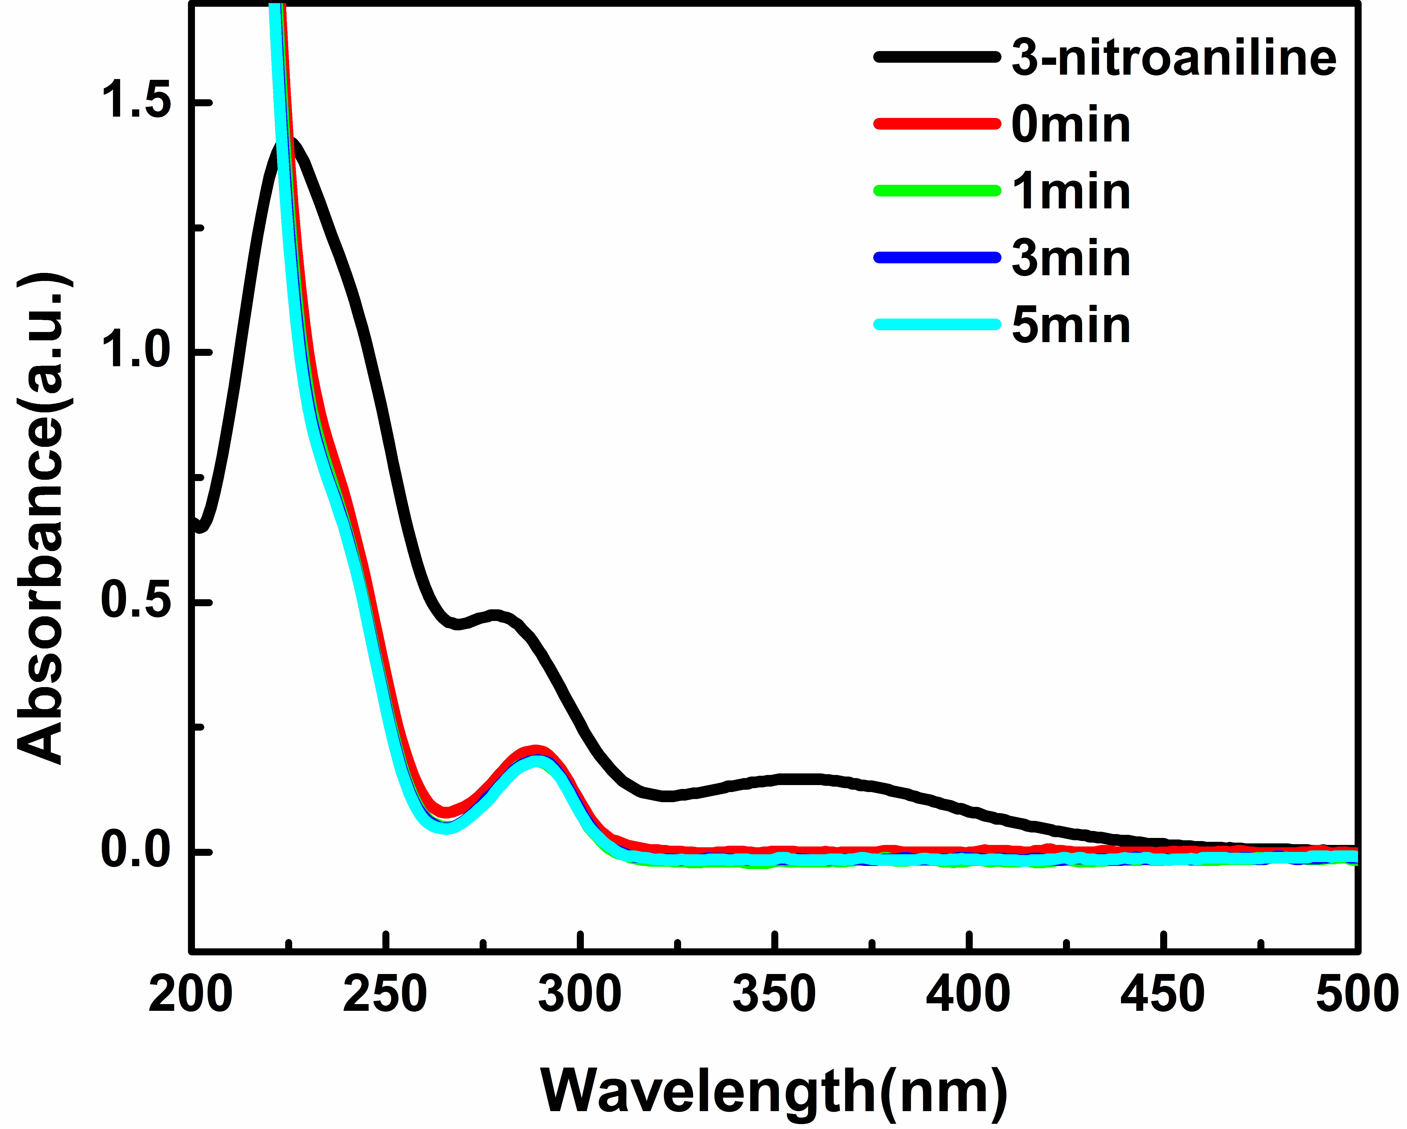
FIG.S8. Spectrogram of the reduction reaction for the conversion of 3-nitroaniline catalyzed by Zn_{0.3}Co_{2.7}@NC in the presence of NaBH₄ (T= 25℃, the amount of the catalyst is 0.02 mg/ml).
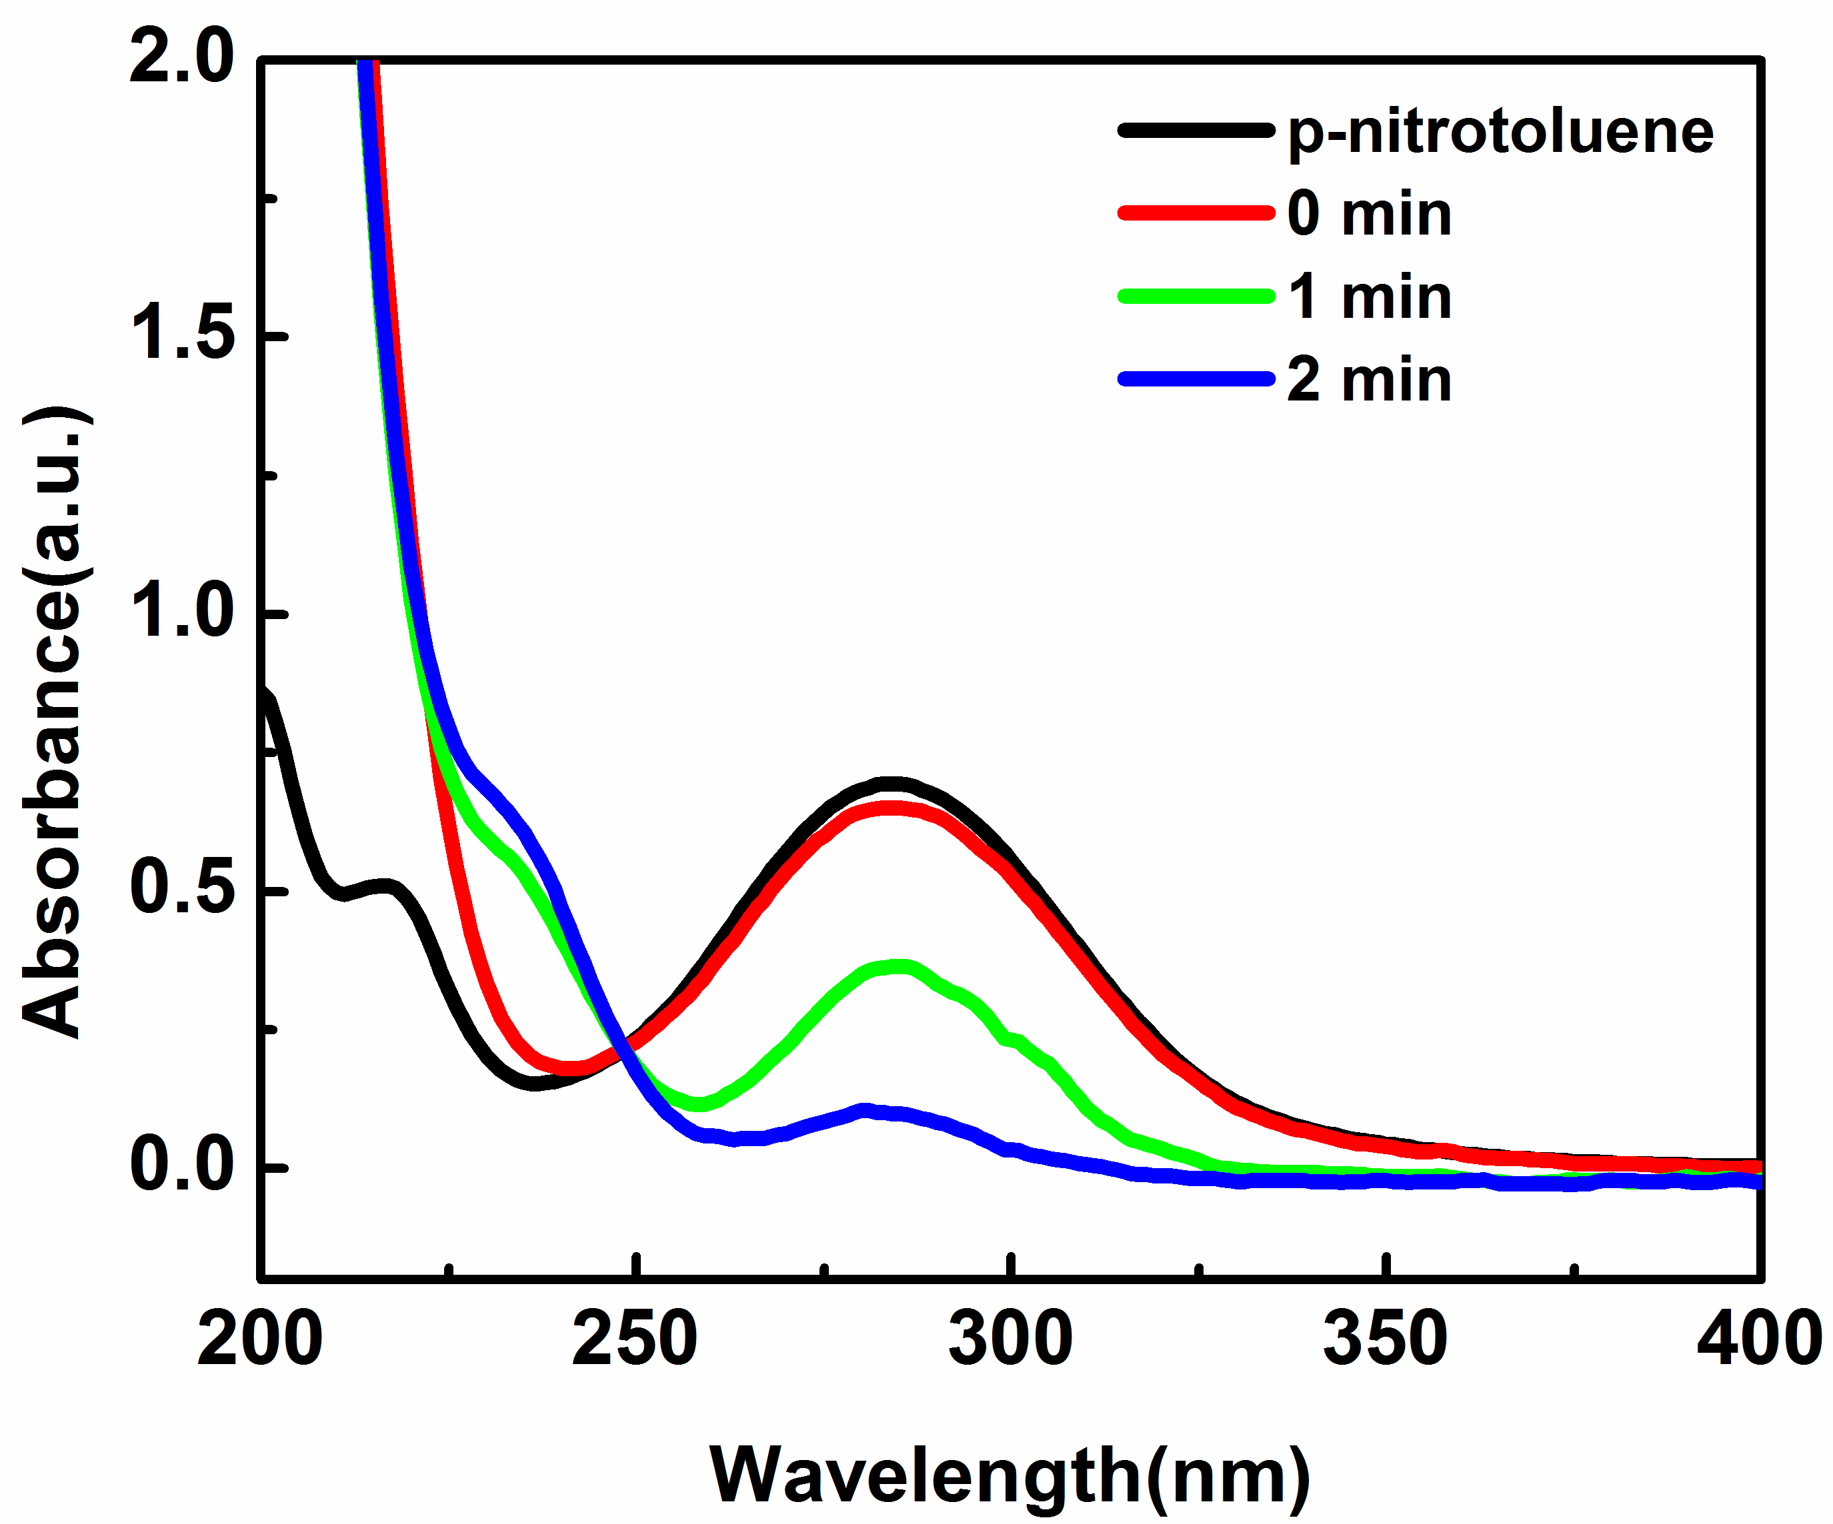
FIG.S9. Spectrogram of the reduction reaction for the conversion of p-nitrotoluene catalyzed by Zn_{0.3}Co_{2.7}@NC in the presence of NaBH₄ (T= 25℃, the amount of the catalyst is 0.02 mg/ml).
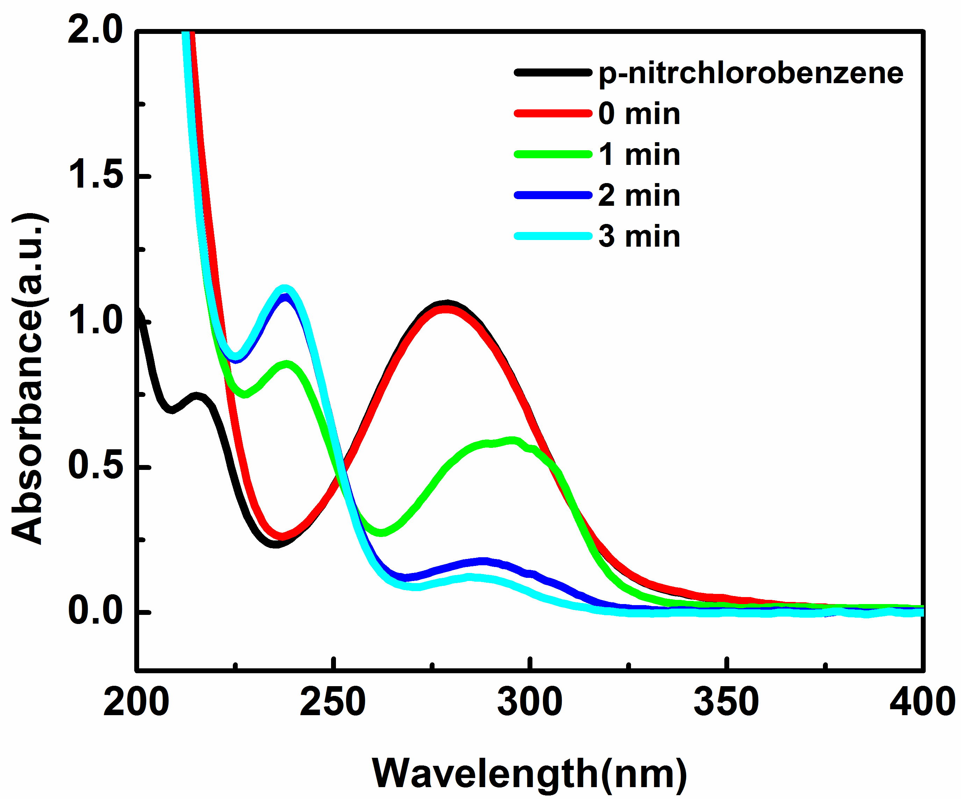
FIG.S10. Spectrogram of the reduction reaction for the conversion of p-chloronitrobenzene catalyzed by Zn_{0.3}Co_{2.7}@NC in the presence of NaBH₄ (T= 25℃, the amount of the catalyst is 0.02 mg/ml).
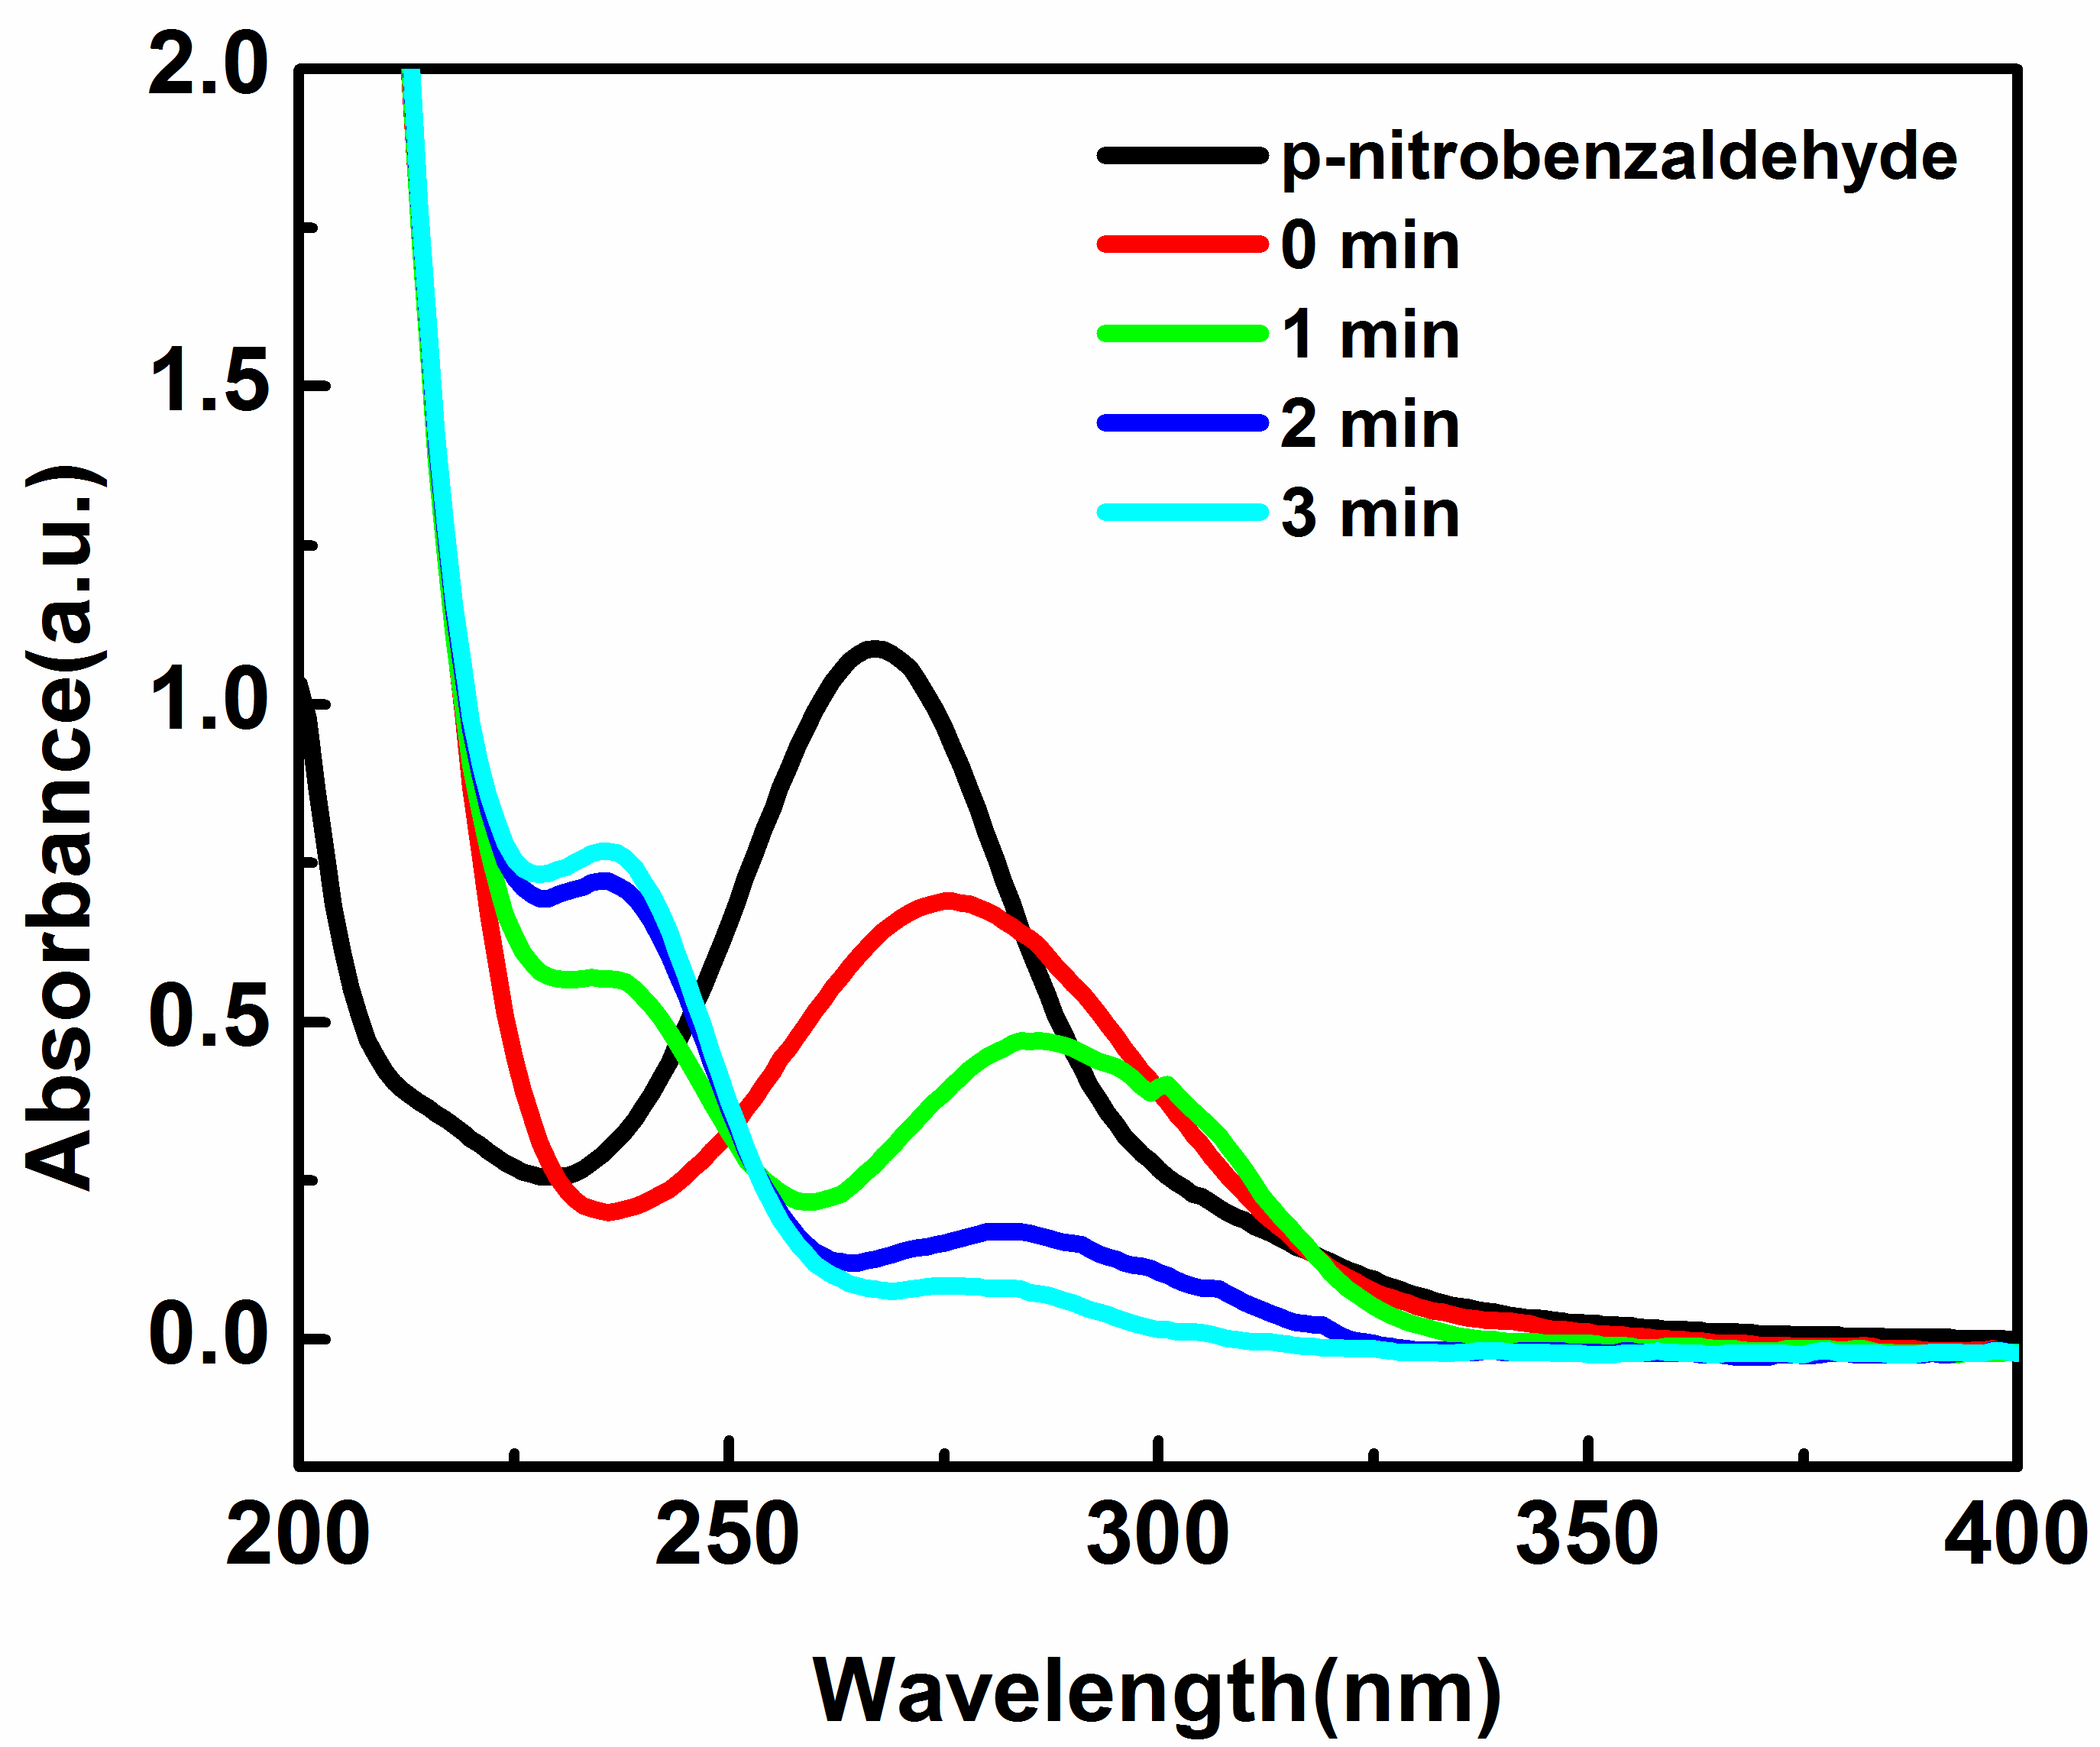
FIG.S11. Spectrogram of the reduction reaction for the conversion of p-nitrobenzaldehyde catalyzed by Zn_{0.3}Co_{2.7}@NC in the presence of NaBH₄ (T= 25℃, the amount of the catalyst is 0.02 mg/ml).
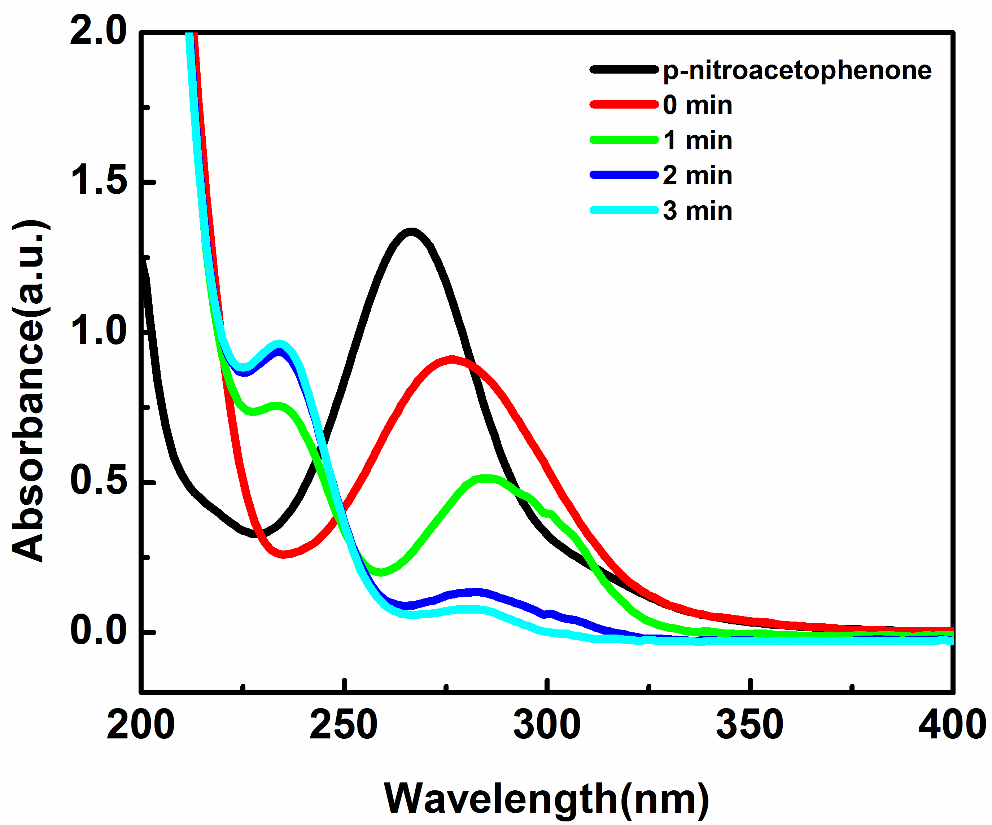
FIG.S12. Spectrogram of the reduction reaction for the conversion of p-nitroacetophenone catalyzed by Zn_{0.3}Co_{2.7}@NC in the presence of NaBH₄ (T= 25℃, the amount of the catalyst is 0.02 mg/ml).
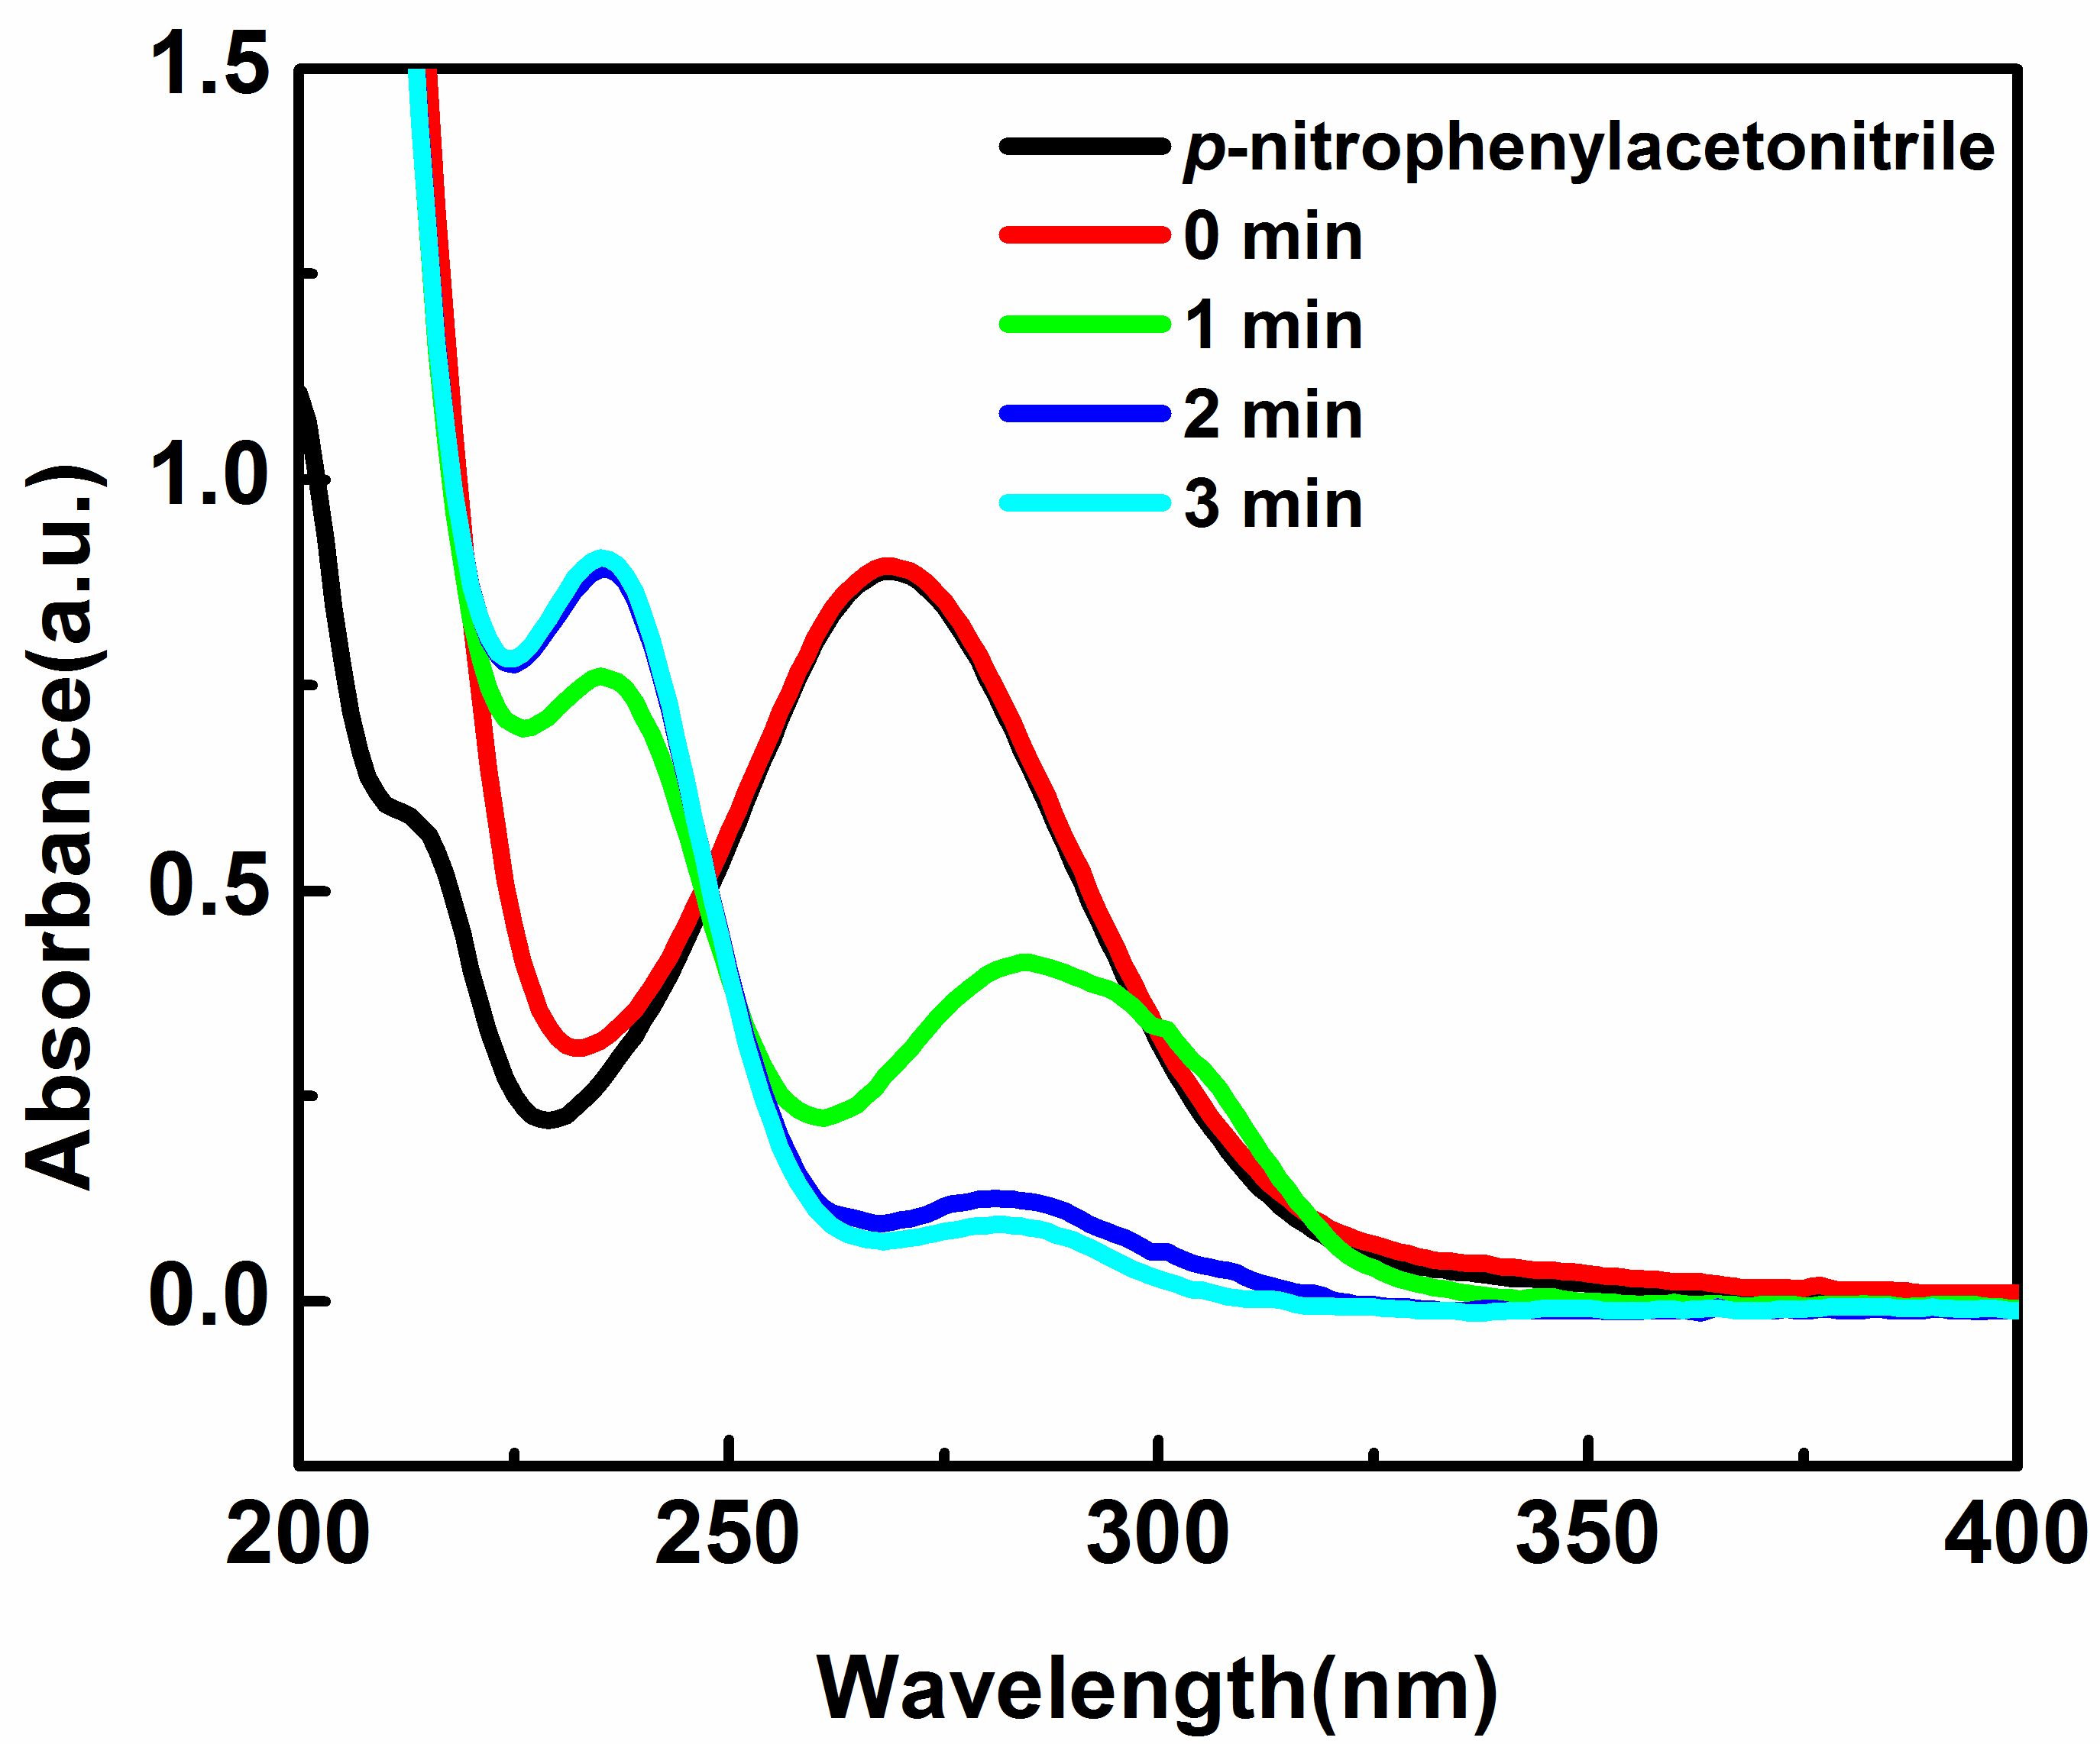
FIG.S13. Spectrogram of the reduction reaction for the conversion of p-nitrophenylacetonitrile catalyzed by Zn_{0.3}Co_{2.7}@NC in the presence of NaBH₄ (T= 25℃, the amount of the catalyst is 0.02 mg/ml).
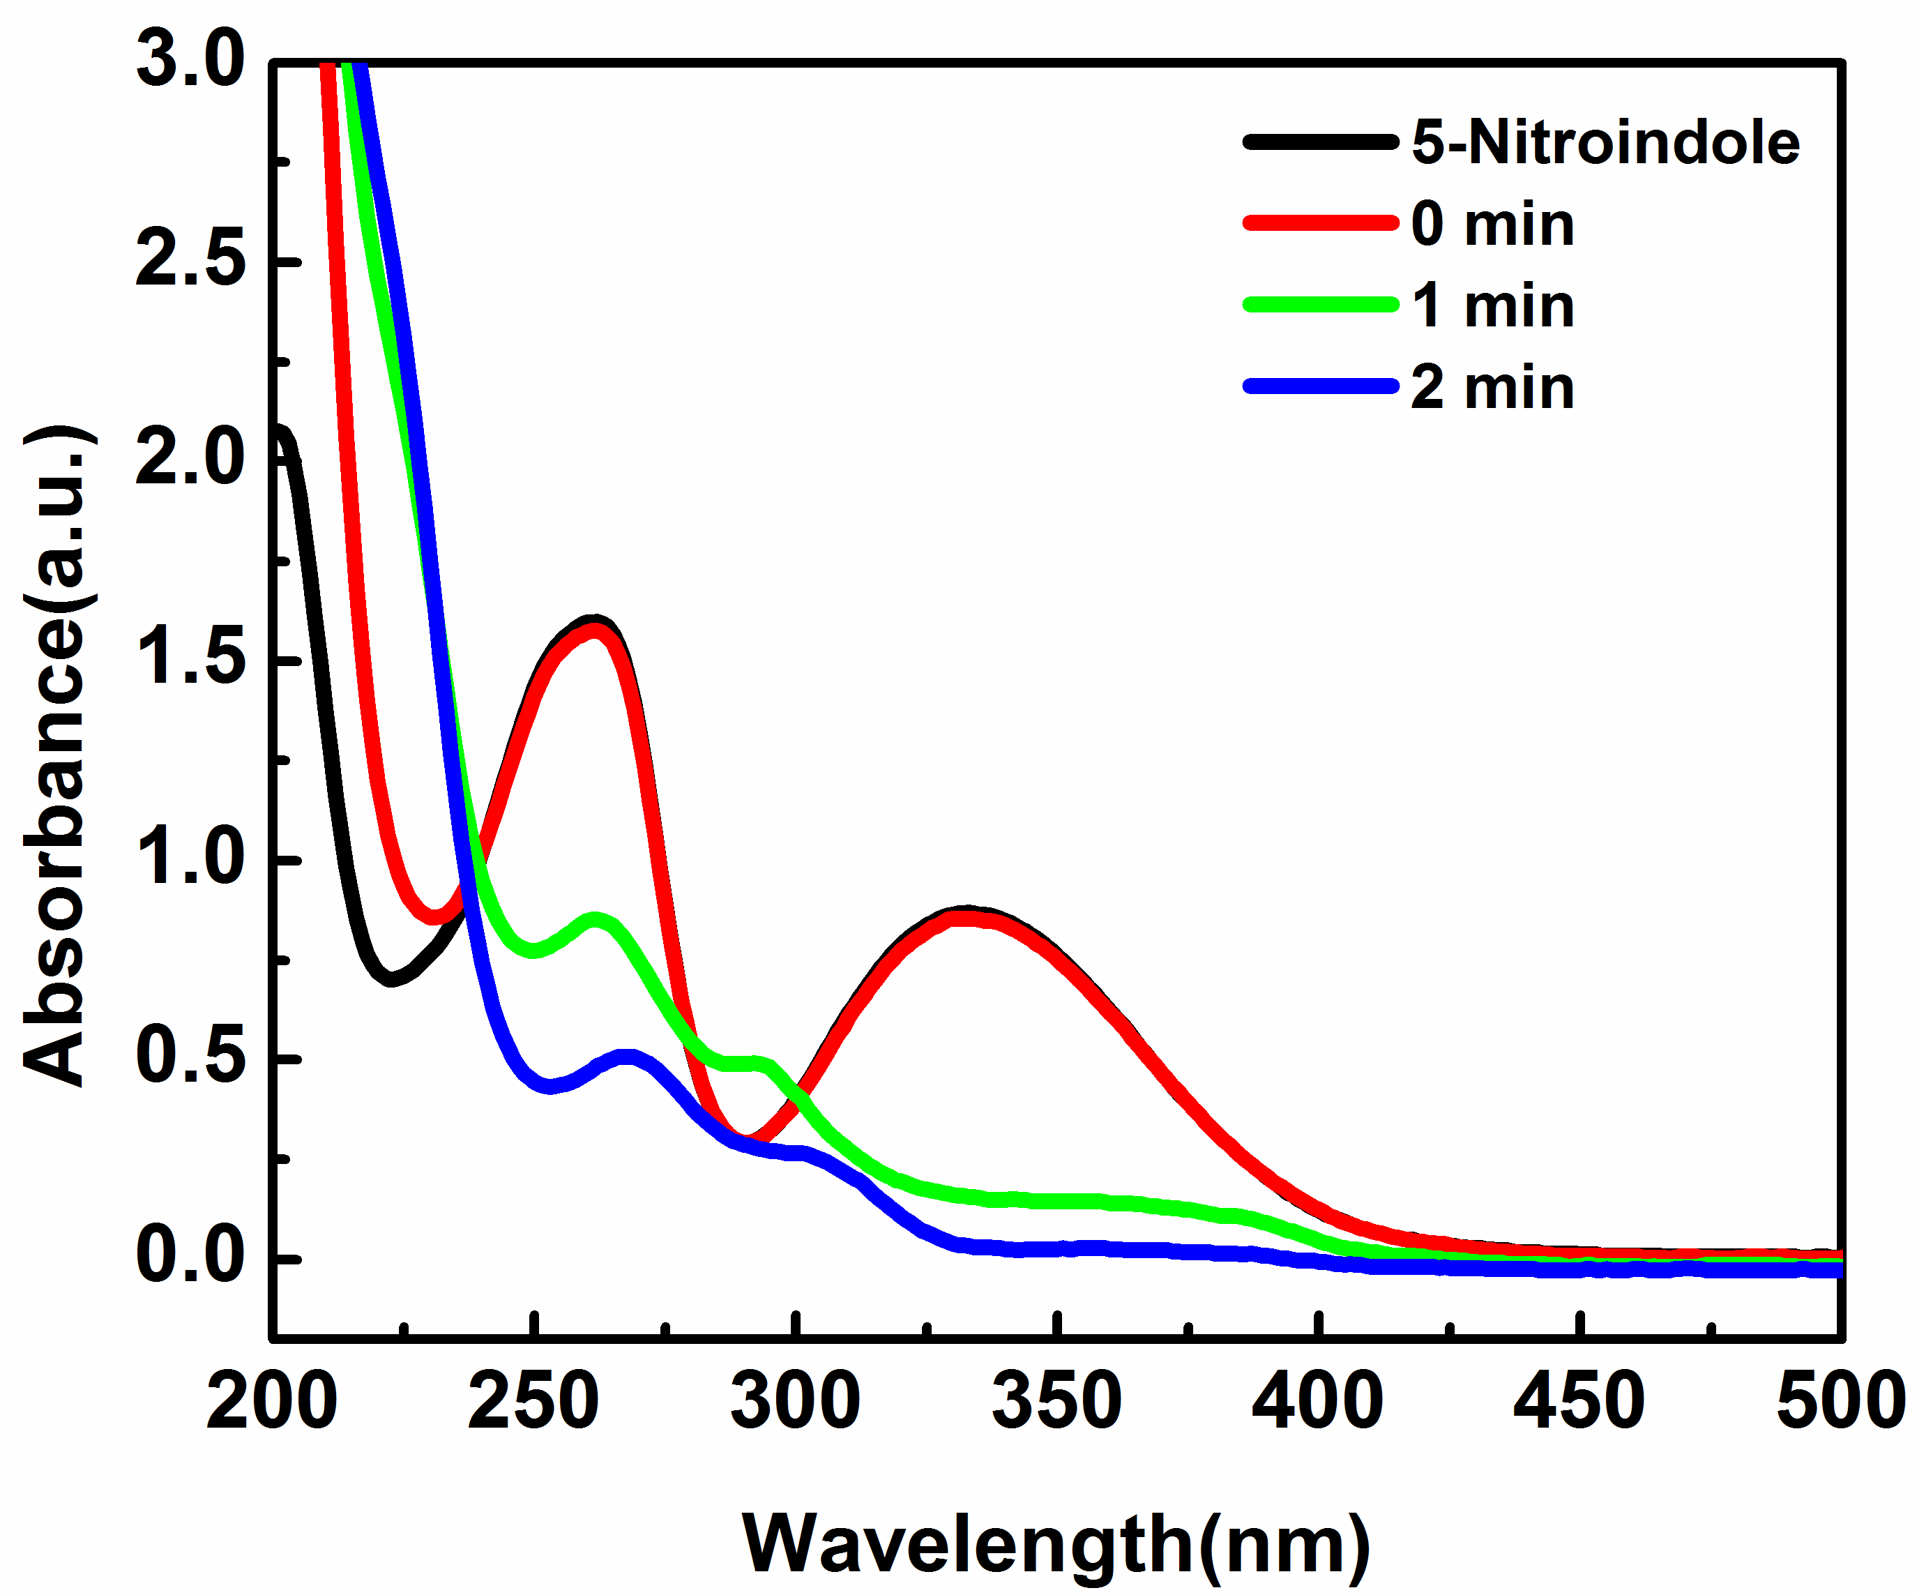
FIG.S14. Spectrogram of the reduction reaction for the conversion of 5-nitroindole catalyzed by Zn_{0.3}Co_{2.7}@NC in the presence of NaBH₄ (T= 25℃, the amount of the catalyst is 0.02 mg/ml).
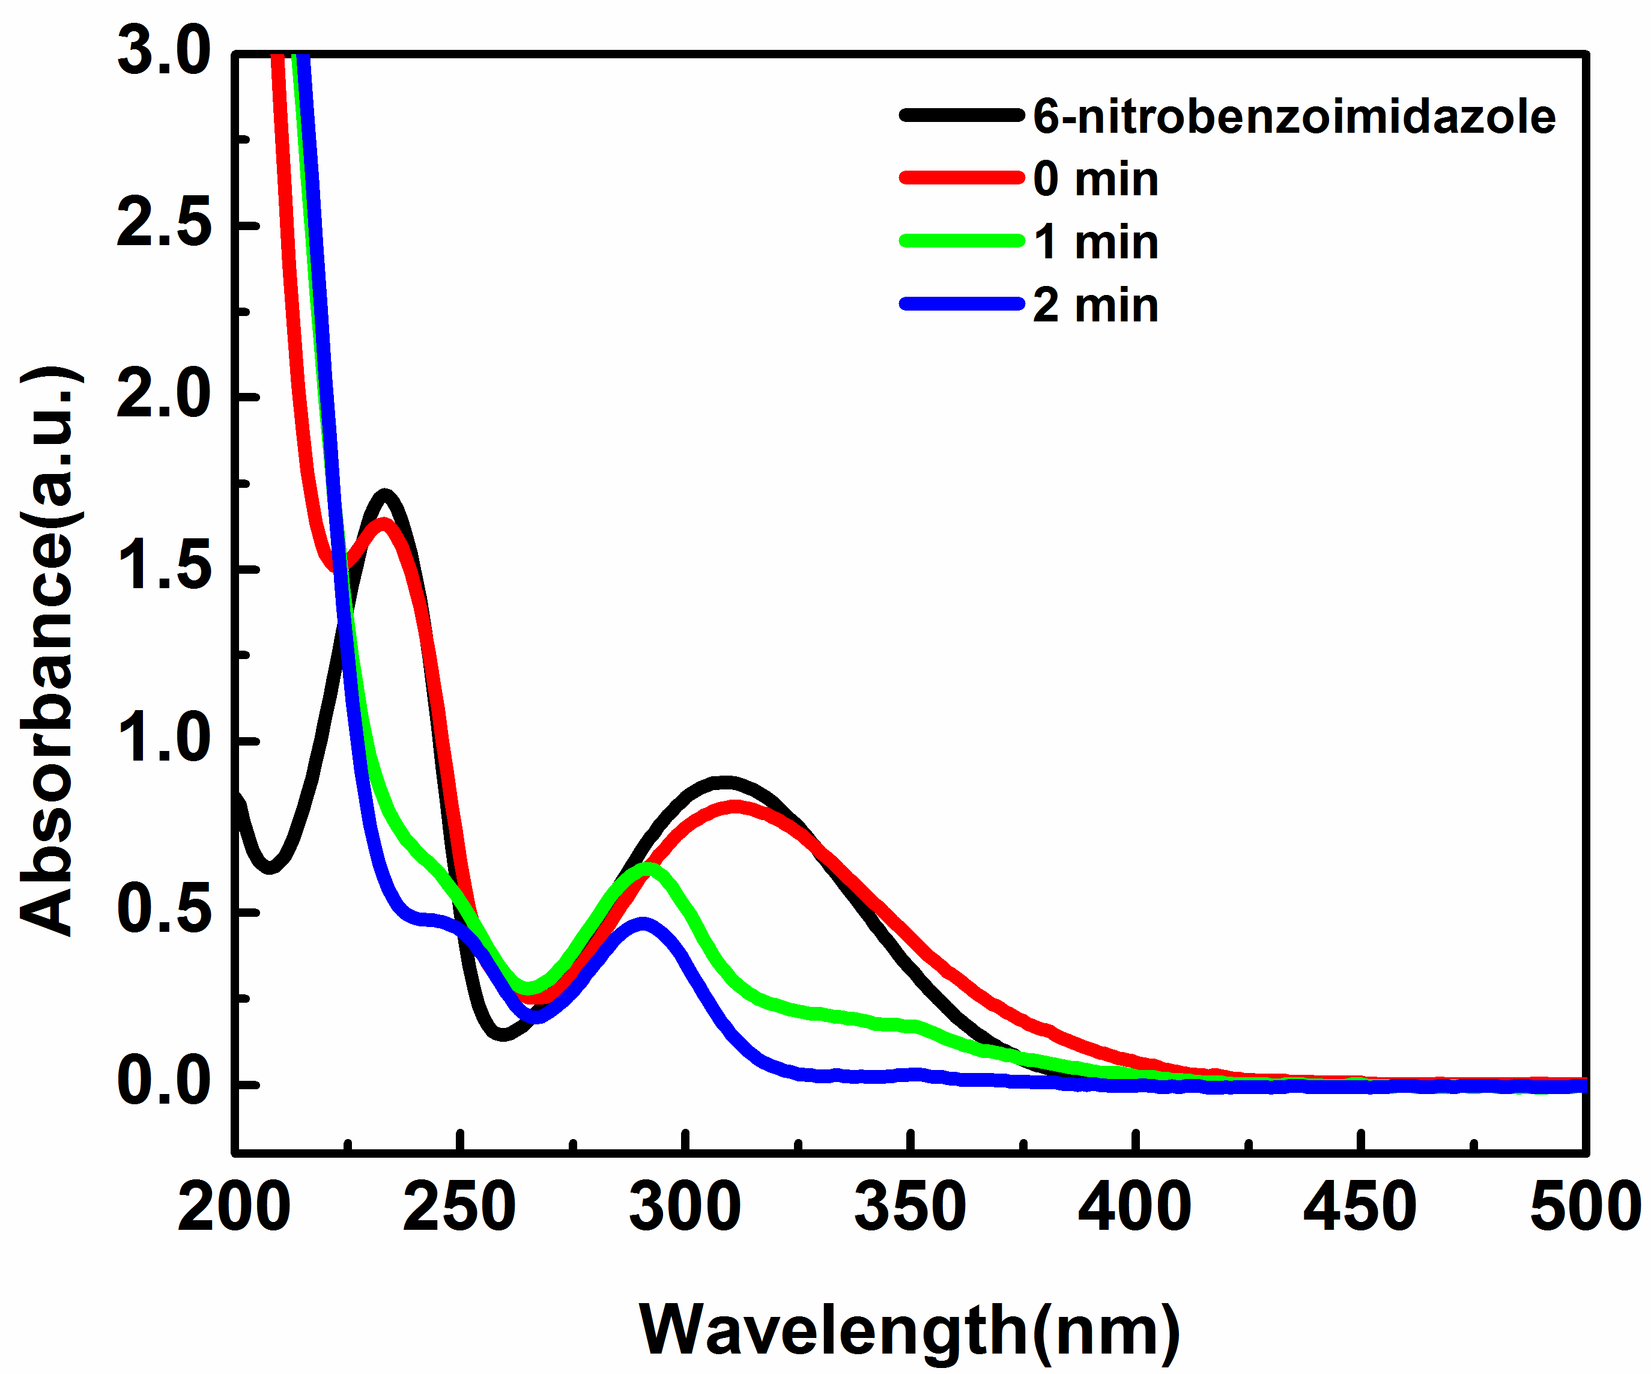
FIG.S15. Spectrogram of the reduction reaction for the conversion of 6-nitrobenzoimidazole catalyzed by Zn_{0.3}Co_{2.7}@NC in the presence of NaBH₄ (T= 25℃, the amount of the catalyst is 0.02 mg/ml).

FIGGURE CAPTION:
FIG.S1. Elemental mapping of Zn_{0.3}Co_{2.7}-ZIF.

FIG.S2. EDS spectrum and Element content of the Zn_{0.3}Co_{2.7}-ZIF.

FIG.S3. TG curve under N₂ condition of Zn_{0.3}Co_{2.7}-ZIF.

FIG.S4. Elemental mapping of Zn_{0.3}Co_{2.7}@NC.

FIG.S5. EDS spectrum and Element content of Zn_{0.3}Co_{2.7}@NC.

FIG.S6. Spectrogram of the reduction reaction for the conversion of 2-NP catalyzed by Zn_{0.3}Co_{2.7}@NC in the presence of NaBH₄ (T= 25℃, the amount of the catalyst is 0.02 mg/ml).

FIG.S7. Spectrogram of the reduction reaction for the conversion of 2, 4-dinitrophenol catalyzed by Zn_{0.3}Co_{2.7}@NC in the presence of NaBH₄ (T= 25℃, the amount of the catalyst is 0.02 mg/ml).

FIG.S8. Spectrogram of the reduction reaction for the conversion of 3-nitroaniline catalyzed by Zn_{0.3}Co_{2.7}@NC in the presence of NaBH₄ (T= 25℃, the amount of the catalyst is 0.02 mg/ml).

FIG.S9. Spectrogram of the reduction reaction for the conversion of p-nitrotoluene catalyzed by Zn_{0.3}Co_{2.7}@NC in the presence of NaBH₄ (T= 25℃, the amount of the catalyst is 0.02 mg/ml).

FIG.S10. Spectrogram of the reduction reaction for the conversion of p-chloronitrobenzene catalyzed by Zn_{0.3}Co_{2.7}@NC in the presence of NaBH₄ (T= 25℃, the amount of the catalyst is 0.02 mg/ml).
FIG.S11. Spectrogram of the reduction reaction for the conversion of p-nitrobenzaldehyde catalyzed by Zn_{0.3}Co_{2.7}@NC in the presence of NaBH₄ (T= 25℃, the amount of the catalyst is 0.02 mg/ml).

FIG.S12. Spectrogram of the reduction reaction for the conversion of p-nitroacetophenone catalyzed by Zn_{0.3}Co_{2.7}@NC in the presence of NaBH₄ (T= 25℃, the amount of the catalyst is 0.02 mg/ml).

FIG.S13. Spectrogram of the reduction reaction for the conversion of p-nitrophenylacetonitrile catalyzed by Zn_{0.3}Co_{2.7}@NC in the presence of NaBH₄ (T= 25℃, the amount of the catalyst is 0.02 mg/ml).

FIG.S14. Spectrogram of the reduction reaction for the conversion of 5-nitroindole catalyzed by Zn_{0.3}Co_{2.7}@NC in the presence of NaBH₄ (T= 25℃, the amount of the catalyst is 0.02 mg/ml).

FIG.S15. Spectrogram of the reduction reaction for the conversion of 6-nitrobenzoimidazole catalyzed by Zn_{0.3}Co_{2.7}@NC in the presence of NaBH₄ (T= 25℃, the amount of the catalyst is 0.02 mg/ml).

