SUPPLEMENTAL INFORMATION

Composite copper oxide-copper bromide films for the selective electroreduction of carbon dioxide

Norma de Tacconi,^{1*} Wilaiwan Chanmanee,² Brian H. Dennis,² and Krishnan Rajeshwar ¹*

¹ Department of Chemistry & Biochemistry, The University of Texas at Arlington, Arlington,

TX 76019,

²Department of Mechanical & Aerospace Engineering, The University of Texas at Arlington, Arlington, TX 76019

*Corresponding authors, Email: rajeshwar@uta.edu; ntacconi@uta.edu

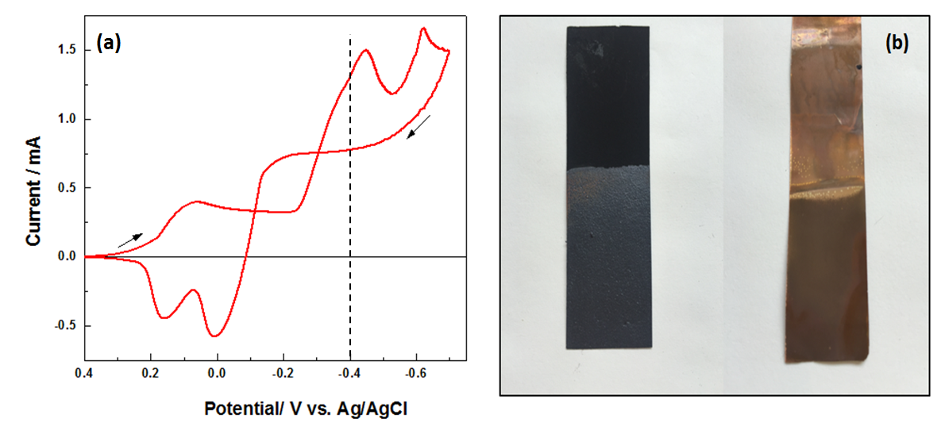

Figure S1. (a) Cyclic voltammogram (CV) for the growth of a Cu₂O-CuBr film from an electroplating solution consisting of 0.1 M Cu(NO₃)₂, 0.17 M NaBr and 0.1 M NaNO₃ and using a glassy carbon disk as working electrode. The CV is initiated at open circuit potential and with a 20 mV/s scan rate; arrows indicate the potential scan direction. (b) Photographs of representative electrodeposited films on GDL (left) and Cu foil (right) at -0.4 V (15 min) using the same electroplating solution.

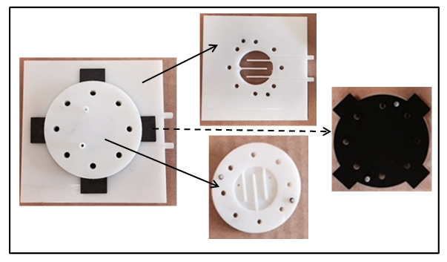

Figure S2. Mounted MFECR single cathode hemicell (left) and its components: GDL support for the electrocatalytic film (4.5 cm²), and channels for the CO₂ gas and electrolyte flow respectively.

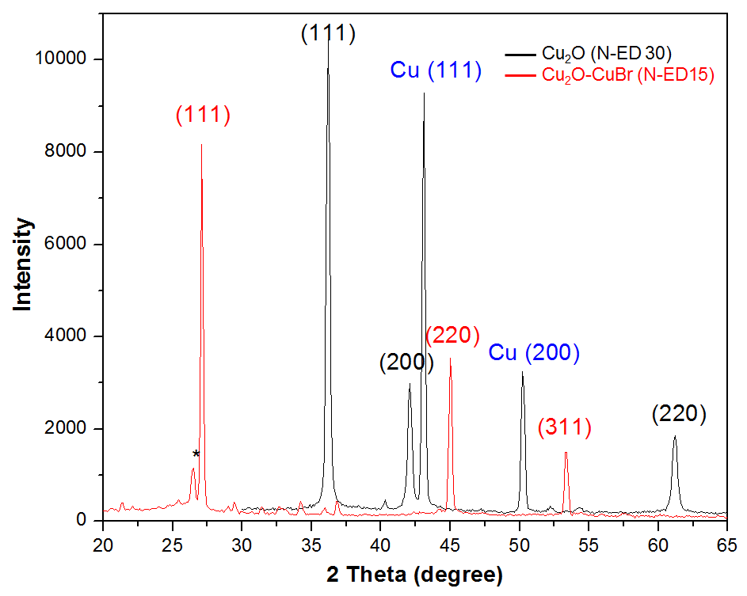

Figure S3. Comparison of XRD patterns for a Cu₂O (N-ED 30) film grown at -0.4 V for 30 min using 0.1 M Cu(NO₃)₂.5H₂O + 0.1 M NaNO₃ as electrolyte (black trace) and composite Cu₂O-CuBr (N-ED 15) layer electrodeposited also at -0.4 V for 15 min using 0.1 M Cu(NO₃)₂.5H₂O + 0.1 M NaNO₃ + 0.17 NaBr (red trace). Both films were electrodeposited on GDL 35 BC.

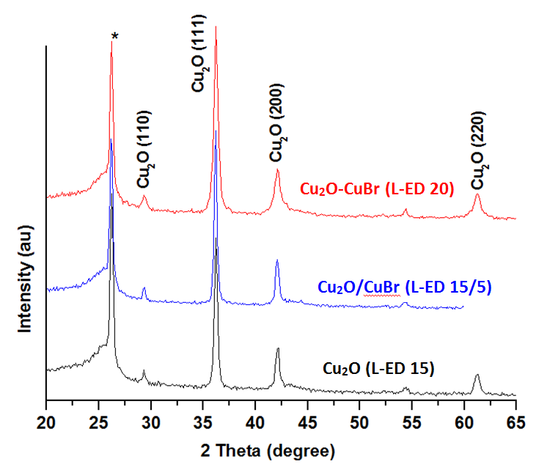

Figure S4. XRD patterns of Cu₂O (L9-ED 15), Cu₂O/CuBr (L9-ED15-5), and Cu₂O-CuBr (L9-ED20) films. Peak marked with asterisk is from GDL substrate.
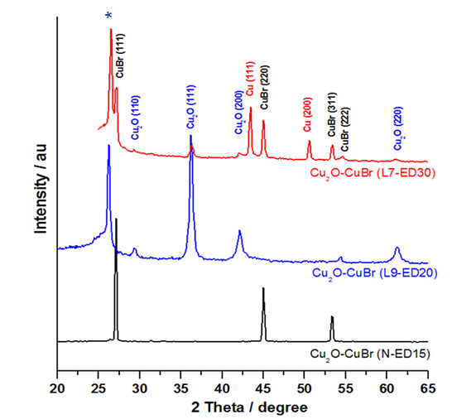

Figure S5. Comparison of XRD patterns for Cu₂O-CuBr (L7-ED30) (top), Cu₂O-CuBr (L9-ED20) (middle) and of Cu₂O-CuBr (N-ED15) (bottom) respectively. The peak marked with * corresponds to the GDL support.

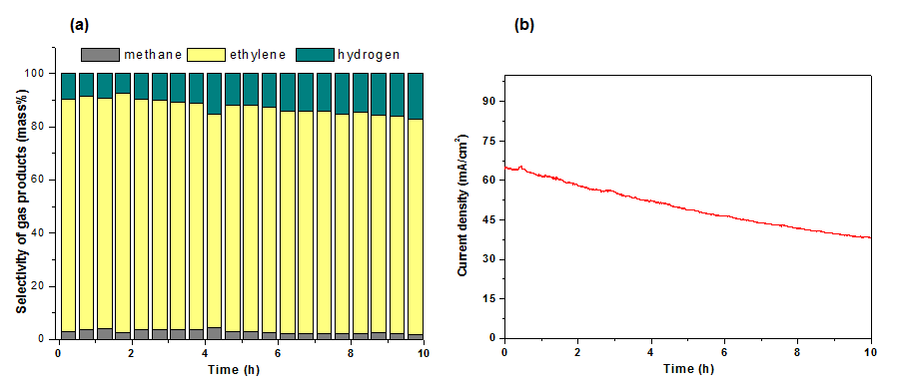
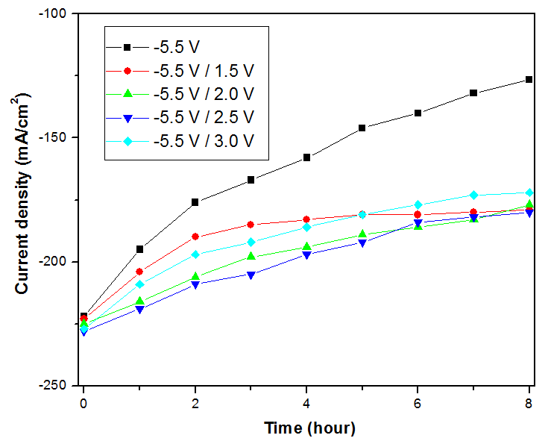
Figure S6. Product selectivity (a) and current stability (b) at -1.9 V (vs. RHE) in 1 M KOH at 3 °C and with a CO₂ flow rate of 8 mL/min. The cathode was GDL/Cu₂O-CuBr (L7) with an electrodeposition charge of 4 C/cm² and the anode was GDL/Pt. Both electrodes were tested in the MCFER mode.

Figure S7. Current/time behavior during CO₂ electrolysis at -5.5 V without (black trace) and with PECA (colored traces) and with four pulses (10s/10s) performed every hour. In all cases, the cathode consisted of Cu₂O-CuBr (L7-ED30) while the anode was a Pt foil. Both electrodes were located in a MFECR with 1 M KOH electrolyte at 25 °C.

