Effect of Gold Underlayer on Copper (I) Oxide Photocathode Performance.
T. Lan¹, C. Mundt² and S. Padalkar^{1, 3, a)}
1. Department of Mechanical Engineering, Iowa State University, Ames, IA 50011, USA
2. Department of Aerospace Engineering, Iowa State University, Ames, IA 50011, USA
3. Microelectronics Research Center, Iowa State University, Ames, IA 50011, USA

Supplementary information

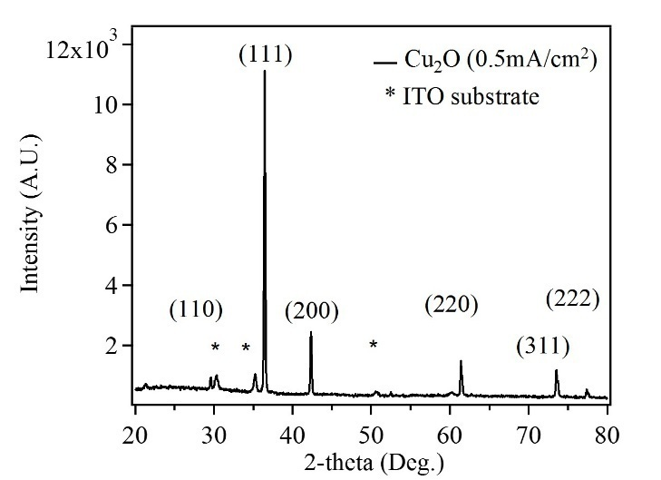
Figure S1: XRD plot of a typical Cu₂O film.
The Cu₂O films electrodeposited on ITO on glass substrate. The electrodeposition was carried out at a current density of 0.5 mA/cm² for 30 minutes. The XRD plot shows a dominant (111) crystallographic orientation.
The figures S2 and S3 show the photoelectrochemical performance of Au-Cu₂O composite photocathodes in comparison to the control Cu₂O photocathode. It has been observed that all the Au-Cu₂O composite photocathodes demonstrate similar enhancements compared to the control Cu₂O photocathode. The enhancement is close to 81%. The similarity in enhancement can be attributed to the difficulty in achieving monodispersed Au nanostrucutres.
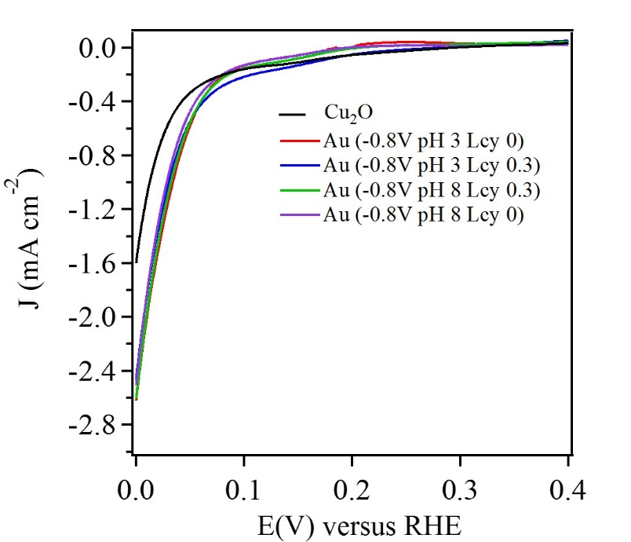
Figure S2: The photocurrent density plots of Au-Cu₂O composite photocathodes and control Cu₂O photocathode. The Au nanostructures were fabricated at an applied potential of -0.8 V.
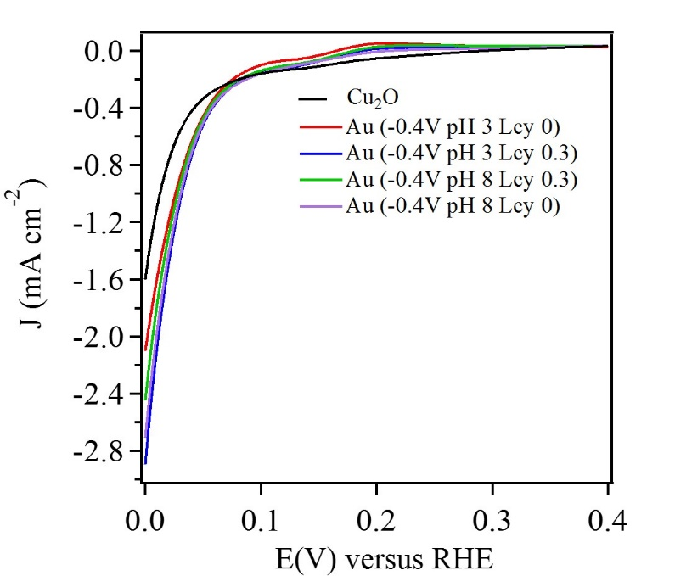
Figure S3: The photocurrent density plots of Au-Cu₂O composite photocathodes and control Cu₂O photocathode. The Au nanostructures were fabricated at an applied potential of -0.4 V.
The dark current was measured over a period of 1 h. For this measurement the working electrode was Au-Cu₂O composite photocathode. A potential of -0.5 V vs Ag/AgCl, which was equivalent to 0 V vs RHE was applied for 1 h, in 0.5 M Na₂SO₄ electrolyte. Figure S4 shows the dark current for 1 h. The dark current approaches 0 mA/cm² and remains constant through the entire experiment.
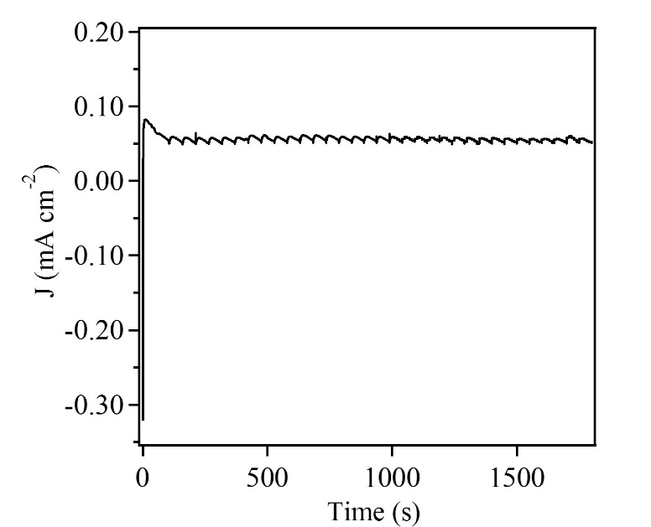
Figure S4: Dark current obtained from Au-Cu₂O composite photocathode.
Admittance defines the ease with which carrier transport can occur. The ease of carrier transport was evaluated by measuring the diameter of the semicircle, which is a characteristic of each admittance plot. The larger the diameter, easier is the carrier transport. Admittance is a reciprocal of impedance (Y´ = 1/Z´) and is measured in siemens. Figure 12 presents admittance plots of Au, Cu₂O and Au-Cu₂O samples. From the admittance plot, it was clear that Au sample demonstrated an ease of carrier transport from the electrode to the electrolyte or greater conductance. However, the Cu₂O exhibited less ease in carrier transport or less conductance. The admittance plot of Au-Cu₂O sample exhibited a greater ease in carrier transport than Cu₂O sample or higher conductance than Cu₂O.
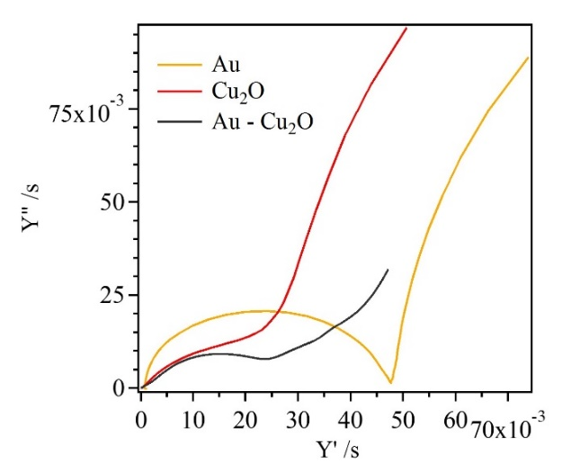
Figure S5: Admittance plots of Au, Cu₂O and Au-Cu₂O samples.
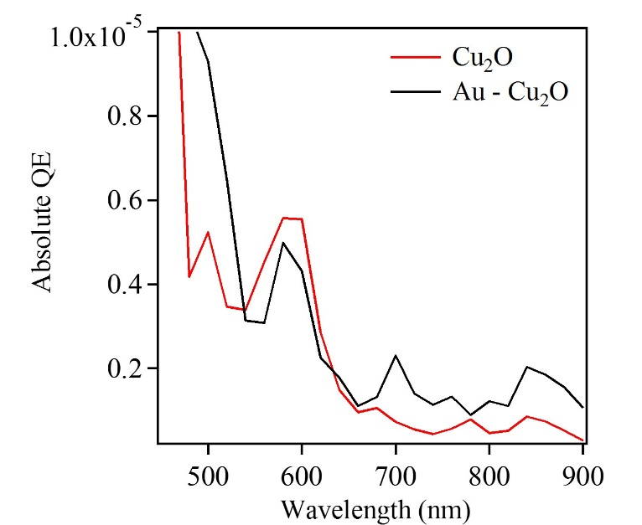
Figure S6: Absolute quantum efficiency for Cu₂O and Au-Cu₂O samples.

