Supporting Information

Controlled synthesis of polystyrene-assisted tin-doped indium oxide nanowire networks
Qiang Li^{1,2,}, Lungang Feng², Shuai Wang², Yu-Feng Li^{1,2}, and Feng Yun^{1,2,}
¹Key Laboratory of Physical Electronics and Devices for Ministry of Education and Shaanxi Provincial Key Laboratory of Photonics & Information Technology, Xi’an Jiaotong University, 710049, Xi’an, Shaanxi, P. R. China
²Solid-State Lighting Engineering Research Center, School of Electronic and Information Engineering, Xi’an Jiaotong University, 710049, Xi’an, Shaanxi, P. R. China

Section 1- Schematic diagram of PS decomposition

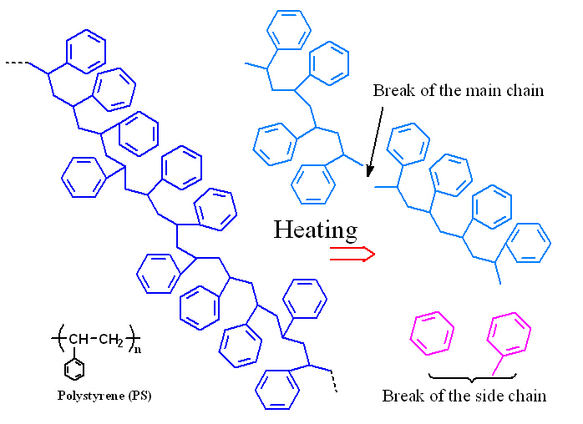
FIG.S1 (color online) The molecular chains of polystyrene were ruptured by heating. One is the main chain broken, and the other is the side chain broken.

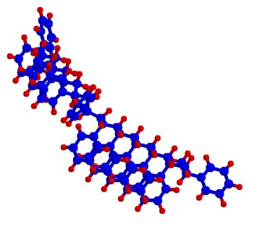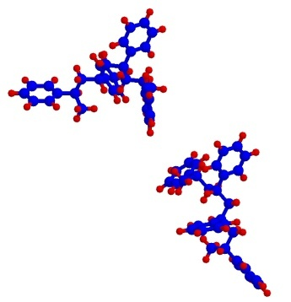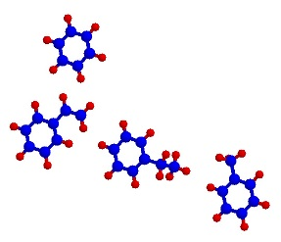
Gas
PS sphere
Heated PS sphere
FIG.S2 (color online)The schematic diagram of the deformation of PS spheres at high temperature.

Section 2- Different density of PS spheres monolayer
The PS spheres dispersion is a concentration of 10% water dispersion. The following figures show the different proportions of PS dispersion in alcoholic solution (99%).
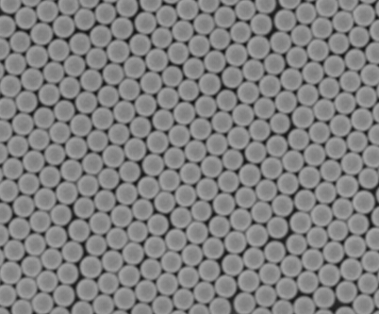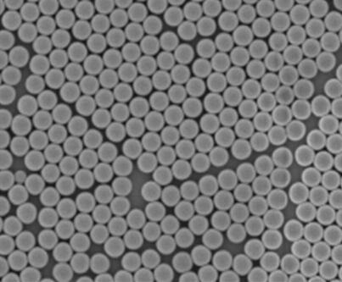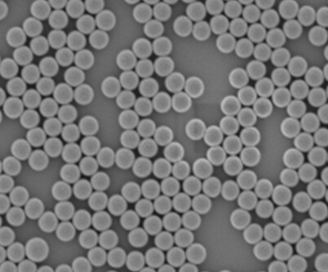
1 µm
1 µm
1 µm
(a)
(b)
(c)
FIG.S3 (color online) The SEM images of PS spheres monolayer with different concentration. The proportions of PS dispersion in alcoholic solution are(a) 1:1.5, (b) 1:3, and (c) 1:6, respectively.

*E-mail: fyun2010@mail.xjtu.edu.cn

