Supporting Information

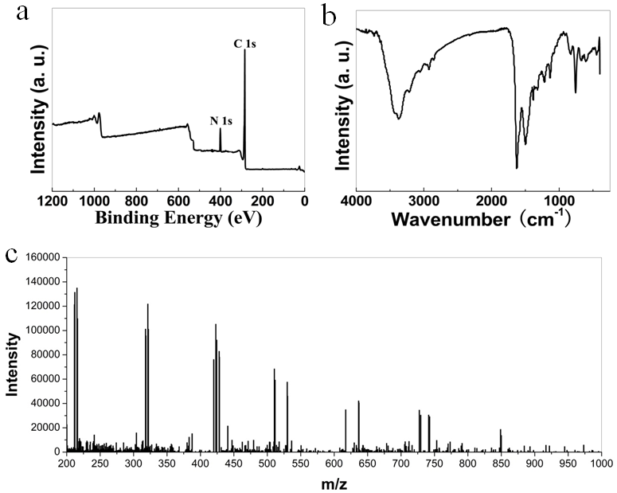
FIG. S1. (a) Survey XPS spectrum of omCP-95. (b) FT-IR spectrum of omCP-95. (c) MALDI-TOF-MASS spectra of omCP-95.

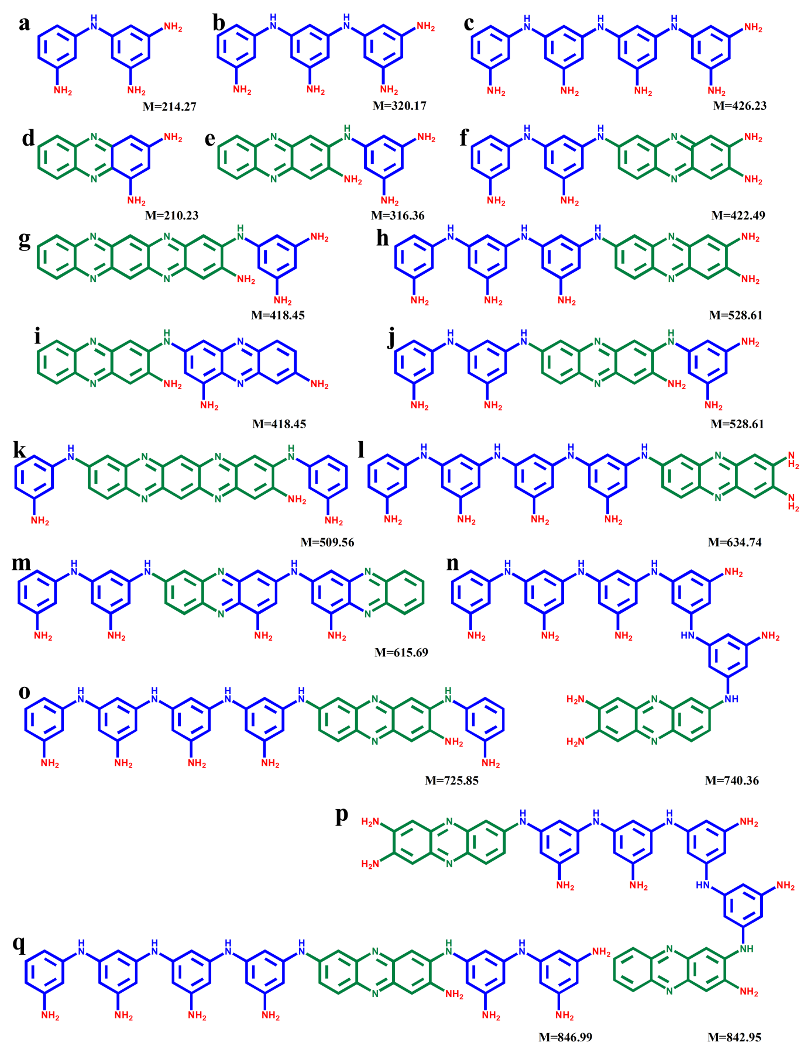
FIG. S2. Corresponding molecular structures of amide compounds in omCP-95, (a) M=214.27, (b) M=320.17, (c) M=426.23, (d) M=210.23, (e) M=316.36, (f) M=422.49, (g) M=418.45, (h) M=528.61, (i) M=418.45, (j) M=528.61, (k) M=509.56, (l) M=634.74, (m) M=615.69, (n) M=740.36, (o) M=725.85, (p) M=842.95, (q) M=846.99.

Table S I A brief summary of the characteristics of omCPs and carbon based quantum dots.

 | φ | τ / ns | Fluorescence in solid state | Ref.
omCP-95 | 0.94 a | 4.6 | omCP-95@ paper | This work
omCP-80 | 0.92 a | 3.9 | omCP-80@ paper | This work
omCP-65 | 0.93 a | 4.1 | omCP-65@ paper | This work
omCP-50 | 0.93 a | 4.5 | omCP-50 @ paper | This work
omCP-35 | 0.91 a | 4.9 | omCP-35@ paper | This work
omCP-25 | 0.93 a | 4.7 | omCP-25@ paper | This work
omCP-20 | 0.92 a | 5.1 | omCP-20@ paper | This work
omCP-05 | 0.92 a | 4.8 | omCP-05@ paper | This work
N-GQDs | 0.74a | 11.5 | N-GQDs @ paper | S1
GQDs | - | - | - | S2
GQDs | 0.16b | - | - | S3
GQDs | 0.24c | - | - | S4
GQDs | 0.49d | - | - | S5
GQDs | 0.29-0.19e | - | GQD @ PDMS | S6
GQDs | 0.086f | - | - | S7
GQDs | - | 1.29 | - | S8
GQDs | 0.11g | - | - | S9
GQDs | 0.12g | 7.7 | - | S10
GQDs | 0.28h | - | - | S11
CDs | 0.088i | - | - | S12
CDs | 0.18j | - | - | S13
CDs | - | 5.36 | - | S14
CDs | 0.71 | 7.6 | - | S15
CDs | 0.60 | 6 | - | S16
Note: - No mention
ª:Quantum yield was calculated using those of Rhodamine B (φ=0.68) in EtOH as a standard.
^{b}:Quantum yield was calculated using those of Quinine sulfate (φ=0.577) in wateras a standard.
^{c}: Quantumyield was calculated using Quinine sulfate (φ= 0.54) in 0.1 M H2SO4 as a standard.
^{d}: Quantumyield was calculated using Rhodamine B (φ=0.31) in water as astandard.
^{e}:Quantumyield was calculated usingquinine sulphate (φ=0.54) in 0.5 M H2SO4 as astandard.
^{f}:Quantumyield was calculated using Quinine sulfate(φ= 0.54)in wateras a standard.
^{g}:Quantumyield was calculated using 9,10-Bis(phenylethynyl) anthracene (φ=1) in cyclohexane as a standard.
^{h}:Quantumyield was calculated using Rhodamine B (φ=0.31) in water as a standard.
^{i}:Quantumyield was calculated using Fluorescein (φ=0.95) in water as astandard.
^{j}:Quantumyield was calculated using 9,10-Bis(phenylethynyl) anthracene(φ=) in cyclohexaneas a standard.

Table SⅡ A brief summary of the characteristics of dyes.

 | φ | τ / ns | Ref.
omCP-95 | 0.94 ª | 4.6 | This work
omCP-80 | 0.92 ª | 3.9 | This work
omCP-65 | 0.93 ª | 4.1 | This work
omCP-50 | 0.93 ª | 4.5 | This work
omCP-35 | 0.91 ª | 4.9 | This work
omCP-25 | 0.93 ª | 4.7 | This work
omCP-20 | 0.92 ª | 5.1 | This work
omCP-05 | 0.92 ª | 4.8 | This work
Rhodamine B | 0.68† | - | S17
BODIPY | 0.42‡ | - | S18
BODIPY | 0.37‡ | - | S18
BODIPY | 0.35‡ | - | S18
ZnAF | 0.17^{‖, b} | - | S19
AsCy3 | 0.28 | - | S20
Core-Modified Rubyrin | 0.3^{‡, c} | 0.09 | S21
Half-Condensed Schiff Base | 0.4‖ | - | S22
dimethylaminocinnamaldehyde-aminothiourea derived Schiff base | 0.25* | - | S23
Note: - No mention
*:Data acquired in aqueous solution.
†:Data acquired in EtOH in dilute solutions.
‡:Data acquired in CHCl₃ in dilute solutions.
‖: Data acquired in 100 mM HEPES buffer, pH 7.4.
※: Data acquired in MeCN/H₂O (1:1, v/v) solution.
ª: Quantum yields were calculated using those of Rhodamine B (φ=0.68) in EtOH as a standard.
^{b}: Quantum yields were calculated using those of fluorescein (φ=0.85) in 0.1 N NaOH as a standard.
^{c}: Quantum yields were calculated using those of cresyl violet in methanol (φ= 0.61 ± 0.01) as a standard.

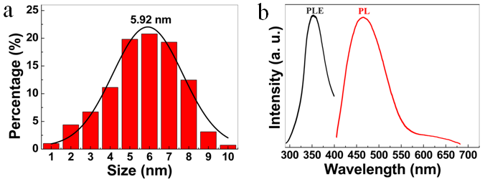
FIG. S3. Corresponding size distribution of omCP-80. Normalized PLE and PL spectra of omCP-80 aqueous solution.

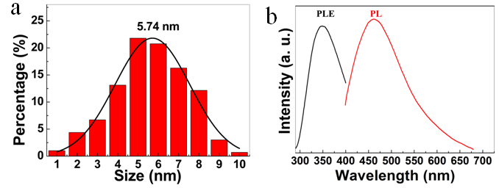
FIG. S4. Corresponding size distribution of omCP-65. Normalized PLE and PL spectra of omCP-65 aqueous solution.

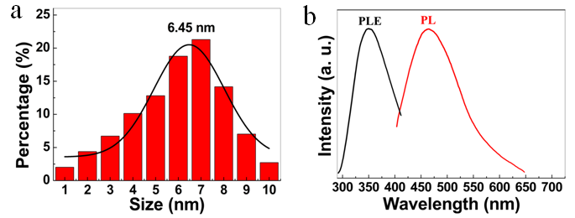
FIG. S5. Corresponding size distribution of omCP-50. Normalized PLE and PL spectra of omCP-50 aqueous solution.

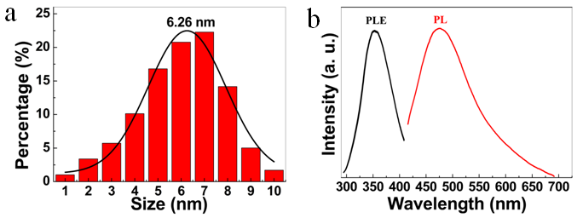
FIG. S6. Corresponding size distribution of omCP-35. Normalized PLE and PL spectra of omCP-35 aqueous solution.

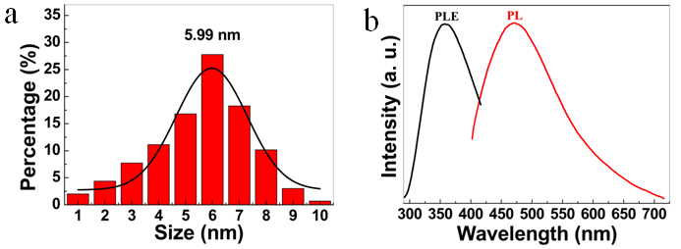
FIG. S7. Corresponding size distribution of omCP-25. Normalized PLE and PL spectra of omCP-25 aqueous solution.

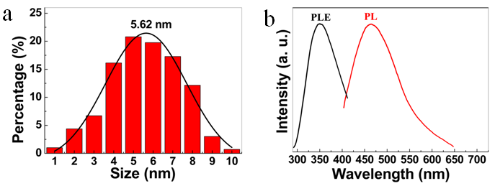
FIG. S8. Corresponding size distribution of omCP-05. Normalized PLE and PL spectra of omCP-05 aqueous solution.

