Mixing in PCBM/P3HT bilayers, using in-situ and ex-situ neutron reflectivity
Supplementary Material

Dyfrig Mônª, Anthony M. Higgins*^{,a}, Philipp Gutfreund^{b} and David Jamesª
ª College of Engineering, Swansea University, Fabian Way, Crymlyn Burrows, Swansea, SA1 8EN, Wales, United Kingdom
^{b} Institut Laue-Langevin, 71 avenue des Martyrs, 38000 Grenoble, France

* a.m.higgins@swansea.ac.uk

Further experimental procedures
GIXD. Samples were ex-situ annealed in a Linkam hot-stage under a nitrogen atmosphere and then rapidly quenched onto a metal surface (still within the nitrogen atmosphere). GIXD measurements were performed at the beam-line I07 at Diamond Light Source. Samples were placed inside a helium-filled chamber, mounted on a 2 + 3 circle diffractometer with a hexapod sample stage. Monochromatic x-rays of energy 10keV were used. Diffraction patterns were detected with a Pilatus silicon photodiode 2M array detector (Dectris). GIXD maps were taken using a range of incident angles, α, above and below the critical angle, α_{c}. Acquisition times of 10s were used at each incident angle during these ‘α–scans’. Repeat measurements before and after the a-scans were used to confirm that no signal degradation, due to beam-damage to the sample, occurred during this procedure.

Fitting of the 80nm P3HT neutron reflectivity sample; Further discussion
The single layer fit in fig. 5f has an integrated SLD that is much too high (by a factor of ~40%; see Table SI), given the known composition of the sample. Fig. 5f also shows a bilayer fit for the 80nm P3HT sample (in which the SLDs, thicknesses and roughnesses of both layers are allowed to vary). This fit is visually better and has a lower value of the goodness-of-fit reduced chi-squared parameter, χ_{ν}²,¹ compared to the single layer fit, but still has an integrated SLD that is unphysically high. However, interestingly this fit does have an SLD profile that has a thin layer of higher SLD material at the free surface. We verified the robustness of this fit by using both a Levenberg-Marquardt (LM) fitting algorithm (from several different initial guesses) and a genetic algorithm.¹ We then tried a systematic series of fits for this sample using different multilayer models, to see if we could obtain a fit with a lower (and hence more physically reasonable) integrated SLD (see fig. S2). This procedure involved modelling the sample as n discrete layers, with a total thickness of 1000 Å (the total thickness of the unannealed sample, determined by AFM measurements). The SLD of each layer was allowed to vary (without any constraints), but the interfacial roughness between each layer was set to zero. This procedure was repeated using the LM fitting algorithm, with n gradually increasing in value and each fitting procedure starting with an initial-guess SLD profile given by the best-fit for the previous (lower) value of n. A parallel approach was tried in which some of the layer thicknesses were also allowed to vary (i.e. relaxing the total thickness constraint). These two parallel approaches led to very similar model SLD profiles (eg; the 20-layer model with variable thickness had a total fitted thickness of 1012 Å, rather than the fixed value of 1000 Å, with χ_{ν}²=3.3 for both approaches). Figs S2a and S2b show the reflectivity data and a selection of the fits for different values of n, for the approach in which the total thickness is not constrained. It is clear that the introduction of more layers enables a better fit to the data, particularly with regard to reproducing the subtle fringes evident in the data around q~0.02-0.03 Å⁻¹ (this is especially evident when the data is plotted in the form R(q)q⁴ versus q, as in fig S2b). This is evidenced by the better visual matching of these features, and the reduction of χ_{ν}² as n increases (fig S2a inset). Fig S2c shows that all fits in this sequence show some degree of surface layer with a larger SLD than the ‘bulk’ of the film. As n increases, the fitted SLD profiles in fig. S2c show a gradual reduction in the minimum SLD value within the film, resulting in an integrated SLD that is a physically better match to the known integrated SLD, given the known film thicknesses before annealing (see values in Table SI).
However, some caution is required here, with regard to the uniqueness of the SLD profiles shown in fig. S2c, particularly given the reproduction of rather subtle features using SLD profiles containing a significant number of adjustable parameters. Following the fitting procedure outlined above, we proceeded to further test the robustness of our fitted SLD profiles, by repeating the LM fit with n=25, but starting from different initial guesses for the SLD profile. Rather than using the SLD profile from a lower value of n, different fits were performed with initial guesses that had uniform SLD profiles with different values of the SLD. This procedure resulted in two other possible SLD profiles that fitted the data well; one starting from a uniform profile with a SLD of 1 x 10⁻⁶ Å⁻², and the other starting from a uniform profile with a SLD of 2 x 10⁻⁶ Å⁻². The reflectivity curves for these fits are not shown, as they are virtually identical to the 25 layer fit shown in fig. S2b. Fig. S2d shows the SLD profiles for these two possible fits, labelled Fit B and Fit C for the fits starting from 2 x 10⁻⁶ Å⁻² and 1 x 10⁻⁶ Å⁻² respectively (Fit A in fig. S2d is the 25 layer fit starting from the 20-layer SLD profile shown in fig. S2c). What is clear from these two profiles is that, while they both fit the data as well as Fit A (the values of χ_{ν}² are 3.2, 3.2 and 3.7 for Fit A, Fit B and Fit C respectively), Fit B has an integrated SLD that is much too high (by a factor of up to 44%, see Table SI) with-respect-to the known composition of the sample. On the other hand, Fit C has an integrated SLD that is lower with-respect-to the known sample composition before annealing by 11-25%, which is a comparable discrepancy to that shown by Fit A (but of opposite sign; the integrated SLD of Fit A is 2-21% too high), with-respect-to the sample before annealing. Given the potential for some sample-sample variation in terms of layer thicknesses in the unannealed samples, and the range of estimates of the SLD of PCBM and P3HT, Fit C cannot therefore be unequivocally rejected as a potential SLD profile on the basis of the reflectivity measurements alone. One may appeal to physical arguments to question the plausibility of Fit C; The SLD minimum near the silicon substrate is completely depleted of PCBM and is also a very sharp feature, while the reduction in SLD towards the surface is very gradual, and contains a few hundred Angstroms with SLD lower than pure P3HT. It may be tempting to prefer Fit A to Fit C for these reasons, and also on the basis that strong substrate depletion of PCBM has not been seen previously for silicon/PCBM/P3HT bilayers (with the PCBM layer on the bottom,²⁻⁴) using either real or reciprocal space methods, while surface enrichment with PCBM has been reported by H. Chen et al.⁴ However the signatures of surface enrichment reported in H. Chen et al. and in the present study are rather subtle features in the reflectivity curves/SLD profiles, and should be treated with some circumspection. In opposition to this preference for Fit A, the SLD profile in Fit C is more commensurate with the AFM measurements on this sample which find an rms roughness of around 25nm. Notwithstanding these notes of caution regarding the exact distribution of PCBM within the 80nm P3HT sample, the physical picture represented by either of the SLD profiles, Fit A or Fit C, corresponds to a situation in which the entire PCBM bottom layer has mixed into the P3HT layer on top.

Optical microscopy, AFM and GIXD
Fig S3 shows the typical morphology development due to micron-sized PCBM crystal formation ⁵⁻¹⁰, found on samples annealed for 120 minutes, showing the dependence on P3HT film thickness and annealing temperature. A significant reduction in crystal density is seen between 140 ºC and 160 ºC. Annealing at 170 ºC for 120 minutes resulted in a further reduction in PCBM crystal density, in comparison with 160 ºC. Fig S4 shows the surface topography on the 35nm P3HT bilayer after annealing in-situ at 170 ºC and fig. S5 shows the surface topography on the 8nm P3HT bilayer sample annealed ex-situ at 140 ºC. Fig. S1 shows GIXD on an unannealed bilayer, and on the same sample after annealing at 140 ºC for 2 hours. There is no evidence of the emergence of any significant scattering due to crystalline PCBM after annealing this sample, or for other samples annealed at 140 ºC for shorter periods of time (not shown).

Figure S1: GIXD intensity maps from a 35nm P3HT/ 20nm PCBM bilayer; a) shows the scattering from the unannealed sample. b) shows the scattering from the same sample after ex-situ annealing. Both measurements were taken at an incident angle of 0.19º (above the critical angle).
Figure S2: Multilayer fitting of the 20nm PCBM/80nm P3HT sample. All models have zero interfacial roughness between layers (and zero roughness at the sample surface). a) Reflectivity, R, versus q, plus fits for 2 and 20 layers. The inset shows the reduced chi-squared parameter χ_{ν}² for each multilayer fit, as a function of the number of layers in the model. b) Reflectivity data and all multilayer fits shown in Rq⁴ format. c) SLD profiles corresponding to the multilayer fits; The SLD profiles are offset with-respect to one another horizontally and vertically for clarity (the 20 layer fit has no vertical offset and profiles with successively fewer layer are vertically offset by a SLD of 5 x 10⁻⁷ Å ⁻²). d) 25 layer fits starting from three different initial guesses. There are no fixed silicon oxide layers included in any of these fits.

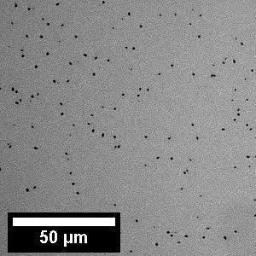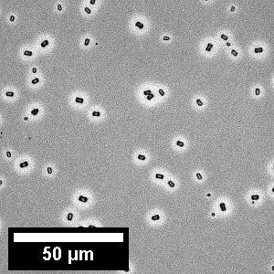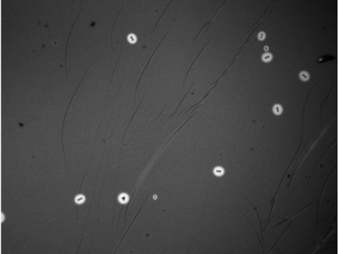
b)
c)
a)

Figure S3: Optical microscopy images of PCBM (20nm)/P3HT bilayers; a) 8nm P3HT annealed at 140 ºC for 120 minutes; b) 35nm P3HT annealed at 140 ºC for 120 minutes; c) 35nm P3HT annealed at 160 ºC for 120 minutes. The linear features in c) are folding defects that sometimes occur during the polymer film deposition step. The image in c) has dimensions 245 μm x 187 μm.

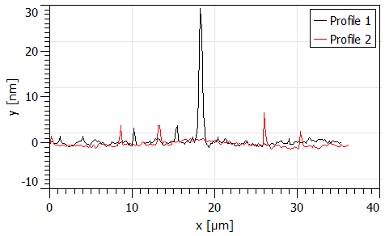
b)
a)
Figure S4: AFM a) topography image and b) line profiles of the (20nm)PCBM/(35nm)P3HT neutron reflectivity sample annealed in-situ at 170 ºC. Line profile 1 is chosen to deliberately go through a defect on the sample surface, while both profiles go through multiple ‘dot-like’ features that protrude around 3-5nm above the sample surface. The rms roughness of this image is 1.2nm.

a)
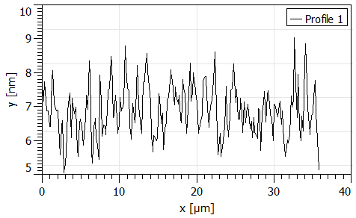
b)
Figure S5: AFM a) image and b) line profile of the (20nm)PCBM/(8nm)P3HT neutron reflectivity sample annealed at 140 ºC. The rms roughness of this image is 1.4nm.

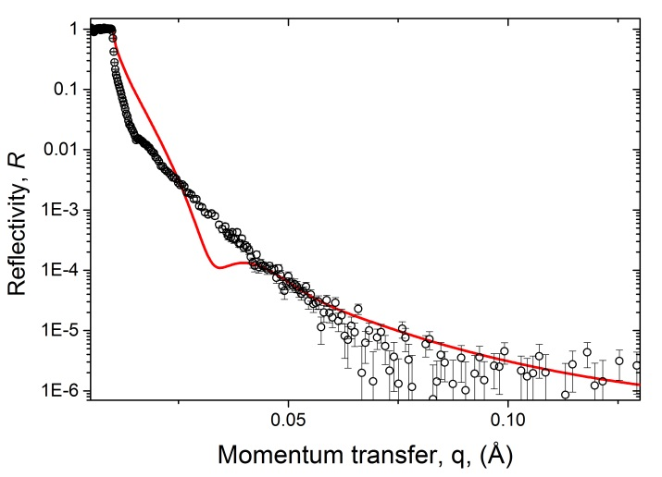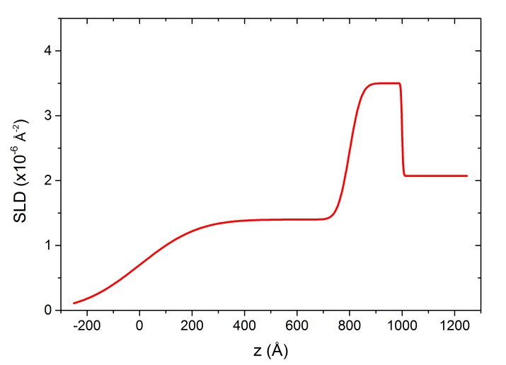
Figure S6: Simulation of a bilayer sample with rough interfaces, but preserving a 20nm layer of relatively high SLD material at the substrate, in comparison with the reflectivity data from the 80nm P3HT/PCBM bilayer sample annealed at 140 ºC; a) the experimental data (as in fig. 5c) and simulated reflectivity curve and b) the simulated SLD profile. In the simulation the interface roughness was set to 5nm, the surface roughness to 25nm and the resolution to 4% in the simulation. The prominent fringe (minimum at ~ 0.03 Å⁻¹and maximum at around 0.04 Å⁻¹) occurs in the simulated data as the bottom layer SLD is changed over a wide range (between approximately 2.5 x 10⁻⁶ Å⁻² and 5 x 10⁻⁶ Å⁻²).

Annealing/neutron reflectivity method | Layer thicknesses in sample before annealing | Ratio of the scattering length density integrated across the total sample thickness after annealing, to that before annealing.
Ex-situ | PCBM 20nm/ P3HT 8nm | 1.01 (0.88)
Ex-situ | PCBM 20nm/ P3HT 35nm | 1.05 (0.94)
Ex-situ | PCBM 20nm/ P3HT 80nm | Single layer fit; 1.47 (1.23)  25 layer fits;  Fit A; 1.21 (1.02)  Fit B; 1.44 (1.21)  Fit C; 0.89 (0.75)
In-situ | PCBM 20nm/ P3HT 35nm | 1.06

Table SI: Sample scattering length per unit area ratios (integrated from the substrate to the sample surface)) for some of the fits shown in figures 5 and S2. The after-annealing/before-annealing scattering length ratios in column 3 were calculated using the fitted SLDs of PCBM and P3HT for the unannealed bilayer (4.3x10⁻⁶Å⁻² and 6.2x10⁻⁷Å⁻² for PCBM and P3HT respectively), and the unannealed layer thicknesses measured by AFM, plus the layer thickness and SLD fit parameters for the annealed samples. The figures in brackets represent the after-annealing/before-annealing scattering length ratios calculated using a PCBM SLD of 4.9x10⁻⁶Å⁻² and a P3HT SLD of 0.8x10⁻⁶Å⁻². This represents the lower limit for these scattering length ratio estimates, as the range 4.3-4.9x10⁻⁶Å⁻² represents the range of SLD fit parameters reported for PCBM in the literature and 0.8x10⁻⁶Å⁻² represents the upper bound for reported P3HT SLD values.[11, 16, 20, 24, 34] Given that the 80nm P3HT single layer fit in fig. 5f has an SLD close to silicon (and is therefore not particularly sensitive to the layer thickness) the calculation of the scattering length ratio for this fit assumes that the total thickness of the annealed samples is 100nm (i.e the same as the unannealed sample).

References for supporting information

1. I.G. Hughes and T.P.A. Hase: Measurements and their uncertinties (book), 1st Edition ed. (Oxford University Press, 2010).
2. N.D. Treat, M.A. Brady, G. Smith, M.F. Toney, E.J. Kramer, C.J. Hawker and M.L. Chabinyc: Interdiffusion of PCBM and P3HT Reveals Miscibility in a Photovoltaically Active Blend Advanced Energy Materials. 1, 82 (2011).
3. D. Chen, A. Nakahara, D. Wei, D. Nordlund and T.P. Russell: P3HT/PCBM Bulk Heterojunction Organic Photovoltaics: Correlating Efficiency and Morphology Nano Letters. 11, 561 (2011).
4. H. Chen, R. Hegde, J. Browning and M.D. Dadmun: The miscibility and depth profile of PCBM in P3HT: thermodynamic information to improve organic photovoltaics Physical Chemistry Chemical Physics. 14, 5635 (2012).
5. D. Mon, A.M. Higgins, D. James, M. Hampton, J.E. Macdonald, M.B. Ward, P. Gutfreund, S. Lilliu and J. Rawle: Bimodal crystallization at polymer-fullerene interfaces Physical Chemistry Chemical Physics. 17(3), 2216 (2015).
6. X. Yang, J.K.J. van Duren, M.T. Rispens, J.C. Hummelen, R.A.J. Janssen, M.A.J. Michels and J. Loos: Crystalline Organization of a Methanofullerene as Used for Plastic Solar-Cell Applications Advanced Materials. 16(9-10), 802 (2004).
7. E. Klimov, W. Li, X. Yang, G.G. Hoffmann and J. Loos: Scanning Near-Field and Confocal Raman Microscopic Investigation of P3HT−PCBM Systems for Solar Cell Applications Macromolecules. 39(13), 4493 (2006).
8. J.J. Richards, A.H. Rice, R.D. Nelson, F.S. Kim, S.A. Jenekhe, C.K. Luscombe and D.C. Pozzo: Modification of PCBM Crystallization via Incorporation of C60 in Polymer/Fullerene Solar Cells Advanced Functional Materials. 23(4), 514 (2013).
9. A. Swinnen, I. Haeldermans, M. vande Ven, J. D'Haen, G. Vanhoyland, S. Aresu, M. D'Olieslaeger and J. Manca: Tuning the Dimensions of C60-Based Needlelike Crystals in Blended Thin Films Advanced Functional Materials. 16(6), 760 (2006).
10. C.H. Woo, B.C. Thompson, B.J. Kim, M.F. Toney and J.M.J. Fréchet: The Influence of Poly(3-hexylthiophene) Regioregularity on Fullerene-Composite Solar Cell Performance Journal of the American Chemical Society. 130(48), 16324 (2008).

