**Supporting Information**

A Comparative Study of Electrochemical, Optical Properties and Electropolymerization Behaviour of Thiophene and Furan Substituted Diketopyrrolopyrrole

Supreetha Paleyanda Ponnappa, 1 Sivanesan Arumugam, 1* Henry J. Spratt2, Sergei Manzhos, 3 Anthony P. O’Mullane, 1 Godwin A. Ayoko,1 Prashant Sonar1*

1. School of Chemistry, Physics and Mechanical Engineering, Nanotechnology and Molecular Sciences Discipline, Queensland University of Technology (QUT), Brisbane, Australia.
2. Central Analytical Research Facility, Institute for Future Environments, Queensland University of Technology (QUT), Brisbane, Australia.
3. Department of Mechanical Engineering, Faculty of Engineering, National University of Singapore Block E2 #07-08, 9 Engineering Drive 1, Singapore 117576.



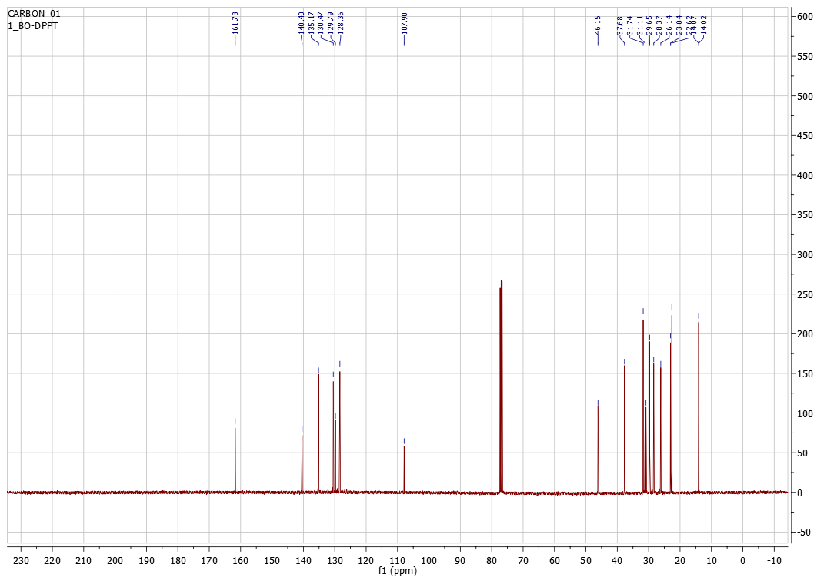

**Figure S1.** 1H (400 MHz, CDCl3) and 13C NMR (100 MHz, CDCl3) spectra of **BO-DPPT**

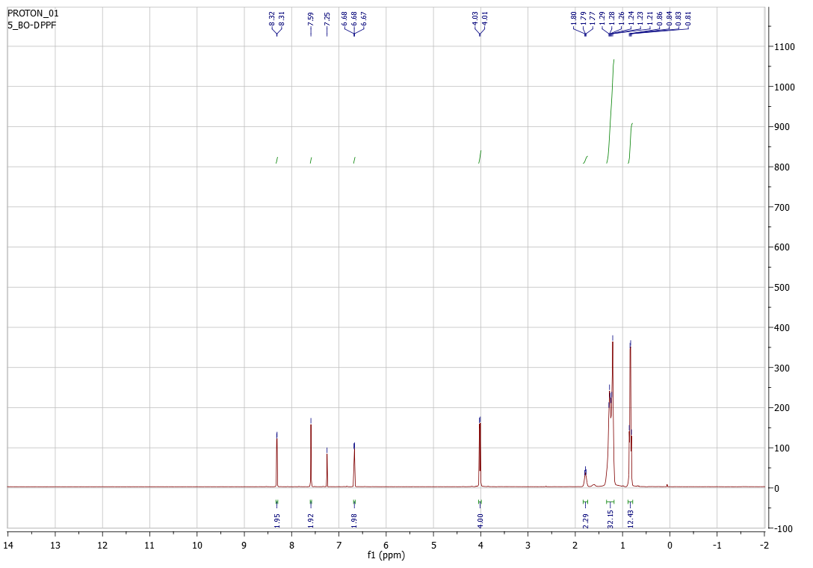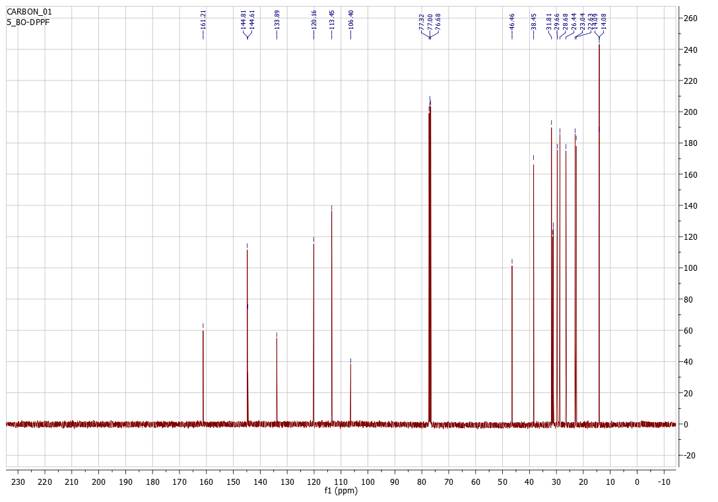

**Figure S2.** 1H (400 MHz, CDCl3) and 13C NMR (100 MHz, CDCl3) spectra of **BO-DPPF**

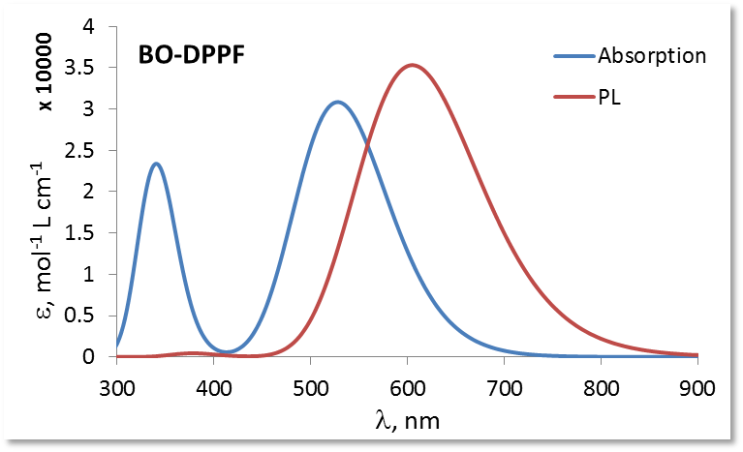

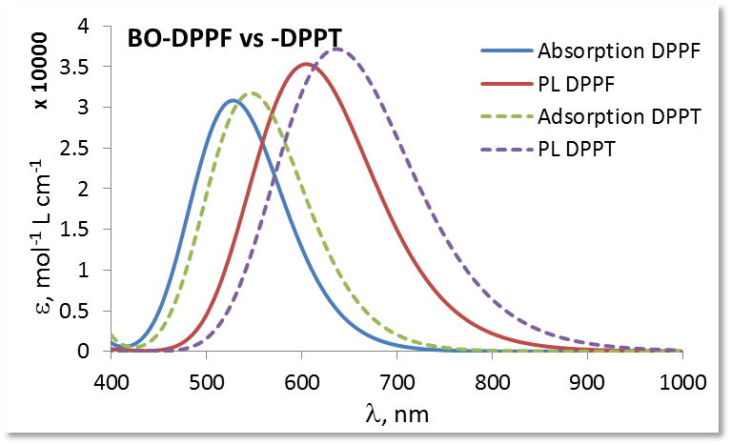

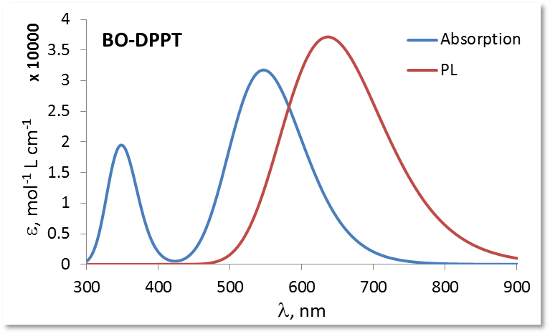

**Figure S3**: Theoretical UV-visible absorption (blue) and photoluminescence (red) spectra of the monomers **BO-DPPT** and **BO-DPPF** in DCM. The spectra are broadened by 0.25 eV HWHM.

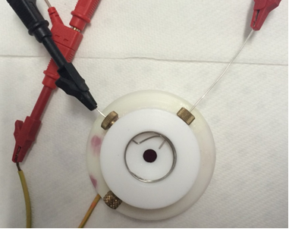

**Figure S4**: Pictorial representation of custom-made electrochemical setup for the electropolymerization study.

**Figure S5:** The above figures are the reduction (-2 V to 0V) and oxidation (0V to +2V) of the electropolymerized polymer thin film **poly-(BO DPPF)** deposited on glassy-carbon electrodes in 0.1 M TBAPF6/DCM. The scan rate employed in all cases was 0.1 Vs-1.

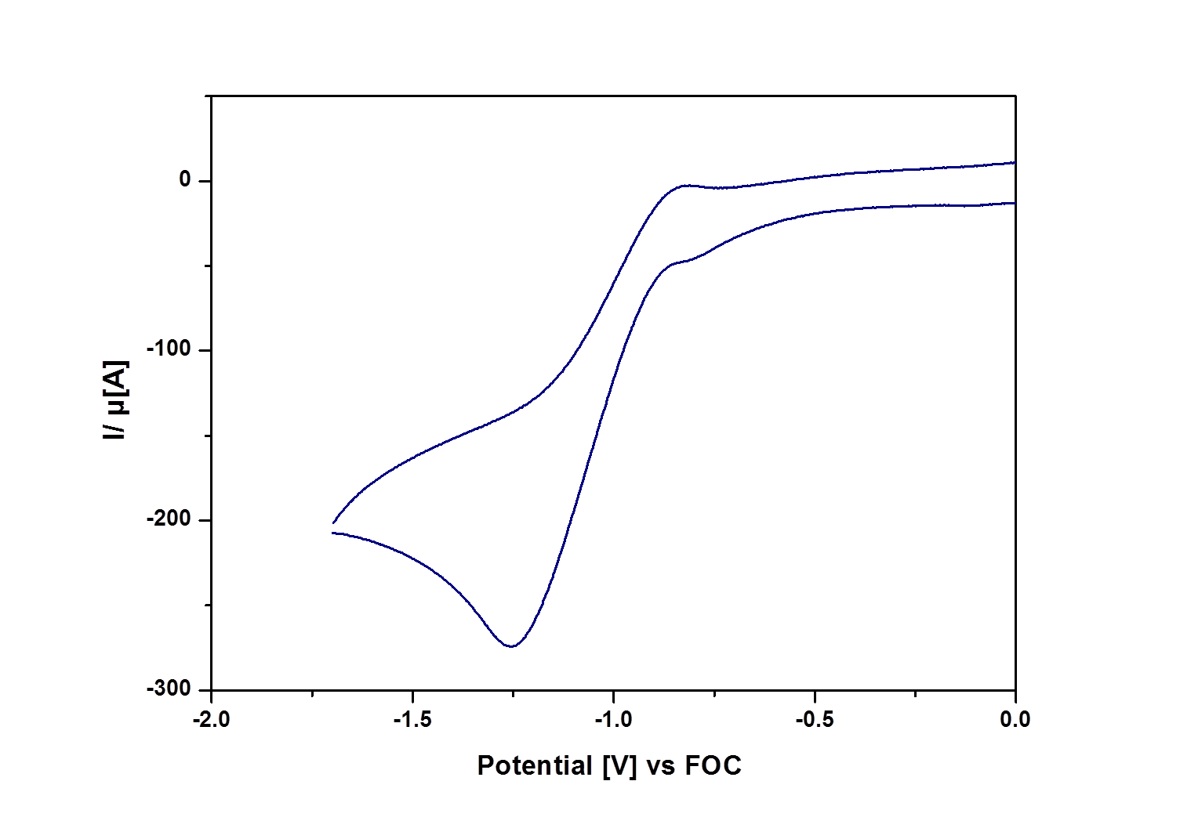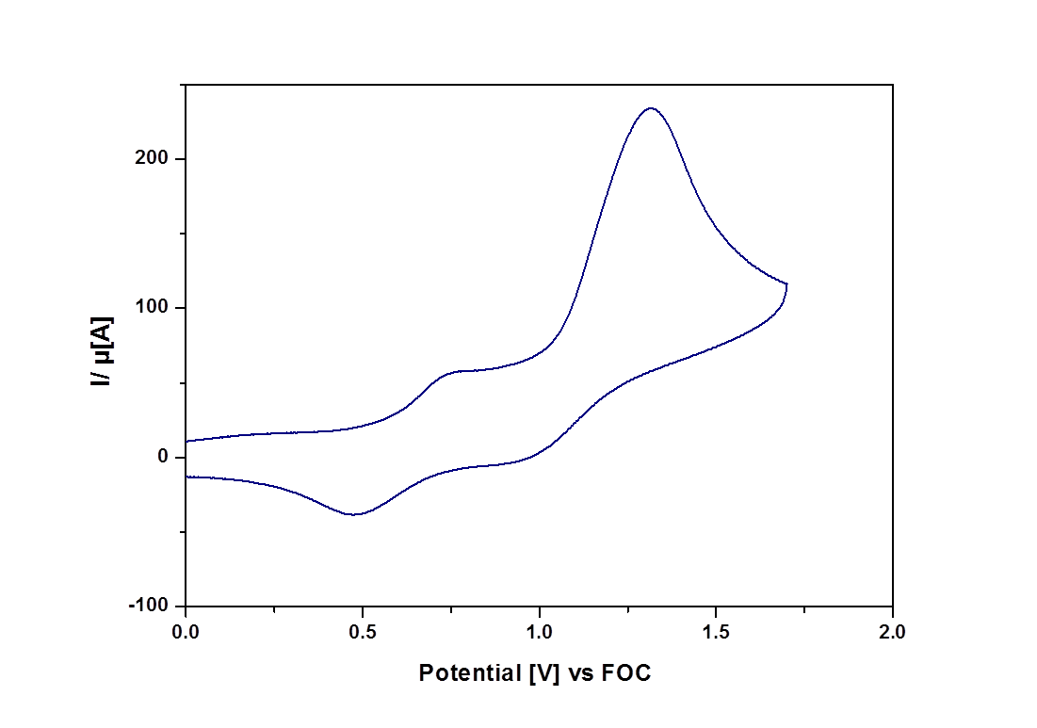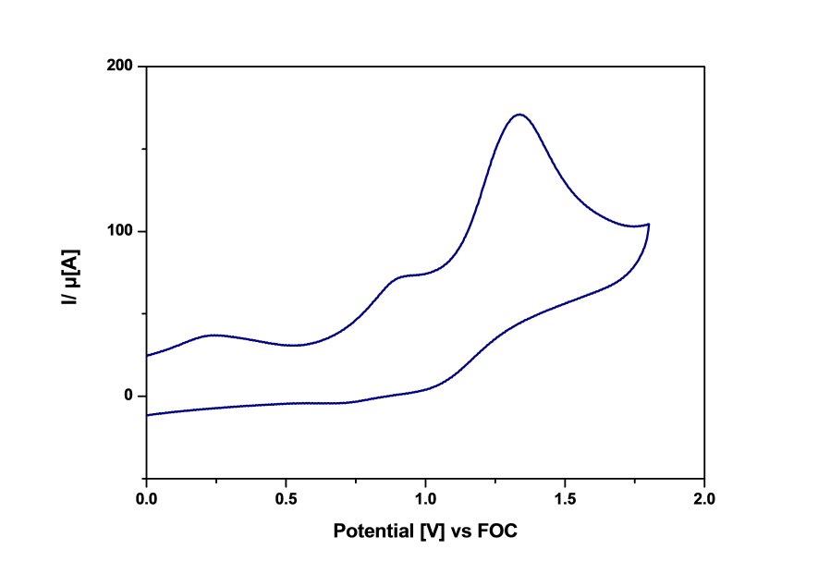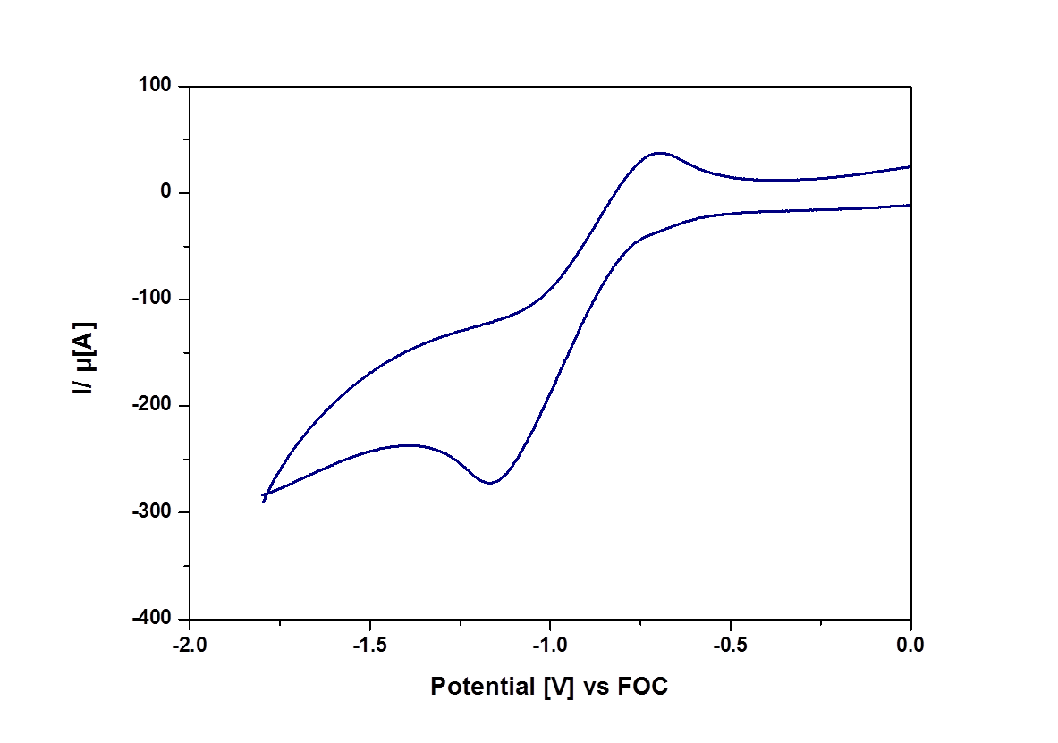

**Figure S6**: The above figures are the reduction (-2 V to 0V) and oxidation (0V to +2V) of the electropolymerized polymer thin film **poly-(BO DPPT)** deposited on glassy-carbon electrodes in 0.1 M TBAPF6/DCM. The scan rate employed in all cases was 0.1 Vs-1.

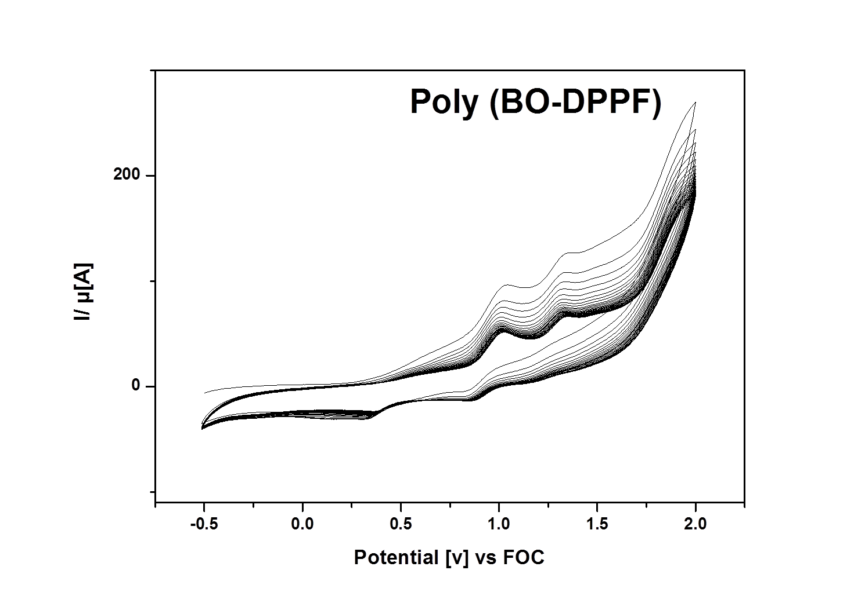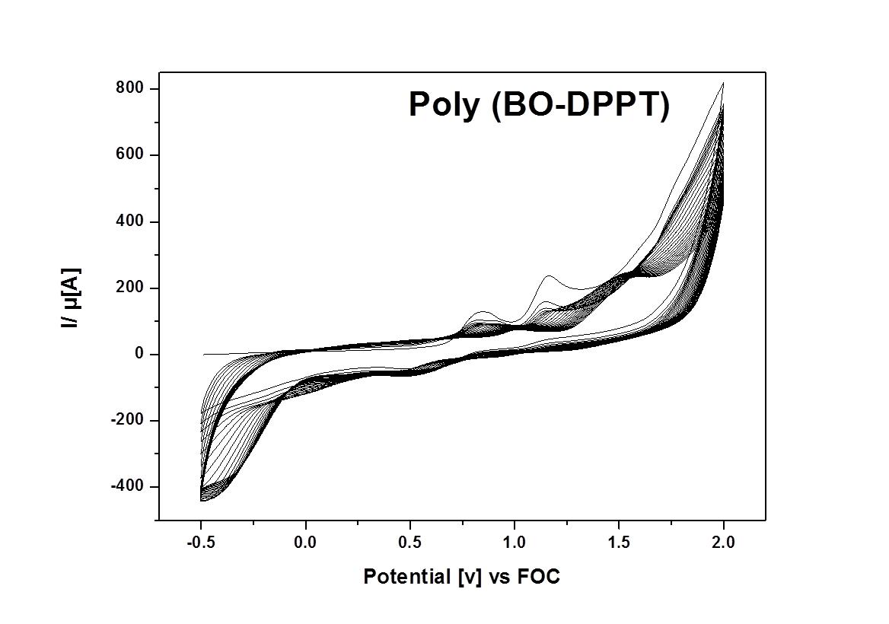

**Figure S7**: Repetitive cyclic voltammograms for the electropolymerization of monomers **BO-DPPF** and **BO-DPPT** on a glassy carbon electrode in dichlromethane containing 0.1 M TBAPF6 as supporting electrolyte. The monomer concentration used was 0.1 mg/mL. The potential window is from -0.5 to +2V. The scan rate employed in all cases was 0.1 Vs-1.

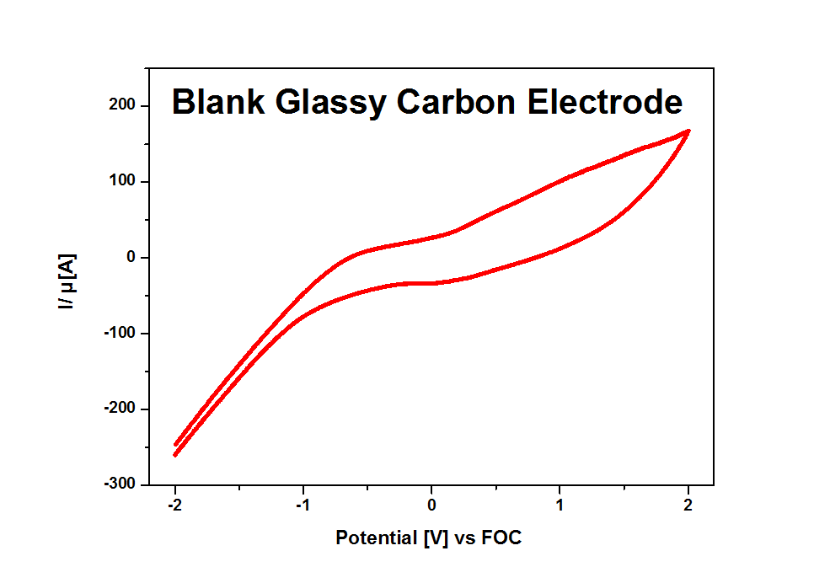

**Figure S8**: Continuous cyclic voltammograms of blank glassy carbon electrode in dichloromethane containing 0.1 M TBAPF6 as supporting electrolyte.

**Procedure of Monomer Synthesis:**

Synthesis of 3,6-di(furan-2-yl)pyrrolo[3,4-c]pyrrole-1,4(2H,5H)- dione (DPPF Core) : To a three-necked flask containing 2-methyl-1-butanol (60 mL) was added sodium (3.45 g, 0.15 mol) under argon. The mixture was heated to 90**°**C and iron (III) chloride (FeCl3) (50 mg) was added. After sodium disappeared, the solution was cooled to 85 **°**C. 2-Furonitrile (9.31 g, 0.10 mol) was added to the reaction mixture, followed by drop-wise addition of diisopropyl succinate (8.1 g, 0.04 mol) in 2-methyl-1-butanol (5 mL) over 1 h at 85 **°**C. When the addition was completed, the mixture was stirred for additional 2 h at this temperature. The reaction mixture was then cooled to 50**°**C, diluted with methanol (50 mL), and then slowly neutralized with glacial acetic acid (15 mL) and refluxed for 15 min. The reaction mixture was cooled down to room temperature and filtered. The solid was washed respectively with hot methanol and de-ionized (DI) water several times, and dried in vacuo at 50**°**C for 15 h. A dark red solid was obtained. Yield: 6.54 g (61.0%).

Synthesis of 2, 5-bis(2-butyloctyl)-3,6-di(furan-2-yl)pyrrolo[3,4-c]pyrrole-1,4(2H,5H)-dione (BO-DPPF): To a dry 250 mL three-neck round bottom flask were added DPPF core (3.0 g. 11.18 mmol), anhydrous K2CO3 (4.63 g, 33.54 mmol), and anhydrous N,N-dimethylformamide (DMF) (250 mL). The mixture was heated to 120 **°**C under argon for 1 h. 2-butyloctylbromide (9.83 g, 33.54 mmol) was then added drop-wise, and the reaction mixture was further stirred overnight at 130 **°**C. The reaction mixture was allowed to cool down to room temperature and poured into DI water (500 mL) and stirred for 30 min. The product was extracted with chloroform, washed with DI water, and dried over anhydrous MgSO4. Removal of the solvent afforded the crude product which was further purified using column chromatography on silica gel (a mixture of hexane and chloroform as eluent) to give the product as a red solid with 50% yield.

1H NMR (400 MHz, CDCl3, δ): d 0.81-0.86 (t, 12H), 1.21–1.29 (m, 32H), 1.89 (s, 2H), 4.01-4.03 (m, 4H), 6.67-6.68 ( d, 2H), 7.59 (s, 2H), 8.31-8.32 (d, 2H).

13C NMR (100 MHz, CDCl3, δ): d 161.21, 144.81, 133.89, 120.16, 113.45, 106.40, 46.46, 38.45, 31.81, 31.11, 29.66, 28.68, 26.44, 23.04, 22.63, 14.09, 14.01.

Synthesis of 3,6-di(thiophene-2-yl)pyrrolo[3,4-c]pyrrole-1,4(2H,5H)- dione (DPPT Core) :

Fine pieces of sodium metal (3.45 g, 0.15 mol) were added to 50 mL tert-amyl alcohol and a small amount of iron (III) chloride (50 mg) was added. The mixture was stirred vigorously for 2hr at 105°C until sodium disappeared. The solution was cooled at 85°C. 2-thiophenecarbonitrile (11.0 g, 0.1 mol) was added to the resultant solution. Then diisopropyl succinate (8.3 g, 0.04 mol) was dissolved in 5 mL of tert-amyl alcohol and added drop wise over 1 hr at 85°C. The reaction mixture was stirred at this temperature for 12 hr, and then cooled to 50°C, diluted with 100 mL of methanol, and then slowly neutralized with 30 ml of glacial acetic acid and refluxed briefly. After filtration, the solid was washed several times with hot methanol and water, and then dried in vacuum oven at 50°C. A dark red powder was obtained which was used further without purification (10 g, 83%).

Synthesis of 2, 5-Bis(2-Butyloctyl)-3,6-di(thieno[3,2-b]thiophen-2-yl)pyrrolo[3,4-c]pyrrole- 1,4(2H,5H)-dione 3 (BO-DPPT): To a dry 250 mL three-neck round bottom flask were added DPPT core (3.0 g. 11.18 mmol), anhydrous K2CO3 (4.63 g, 33.54 mmol), and anhydrous N,N-dimethylformamide (DMF) (250 mL). The mixture was heated to 120 C under argon for 1 h. 2-butyloctylbromide (9.83 g, 33.54 mmol) was then added drop-wise, and the reaction mixture was further stirred overnight at 130 C. The reaction mixture was allowed to cool down to room temperature and poured into DI water (500 mL) and stirred for 30 min. The product was extracted with chloroform, washed with DI water, and dried over anhydrous MgSO4. Removal of the solvent afforded the crude product, which was further purified using column chromatography on silica gel (a mixture of hexane and chloroform as eluent) to give the product as a red solid with 48% yield.

1H NMR (400 MHz, CDCl3, δ): d 0.81-0.85 (t, 12H), 1.18–1.29 (m, 32H), 1.89 (s, 2H), 4.00-4.01 (m, 4H), 7.24-7.26 (dd, 2H), 7.61-7.62 (s, 2H), 8.85-8.86 (d, 2H).

13C NMR (100 MHz, CDCl3, δ): d 161.73, 140.40, 135.17, 130.47, 129.79, 128.36, 107.90, 46.15, 37.68, 31.74, 31.11, 29.65, 28.37, 26.14, 23.04, 22.62, 14.07, 14.02.