Supporting Information
Aerosol Synthesis of Phase Pure Iodine/Iodic Biocide Microparticles Tao Wu, Andrew SyBing, Xizheng Wang and Michael R. Zachariah⁾

Department of Chemistry and Biochemistry and Department of Chemical and Biomolecular Engineering, University of Maryland, College Park, MD 20742, USA

FIG. S1. The SEM images and XRD pattern of as-received HIO₃

FIG. S2. TGA and DSC curves of HIO₃ under argon environment at a heating rate of 5 ºC/min.

002
210
21-1
11-1
11-1
21-1
210
011
-121
103
200
103
-121
200
110
200
FIG. S3. The XRD patterns of HIO₃ at different temperatures

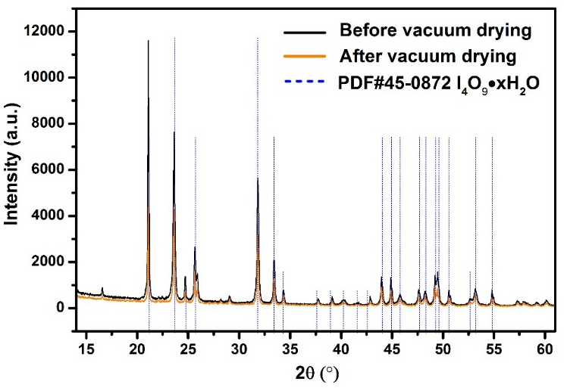
A B
212
012
102
110
C
FIG. S4. TGA/DSC (A) and XRD (B) of as-prepared I₄O₉• xH₂O before vacuum drying treatment and XRD (C) of as-prepared I₄O₉• xH₂O and as-received HIO₃.
-121
103
200
012
002
110
A B
-121
103
200
-121
103
200
C D
103
-121
200
200
103
-121
E F
FIG. S5. XRD patterns of the product by annealing of HIO₃ at 139 (A), 150 (B), 180 (C) and 260 °C (D) for one hour, respectively. XRD patterns of the product by annealing of HIO₃ at 150 (E) and 180 (F) for two minutes, respectively.

Table SI. Listed hkl values for each phase in each XRD pattern.
PDF#22-0338 I₂O₅ |  | PDF#21-1126 HI₃O₈
2θ (º) | hkl values | 2θ (º) | hkl values
21.29 | -111 | 22.72 | 112
1.87 | -102 | 23.14 | 020
22.9 | 002 | 23.58 | 200
24.4 | 210 | 26.27 | 103
24.71 | -211 | 27.16 | -121
26.67 | 102 | 28.03 | 022
28.13 | -112 | 35.26 | 123
28.77 | -302 | 36.88 | -222
28.96 | 012 | 43.71 | 321
29.06 | 211
29.94 | -212
33.86 | -312
33.99 | 400
35.02 | -402
37.04 | 212
37.3 | 021
38.5 | 410

Address all correspondence to this author. e-mail: mrz@umd.edu

