Creep Properties of a Powder Metallurgy Disk Superalloy at 700℃
Kaixin Dong¹, Chao Yuan¹*⁾, Shuang Gao¹, Chonglin Jia², Jianting Guo¹ and Changchun Ge²
1. Institute of Metal Research, Chinese Academy of Sciences, Shenyang 110016, China
2. School of Materials Science and Engineering, University of Science and Technology Beijing, Beijing 100083, China

Notes
SI 1. Statistics of Grain Size
Table SⅠ. Statistics of grain size (μm)
N total | Mean | Standard Deviation | Sum | Minimum | Median | Maximum
146 | 57.86 | 35.68 | 8447.24 | 4.45 | 51.15 | 169.56
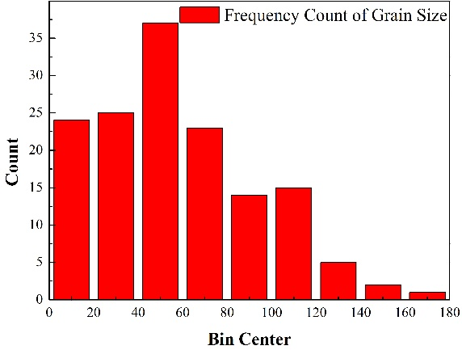
Figure S1. Frequency count of grain size (μm)

SI 2. Statistics of Primary γ' Precipitates
Table SⅡ. Statistics of primary γ' precipitates (μm)
N total | Mean | Standard Deviation | Sum | Minimum | Median | Maximum
307.00 | 0.93 | 0.43 | 284.81 | 0.29 | 0.86 | 3.92
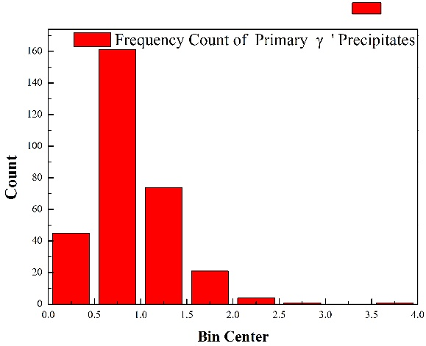
Figure S2. Frequency count of primary γ' precipitates (μm)

SI 3. Statistics of Secondary γ' Precipitates
Table SⅢ. Statistics of secondary γ' precipitates (μm)
N total | Mean | Standard Deviation | Sum | Minimum | Median | Maximum
125.00 | 0.20 | 0.04 | 24.98 | 0.12 | 0.20 | 0.30
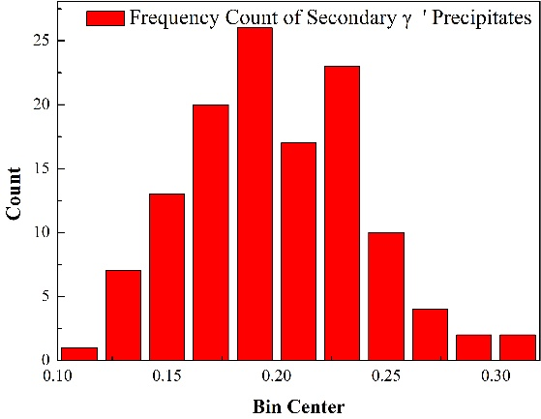
Figure S3. Frequency count of secondary γ' precipitates (μm)

SI 4. Statistics of Tertiary γ' Precipitates
Table SⅣ. Statistics of tertiary γ' precipitates (nm)
N total | Mean | Standard Deviation | Sum | Minimum | Median | Maximum
74.00 | 34.92 | 8.90 | 2584.37 | 23.10 | 30.75 | 67.49
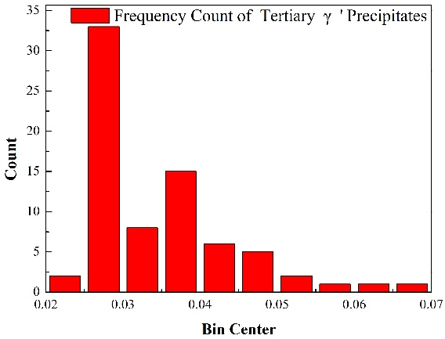
Figure S4. Frequency count tertiary γ' precipitates (nm)

* Address all correspondence to this author. ychao@imr.ac.cn

