**An experimental and theoretical study of the optical, electronic and magnetic properties of novel inverted α**-**Cr2O3@α**-**Mn0.35Cr1.65O2.94 core shell nanoparticles**

M. D. Hossaina, R. A. Mayanovica*, R. Sakidjaa, M. Benamarab

aDepartment of Physics, Astronomy & Materials Science, Missouri State University, Springfield, MO 65897.

bUniversity of Arkansas Nano-Bio Materials Characterization Facility, University of Arkansas, Fayeteville, AR 72701, USA.

*robertmayanovic@missouristate.edu.

**CHARACTERIZATION AND COMPUTATIONAL DETAILS**

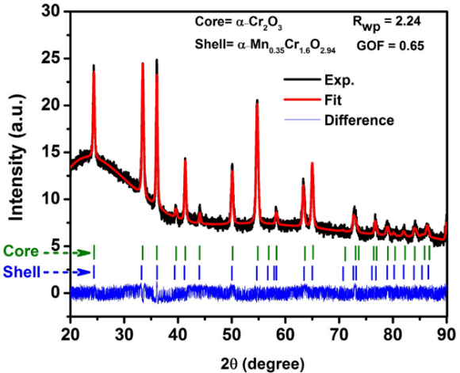

FIG. S1. XRD data of α**-Cr2O3@**α**-Mn0.35Cr1.65O2.94 core shell nanoparticles.**

Table S1. Summary of structural results obtained from Rietveld refinement for α-Cr2O3@α-Mn0.35Cr1.65O2.94 inverted CSNs.

|  |  |  |  |  |  |  |
| --- | --- | --- | --- | --- | --- | --- |
| Core: α-Cr2O3 NPs (SG #167: ); a = b = 4.95831(84) Å; c = 13.5815(22) Å ; V = 289.16(11) Å3; | | | | | | |
| Atoms | x | y | z | Site occupancy | | B (Å2) |
| Cr | 0 | 0 | 0.34558(18) | 1.0 | | 0.4 |
| O | 0.31940 | 0 | 1/4 | 1.0 | | 0.4 |
| Shell: α**-Mn0.35Cr1.65O2.94** (SG #167: ); a = b = 4.9622(18) Å; c = 13.6549(47) Å ; V = 291.18(23) Å3; core-shell size = 33(14) nm | | | | | | |
| Mn | 0 | 0 | 0.35180 | | 0.175 | 0.6 |
| Cr | 0 | 0 | 0.34839(77) | | 0.825 | 0.6 |
| O | 0.31940 | 0 | 1/4 | | 0.98 | 0.6 |

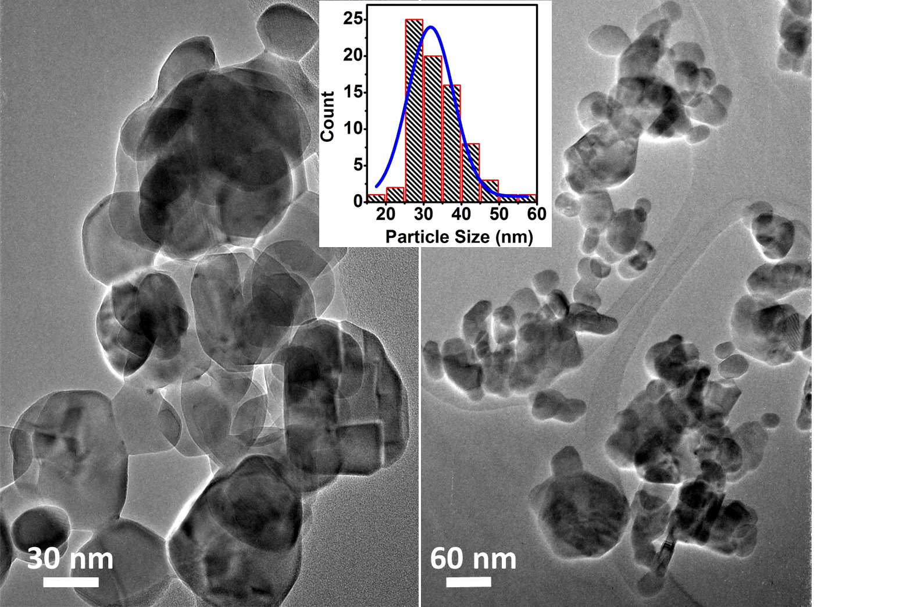

FIG. S2. TEM image and particle size distribution analysis of α**-Cr2O3@**α**-Mn0.35Cr1.65O2.94 core shell nanoparticles**

Fig. S2 shows a TEM image of our α**-Cr2O3@**α**-Mn0.35Cr1.65O2.94** CSNs used for particle size distribution analysis. The inset shows the histogram plot of particle size distribution with a Gaussian fit of the data. The particle size from the fit determined to be 32 nm. Most of the particles are in quasi spherical shape. In some cases, a distinct nanocrystalline morphology is observed for the CSNs, as shown in Fig. S3.

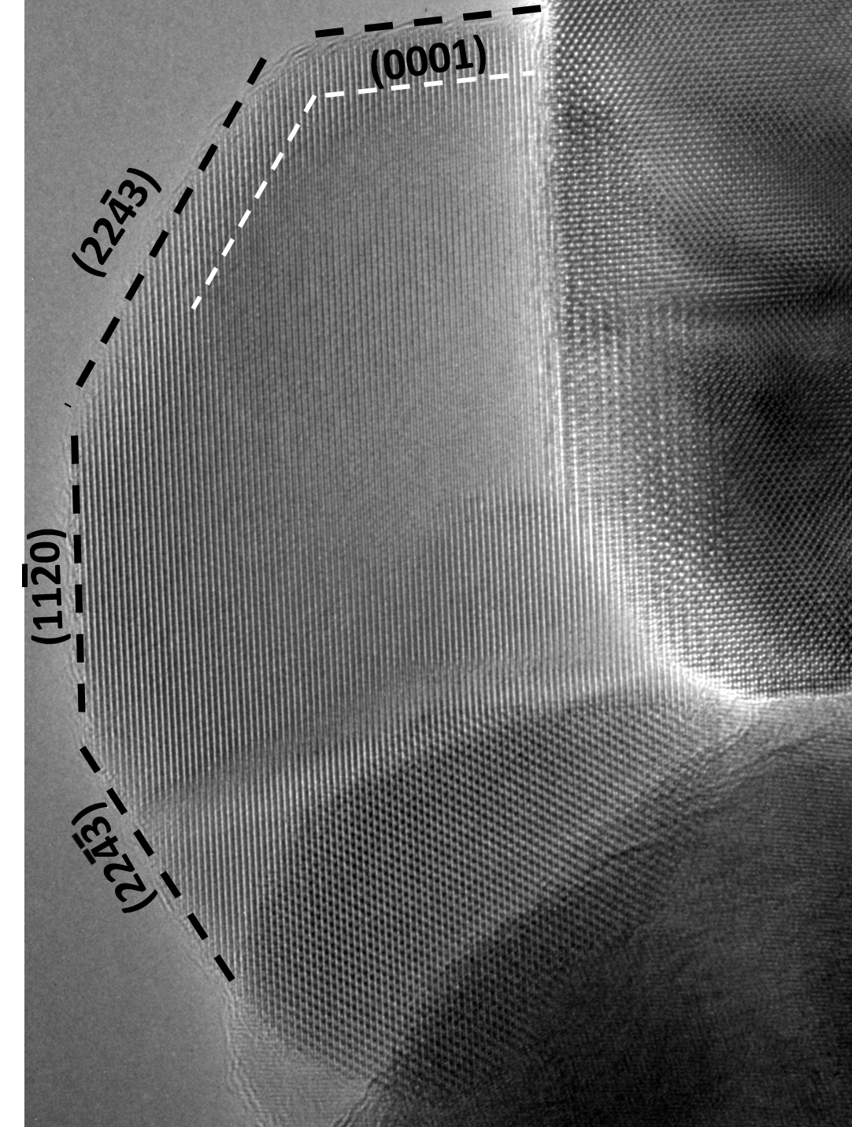

FIG. S3. An HRTEM image of a select α**-Cr2O3@**α**-Mn0.35Cr1.65O2.94 core shell nanoparticles. The faceting of one of the CSNs is indicated in the in the figure.**

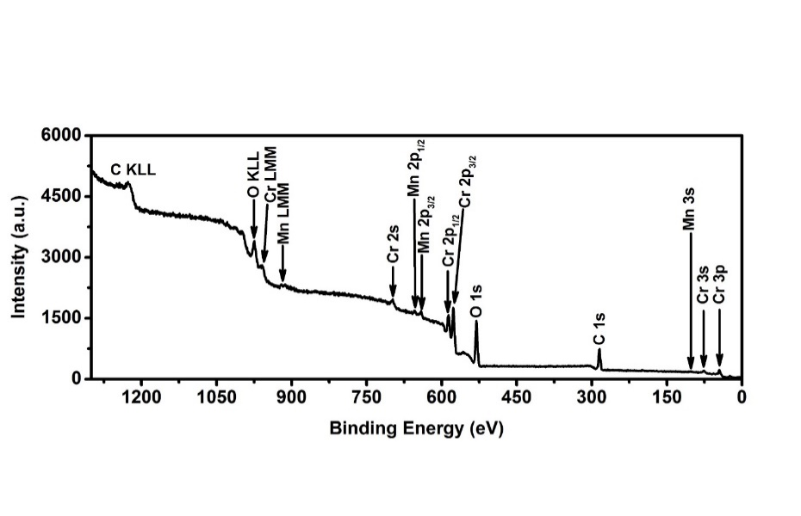

FIG. S4. XPS analysis data of the α**-Cr2O3@**α**-Mn0.35Cr1.65O2.94 core shell nanoparticles**

Table SII. XPS survey scan analysis of α**-Cr2O3@**α**-Mn0.35Cr1.65O2.94 core shell nanoparticles**

|  |  |  |  |  |
| --- | --- | --- | --- | --- |
|  | | | | |
| Name | Position | FWHM | Area | Atomic% |
| Cr2p3/2 | 575.54 | 5.069 | 3892.47 | 27.04 |
| O1s | 530.04 | 3.578 | 3852.74 | 70.23 |
| Mn2p3/2 | 468.84 | 4.288 | 468.84 | 2.73 |

**Table SIII: High resolution XPS fit data**

|  |  |  |  |  |  |  |
| --- | --- | --- | --- | --- | --- | --- |
| Cr2p3/2 | | Position | FWHM | Line Shape | Area | %Area |
| Cr-O | Peak-1 | 573.04 | 2.68 | GL(30) | 483.90 | 11.53 |
| Peak-2 | 574.14 | 2.68 | GL(30) | 392.6 | 9.36 |
| Peak-3 | 575.24 | 2.68 | GL(30) | 785.3 | 18.72 |
| Peak-4 | 576.34 | 2.68 | GL(30) | 1787.7 | 42.61 |
| Cr-OH | | 577.54 | 2.68 | GL(30) | 745.6 | 17.77 |
| O1s | |  |  |  |  |  |
| Mn-O | | 529.07 | 2.93 | GL(30) | 377.38 | 10.29 |
| Cr-O | | 530.17 | 2.93 | GL(30) | 2695.58 | 73.53 |
| Cr-OH | | 531.87 | 3.22 | GL(30) | 593.03 | 16.18 |
| Mn2p3/2 | |  |  |  |  |  |
| Mn-O | | 640.87 | 4.87 | GL(30) | 572.01 | 100 |

**We have carried out Bader charge analysis of** α-Cr2O3 and Mn substituted α-Mn(III&II)Cr3O6 structures using a grid based algorithm.3 This analysis gives the charge of each individual atom used in the computational cell. Table V shows the Bader charge analysis data of α-Cr2O3 and α-Mn(III&II)Cr3O6 structures. For α-Cr2O3, both the O and Cr have a reduced charge balance compared to the ideal ionic charge balance of +2e and +3e, respectively. This deviation from the exact ionic character is interpreted in terms of covalent bonding character of α-Cr2O3. Also Mn(III) and Mn(II) in α-MnCr3O6is calculated to have a charge balance of +1.99e and +1.66e, respectively. Thus, our Bader charge analysis shows that when Mn3+ is substituted for Cr3+**, Mn has reduced charge (+1.99e) compared to the Cr’s charge (+2.54e) in** α-Cr2O3. In comparison to Mn3+, which has a charge reduction of approximately +1e, Mn2+ only has a charge reduction of +0.34e upon substitution for Cr in the chromia structure. This indicates that α-Mn(III)Cr3O6 has a greater degree of Mn-O covalent bonding characteristics than α-Mn(II)Cr3O6.

**Table SIV.** Bader charge analysis of primitive α-Cr2O3, α-Mn(III)Cr3O6 and α-Mn(II)Cr3O6 structure.

|  |  |  |  |
| --- | --- | --- | --- |
| Atom | Charge (α-Cr2O3 structure) *e | Charge (α-Mn (III)Cr3O6 structure) *e | Charge (α-Mn (II)Cr3O6 structure) *e |
| O1 | -1.68 | -1.63 | -1.72 |
| O2 | -1.68 | -1.56 | -1.67 |
| O3 | -1.69 | -1.57 | -1.65 |
| O4 | -1.69 | -1.64 | -1.65 |
| O5 | -1.71 | -1.63 | -1.74 |
| O6 | -1.71 | -1.59 | -1.69 |
| Cr1 | 2.54 | 2.49 | 2.52 |
| Cr2 | 2.54 | 2.66 | 2.51 |
| Cr3/Ni | 2.54 | 1.99 | 1.66 |
| Cr4 | 2.54 | 2.47 | 2.42 |

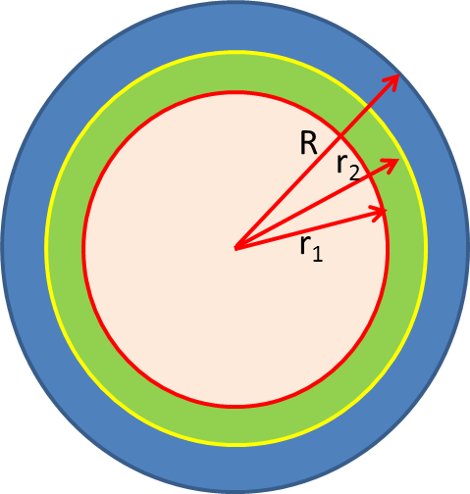

**Stoichiometric formula calculation**

Core-shell NP model

Assumed NP dimensions:

R = 16 nm (D = 32 nm)

r2 = 12 nm (4 nm shell)

r1 = 6 nm (10 nm sampling depth)

Let

z = (vol. of shell)/(sampling vol.)

= (R3-r23)/(R3-r13)

= 0.61 using dimensions above

XPS at% values:

Mn:Cr:(O+OH) 🡪 2.78:24:73.22

and discarding the contribution from OH-, for stoichometric chromate phase only, we have, Mn:Cr:O 🡪 2.78:24:39.44. (Considered Mn in bonding with O; +2 oxidation state of Mn)

Now, renormalizing, we have,

Mn:Cr:O 🡪4.24:36.60:59.15

Calculation for x in shell:

Using, concentration in sampling vol. = (1-z)•[Cr2O3] + z•[MnxCr(2-x)Op]

We can write,

0.0424Mn + 0.366Cr + 0.5915O = 0.39•[0.4Cr + 0.6O] + 0.61•[yMn + (0.4-y)Cr + 0.6O]

0.0424Mn + 0.366Cr + 0.5915O = 0.156Cr + 0.234O + 0.61yMn + 0.244Cr - 0.61y Cr + 0.366O

0.0424Mn + 0.3633Cr + 0.5915O ≈ 0.4Cr + 0.6O + 0.61y(Mn – Cr)

0.0424Mn - 0.0367Cr+0.5915O = 0.61y(Mn – Cr)+0.6O; or,

0.0424 = 0.61y so that y = 0.06951, thus x = 5*0.06951 ≈ 0.35 (note, lowering y is in keeping with the approximations used above).

**Formula = Mn0.35Cr1.65O2.94**

For the correct cation:anion ratio in the shell portion, we use,

0.5915O = (1-z)•0.6O + z•(0.6-q)O = (0.6-z•q)O which yields, z = 0.71

z•qO = 0.0085*O and q = 0.01197

References:

1. TOPAS V4: General profile and structure analysis software for powder diffraction data.- User’s Manual, Bruker AXS, Karlsruhe, Germany, 2008. (n.d.).

2. R. Dinnebier and M. Müller: in *Mod. Diffr. Methods*, edited by E. J. Mittemeijer and U. Welzel (Wiley-VCH Verlag GmbH & Co. KGaA, 2012), pp. 27–60.

3. W. Tang, E. Sanville, and G. Henkelman: A grid-based Bader analysis algorithm without lattice bias. *J. Phys. Condens. Matter* **21**(8), 84204 (2009).