Supporting Information

Effect of pressure on crystal structure and charge transport properties of 2,6-diphenylanthracene
Kadali Chaitanya and Xue-Hai Ju
Key Laboratory of Soft Chemistry and Functional Materials of MOE, School of Chemical Engineering, Nanjing University of Science and Technology, Nanjing 210094, P. R. China.

Table S1: The Lattice Constants, volume and density obtained at different electric field with GGA/ PBE for 2,6-DPA at Ambient Pressure
Electric field (V/nm) | a (Å) | b (Å) | c (Å) | α (˚) | β (˚) | γ (˚) | Volume (Å³ ) | Density (g – cm³) | E_{g} (eV)
0 | 18.109 | 7.526 | 6.269 | 90 | 90.627 | 90 | 854.52 | 1.284 | 1.651
0.514 | 18.121 | 7.547 | 6.287 | 90 | 90.301 | 90 | 859.937 | 1.276 | 1.658
1.54 | 18.116 | 7.530 | 6.261 | 90 | 90.589 | 90 | 854.227 | 1.284 | 1.653
2.57 | 18.12 | 7.545 | 6.281 | 90 | 90.410 | 90 | 858.88 | 1.277 | 1.657
3.60 | 18.121 | 7.542 | 6.273 | 90 | 90.524 | 90 | 857.384 | 1.279 | 1.656
4.63 | 18.107 | 7.546 | 6.263 | 90 | 90.632 | 90 | 855.719 | 1.282 | 1.659
8.017 | 18.123 | 7.549 | 6.284 | 90 | 90.332 | 90 | 859.911 | 1.276 | 1.651

Table S2: Comparison of the molecular geometry obtained with LDA/CA-PZ, GGA/PBE, GGA/PW91, and the experimental data for 2, 6 - DPA at ambient pressure
 |  |  | Bond lengths |  |  |  |  |  |  | Bond angles
Number | Atom1 | Atom2 | Exp | GGA | LDA | PW91 |  | Number | Atom1 | Atom2 | Atom3 | Exp | GGA | LDA | PW91
1 | C1 | H1 | 0.9498 | 1.0896 | 1.0927 | 1.0874 |  | 1 | H1 | C1 | C2 | 119.41 | 118.66 | 118.69 | 118.54
2 | C1 | C2 | 1.3901 | 1.3934 | 1.3711 | 1.3826 |  | 2 | H1 | C1 | C6 | 119.5 | 120.67 | 120.92 | 120.89
3 | C1 | C6 | 1.4014 | 1.4079 | 1.3888 | 1.4013 |  | 3 | C2 | C1 | C6 | 121.09 | 120.66 | 120.39 | 120.54
4 | C2 | H2 | 0.95 | 1.0896 | 1.0909 | 1.0834 |  | 4 | C1 | C2 | H2 | 119.84 | 119.24 | 119.75 | 119.26
5 | C2 | C3 | 1.3835 | 1.3952 | 1.3742 | 1.3854 |  | 5 | C1 | C2 | C3 | 120.34 | 120.64 | 120.75 | 120.94
6 | C3 | H3 | 0.9499 | 1.0914 | 1.0938 | 1.0861 |  | 6 | H2 | C2 | C3 | 119.82 | 120.11 | 119.49 | 119.77
7 | C3 | C4 | 1.3868 | 1.3964 | 1.3763 | 1.3901 |  | 7 | C2 | C3 | H3 | 120.23 | 120.26 | 119.23 | 118.75
8 | C4 | H4 | 0.95 | 1.0905 | 1.097 | 1.0898 |  | 8 | C2 | C3 | C4 | 119.49 | 119.44 | 119.69 | 119.56
9 | C4 | C5 | 1.3894 | 1.3921 | 1.3781 | 1.3925 |  | 9 | H3 | C3 | C4 | 120.27 | 120.3 | 121.08 | 121.68
10 | C5 | H5 | 0.9498 | 1.0896 | 1.0916 | 1.0866 |  | 10 | C3 | C4 | H4 | 119.91 | 120.74 | 120.22 | 120.61
11 | C5 | C6 | 1.3989 | 1.4067 | 1.3881 | 1.3996 |  | 11 | C3 | C4 | C5 | 120.27 | 119.91 | 119.56 | 119.45
12 | C6 | C7 | 1.4886 | 1.48 | 1.4506 | 1.4723 |  | 12 | H4 | C4 | C5 | 119.81 | 119.36 | 120.2 | 119.93
13 | C7 | C8 | 1.4346 | 1.4295 | 1.4108 | 1.4282 |  | 13 | C4 | C5 | H5 | 119.44 | 118.69 | 119.32 | 118.74
14 | C7 | C12 | 1.376 | 1.384 | 1.3687 | 1.379 |  | 14 | C4 | C5 | C6 | 121.17 | 121.46 | 121.24 | 121.52
15 | C8 | H8 | 0.9493 | 1.0892 | 1.0942 | 1.0869 |  | 15 | H5 | C5 | C6 | 119.39 | 119.73 | 119.44 | 119.74
16 | C8 | C9 | 1.3594 | 1.3652 | 1.3542 | 1.3626 |  | 16 | C1 | C6 | C5 | 117.63 | 117.84 | 118.11 | 117.88
17 | C9 | H9 | 0.9498 | 1.0919 | 1.0936 | 1.0876 |  | 17 | C1 | C6 | C7 | 120.78 | 120.83 | 120.65 | 120.22
18 | C9 | C10 | 1.4297 | 1.4234 | 1.403 | 1.417 |  | 18 | C5 | C6 | C7 | 121.59 | 121.3 | 121.21 | 121.83
19 | C10 | C11 | 1.4376 | 1.4438 | 1.4238 | 1.439 |  | 19 | C6 | C7 | C8 | 120.24 | 119.92 | 120 | 120.61
20 | C10 | C13 | 1.3947 | 1.3971 | 1.3802 | 1.3921 |  | 20 | C6 | C7 | C12 | 121.67 | 121.71 | 121.43 | 121.41
21 | C11 | C12 | 1.4267 | 1.4207 | 1.4004 | 1.4133 |  | 21 | C8 | C7 | C12 | 118.06 | 118.35 | 118.52 | 117.91
22 | C11 | C13 | 1.3998 | 1.4032 | 1.386 | 1.3954 |  | 22 | C7 | C8 | H8 | 119.12 | 119.64 | 119.86 | 120.24
23 | C12 | H12 | 0.95 | 1.0921 | 1.0968 | 1.0887 |  | 23 | C7 | C8 | C9 | 121.79 | 121.29 | 121.42 | 121.42
24 | C13 | H13 | 0.9502 | 1.0917 | 1.0955 | 1.0894 |  | 24 | H8 | C8 | C9 | 119.09 | 119.06 | 118.71 | 118.33
25 | C13 | C11 | 1.3998 | 1.4032 | 1.386 | 1.3954 |  | 25 | C8 | C9 | H9 | 119.44 | 119.88 | 120.17 | 119.73
26 | C1 | H1 | 0.9498 | 1.0896 | 1.0927 | 1.0874 |  | 26 | C8 | C9 | C10 | 121.05 | 121.34 | 120.88 | 121.34
27 | C1 | C2 | 1.3901 | 1.3934 | 1.3711 | 1.3826 |  | 27 | H9 | C9 | C10 | 119.51 | 118.77 | 118.93 | 118.93
28 | C1 | C6 | 1.4014 | 1.4079 | 1.3888 | 1.4013 |  | 28 | C9 | C10 | C11 | 118.03 | 118.23 | 118.2 | 117.93
29 | C2 | H2 | 0.95 | 1.0896 | 1.0909 | 1.0834 |  | 29 | C9 | C10 | C13 | 122.39 | 121.02 | 122.04 | 122.46
30 | C2 | C3 | 1.3835 | 1.3952 | 1.3742 | 1.3854 |  | 30 | C11 | C10 | C13 | 119.59 | 120.75 | 119.76 | 119.6
31 | C3 | H3 | 0.9499 | 1.0914 | 1.0938 | 1.0861 |  | 31 | C10 | C11 | C12 | 118.9 | 118.62 | 119.29 | 118.89
32 | C3 | C4 | 1.3868 | 1.3964 | 1.3763 | 1.3901 |  | 32 | C10 | C11 | C13 | 118.88 | 118.49 | 119.1 | 119.31
33 | C4 | H4 | 0.95 | 1.0905 | 1.097 | 1.0898 |  | 33 | C12 | C11 | C13 | 122.17 | 122.9 | 121.55 | 121.74
34 | C4 | C5 | 1.3894 | 1.3921 | 1.3781 | 1.3925 |  | 34 | C7 | C12 | C11 | 122.03 | 122.06 | 121.28 | 122.16
35 | C5 | H5 | 0.9498 | 1.0896 | 1.0916 | 1.0866 |  | 35 | C7 | C12 | H12 | 119.03 | 120.14 | 121.49 | 120.62
36 | C5 | C6 | 1.3989 | 1.4067 | 1.3881 | 1.3996 |  | 36 | C11 | C12 | H12 | 118.95 | 117.67 | 117 | 117.04
37 | C6 | C7 | 1.4886 | 1.48 | 1.4506 | 1.4723 |  | 37 | C10 | C13 | H13 | 119.19 | 119.36 | 118.99 | 119.2
38 | C7 | C8 | 1.4346 | 1.4295 | 1.4108 | 1.4282 |  | 38 | C10 | C13 | C11 | 121.54 | 120.77 | 121.14 | 121.08
39 | C7 | C12 | 1.376 | 1.384 | 1.3687 | 1.379 |  | 39 | H13 | C13 | C11 | 119.27 | 119.87 | 119.86 | 119.7
40 | C8 | H8 | 0.9493 | 1.0892 | 1.0942 | 1.0869 |  | 40 | H1 | C1 | C2 | 119.41 | 118.66 | 118.69 | 118.54
41 | C8 | C9 | 1.3594 | 1.3652 | 1.3542 | 1.3626 |  | 41 | H1 | C1 | C6 | 119.5 | 120.67 | 120.92 | 120.89
42 | C9 | H9 | 0.9498 | 1.0919 | 1.0936 | 1.0876 |  | 42 | C2 | C1 | C6 | 121.09 | 120.66 | 120.39 | 120.54
43 | C9 | C10 | 1.4297 | 1.4234 | 1.403 | 1.417 |  | 43 | C1 | C2 | H2 | 119.84 | 119.24 | 119.75 | 119.26
44 | C10 | C11 | 1.4376 | 1.4438 | 1.4238 | 1.439 |  | 44 | C1 | C2 | C3 | 120.34 | 120.64 | 120.75 | 120.94
45 | C10 | C13 | 1.3947 | 1.3971 | 1.3802 | 1.3921 |  | 45 | H2 | C2 | C3 | 119.82 | 120.11 | 119.49 | 119.77
46 | C11 | C12 | 1.4267 | 1.4207 | 1.4004 | 1.4133 |  | 46 | C2 | C3 | H3 | 120.23 | 120.26 | 119.23 | 118.75
47 | C12 | H12 | 0.95 | 1.0921 | 1.0968 | 1.0887 |  | 47 | C2 | C3 | C4 | 119.49 | 119.44 | 119.69 | 119.56
48 | C13 | H13 | 0.9502 | 1.0917 | 1.0955 | 1.0894 |  | 48 | H3 | C3 | C4 | 120.27 | 120.3 | 121.08 | 121.68
 |  |  |  |  |  |  |  | 49 | C3 | C4 | H4 | 119.91 | 120.74 | 120.22 | 120.61
 |  |  |  |  |  |  |  | 50 | C3 | C4 | C5 | 120.27 | 119.91 | 119.56 | 119.45
 |  |  |  |  |  |  |  | 51 | H4 | C4 | C5 | 119.81 | 119.36 | 120.2 | 119.93
 |  |  |  |  |  |  |  | 52 | C4 | C5 | H5 | 119.44 | 118.69 | 119.32 | 118.74
 |  |  |  |  |  |  |  | 53 | C4 | C5 | C6 | 121.17 | 121.46 | 121.24 | 121.52
 |  |  |  |  |  |  |  | 54 | H5 | C5 | C6 | 119.39 | 119.73 | 119.44 | 119.74
 |  |  |  |  |  |  |  | 55 | C1 | C6 | C5 | 117.63 | 117.84 | 118.11 | 117.88
 |  |  |  |  |  |  |  | 56 | C1 | C6 | C7 | 120.78 | 120.83 | 120.65 | 120.22
 |  |  |  |  |  |  |  | 57 | C5 | C6 | C7 | 121.59 | 121.3 | 121.21 | 121.83
 |  |  |  |  |  |  |  | 58 | C6 | C7 | C8 | 120.24 | 119.92 | 120 | 120.61
 |  |  |  |  |  |  |  | 59 | C6 | C7 | C12 | 121.67 | 121.71 | 121.43 | 121.41
 |  |  |  |  |  |  |  | 60 | C8 | C7 | C12 | 118.06 | 118.35 | 118.52 | 117.91
 |  |  |  |  |  |  |  | 61 | C7 | C8 | H8 | 119.12 | 119.64 | 119.86 | 120.24
 |  |  |  |  |  |  |  | 62 | C7 | C8 | C9 | 121.79 | 121.29 | 121.42 | 121.42
 |  |  |  |  |  |  |  | 63 | H8 | C8 | C9 | 119.09 | 119.06 | 118.71 | 118.33
 |  |  |  |  |  |  |  | 64 | C8 | C9 | H9 | 119.44 | 119.88 | 120.17 | 119.73
 |  |  |  |  |  |  |  | 65 | C8 | C9 | C10 | 121.05 | 121.34 | 120.88 | 121.34
 |  |  |  |  |  |  |  | 66 | H9 | C9 | C10 | 119.51 | 118.77 | 118.93 | 118.93
 |  |  |  |  |  |  |  | 67 | C9 | C10 | C11 | 118.03 | 118.23 | 118.2 | 117.93
 |  |  |  |  |  |  |  | 68 | C9 | C10 | C13 | 122.39 | 121.02 | 122.04 | 122.46
 |  |  |  |  |  |  |  | 69 | C11 | C10 | C13 | 119.59 | 120.75 | 119.76 | 119.6
 |  |  |  |  |  |  |  | 70 | C13 | C11 | C10 | 118.88 | 118.49 | 119.1 | 119.31
 |  |  |  |  |  |  |  | 71 | C13 | C11 | C12 | 122.17 | 122.9 | 121.55 | 121.74
 |  |  |  |  |  |  |  | 72 | C10 | C11 | C12 | 118.9 | 118.62 | 119.29 | 118.89
 |  |  |  |  |  |  |  | 73 | C7 | C12 | C11 | 122.03 | 122.06 | 121.28 | 122.16
 |  |  |  |  |  |  |  | 74 | C7 | C12 | H12 | 119.03 | 120.14 | 121.49 | 120.62
 |  |  |  |  |  |  |  | 75 | C11 | C12 | H12 | 118.95 | 117.67 | 117 | 117.04
 |  |  |  |  |  |  |  | 76 | C11 | C13 | C10 | 121.54 | 120.77 | 121.14 | 121.08
 |  |  |  |  |  |  |  | 77 | C11 | C13 | H13 | 119.27 | 119.87 | 119.86 | 119.7
 |  |  |  |  |  |  |  | 78 | C10 | C13 | H13 | 119.19 | 119.36 | 118.99 | 119.2

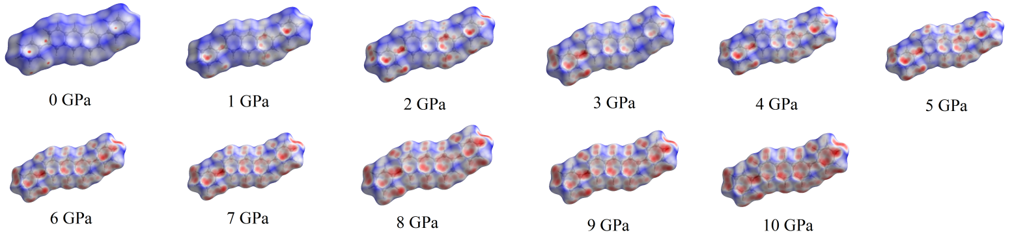

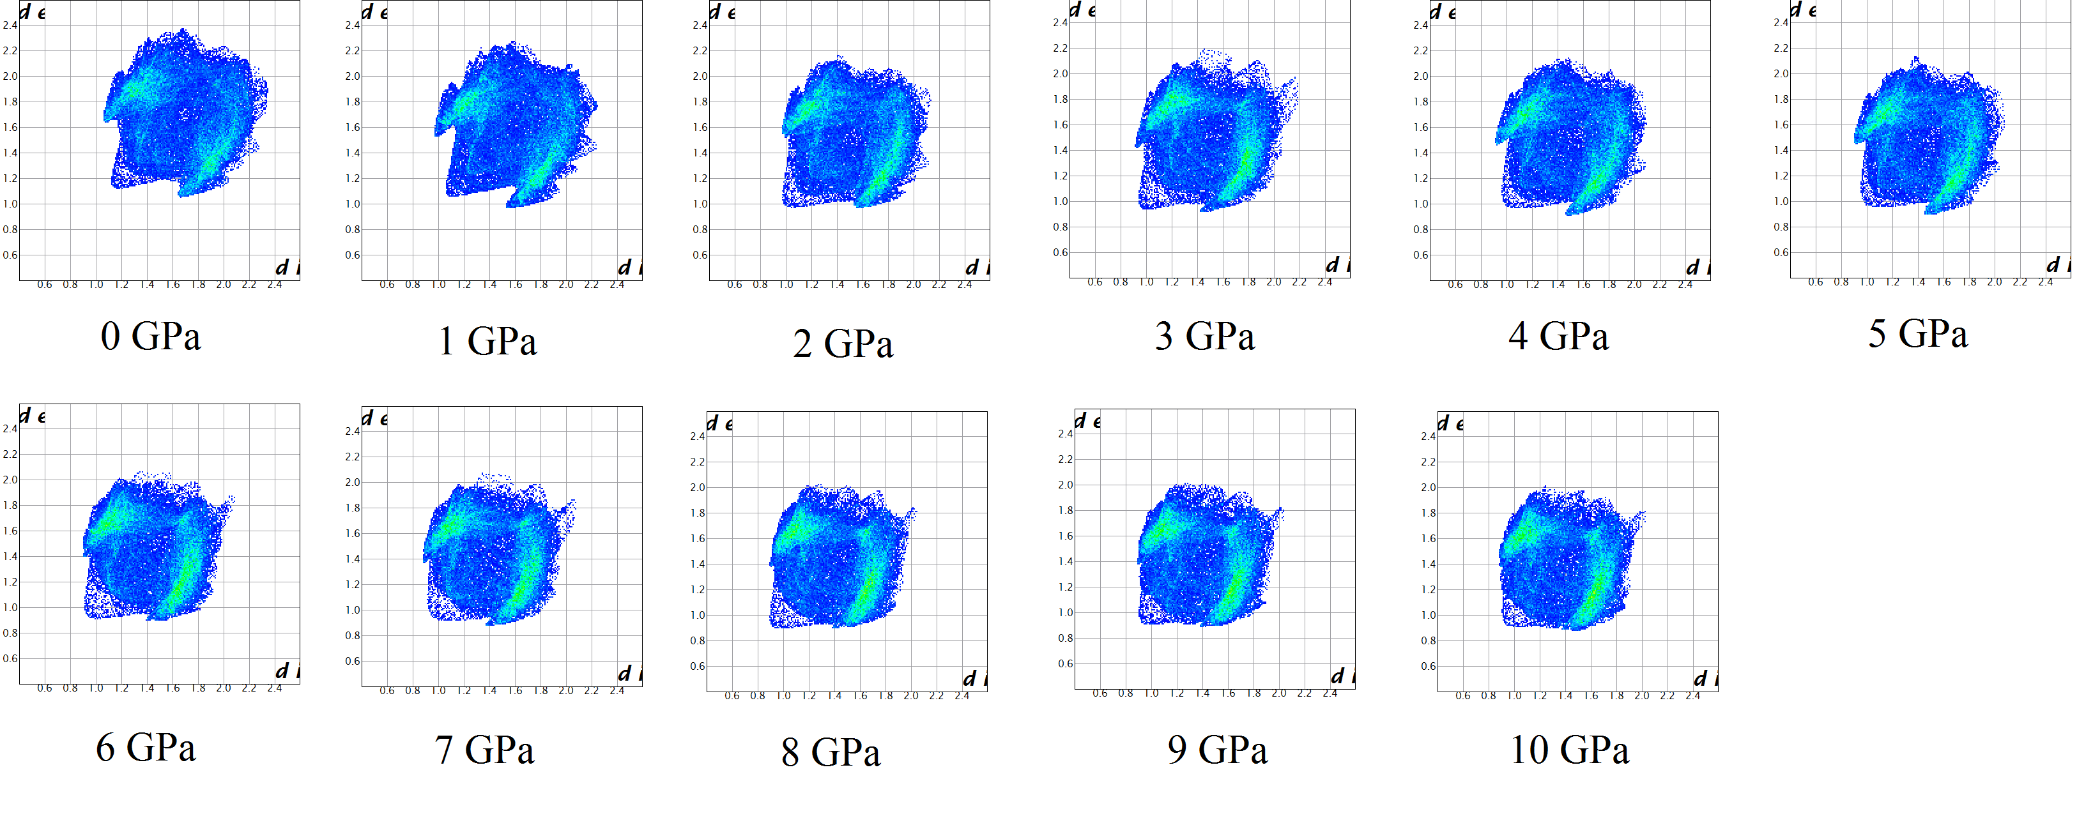

Figure S1: Hirshfeld surfaces and derived fingerprint plots (d_{norm}) of 2, 6 – DPA at 0 – 10 GPa. Fingerprint plots show the distance from the Hirshfeld surface to the nearest nucleus inside of the surface (d_{i}) and from the Hirshfeld to the nucleus outside of the surface (d_{e}). Contraction of the crystal contacts is clearly visible by a general shift of the plot to smaller de/di values. The longer contacts outside the surface (d_{e}) are decreased between the ambient pressure (ca 2.4 Å) and 10 GPa (2.0-2.2 Å). A similar compression is observed for the d_{i} type contacts (from 2.4 Å to 2.0 Å).

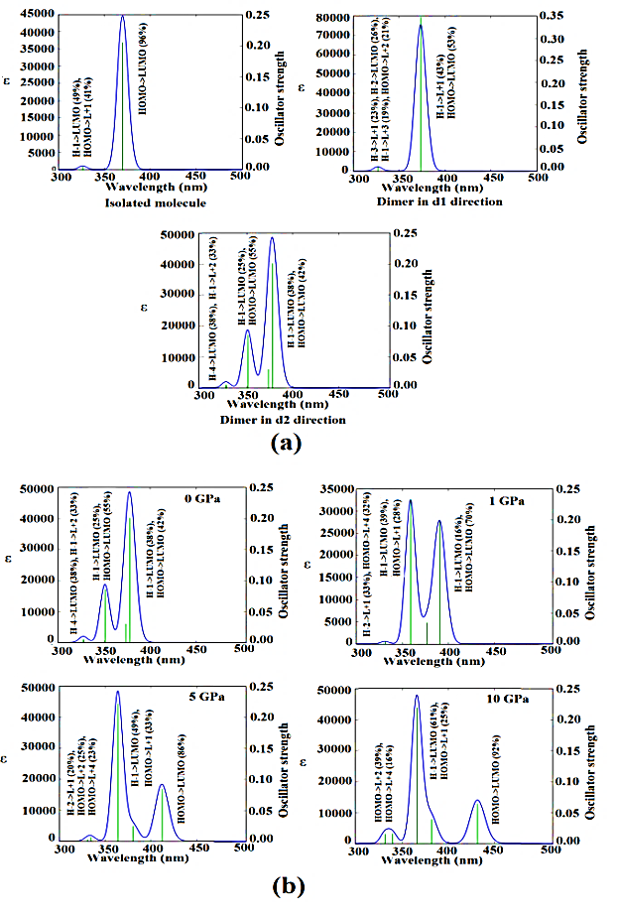
Figure S2. Electronic spectra calculated at the CAM-B3LYP/6-31G(d,p) level for (a) an isolated molecule, dimers in the d1 and d2 directions of 2,6-DPA at ambient condition and for (b) the dimer in the d2 direction of 2,6-DPA at different hydrostatic pressures.

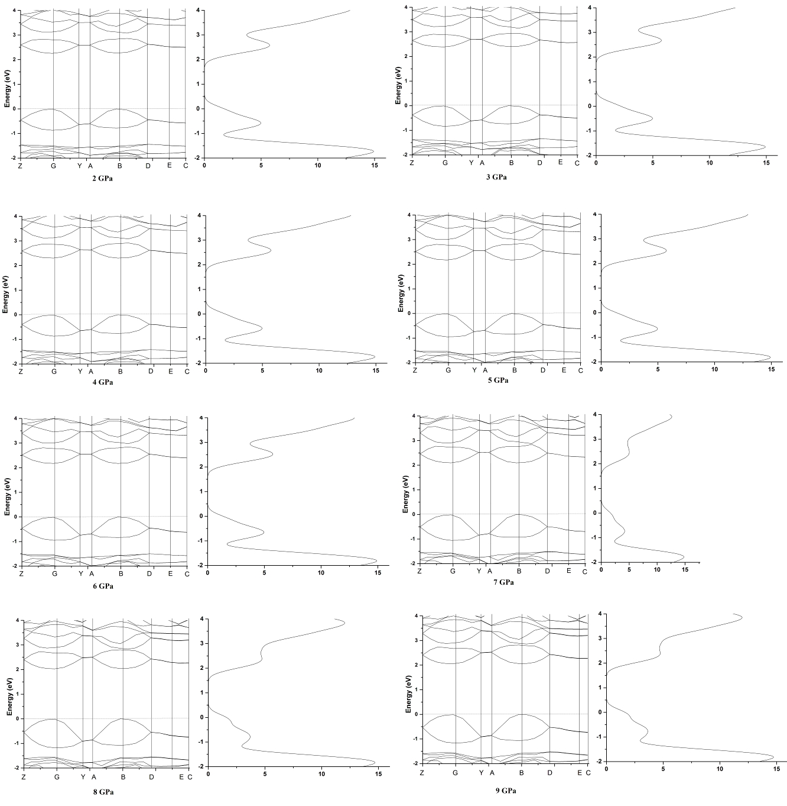
Figure S3:. The self-consistent band structures of 2,6-DPA crystal under diﬀerent pressures. The Fermi energy is shown as a dashed horizontal line.

E-mail: xhju@njust.edu.cn; Fax: +86-25-84431622; Tel: +86-25-84315947-801

