***Supporting Materials***

***CuO photocathode-embedded semi-transparent photoelectrochemical cell***

Malkeshkumar Patel a), Hong-Sik Kim a), Dipal B. Patel a) and Joondong Kima)*

a Photoelectric and Energy Device Application Lab (PEDAL) and Department of Electrical Engineering, Incheon National University, Incheon, 406772, Republic of Korea. Email: [joonkim@incheon.ac.kr](mailto:joonkim@incheon.ac.kr)

**Table SI.** Performance comparison for our nanoscaled CuO photocathode with the CuO based photocathodes in literature. Reference potential for measured photocurrent density is mentioned as reversible hydrogen electrode (RHE), silver/silver chloride (Ag/AgCl) and saturated calomel electrode (SCE).

|  |  |  |  |  |  |
| --- | --- | --- | --- | --- | --- |
| **Method of preparing CuO** | ***Eg* (eV)** | **Electrolyte** | **Light source** | **Photocurrent density**  **(mA cm-2)** | **Year/Ref.** |
| Reactive DC sputtering, room temperature | 1.85 | 0.1 M NaOH | LED, 100 mW cm-2 | 1.75 (0.3 V vs. RHE) | This work |
| Reactive DC sputtered + RTP | 1.7 | 0.1 M NaOH | LED, 100 mW cm-2 | 6.4 (0.3 V vs. RHE) | This work |
| Grind powder + LiNO3 | 1.35 | 0.1 M Na2HP04 | Xenon lamp, 810 mW cm-2 | ~0.44 (-0.4 V vs. SCE) | 1982/1 |
| Electrodeposition | 1.56 | - | 500 W xenon lamp | ~0.08 (-0.2 V vs. Ag/AgCl) | 2004/2 |
| Sol-gel | 1.77 | NaOH (pH 13) | 150 W xenon arc lamp | ~2.02 (-0.5 V vs. SCE) | 2009/3 |
| Electrochemical two stage growth | - | NaOH (pH 11) | W-halogen lamp, 125 mW cm-2 | ~0.35 (0.05 V vs. RHE) | 2010/4 |
| Spin coating of CuO particle prepared by flame spray pyrolysis | 1.44 | 1M KOH (pH 14) | 1 sun | 1.2 (-0.55 V vs. Ag/AgCl) | 2011/5 |
| RF sputtering of CuO | - | 1M KOH (pH 14) | 150 W solar simulator | ~3.15 (-0.55 V vs. Ag/AgCl) | 2012/6 |
| Flame spray pyrolysis Li:CuO | - | 1M KOH | 1 sun | ~1.69 (-0.55 V vs. Ag/AgCl) | 2012/7 |
| spinning disk reaction/spin coating | 1.68 | 1M KOH | 1 sun | 1.58 (-0.55 V vs. Ag/AgCl) | 2012/8 |
| Solution processed porous CuO | 1.35 | 1M KOH | 1 sun | 1.2 (-0.55 V vs. Ag/AgCl) | 2012/9 |
| RF co-sputtered Cu and Ti for Ti:CuO | 1.12 – 1.46 | 1M Na2SO4 | 250-W quartz tungsten lamp | 0.09 (-0.5 V vs. Ag/AgCl) | 2012/10 |
| Sol–gel | 1.2 | 0.1M Na2SO4 (pH 5.84) | 150 W Xenon arc lamp and AM1.5 filter | ~0.35 (0.05 V vs. RHE) | 2014/11 |
| Doped CuO by flame spray pyrolysis | - | 1M KOH (pH 14) | 1 sun | ~ 1.07 (-0.55 V vs. Ag/AgCl)) | 2014/12 |
| Anodising Cu foil: TiO2/CuO | - | 0.5 M K2SO4 | 300 W xenon arc lamp | 2.4 (-0.36 V vs. Ag/AgCl) | 2015/13 |
| Template assisted electrodeposition of CuO/ZnO | 1.5 | 0.1 M KOH | White light | 1.2 (-0.5 V vs. Ag/AgCl) | 2016/14 |
| RF sputtering of CuO target | 1.25 | 0.1 M Na2SO4 (pH 5.84) | 1 sun | 2.5 (0 V vs. RHE) | 2016/15 |
| RF sputtered CuO + RTP | 1.35 | 0.1 M Na2SO4 (pH 5.84) | 1 sun | 1.68 (0 V vs. RHE) | 2016/16 |
| Doped Ni:CuO by flame spray pyrolysis | - | 1M KOH (pH 14) | 1 sun | 1.07 (-0.55 V vs. Ag/AgCl) | 2016/17 |



**FIG. S1.** Photograph of samples including their classification and process conditions.

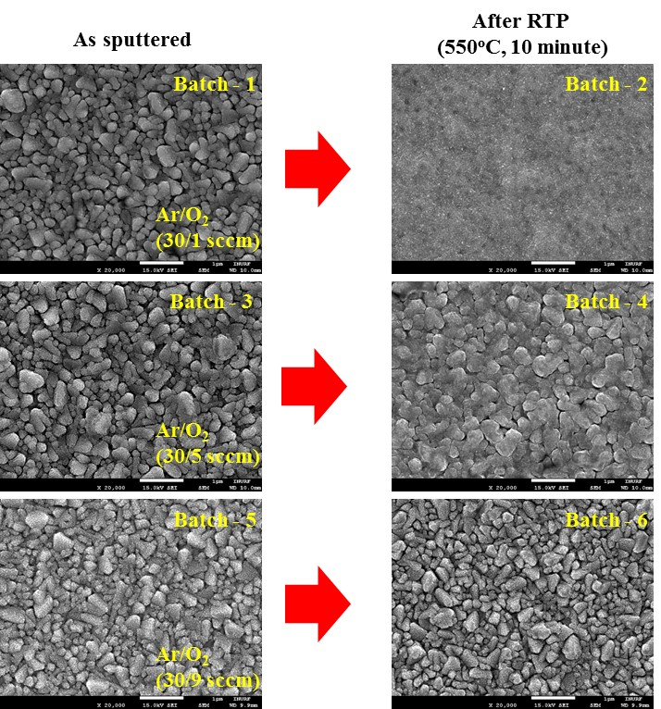

**FIG. S2.** FESEM images of the samples featuring the surface morphological variation for given synthesis condition. Left images presents as sputtered samples, the surface morphology of various Cu oxides prepared by changing the oxygen flow rate. Right images presents samples treated by atmospheric RTP, the surface morphology of nanoscaled CuO converted from various Cu oxides. Scale bar, 1 μm.

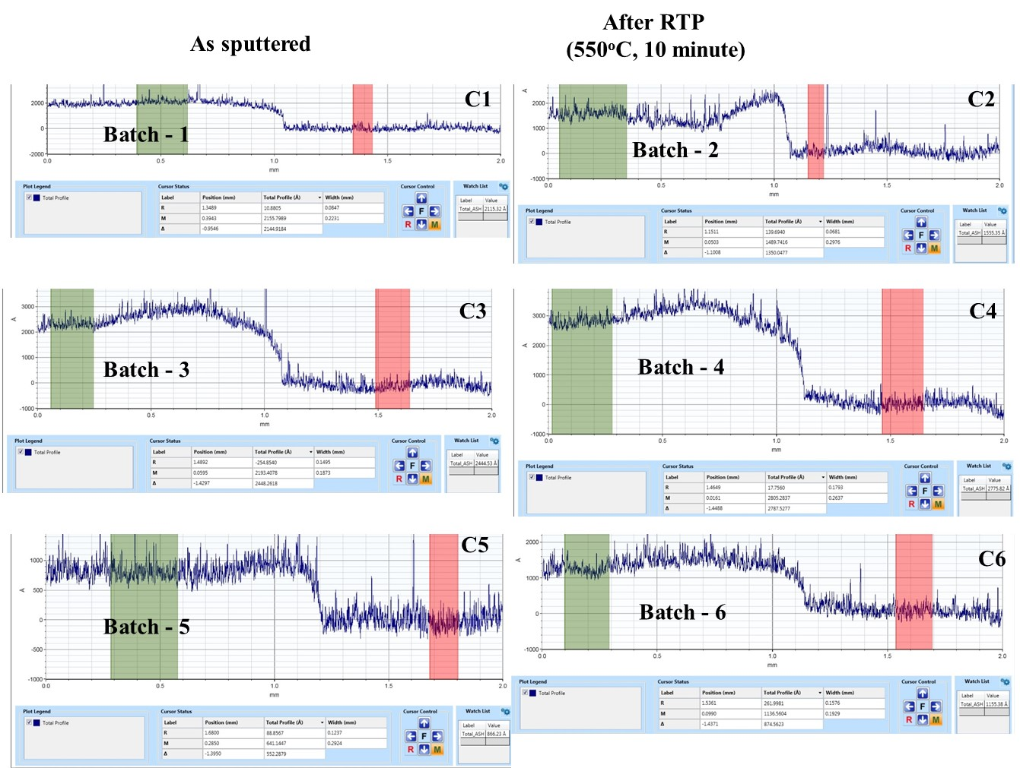

**FIG. S3.** Depth profiles of batch samples. Green marker on left side of each plot present thin film surface and red marker on right side in each plot present the substrate surface.



**FIG. S4**. Reflectance profiles of as sputtered and RTP treated samples.



**FIG. S5.** Tauc plot of RTP-treated samples.



**FIG. S6.** Current-potential characteristics in the forward bias (anodic) direction revealed the rectification nature of CuO photocathode.



**FIG. S7.** Current-time characteristics of bare CuO photocathode (Batch-2). Light intensity, 100 mW/cm2.

**Batch 6**

**Batch 4**

**Batch 2**

**FIG. S8.** Mott-Schottky plots of samples treated by RTP. These samples present various nanoscalefeatures of CuO materials. Here, 1/C2 vs. V shown for various frequencies from 500 Hz to 5 kHz. Consistence slope and intersection on potential axis firmed the accurate accepter carrier concentration and flat band potentials of these samples are attributed to the bulk properties and without involving surface states.

**References**:

1. F.P. Koffyberg, F.A. Benko: A photoelectrochemical determination of the position of the conduction and valence band edges of p-type CuO. *J. Appl. Phys.* **53**, 1173 (1982).

2. K. Nakaoka, J. Ueyama, K. Ogura: Photoelectrochemical Behavior of Electrodeposited CuO and Cu2O Thin Films on Conducting Substrates. *J. Electrochem. Soc.* **151**, C661 (2004).

3. D. Chauhan, V.R. Satsangi, S. Dass, R. Shrivastav: Preparation and characterization of nanostructured ZnO thin films for photoelectrochemical splitting of water. *Bull. Mater. Sci.* **29**, 709 (2009).

4. L. Chen, S. Shet, H. Tang, H. Wang, T. Deutsch, Y. Yan, et al.: Electrochemical deposition of copper oxide nanowires for photoelectrochemical applications. *J. Mater. Chem.* **20**, 6962 (2010).

5. C.-Y. Chiang, K. Aroh, S.H. Ehrman: Copper oxide nanoparticle made by flame spray pyrolysis for photoelectrochemical water splitting – Part II. Photoelectrochemical Study. *Int. J. Hydrogen Energy.* **37**, 4871 (2011).

6. C.-Y. Chiang, J. Epstein, A. Brown, J.N. Munday, J. Culver, S.H. Ehrman: Biological Templates for Anti Reflective Current Collectors for Photoelectrochemical Cell Applications. *Nano Lett.* **12**, 6005 (2012).

7. C.-Y. Chiang, Y. Shin, S. Ehrman: Li Doped CuO Film Electrodes for Photoelectrochemical Cells. *J. Electrochem. Soc.* **159,** B227 (2012).

8. C.Y. Chiang, M.H. Chang, H.S. Liu, C.Y. Tai, S. Ehrman: Process intensification in the production of photocatalysts for solar hydrogen generation. *Ind. Eng. Chem. Res.* **51,** 5207 (2012).

9. C.Y. Chiang, Y. Shin, K. Aroh, S. Ehrman: Copper oxide photocathodes prepared by a solution based process. *Int. J. Hydrogen Energy.* **37**, 8232 (2012).

10. H. Tang, M.A. Matin, H. Wang, S. Sudhakar, L. Chen, M.M. Al-Jassim, et al.: Enhancing the stability of CuO thin-film photoelectrodes by Ti alloying, *J. Electron. Mater.* **41**, 3062 (2012).

11. Y.-F. Lim, C.S. Chua, C.J.J. Lee, D. Chi: Sol-gel deposited Cu2O and CuO thin films for photocatalytic water splitting. *Phys. Chem. Chem. Phys.* **16**, 25928 (2014).

12. C.-Y. Chiang, Y. Shin, S. Ehrman: Dopant Effects on Copper Oxide Photoelectrochemical Cell Water Splitting. *Energy Procedia.* **61**, 1799 (2014).

13. P. Wang, X. Wen, R. Amal, Y.H. Ng: Introducing a protective interlayer of TiO2 in Cu2O–CuO heterojunction thin film as a highly stable visible light photocathode. *RSC Adv.* **5**, 5231 (2015).

14. U. Shaislamov, K. Krishnamoorthy, S.J. Kim, A. Abidov, B. Allabergenov, S. Kim, et al.: Highly stable hierarchical p-CuO/ZnO nanorod/nanobranch photoelectrode for efficient solar energy conversion. *Int. J. Hydrogen Energy.* **41,** 2253 (2016).

15. S. Masudy-Panah, R. Siavash Moakhar, C.S. Chua, H.R. Tan, T.I. Wong, D. Chi, et al.: Nanocrystal Engineering of Sputter-Grown CuO Photocathode for Visible-Light-Driven Electrochemical Water Splitting. *ACS Appl. Mater. Interfaces.* **8**, 1206 (2016).

16. S. Masudy-Panah, R.S. Moakhar, C.S. Chua, A. Kushwaha, T.I. Wong, G.K. Dalapati: Rapid thermal annealing assisted stability and efficiency enhancement in a sputter deposited CuO photocathode. *RSC Adv.* **6**, 29383 (2016).

17. C.Y. Chiang, Y. Shin, S. Ehrman: Dopant effects on conductivity in copper oxide photoelectrochemical cells. *Appl. Energy.* **164**, 1039 (2014).