ELECTRONIC SUPPLEMENTARY MATERIAL FOR THE ARTICLE:

Three-dimensional anodes prepared by β-PbO₂ electrodeposition onto reticulated vitreous carbon with different porosities
Rosimeire M. Farinos and Luís A. M. Ruotolo
Department of Chemical Engineering, Federal University of São Carlos, P.O. Box 676, 13565-905 Sao Carlos, Brazil

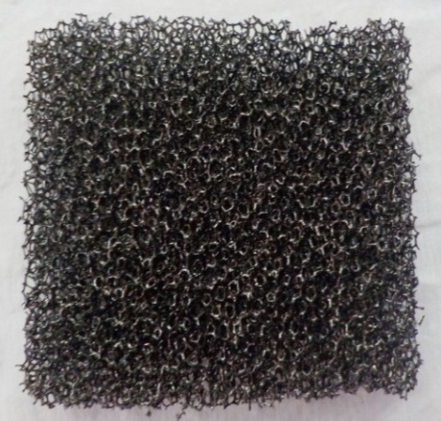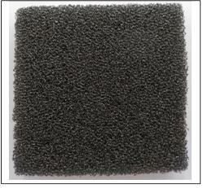
FIG. S1. RVC substrates: (a) 45 ppi, (b) 60 ppi, and (c) 80 ppi (0.5 cm x 2.5 cm x 2.5 cm).

FIG. S2. Schematic representation of the experimental system used for electrodeposition of PbO₂: 1) multimeter; 2) current source; 3) peristaltic pump; 4) electrochemical reactor; 5) electrolyte reservoir and magnetic agitator; 6) thermostatically-controlled bath.
FIG. S3. Schematic representation of the experimental system used for dye decolorization: 1) computer; 2) UV-Vis spectrophotometer; 3) peristaltic pump; 4) electrochemical reactor; 5) electrolyte reservoir; 6) multimeter; 7) current source.

FIG. S4. Schematic representation of the electrochemical reactor: 1) current collector, 2) three-dimensional anode, 3) electrolyte flow cannel, 4) polyamide fabric, 5) polyethylene mesh, 6) counter-electrode, and 7) electrolyte inlet.

FIG. S5. Schematic representation of the surface of the RVC/PbO₂ electrode analyzed using SEM.

FIG. S6. X-ray diffraction pattern of the PbO₂ electrodes deposited on (a) 60 ppi and (b) 45 ppi substrates. j = 3.5 mA cm⁻².

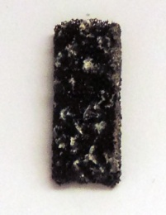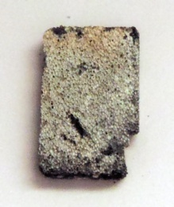
(a) (b)
FIG. S7. Photographs of the RVC/PbO₂ electrodes obtained applying 5.0 mA cm⁻²: (a) 60 ppi substrate; (b) 80 ppi substrate.
FIG. S8. Voltammograms of the VC, VC/PbO₂, and RVC electrodes Conditions: 0.1 mol L⁻¹ Na₂SO₄; ν = 50 mV s⁻¹.
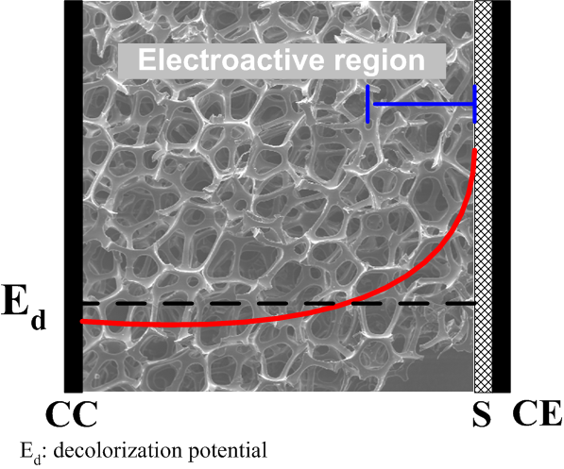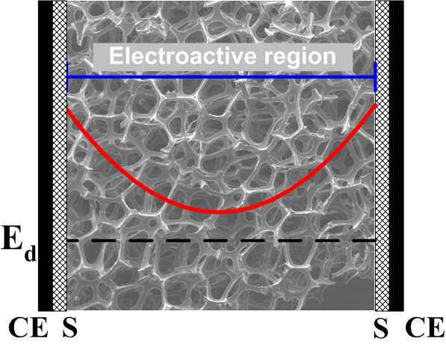
(a) (b)
FIG. 9. Schematic representations of the potential distributions in porous electrodes: (a) single counter electrode and (b) two counter electrodes.

