Low density ceramic foams from alumina-sucrose using magnesium nitrate as a blowing and setting agent
Sujith Vijayan, Praveen Wilson and K. Prabhakaran*
Department of Chemistry, Indian Institute of Space Science and Technology, Thiruvananthapuram- 695 022, India

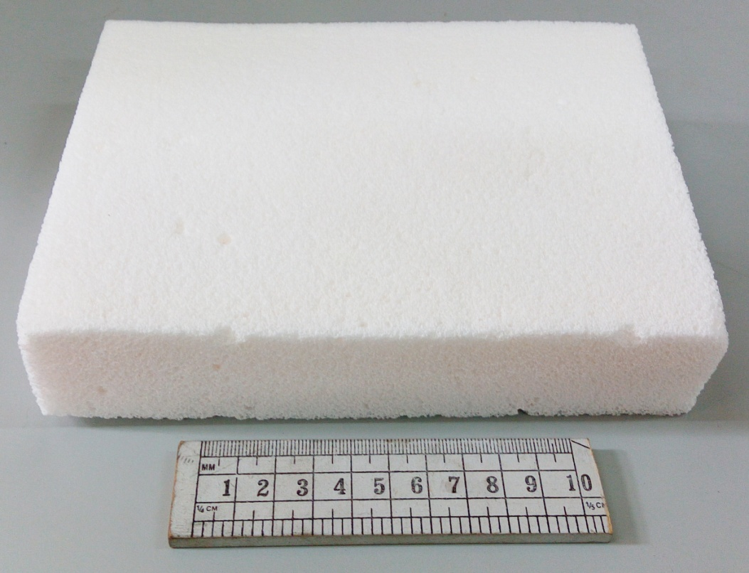

Fig. S1 Photograph of a large alumina foam body fabricated by thermo-foaming of alumina powder dispersions in molten sucrose using magnesium nitrate blowing agent

*Corresponding author. Tel.: +91 4712568535; fax: +91 471 2568541. E-mail addresses: kp2952002@gmail.com (K. Prabhakaran).

Fig.S2 Infrared spectrum of sucrose polymer prepared (a) without and (b) with magnesium nitrate blowing agent

Fig. S3 Variation of average grain size with magnesium nitrate concentration

