Hydrothermal Synthesis of 3D Ba₅Ta₄O₁₅ Flower-like Microsphere Photocatalyst with High Photocatalytic Properties
Dongbo Xu^{a,b}, Weidong Shi^{a,b,}*, Chao Xu^{b}, Songbo Yang^{b}, Hongye Bai^{b}, Chengjie Song,^{c} Biyi Chen^{b}
ªSchool of Energy and Power Engineering, Jiangsu University, Zhenjiang, 212013, P. R. China.
^{b}School of Chemistry and Chemical Engineering, Jiangsu University, Zhenjiang, 212013, P. R. China.
^{c}School of Environmental and Safety Engineering, Changzhou University,
Changzhou, 213164, P. R. China.
E-mail: swd1978@ujs.edu.cn;

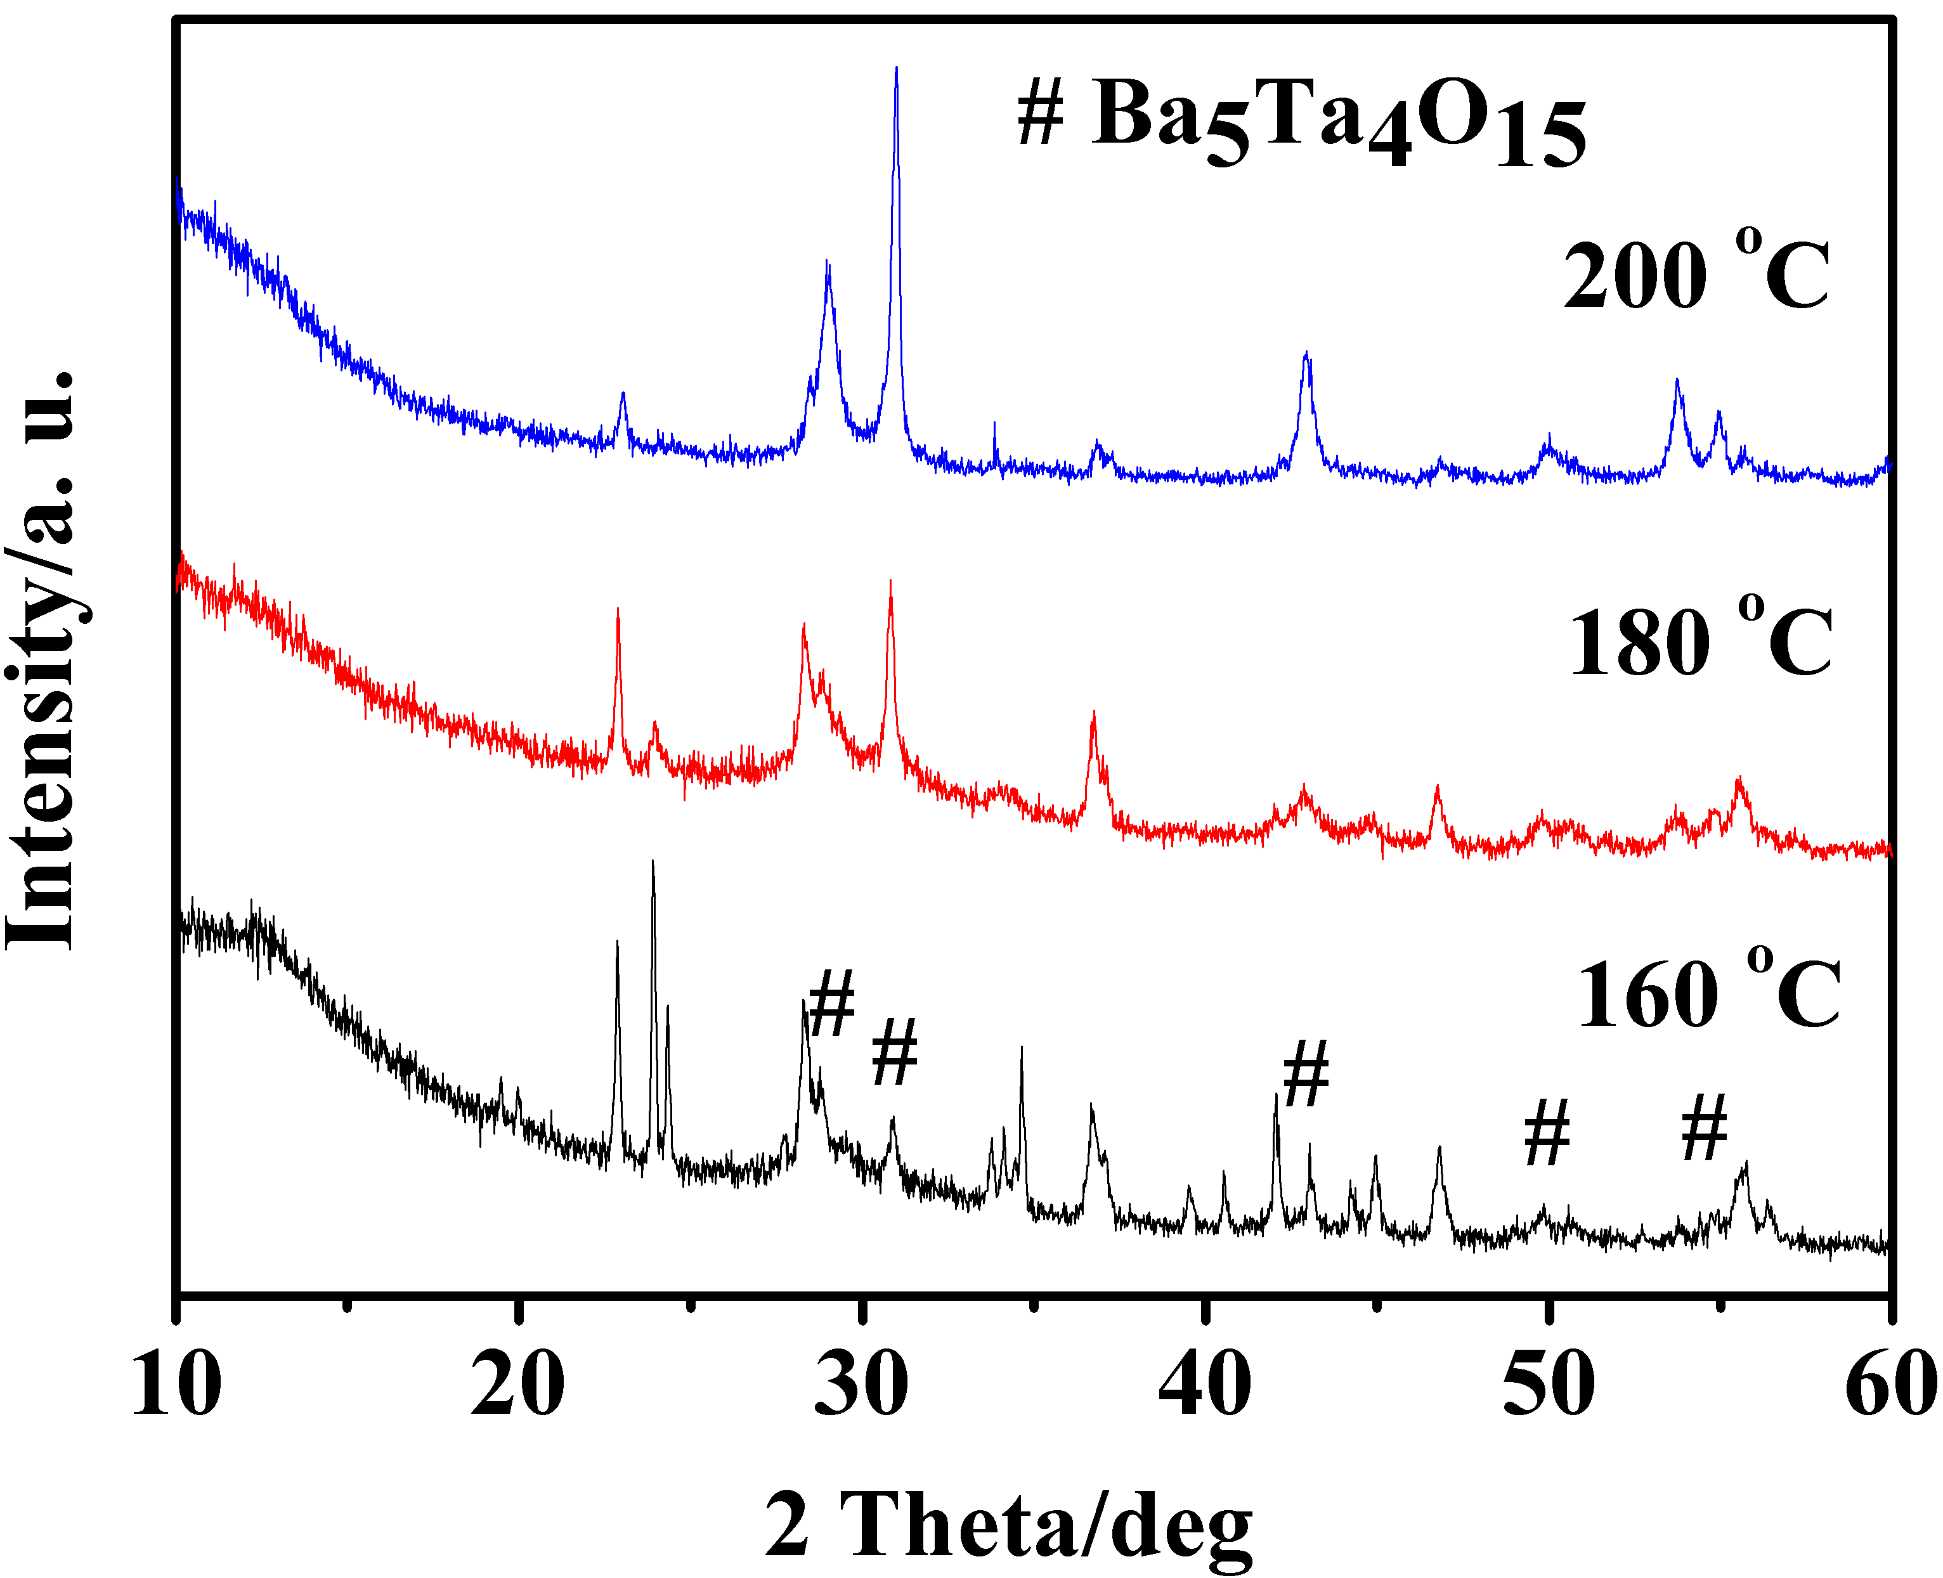
Fig. S1 XRD patterns of Ba₅Ta₄O₁₅ produced by hydrothermal method at 160, 180, and 200 °C, respectively.
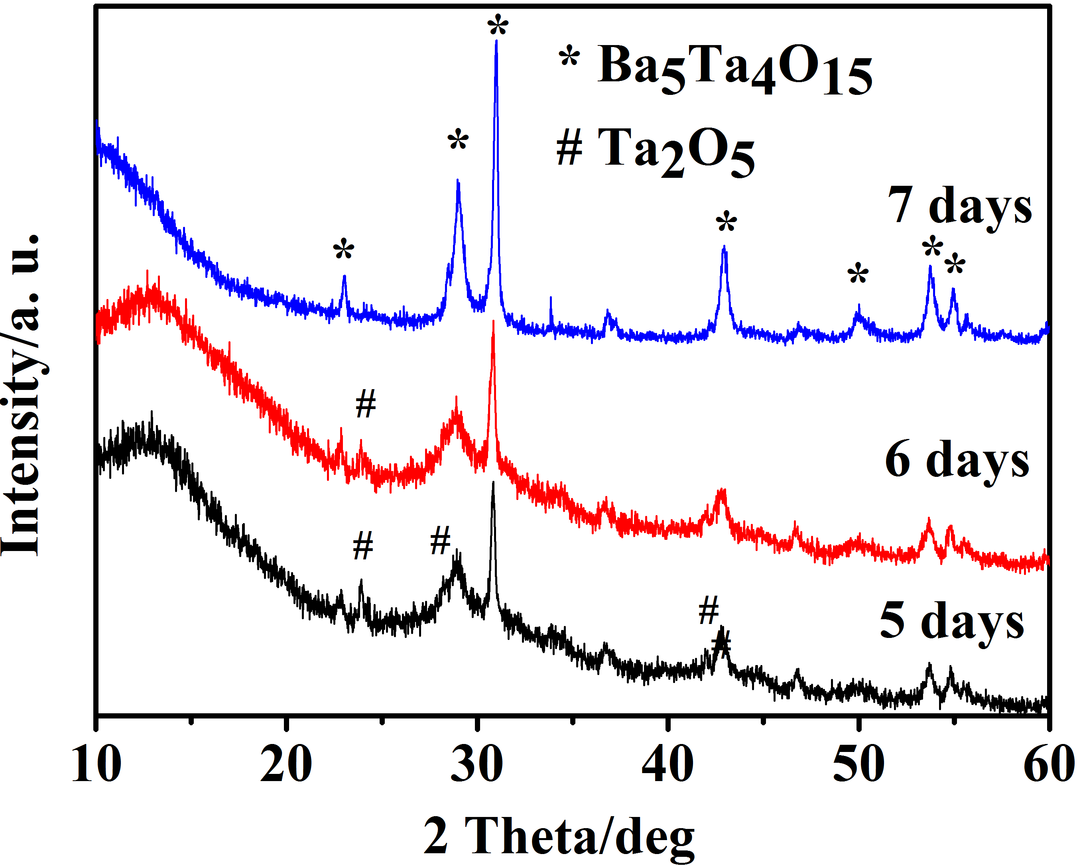
Fig. S2 XRD patterns of the as-prepared Ba₅Ta₄O₁₅ at 200 °C for different times.
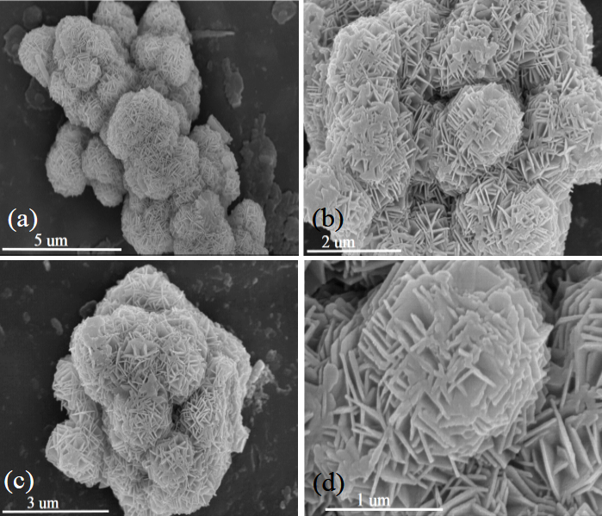
Fig. S3 The 3D Ba₅Ta₄O₁₅ flower-like microsphere SEM images: (a) 160 °C, Ba(OH)₂ 0.40 M, 7 days; (b) 180 °C, Ba(OH)₂ 0.40 M, 7 days; (c) 5 days, 200 °C, Ba(OH)₂ 0.40 M; (d) 6 days, 200 °C, Ba(OH)₂ 0.40 M;
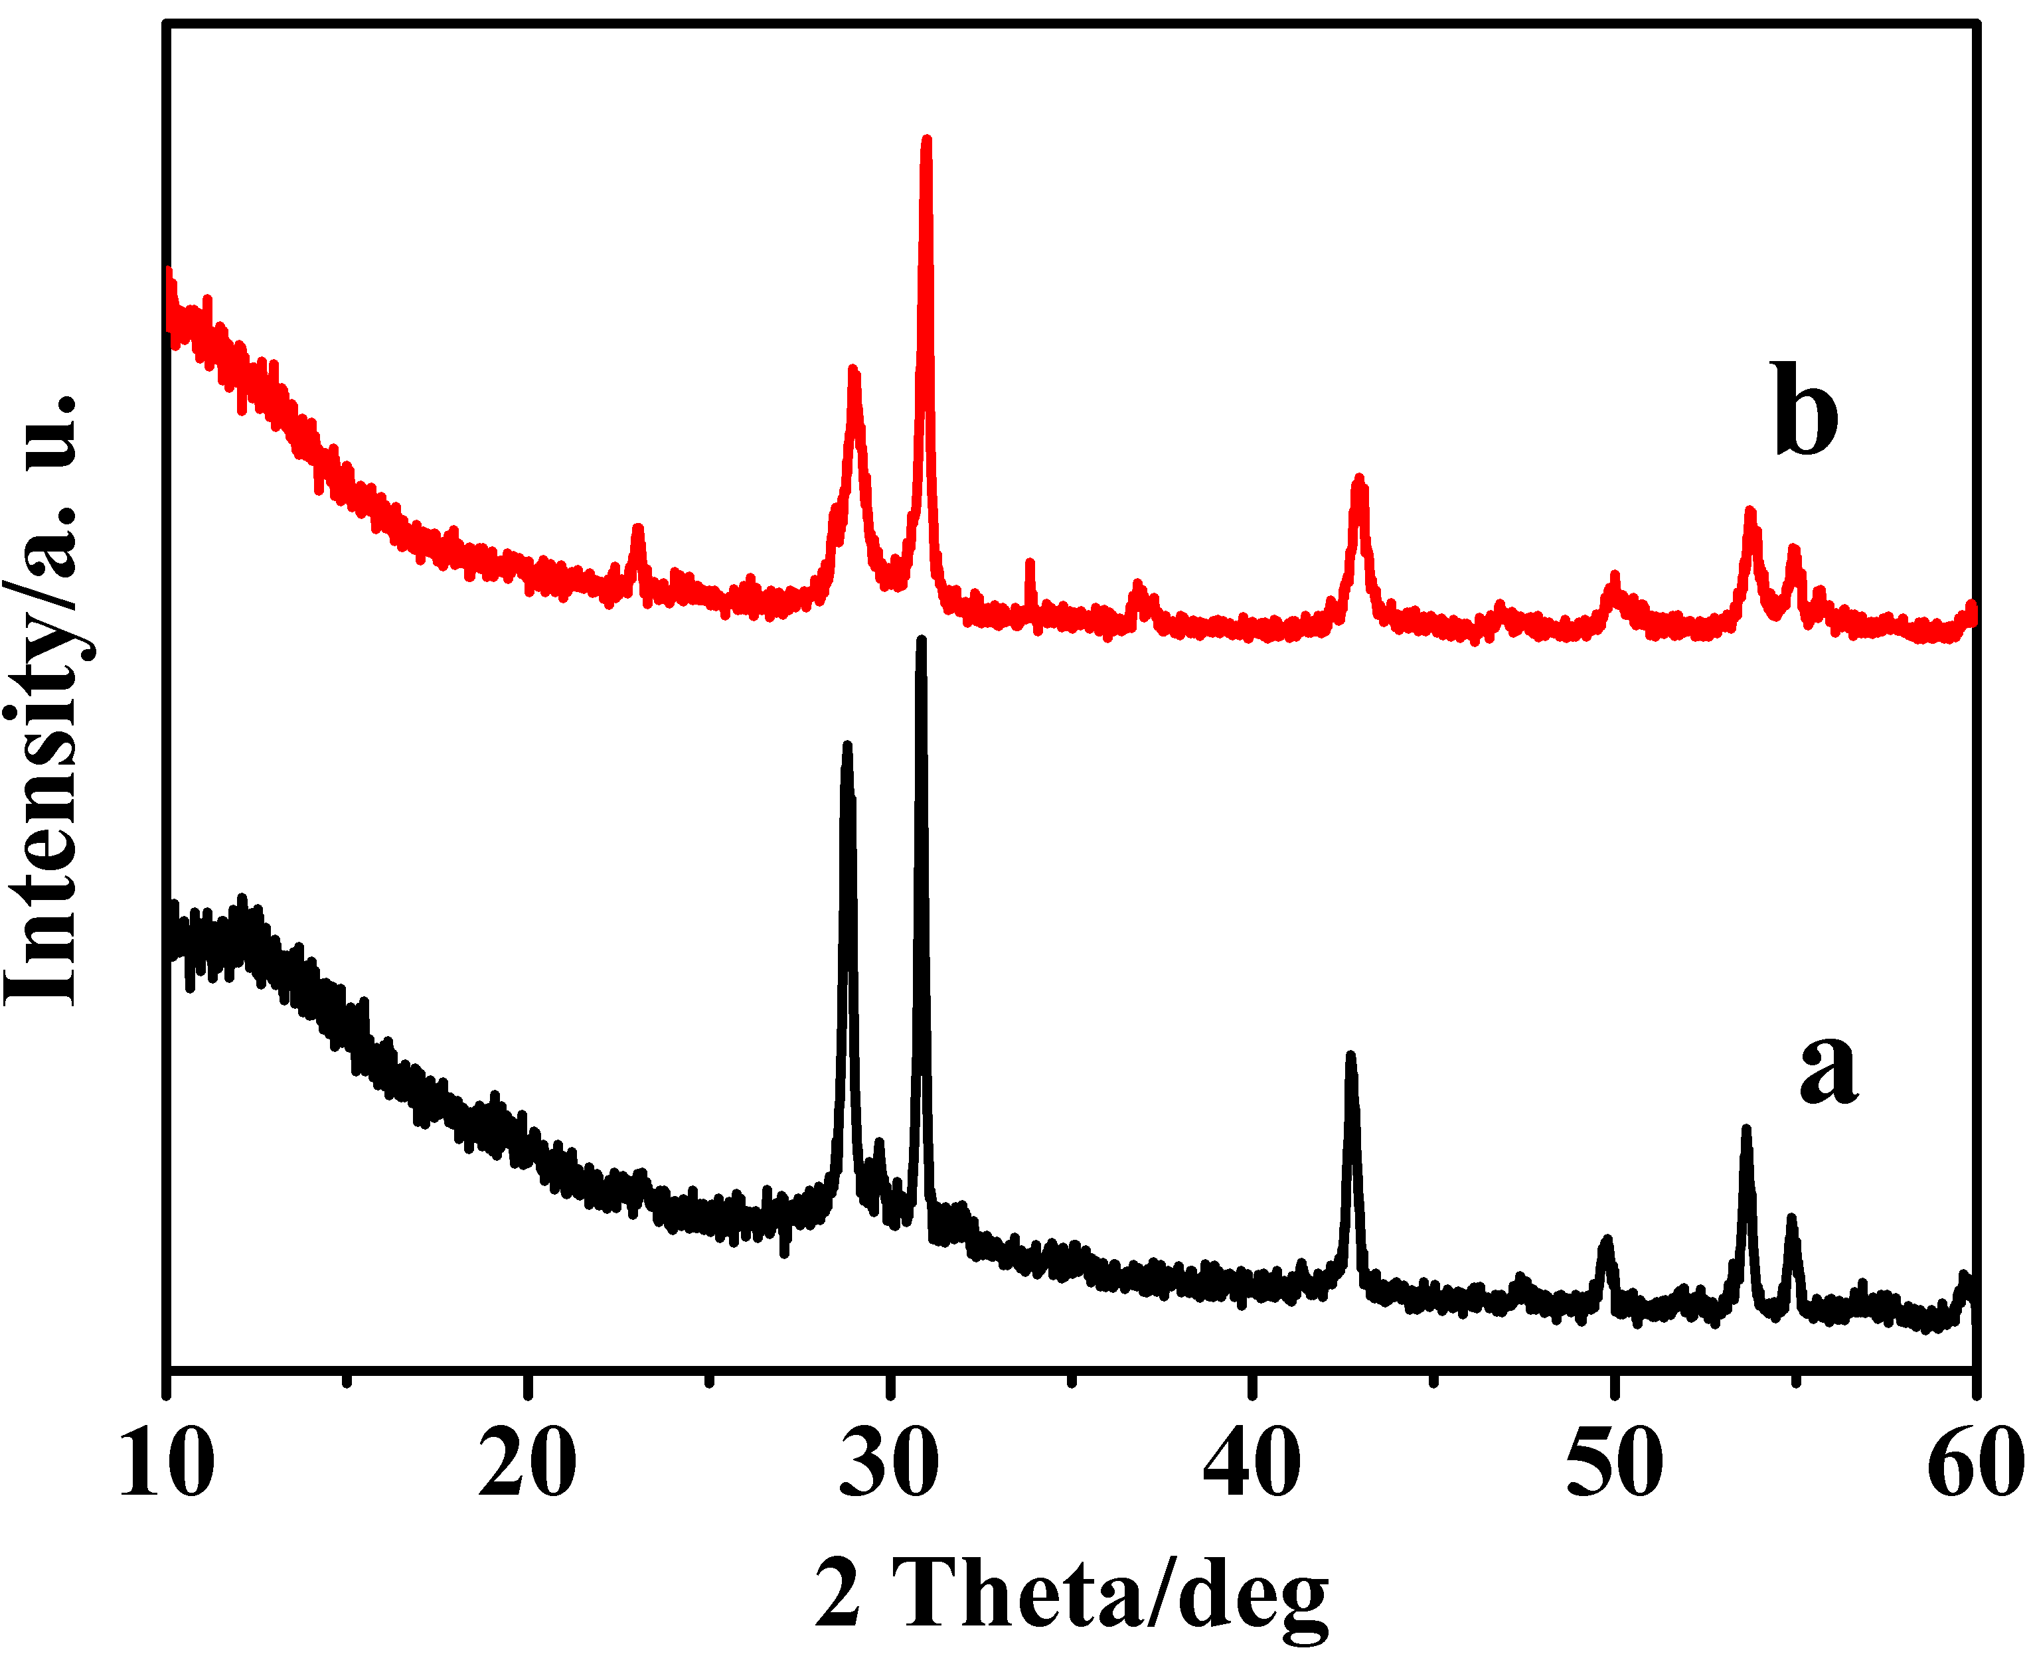
Fig. S4 XRD patterns of Ba₅Ta₄O₁₅: a, SSR; b, hydrothermal method.
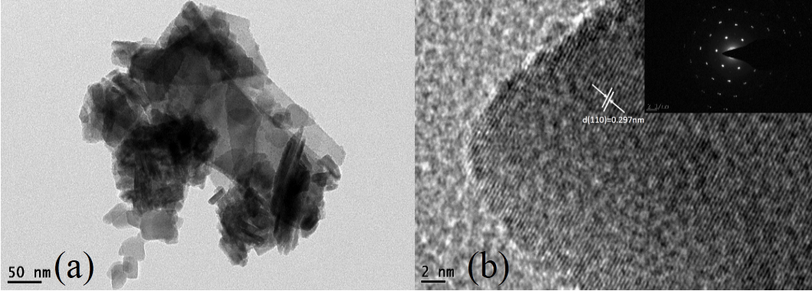
Fig S5 TEM, HRTEM and SAED images of the flower-like Ba₅Ta₄O₁₅ microcrystal.

