Supporting Information
for
Visible-Light Responsive Plasmonic Ag₂O/Ag/g-C₃N₄ Nanosheets with Enhanced Photocatalytic degradation of RhB
Shurong Fu, Yiming He, Qi Wu, Ying Wu*, Tinghua Wu*
Zhejiang Key Laboratory for Reactive Chemistry on Solid Surfaces, Institute of Physical Chemistry, Zhejiang Normal University, Jinhua 321004, China

Corresponding author, Tel.: +86 0579 82282234; Fax: +86 0579 82282595.
E-mail: yingwu@zjnu.cn (Y. Wu), thwu@zjnu.cn (T. Wu).

element | weight percentage | atom percentage
C K | 31.76 | 35.38
N K | 63.46 | 60.62
O K | 4.78 | 4.00
total | 100.00

FIG. S1 EDS spectrum of g-C₃N₄ NS

element | weight percentage | atom percentage
C K | 28.89 | 34.68
N K | 52.45 | 53.98
O K | 11.53 | 10.39
Ag L | 7.13 | 0.95
total | 100.00

FIG. S2 EDS spectrum of Ag(10.0)/g-C₃N₄ NS

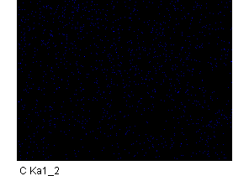

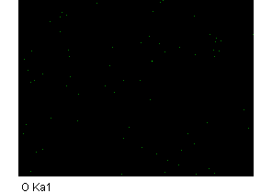
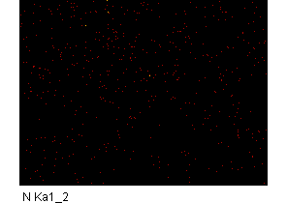

FIG. S3 Mapping spectrum of Ag(10.0)/g-C₃N₄ NS

