Appendices

Particle size distribution
Powdered samples were passed through a range of sieve sizes including 38, 75, 150 and 250 µm. The particle size distribution is shown in Figure A.1. The effective particle size was then determined based on the weight percentage of particles in each size range (Table A.1).
 | Na-free sample | Na-doped sample
Effective particle size (µm) | 134 ± 10 | 111 ± 10
Table A.1. Effective particle size for samples with/without Na
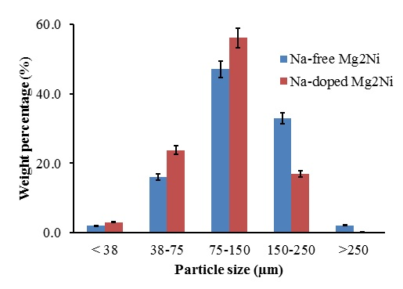
FIG A.1. Distribution of particle size for samples with/without Na

Measurement of interphase boundary density
An example of the measurement of interphase boundary density between primary Mg₂Ni/eutectic structures is shown in Figure B.1. ImageJ 1.47v software was used for the analysis. The final result is summarised in Table B.1 for a population of 10 samples.
 | Density of interphase boundary (Primary Mg₂Ni/Eutectic) (µm/µm²)
No. | Na-free Mg₂Ni | Na-doped Mg₂Ni
1 | 3.63E-03 | 7.10E-03
2 | 3.99E-03 | 7.72E-03
3 | 4.07E-03 | 9.16E-03
4 | 3.78E-03 | 9.40E-03
5 | 4.00E-03 | 9.10E-03
6 | 3.38E-03 | 7.82E-03
7 | 4.01E-03 | 7.40E-03
8 | 3.79E-03 | 7.45E-03
9 | 3.64E-03 | 7.22E-03
10 | 3.88E-03 | 6.82E-03
Median | 3.84E-03 | 7.59E-03
Standard deviation | 0.21E-03 | 0.90E-03

Table B.1. Result summary for the measurement of density of interphase boundary for a population of 10 samples
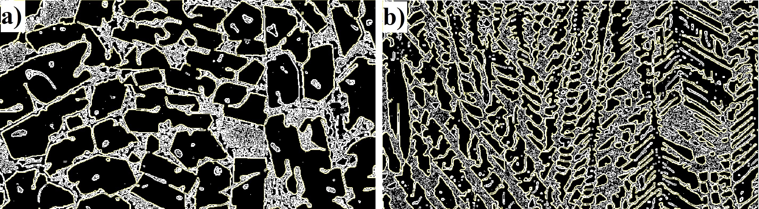
FIG B.1. An example for the measurement of interphase boundary using ImageJ software
a) Na-free Mg₂Ni and b) Na-doped Mg₂Ni

