Supporting Information

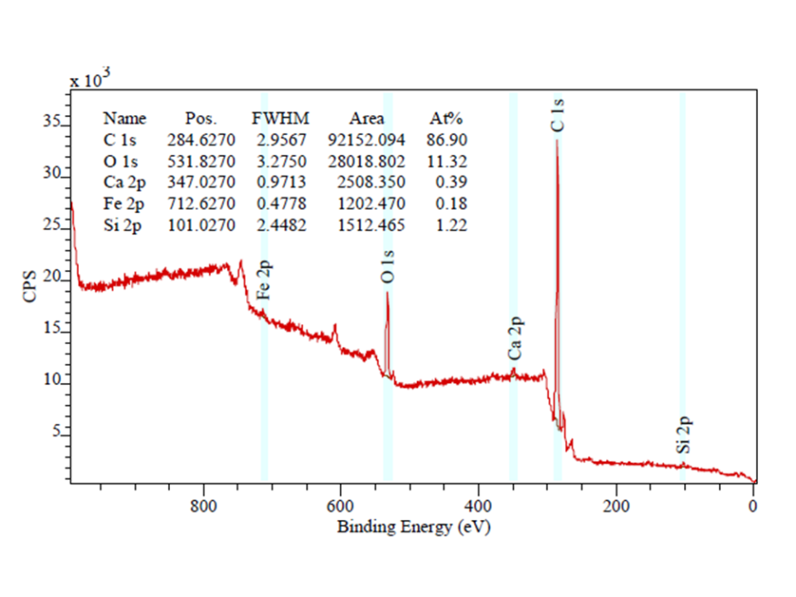

**Figure S1**: XPS survey scans showing the Composition of silicon doped hematite film.



**Figure S2**: XRD comparison of hematite and silicon doped hematite films. [D.K. Bora, Materials Science in Semiconductor Processing, 31 (2015)728–738]