Supporting Information

Distinguishing Surface Effects of Gold Nanoparticles from Plasmonic Effect on Photoelectrochemical Water Splitting by Hematite

Jiangtian Liª, Scott K. Cushing^{a,b}, Deryn Chu^{c}, Peng Zhengª, Joeseph Brightª, Conner Castle ª, Ayyakkannu Manivannan^{d}, Nianqiang Wu^{a,}*

ª Department of Mechanical and Aerospace Engineering, West Virginia University, Morgantown, WV 26506-6106, USA
^{b} Department of Physics and Astronomy, West Virginia University, Morgantown, WV 26506-6315, USA
^{c} Sensors and Electron Devices Directorate, US Army Research Laboratory, Adelphi, MD 20783-1197, USA
^{d} National Energy Technology Laboratory, U.S. Department of Energy, Morgantown, WV 26507, USA
*Corresponding Author: nick.wu@mail.wvu.edu

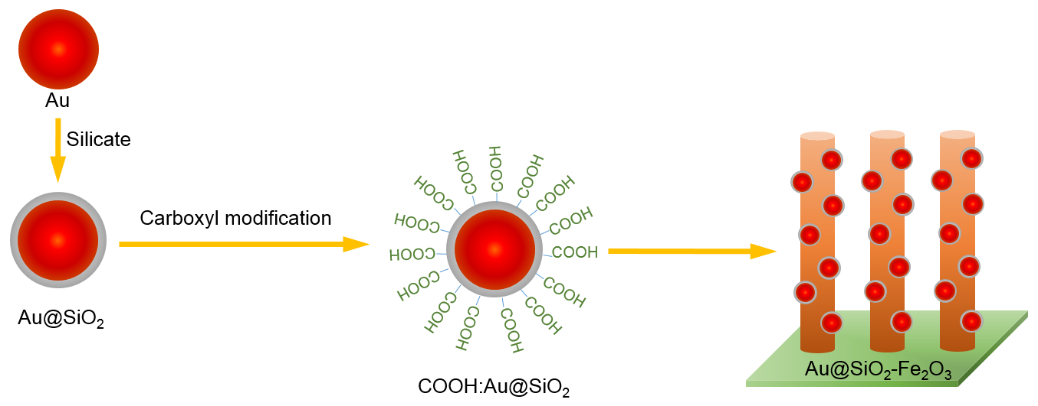
Figure S1. Immobilization of Au@SiO₂ nanoparticles on the hematite nanorod array. The Au nanoparticles were first coated with a SiO₂ layer, and then modified with the COOH-terminated silane, which allowed anchoring of the Au@SiO₂ on the hematite nanorod array. Finally the Au@SiO₂/hematite samples were heat treated at 350 ºC.

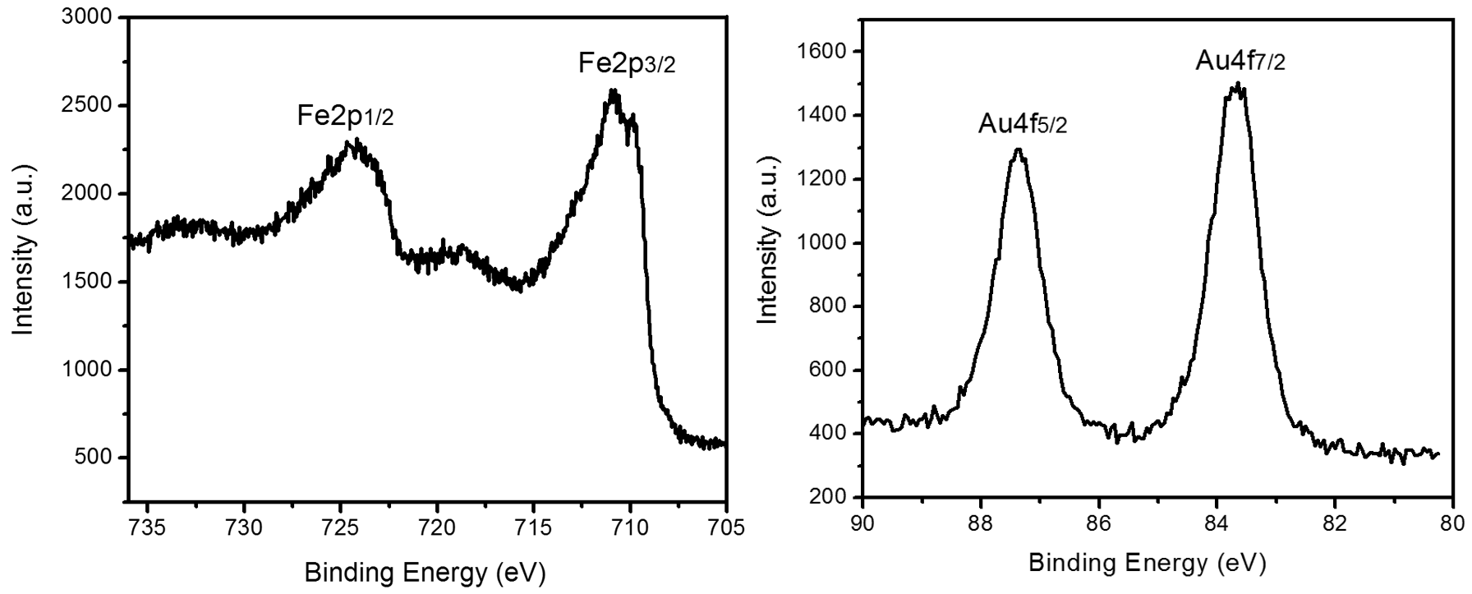
Figure S2. XPS spectra for Fe (left) and Au (right) in the Au-hematite sample. The data show that Fe exists as Fe³⁺ in the oxide, while Au exists as a metal, indicating that Au has been completely reduced through the co-precipitation method.

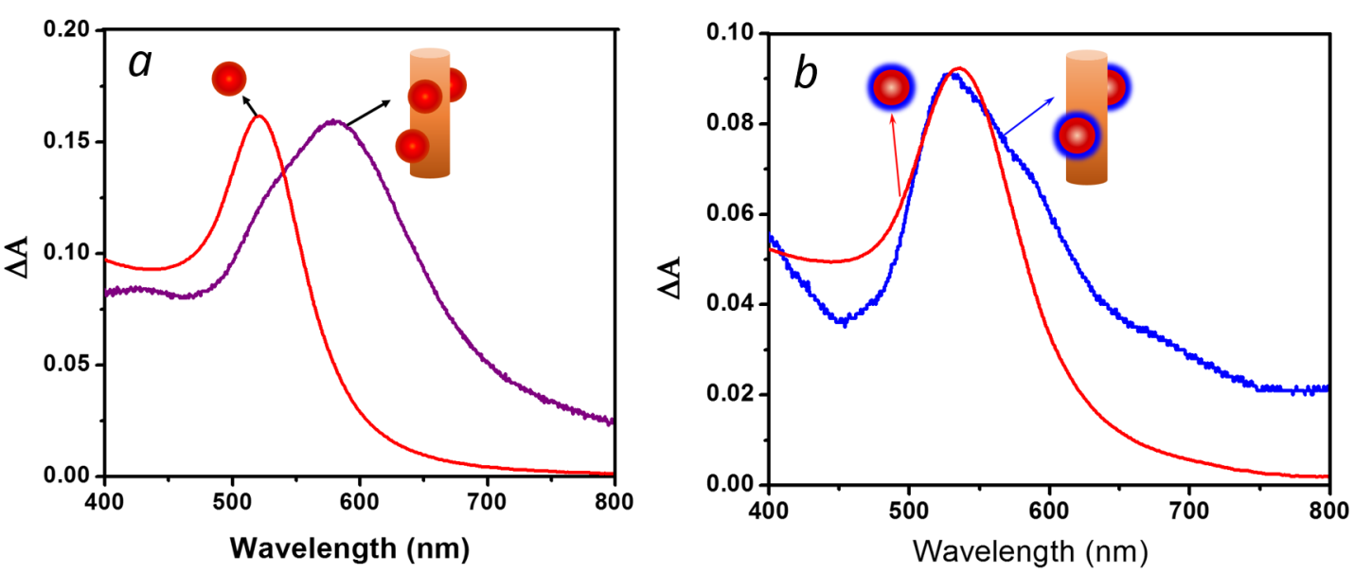
Figure S3. Light absorption enhancement from plasmonic nanoparticles on the hematite nanorod array versus free-standing in an aqueous solution. (a) Bare Au nanoparticles and enhancement for Au/hematite, (b) Au@SiO₂ and light absorption enhancement for Au@SiO₂/hematite.

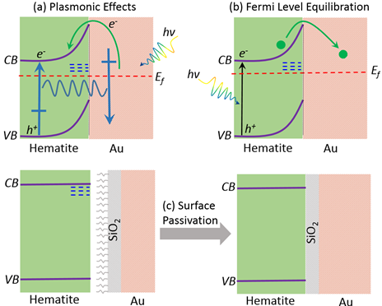
Figure S4. Schematic diagram of the effects of gold nanoparticles on hematite surface. (a) Plasmonic effect. (b) Fermi level equilibration effect, and (c) surface passivation effect.

