**Collagen-Fibril Matrices Modulate the Kinetics of Silica Polycondensation to Template and Direct Mineralization**

Jennifer L. Kahn, Necla Mine Eren, Osvaldo Campanella, Sherry L. Voytik-Harbin, Jenna L. Rickus

**Supplementary Material**

**Table S1: Constant Parameters for Collagen Oligomer Preparations Used**

|  |  |  |  |  |  |  |  |
| --- | --- | --- | --- | --- | --- | --- | --- |
| Constant Parameter | *a* | *b* | *c* | *a’* | *b’* | *c’* | *X* |
| Oligomer Preparation A | 2241.3 | 285.75 | -10.94 | 74.722 | 52.175 | -10.94 | 5.4768 |
| Oligomer Preparation B | 2396 | 185.37 | -20.289 | 81.235 | 34.132 | -20.289 | 5.4309 |

**System:Users:JenPro:Documents:PhD Research:Data:Kinetics Paper:Figure S1.pdf**

**Figure S1: Depletion of silicic acid monomers and dimers over time.** Concentration of mono- and disilicic acids is plotted over time (0-300 s) during exposure of SS to 4 different collagen fibril volume fraction levels and a negative control containing SS only with no collagen exposure. Error bars represent one standard deviation for three independent reactions.

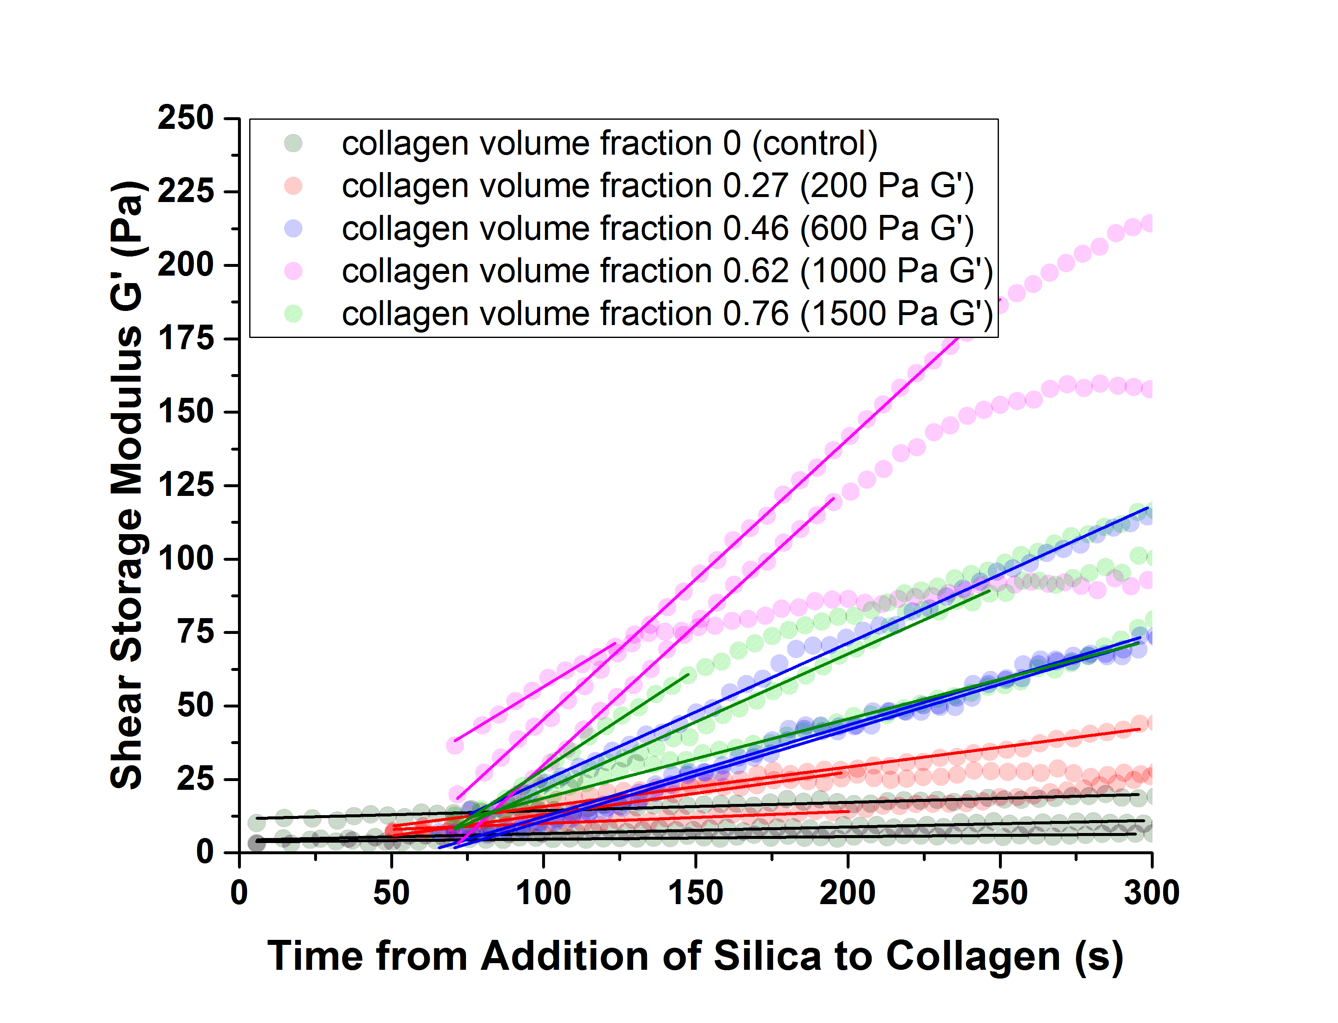

**Figure S2: Real-time measurement of G’ during gelation.** Shear storage modulus (G’) of bulk SS was measured over time (0-300 s) for 4 different collagen fibril volume fraction levels and a negative control containing SS only with no collagen exposure. Linear fits used to determine gelation rate during this time period are provided for each sample.