Supplemental Material:

An In-situ Phosphorus Source for the Synthesis of Cu₃P and the Subsequent Conversion to Cu₃PS₄ Nanoparticle Clusters

Erik J. Sheets
School of Chemical Engineering, Purdue University, 480 Stadium Mall Dr. West Lafayette, Indiana 47907, USA

Wei-Chang Yang
School of Materials Engineering, Purdue University, 701 Stadium Mall Dr. West Lafayette, Indiana 47907, USA

Robert B. Balow
Department of Chemistry, Purdue University, 560 Oval Dr. West Lafayette, Indiana 47907, USA

Yunjie Wang and Bryce C. Walker
School of Chemical Engineering, Purdue University, 480 Stadium Mall Dr. West Lafayette, Indiana 47907, USA

Eric A. Stach^{a)}
Center for Functional Nanomaterials, Brookhaven National Laboratory, 2 Center Street, Upton, NY 11973, USA

Rakesh Agrawal^{b)}
School of Chemical Engineering, Purdue University, 480 Stadium Mall Dr. West Lafayette, Indiana 47907, USA

^{a)} This author was an editor of this journal during the review and decision stage. For the JMR policy on review and publication of manuscripts authored by editors, please refer to http://www.mrs. org/jmr-editor-manuscripts/

^{b)} Address all correspondence to this author. Email: agrawalr@purdue.edu

Characterization Details.
X-ray Diffraction. Samples of both materials were drop cast from ethanol onto a quartz or molybdenum coated glass substrates and were analyzed by x-ray diffraction (XRD) using a Bruker D8 with a Cu-Kα radiation source at room temperature (40 kV, 40 mA). The background was subtracted from the original diffraction patterns without changing peak locations for simple comparisons across multiple scans unless otherwise noted. Molybdenum substrates were used to align the 110 peak to 40.5 degrees 2-theta.
SEM EDS. Field emission scanning electron microscopy energy dispersive x-ray spectroscopy (FE-SEM EDS) measurements were obtained from samples cast onto a silicon wafer substrate using an FEI Quanta 3D FEG Dual-beam scanning electron microscope with an Oxford INCA Xstram-2 silicon drift detector operated at an accelerating voltage of 20 kV. Data analysis was performed using Oxford’s INCA software.
TEM. Transmission electron microscopy (TEM) bright field images were obtained using a FEI Technai 20 operated at an accelerating voltage of 200 kV. Scanning TEM (STEM) EDS and STEM electron energy loss spectroscopy (EELS) data was obtained using FEI Titan operated with an accelerating voltage of 300 kV and was analyzed using Oxford’s AZTEC software. Samples were cast on holey carbon with 300 mesh Au grids from dilute toluene suspensions. Samples for TEM EDS were prepared on SiN grids. Energy-filtered TEM (EFTEM) was used to detect the small amount of P between the particles as shown in FIG. 2 (e-g). The EFTEM phosphorous map was derived using the three-window method at the P-L_{2,3} edge with a 20 eV energy selecting slit. Two pre-edge images located at 90-110 and 110-130 eV, respectively, were recorded and extrapolated to obtain the background image of a post-edge image at 135-155 eV. The post-edge image was then subtracted by the background image to acquire the phosphorous map.
Photoluminescence Spectroscopy. Photoluminescence spectroscopy (PL) measurements were taken using a Horiba Jobin Yvon T64000 equipped with a 488 nm, 1 mW laser.
GC-MS. Gas chromatography-mass spectroscopy (GC-MS) was used to analyze the intermediate product of P₂S₅ in TOP. An Agilent 5975C mass spectrometer system with a typical electron energy of 70 eV and an ion source temperature of 250 ºC was used to analyze dilute samples from toluene. Chemical components were separated using a 30 m DB-5 capillary column with an i.d. of 250 μm and a 0.25 μm film thickness. The initial column temperature was 40 ºC which heated to 320 ºC at 10 ºC/min. The injector temperature was set to 250 ºC.
PEC Measurements. Photoelectrodes were fabricated by dropcasting the Cu₃PS₄ on ITO coated soda-lime glass and heating at 200 ºC under nitrogen for better adhesion to the substrate. Photoelectrochemical (PEC) measurements were conducted using a Digi-Ivy D2011 single channel potentiostat with a molybdenum counter electrode, Ag/AgCl (4 M KCl) reference electrode, and Cu₃PS₄ nanoparticles on ITO as the working electrode. Solar simulated light at 1 sun intensity (100 mw/cm²) was used to back-illuminate the Cu₃PS₄ photoelectrodes using a Newport 300 watt Xe arc lamp (Model 66902) with an AM1.5G filter. An infrared (IR) water filter is attached to attenuate the IR light of the solar spectrum to prevent heating of the PEC cell during measurement. The PEC cell was fabricated from fused quartz for transparency to ultraviolet light. To purge the electrolyte, argon was bubbled for at least 1 h prior to PEC measurements. A steady stream of argon was maintained over the quartz cell during PEC measurements.

XRD Refinement. Rietveld refinement of the Cu₃P and Cu₃PS₄ XRD spectrums was done using Maud software. Fitting parameters were attained to verify the goodness of fit. Standard refinement requires Rw < 15 % and Sigma < 2.0. Both refinements are within the acceptable range as seen in TABLE SI below.
TABLE SI. Rietveld refinement parameters for Cu₃P and Cu₃PS₄
 | Rw | Sigma
Cu₃P | 14.29 % | 1.15
Cu₃PS₄ | 8.72 % | 1.88

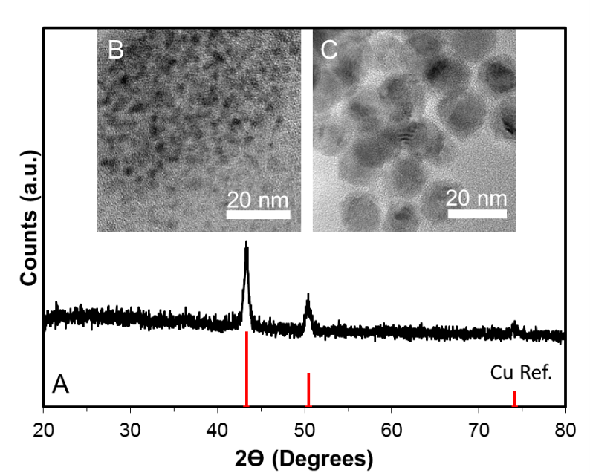

FIG. S1. (A) XRD of copper nanocrystals from copper (II) acetylacetonate in oleylamine with reference to JCPDS# 4-836 (red). (B,C) TEM image of Cu nanocrystals synthesized from Cu(acac)₂ in oleylamine at (B) 200 ºC, and (C) 300 ºC. The average diameter increases from 3.8 nm to 15.0 nm respectively and statistics can be found in FIG. S4.

Copper nanocrystals are formed from copper (II) acetylacetonate (99.99%, Sigma Aldrich) in oleylamine (80-90%, Acros) heated to 300 ºC for 30 min under argon in a standard Schlenk line apparatus. Particles were collected and washed in a 1:1 by volume toluene:ethanol solution.

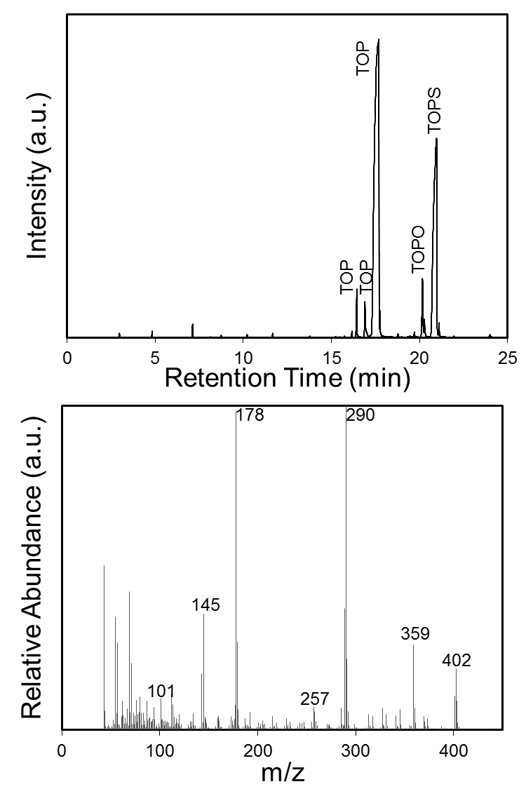
B
A

FIG. S2. Gas chromatograph (A) and mass spectrum (B) of P₂S₅ in TOP diluted in toluene confirming the formation of TOPS. The mass spectrum (B) is of the gas phase peak at 21min.
Gas chromatography-mass spectroscopy data of the trioctylphosphine (TOP) and P₂S₅ mixture is depicted in FIG. S2 above. TOP, trioctylphosphine oxide (TOPO), and trioctylphosphine sulfide (TOPS) are observed. The characteristic mass spectrum for TOPS consisting of the main species, m/z 402, and its octyl- groups (C₈H₁₇), m/z 290 and m/z 178, are observed from the mass spectrum of the peak at 21 min. The experiment also indicated an unusual observation of an ion with m/z 359. This indicates the loss of a C₃H₇ ion. The leftover product would then potentially consist of a penthiophane ring attached to the phosphorus atom. The loss of this ring (C₅H₁₀S, m/z = 101) would leave an ion with an m/z 257, both of whose m/z are observed. Further, the loss of an octyl- group (C₈H₁₇) from the original de-sulfided phosphorus site would leave an ion consisting of C₈H₁₇P with an m/z of 145, which is observed as well. We hypothesize the observed breakdown could be related to the McLafferty rearrangement.¹ Regardless, results support the hypothesis that TOP froms TOPS in the presence of P₂S₅.

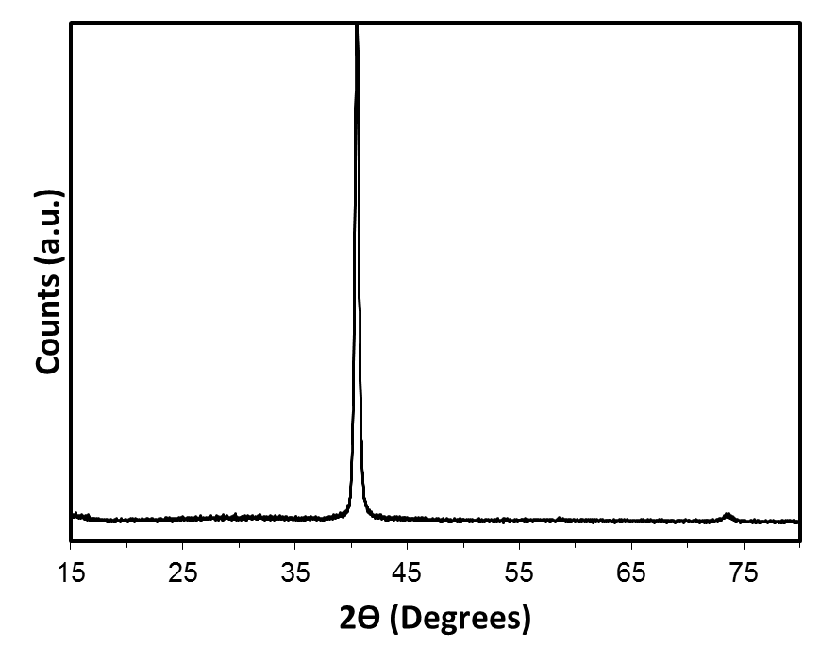
Mo
Mo
FIG. S3. XRD of amorphous red phosphorus on a molybdenum substrate. No characteristic peaks are observed besides the substrate (molybdenum) peaks. The background was not subtracted from this data.

The TOP-P₂S₅ precursor used in standard Cu₃P syntheses was injected into hot oleylamine (300 ºC) without the presence of copper. A red, insoluble precipitate formed which was washed with toluene and cast on a molybdenum coated glass substrate as a reference. XRD in FIG. S3 showed no characteristic peaks other than the substrate. SEM EDS analysis of the precipitate showed a phosphorus:sulfur ratio greater than 100:1. Thus the precipitate was concluded to be amorphous red phosphorus.

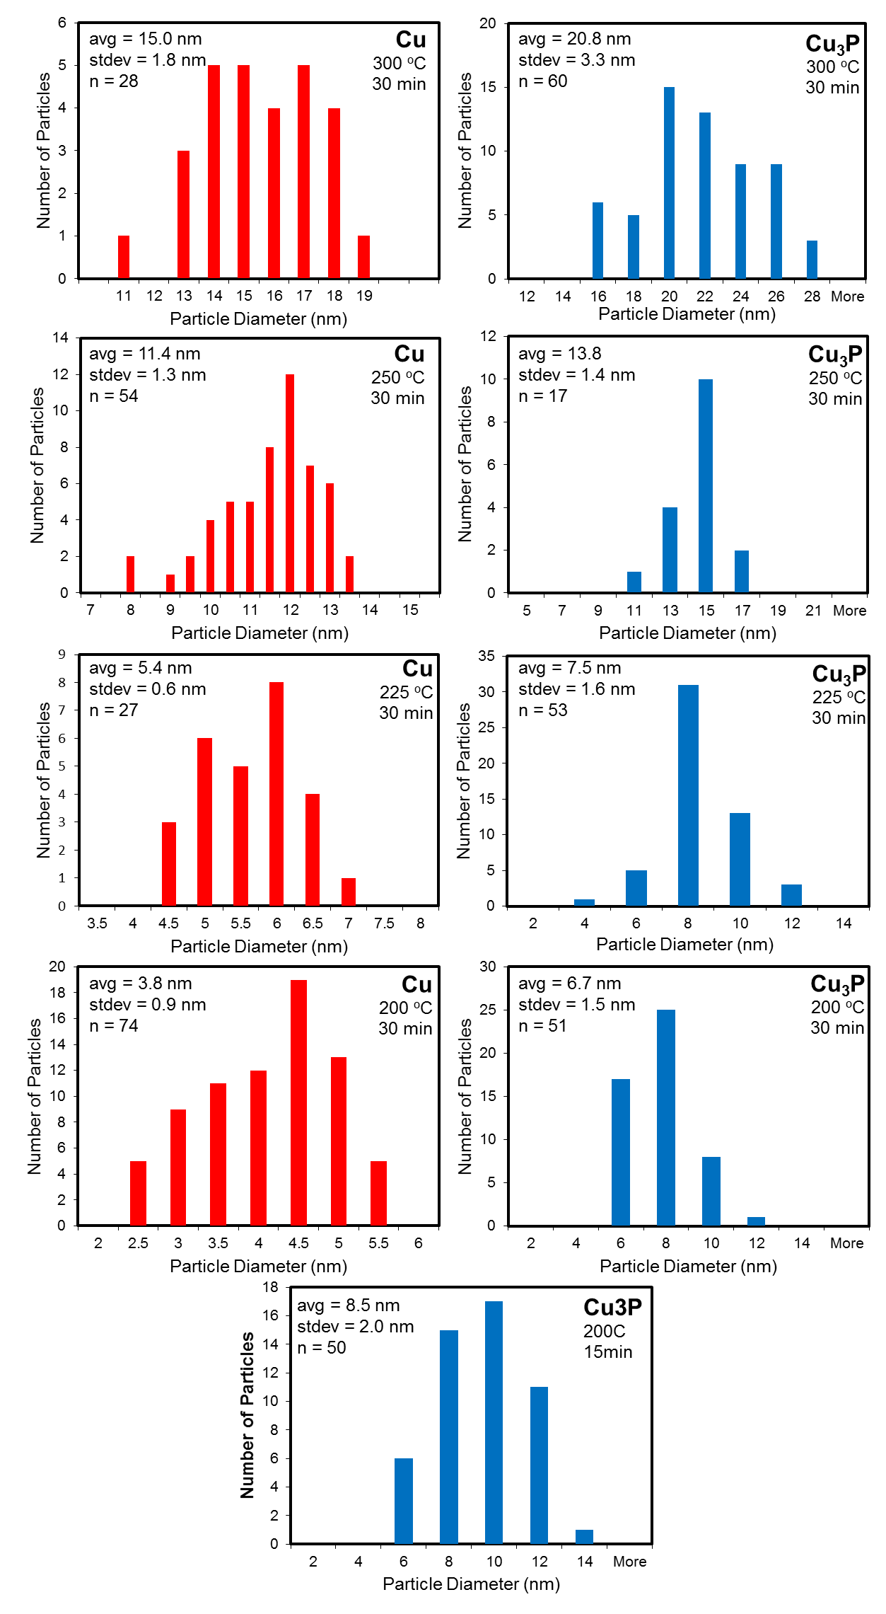
FIG. S4. Particle size distributions for parent copper nanoparticles and as synthesized Cu₃P nanoparticles. Bin sizes on the x-axis represent the maximum size of the particles per bin.
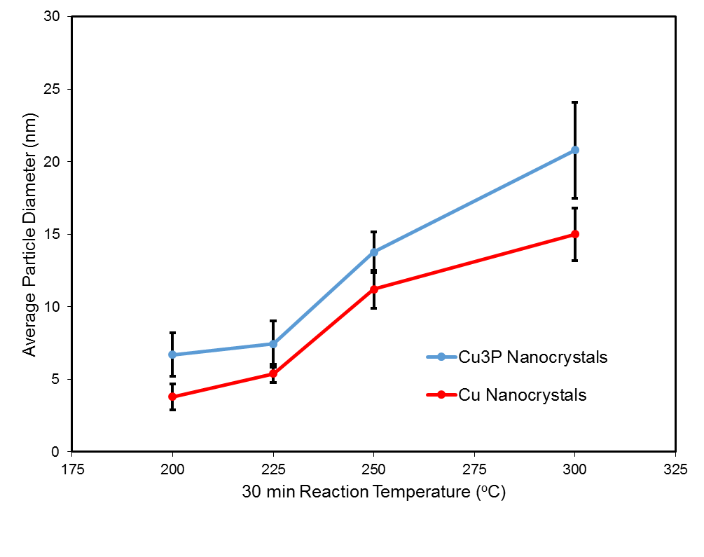
FIG S5. Plot of the average particle diameters and standard deviation (error bars) for the series of experiments observing the growth of copper nanoparticles before their reaction with the P₂S₅-TOP solution at various temperatures.

FIG. S6. Cu₃P nanocrystals synthesized at 200 ºC are much smaller in comparison to the nanocrystals grown at 300 ºC seen in FIG. 2(a).

From FIG. S4-6, we have concluded that the size of the copper nanocrystals initially formed before the injection of the phosphorus source is related to the final size of the Cu₃P nanocrystals. TEM images of copper nanoparticles prior to the injection of the P₂S₅-TOP solution were obtained from removing a small sample (approximately 0.2 mL) at the temperature indicated in FIG S4. Final products after the injection of the P₂S₅-TOP solution were washed and analyzed for particle sizes for comparison to their copper precursor. Particle diameters were measured by hand using ImageJ software. As temperature increases, so does particle size. A summary of all the data in FIG. S4 is presented as FIG S5.

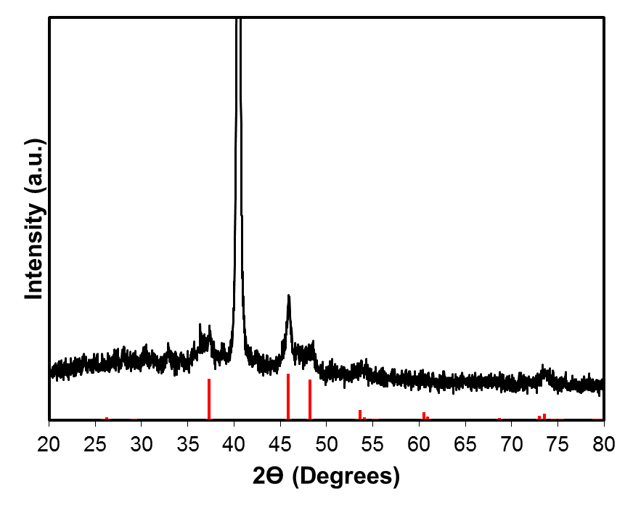
Cu₂S
Exp.
Mo
Mo
FIG. S7. XRD pattern of the product observed following the reaction of P₂S₅-TOP solution with in-situ formed copper nanocrystals in OLA at 300 ºC for 30 min. The minimum molar quantity of TOP was used that would react with all the sulfur from P₂S₅ to observe the effect versus the standard synthesis (excess TOP). Cu₂S was formed (red) (PDS # 53-522).
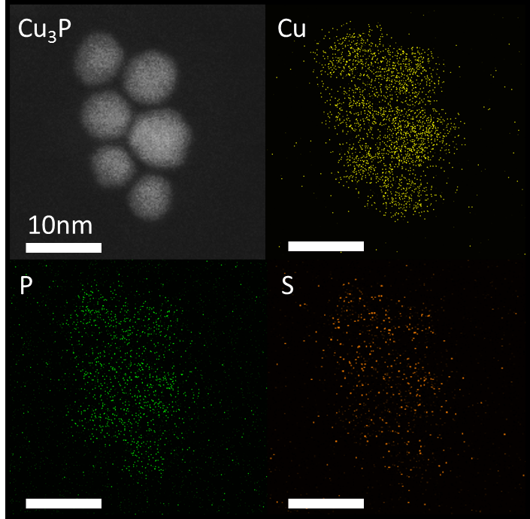
FIG. S8. Dark field STEM image of Cu₃P standard nanocrystals and subsequent elemental maps of Cu, P, and S using EDS.
STEM EDS maps of standard Cu₃P nanocrystals obtained in a 300 kV STEM (FEI Titan) were used to confirm the homogeneity of the synthesized particles. The elemental distributions of Cu and P are found consistent throughout the sample. The weak sulfur signals that coincide with the nanocrystals in the S map are likely due to TOP/TOPS capping ligands on the surface. Compared to that of Cu and P, the signal-to-noise ratio of S map is relatively low and the elemental distribution hardly defines the shapes individual particles. In order to further confirm this, a STEM EDS linescan was performed across the Cu₃P nanocrystals (FIG. S9). In the stacked profile, the copper and phosphorus signals are strong and consistent throughout the particles, while the sulfur signal observed is noisy and weak. On the basis of the EDS results here and the PXRD analysis in manuscript, the observed S signals are merely contributed to the surface ligands or small amount of solutes in the Cu₃P phase.
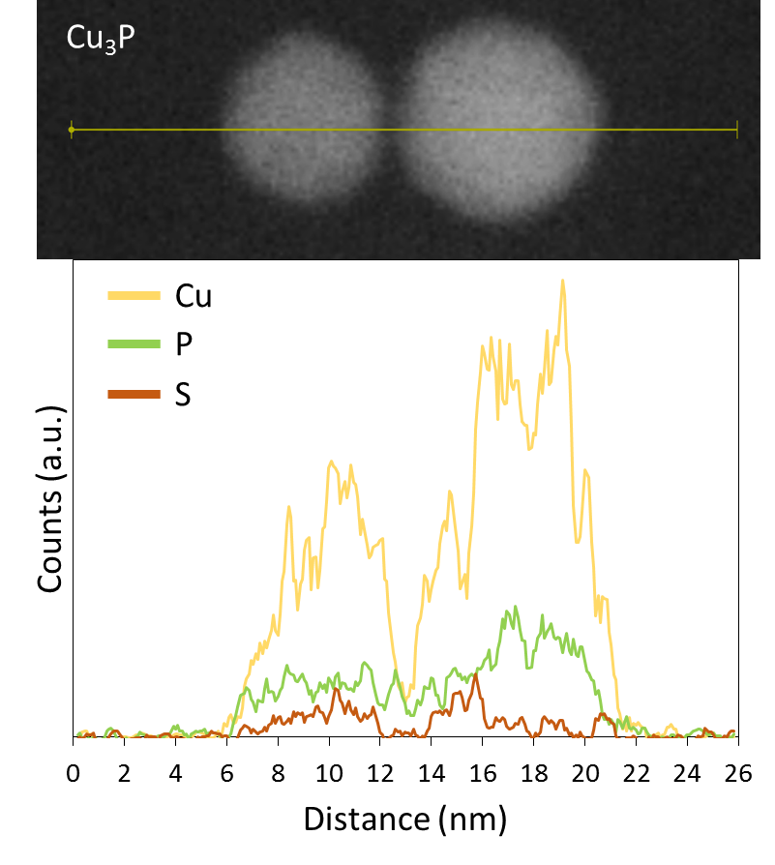
FIG. S9. Dark field STEM image of Cu₃P standard nanocrystals and subsequent elemental linescan of Cu, P, and S using EDS.

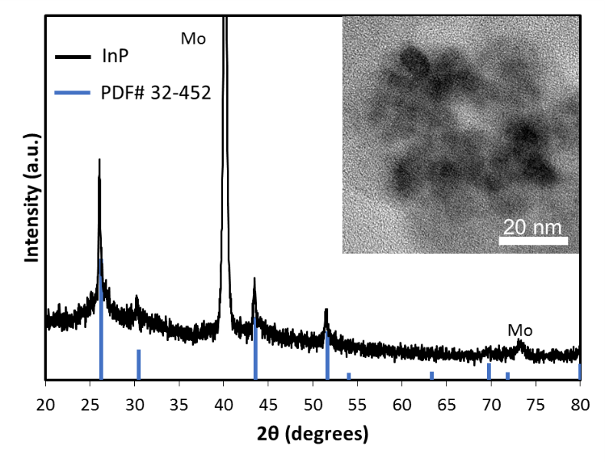
FIG. S10. XRD pattern of InP nanoparticles synthesized by adding 1 mmol InCl₃ and 10 ml of 1-octadecene to a flask and heating to 300 ºC when a 0.5 mmol solution of P₂S₅ in 4.5 ml TOP is injected. After 2 hours, the product was cooled and washed with toluene and ethanol. InP nanoparticles are drop cast on molybdenum coated soda-lime glass. (inset) Bright field TEM image of an initial InP nanoparticle cluster.
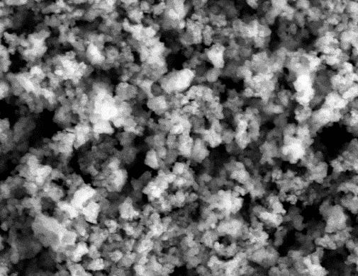
10 μm

Intensity (a.u.)

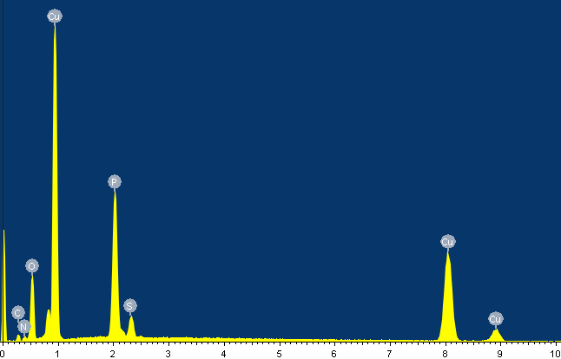

keV

FIG. 11. SEM image and SEM EDS spectra of the Cu₃P nanoparticles as synthesized. Copper and phosphorus dominate the spectrum with a trace of sulfur.

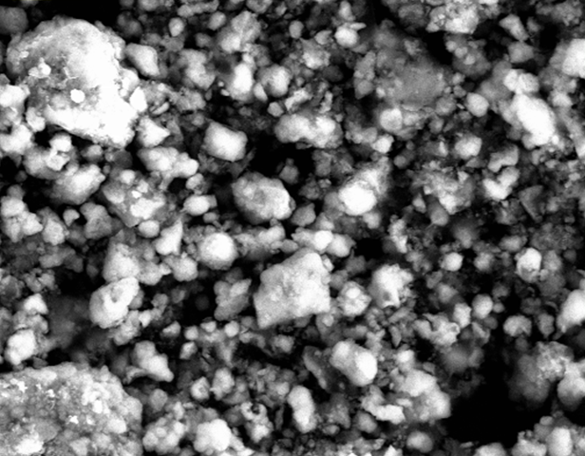
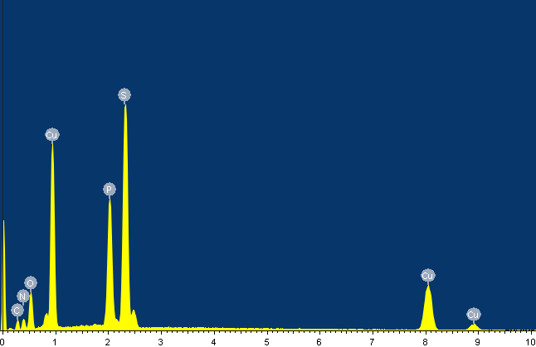
20 μm
keV
Intensity (a.u.)

FIG. S12. SEM image and SEM EDS spectra of the Cu₃PS₄ particles using decomposing thiourea in 1-octadecene. Copper, phosphorus, and sulfur are present with an increase in the sulfur conent compared to the original Cu₃P sample.
FIG. 13. TEM image of Cu₃PS₄ particles from the reaction of Cu₃P with decomposing thiourea without a solvent present (1-octadecene).

FIG. S14. STEM EDS linescan showing compositional uniformity across the particles by taking the ratio of elemental signals as a function of location (5 point moving average). An effectively flat line is observed in the location of the particles. Near the thin edges of the particles, low detected photon counts cause an increase in the observed noise. Note that the flat ratios (approximately 0.75 and 0.25 for Cu/S and P/S respectively) do not precisely correspond to the compound’s overall atomic ratios.

