**Supplementary Information for:**

**Grain Growth Resistant Nanocrystalline Zirconia by Targeting Zero Grain Boundary Energies**

By: Sanchita Dey1, Chi-Hsiu Chang1, Mingming Gong1,2, Feng Liu2, Ricardo H.R. Castro1*\**

*1 Department of Chemical Engineering and Materials Science & NEAT ORU, University of California - Davis, One Shields Avenue, Davis, CA*

*2 State Key Laboratory of Solidification Processing, Northwestern Polytechnical University, Shaanxi, Xi’an 710072, P.R. China*

**Considerations on Activation Energy Analysis**

Kissinger equation can be expressed as:

$\frac{d(ln\frac{Φ}{T_{p}^{2}})}{d(\frac{1}{T_{p}})}= -\frac{Q}{R}$ (S.1)

(*Tp*) vs. ln (*Φ*/ *Tp2* ) Where, *Φ* is the reaction rate, *Tp* is the peak temperature, *Q* is the activation energy and *R* is gas constant 42,43. The slope of the straight line fit through the points gives activation energy for the grain growth. Though this method is extensively used to study grain growth, strictly speaking, Kissinger analysis is only suitable for the case where the grain boundary (GB) and the GB mobility (in other words, GB migration activation energy) are constant along the process. That is, consider grain growth can be described by:

 (S.2)

where *G* denotes the grain size, *t* the grain growth time, *M* the grain boundary (GB) mobility (equal to *M*=*M0*/*T*exp(*-Q/RT*) with *M0* as a constant, *T* the absolute temperature, *Q* the GB migration activation energy, and *R* the molar gas constant) , γ the GB energy, and *n* the growth exponent that depends on the growth mechanism and is theoretically equal to 2. *When the GB energy and the GB mobility (activation energy) are constant during the process of grain growth*, the integral of Eq. (S.2) leads to, for isothermal process,

 (S.3)

and for the process at the constant heat rate,

 (S.4)

where G0 and T0 respectively represent the grain size and the temperature at the beginning of grain growth, and *I(T)* is an integral function of temperature including GB energy *γ* and activation energy *Q*. If the GB energy (activation energy) changes during this process, e.g. the GB energy is reduced by dopant segregation in GBs, Eq. (S.3) and/or Eq. (S.4) cannot be obtained from the integral of Eq. (S.2). For this case, if we still insist to adopt the form of Eq. (S.3) and /or Eq. (S.4) to present the grain size dependent on time and/or temperature, the GB energy and the activation energy included in the constant k(T) should be replaced by their average.

In order to deduce the activation energy, only constant heating rate process is considered in the following section. *The invariable GB energy enables the following relation*:

 (S.5)

where *H* denotes the total GB enthalpy of the system, subscript “0” represents the initial state of grain growth. Actually, *Eq. (S.5) plays the crucial role in Kissinger analysis of grain growth process since it relates heat release and grain growth*. As for the case of dopant segregation in GBs, this last equation cannot be held any more, instead, additional physical relations should be employed, e.g. specified expression of GB energy (affected by GB segregation) as function of grain size, in order to establish the relation between heat release and grain size. Further mathematical treatment of Eq. (S.5) in combination of Eq. (S.4) gives rise to the Kissinger equation:

 (S.6)

As for the current work, Kissinger analysis should be suitable for the derivation of activation energy of 12YSZ due to its constant GB energy and activation energy. However, due to the segregation of La3+, the average GB energy of 2La10YSZ has been confirmed to be noticeably reduced as compared with that of 12YSZ, which further suggests a changed GB energy during the process of grain growth. Then the activation energy of 2La10YSZ is also inferred to change during this process. Besides, the heat rate *Φ* also affects the grain growth as well as GB segregation, implying the activation energy affected by GB segregation may also be different at different heat rate. Consequently, if still using Eq. (S.6) or Eq. (S.1) to conduct Kissinger analysis, an average of activation energy will be derived for 2La10YSZ, probably accompanied with a non-ignorable deviation from its true value due to the error produced in the process of deducing Kissinger equation.

**Grain boundary energy measurement for 38 nm grained 2La10YSZ**

The procedure to measure the grain boundary energy for this size was exactly the same as for the previous presented for 9 nm grain size, using the same DSC instrument, atmosphere, sample preparation conditions, baseline corrections, and heat integration method. The only difference was in the measurement of the grain size distribution, which for this sample was performed using Scanning Electron Microscopy (SEM) instead of TEM. This can potentially lead to a larger grain size as when measuring from TEM since in TEM low angle and low sigma boundaries are more visible. Note that an overestimation of the grain boundary area will lead to an overestimation of the grain boundary energy since the energy is divided by the area. Hence the final result of 0.36 J.m-2 is the maximum value and can potentially be smaller (which would be even more consistent with the thesis of zero-energy boundary). See representative images in Figure S4for reference.

The grain sizes before the DSC peak was 40.9 nm and after was 328.4 nm. The size distribution is shown in Figure S4. The total energy measured in the DSC peak was 3.5014 J/g. By applying the change in GBA as 9.6084 m2/mol, the grain boundary energy of 0.36 J/m2 was determined.

**Supplemental Figures**

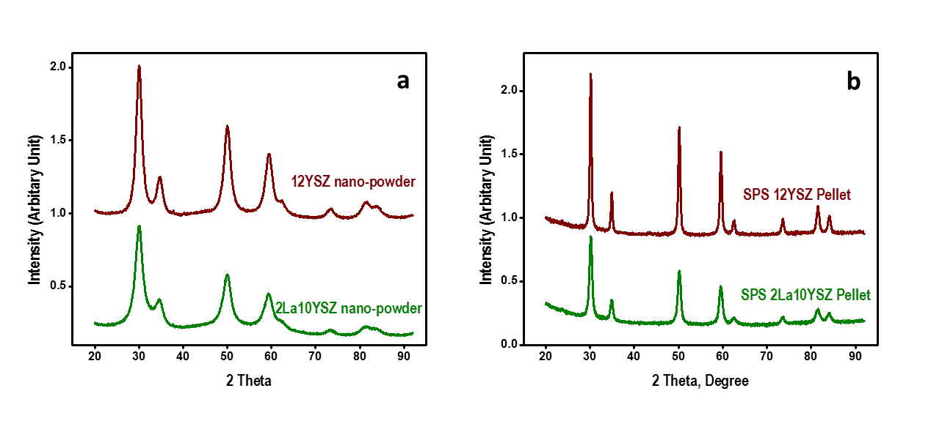**Fig S1:**

Figure S1: *XRD of all Nanopowders and sintered pellets.* (a) XRD patterns of synthesized 12YSZ (wine color) and 2La10YSZ powders (Olive color curve), and (b) XRD patterns of SPS 12YSZ pellets (wine color) and SPS2La10YSZ pellet (olive color).

**Fig S2:**

Figure S2: *Activation energy of grain growth*: Kissinger plot using DSC runs of grain growth in both 12YSZ and 2La10YSZ. Fitting showed quite similar slopes, consistently with similar activation energies, and supporting role of thermodynamics in controlling the process.

**Fig. 3S:**

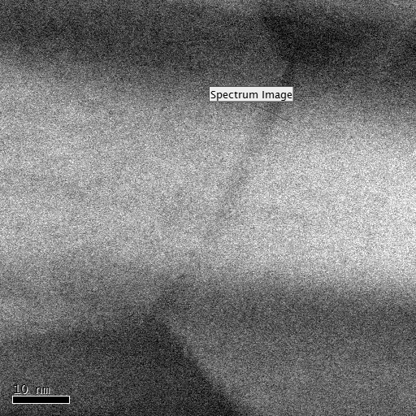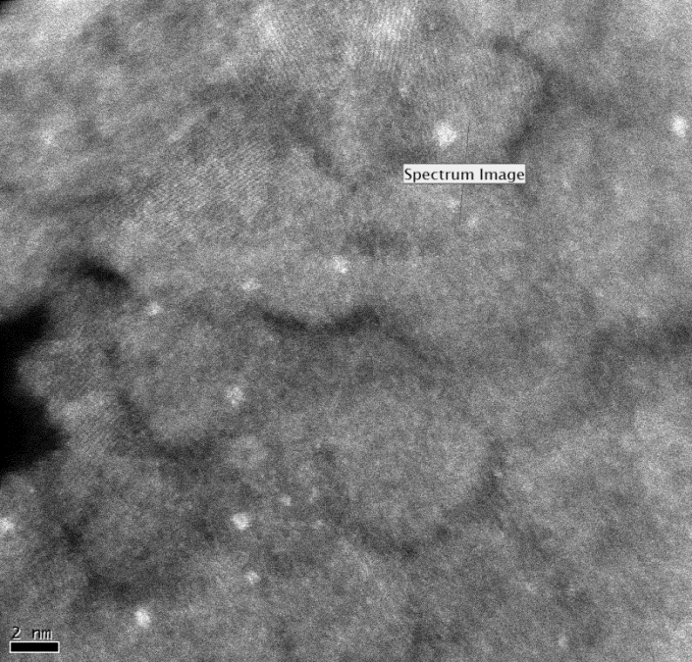

Figure S3: *EELS Survey Images* : Electron Energy Loss Spectroscopy (EELS) survey images for spectrum taken using STEM DF for 2La10YSZ calcined at 900°C (left) and 1300 °C (right). These are representative images of the samples, but multiple analyses were performed.

**Fig. S4:**

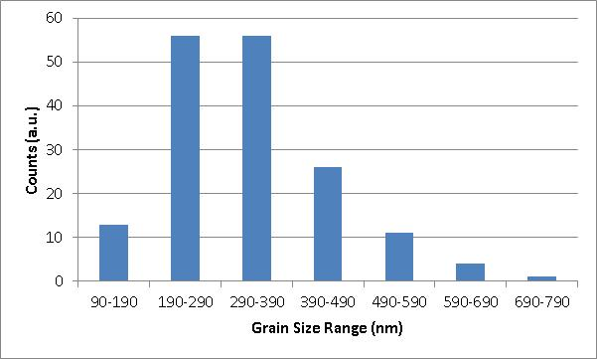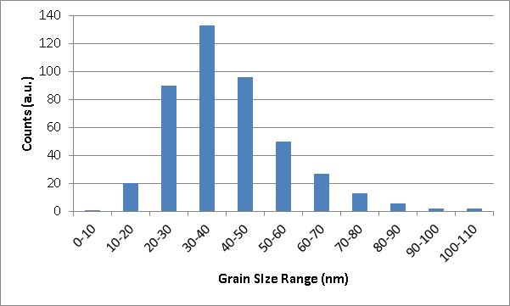

D:\My Documents\1 Current\My Articles\Sanchita - GG YSZ\Nature Comm\before-LaYSZ-40nm.tif D:\My Documents\1 Current\My Articles\Sanchita - GG YSZ\Nature Comm\after-LAYSZ-380nm.tif

**Figure S4.** *Grain sizes for DSC in large grained sample:* SEM image of 2La10YSZ with 40.9 nm before and after peak of DSC and respective size distributions.