

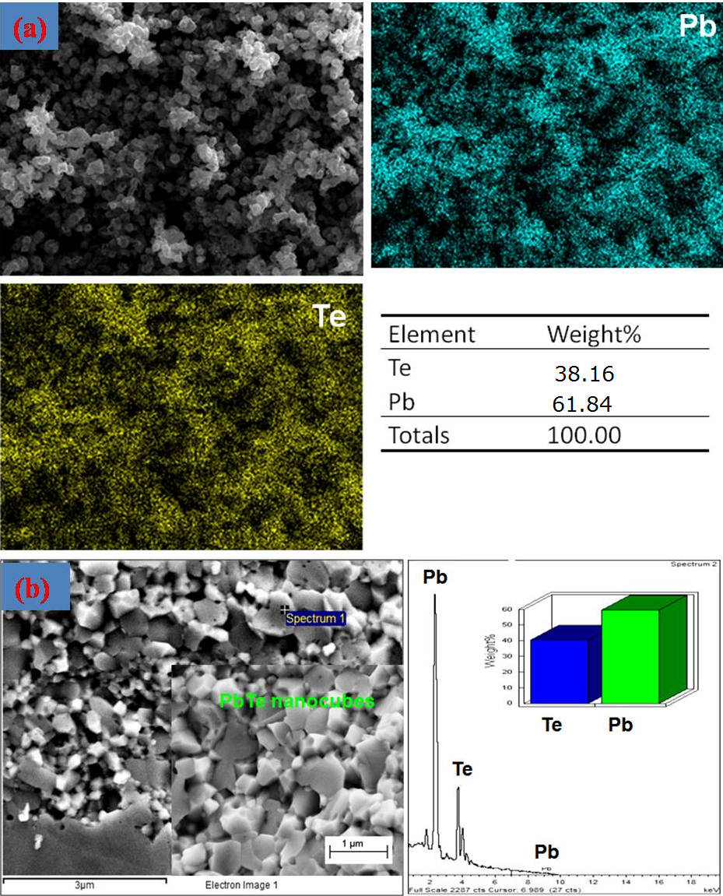Fig. S1: Rietveld reﬁned XRD analysis of the SPS processed PbTe nanocubes.

Fig. S2(a) Elemental mapping of PbTe nano cubes illustrates the homogenous distribution of Pb and Te with 1:1 atomic ratio, (b) FESEM image and EDAX of SPS PbTe nanocubes confirm that Pb and Te have the same ratio after SPS.



Fig. S3 (a) The electrical conductivity as a function of T-1.5, indicating acoustic phonon scattering in the temperature range (300-450) K. Fig. S3(b) shows dS/dT *vs*. a temperature.