Pt-Pd catalytic nanoflowers: synthesis, characterization and the activity toward electrochemical oxygen reduction.
Simon Tymen, Andreas Undisz, Markus Rettenmayr, Anna Ignaszak

Fig. S1 XRD patterns of Pt/C commercial catalysts and 30NP, 45NP and 60 NP supported on carbon.

Table S1. Lattice constant calculated for the face-centered cubic structure of PtPd clusters.

Sample | Lattice constant (Å)
Pt reference | 3.920
Pd reference | 3.890
Pt/C | 3.917
30NP | 3.907
45NP | 3.908
60NP | 3.904

The number of electrons exchanged in mass-transport limited potential range (0.508 V) was calculated according to Levich equation of the diffusion current dependence on the rotation speed:
$$i_{d}=0.602∙n∙F∙A∙c_{O2}∙{{(D}_{O2})}^{2/3}∙γ^{-1/6}∙ω^{1/2}$$
Where i_{d} is the diffusion current (or Levich current) (A), n is the number of electrons, F is the Faraday constant (96485.34 C.mol⁻¹), A denotes to the area of the RDE (0.19635 cm⁻²), c_{O2} is the concentration of oxygen in electrolyte (1.146.10⁻⁶ mol.cm⁻³), D oxygen diffusion coefficient in 0.1 M HClO₄ (1.930.10⁻⁵ cm⁻² s⁻¹), γ is viscosity of electrolyte (1.01*10⁻² cm².s⁻¹), ω RDE rotational speed (1600 rpm or 167.55 rad s⁻¹), values according to [S1].
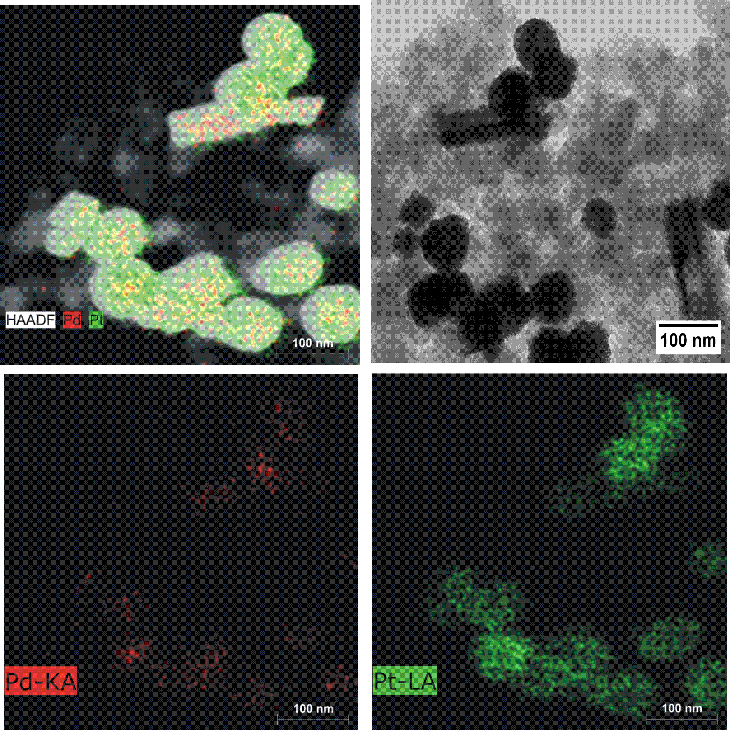
Fig. S2. Spot-resolved EDX mapping of catalytic nanoflowers (example 45NP): Pt and Pd mapping (left top) and a relevant TEM image (right top); bottom images represent distribution of individual Pt and Pd atoms in this sample.
Table S2. Mass transfer-controlled current and number of electrons exchanged at 0.508 V.
Sample | i_{d} ×10⁻⁴ (A) | n (/)
30NP (as-prepared) | -3.38 | 1.17
45NP (as-prepared) | -2.61 | 0.91
60NP (as-prepared) | -2.84 | 0.99
30NP (degraded) | -2.53 | 0.88
45NP (degraded) | -2.52 | 0.87
60NP (degraded) | -2.44 | 0.85

[S1] Hong JW, Kang SW, Choi B-S, Kim D, Lee SB, Han SW. Controlled Synthesis of Pd–Pt Alloy Hollow Nanostructures with Enhanced Catalytic Activities for Oxygen Reduction. ACS Nano. 2012 Mar 27;6(3):2410-9.

