Supplementary Material

Ultramicroporous silicon nitride ceramics for CO₂ capture

Cristina Schitco, *¹ Mahdi Seifollahi Bazarjani, ² Ralf Riedel, ¹ and Aleksander Gurlo ²

¹Technische Universität Darmstadt, Fachbereich Material-und Geowissenschaften, Jovanka-Bontschits-Strasse 2, 64287 Darmstadt, Germany
²Technische Universität Berlin, Fakultät III Prozesswissenschaften, Institut für Werkstoffwissenschaften und -technologien, Fachgebiet Keramische Werkstoffe, Hardenbergstrasse 40, 10623 Berlin, Germany
*Corresponding author: E-mail: schitco@materials.tu-darmstadt.de

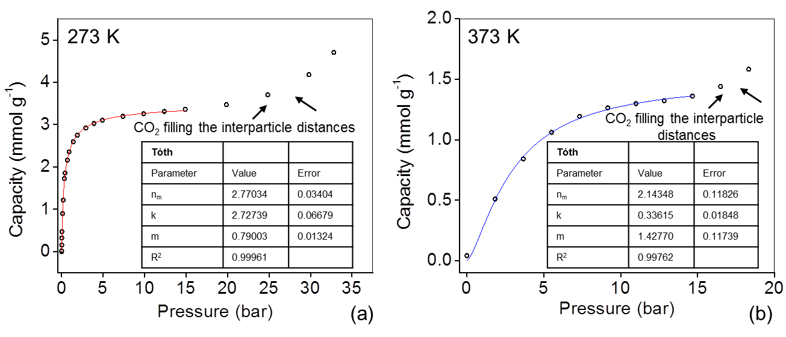
FIG S1. The Tóth fit of CO₂ adsorption isotherm of HTT600NH up to 15 bars at (a) 273 K and (b) 373 K.
TABLE SI. CO₂ adsorption capacities of different materials at 1 bar represented in FIG 5.

 | Sample | Specific Surface Area  [m² g⁻¹] | Pore size  [nm] | Adsorption capacity  [mmol g⁻¹] | Ref.
MOMs | SIFSIX-3Zn | 250 | 0.384 | 2.54^{a)} | ¹
 | SIFSIX-2-Cu-i | 735 | 0.515 | 5.41^{a)} | ¹
 | SIFSIX-2-Cu | 3140 | 1.305 | 1.84^{a)} | ¹
Zeolites | Zeolite 13X | 616 | 1.0 | 3.9^{a)} | ^{2, 3}
Nitrides | MSIN-673 | 1009 | 2.3 | 2.6^{a)} | ⁴
 | HTT600NH | 230 | 0.5 | 2.3^{b)} | This work
Activated carbons | AC | 2994 | 2.35 | 2.1^{a)} | ⁵
a) CO₂ adsorption at 298 K b) CO₂ adsorption at 273 K

1. P. Nugent, Y. Belmabkhout, S.D. Burd, A.J. Cairns, R. Luebke, K. Forrest, T. Pham, S. Ma, B. Space, L. Wojtas, M. Eddaoudi and M.J. Zaworotko: Porous materials with optimal adsorption thermodynamics and kinetics for CO₂ separation. Nature. 495(7439), 80 (2013).
2. Z. Liang, M. Marshall and A.L. Chaffee: CO₂ Adsorption-Based Separation by Metal Organic Framework (Cu-BTC) versus Zeolite (13X). Energy Fuels. 23(5), 2785 (2009).
3. P.D. Jadhav, R.V. Chatti, R.B. Biniwale, N.K. Labhsetwar, S. Devotta and S.S. Rayalu: Monoethanol Amine Modified Zeolite 13X for CO₂ Adsorption at Different Temperatures. Energy Fuels. 21(6), 3555 (2007).
4. H.W. Yang, A.M. Khan, Y.Z. Yuan and S.C. Tsang: Mesoporous Silicon Nitride for Reversible CO₂ Capture. Chemistry-an Asian Journal. 7(3), 498 (2012).
5. C. Zhang, W. Song, G. Sun, L. Xie, J. Wang, K. Li, C. Sun, H. Liu, C.E. Snape and T. Drage: CO₂ Capture with Activated Carbon Grafted by Nitrogenous Functional Groups. Energy Fuels. 27(8), 4818 (2013).

