SUPPORTING INFORMATION

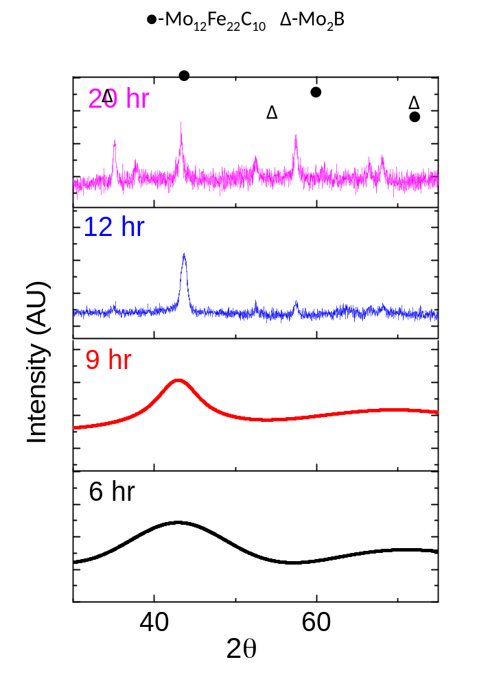
Figure S1a: XRD pattern of 6 hours, 9 hours, 12 hours and 20 hours milled particles.

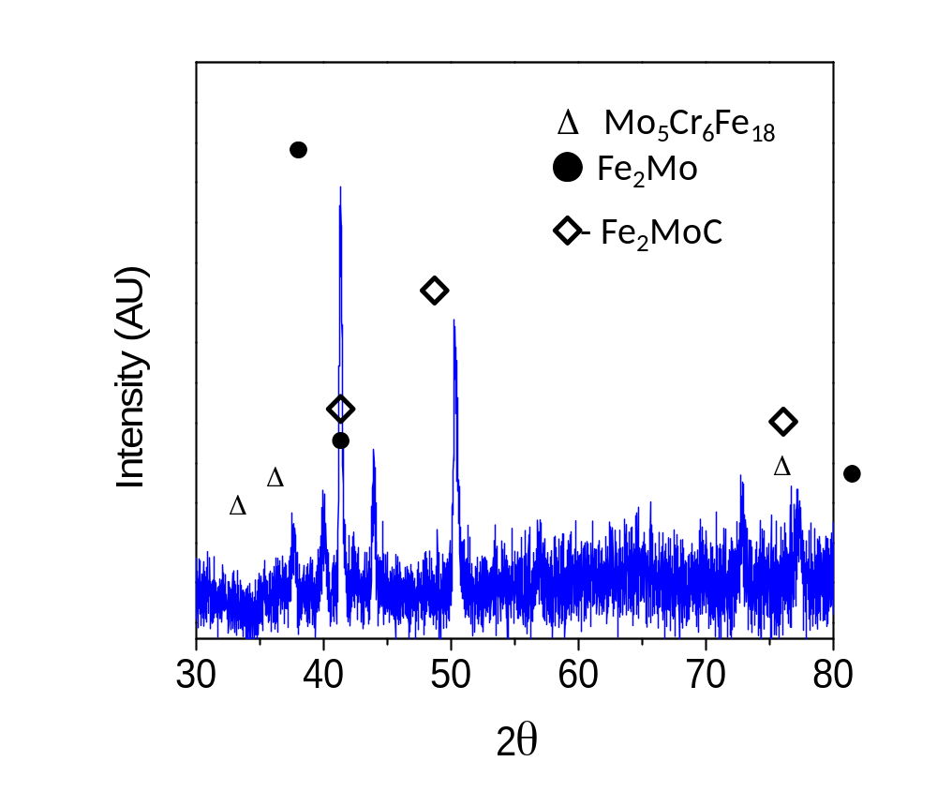
Figure S1b: XRD pattern of furnace crystallized FeMG particles.

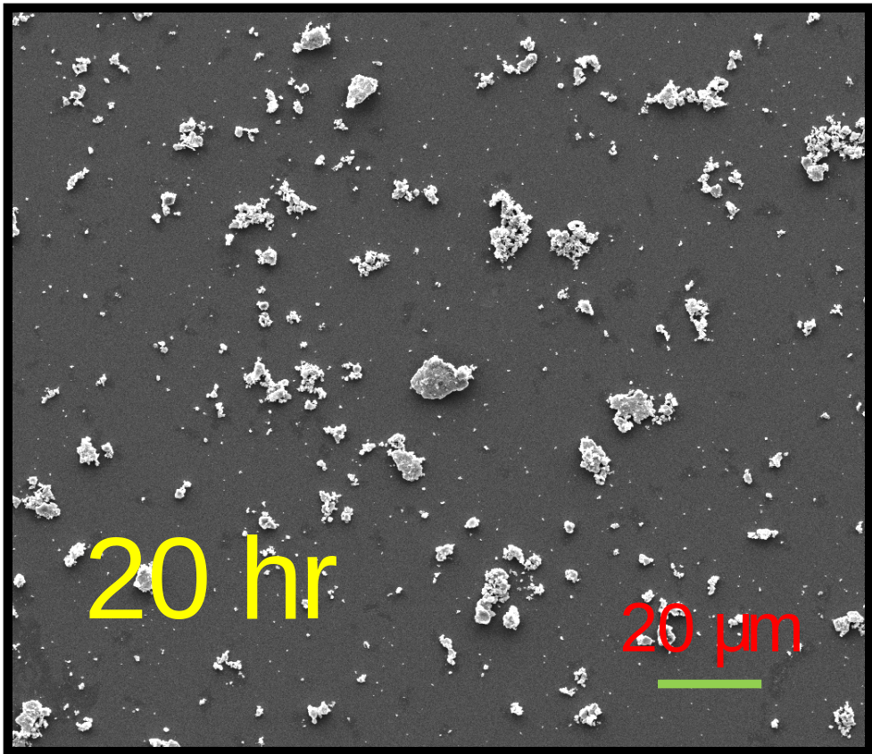
Figure S2: Scanning electron micro-graph showing the morphologies of 20 hours of activated particles in its dispersed form.

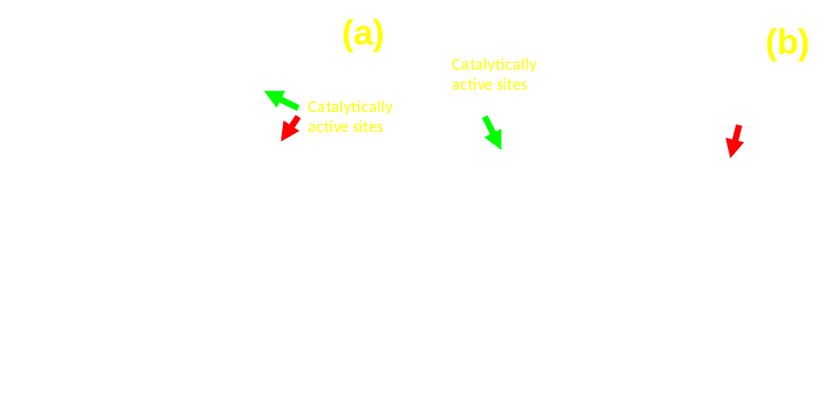

Figure S3: Transmission electron micrograph of 9 hour ball milled FeMG particles with extremely sharp edges as their catalytically active sites.

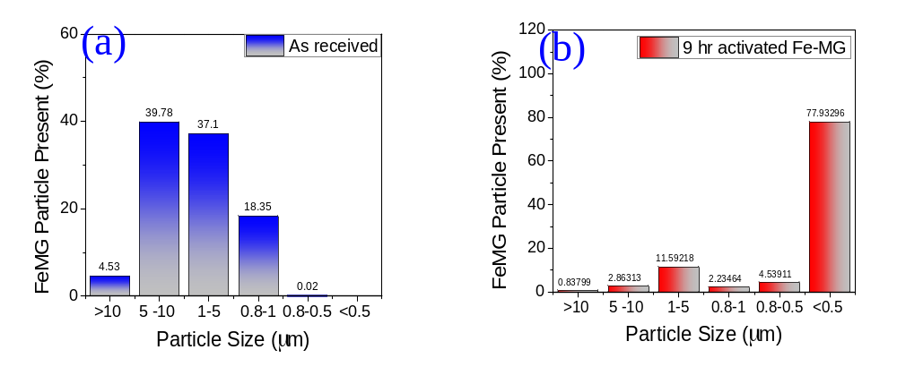
Figure S4: (a) Particle size distribution of as received FeMG particles and (b) particle size distribution of 9 hour activated particles.

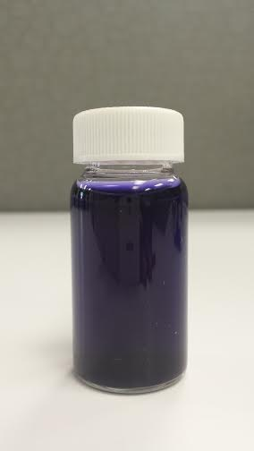

Figure S5: Picture showing the Direct blue dye solution.

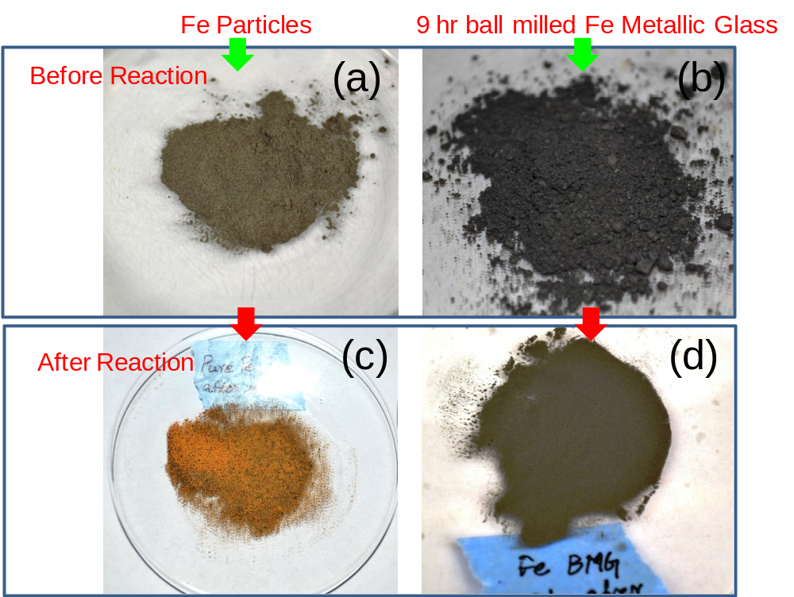

Figure S6: Picture showing the (a & c) Fe micro particles before and after reaction to direct blue dye and (b & d) Fe MG particles before and after reaction.

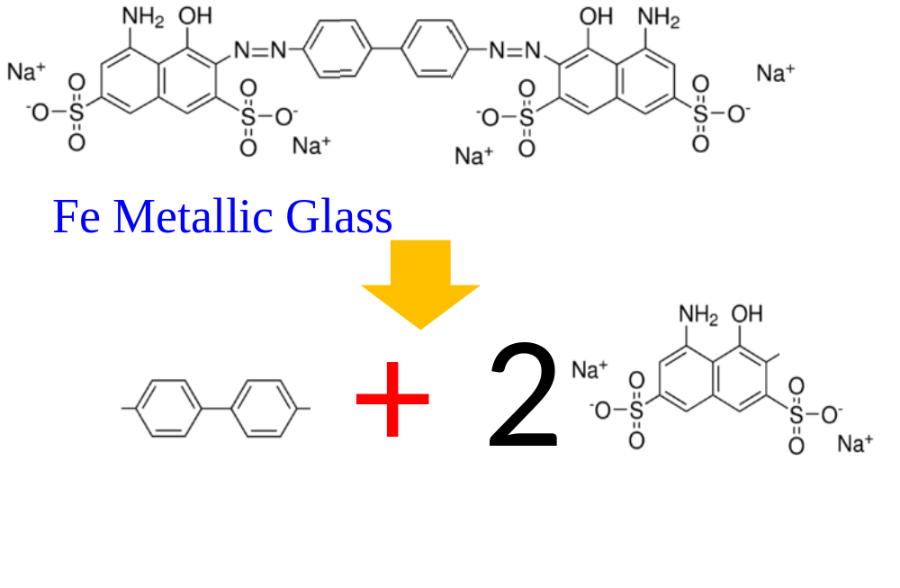

Figure S7: Schematic explaining the mechanism of direct blue dye dissociation under the catalytic influence of Fe metallic glass.

