Supplementary Information

Nan Jiang

Arizona State University, Department of Physics, Tempe, Arizona 85287-1504

1. Decomposition of Li4SiO4 under electron beam irradiation

Li+ ions were released from Li4SiO4 crystal during decomposition under the electron beam: Li4SiO4 crystals transformed into Li-free amorphous SiO2. This was confirmed by EELS analysis. As shown in Fig. S.1a, the spectra were acquired from two different areas in the same decomposed Li4SiO4 particle: one was from a thin and another from a thick area. Characteristic low-energy loss spectra and Si L23-edge near-edge fine structure (ELNES) of am-SiO2 are all observed. Neither spectra show the Li K-edge, which should be around 60 eV, indicating that Li is absent in both thin and thick areas after decomposition. The formation of O2 during decomposition is confirmed by O K-edge EELS (Fig. S1b), in which a characteristic O – O peak is clearly seen [S1]. The absence of this peak in the decomposed specimen indicates that the formed O2 molecules cannot sustain within the particle, instead they burst out into vacuum after decomposition. The image of decomposed Li4SiO4 is given in Fig. S.2. The particle was supported by a lacy C. After decomposition, the features in white patch contrast are due to the burst of O2. Similar phenomena have been extensively observed in other silicate glasses and minerals, which contain alkali or alkaline-earth species [S1 – S3].

Electron-irradiation-induced phase decomposition in this type of materials is caused by the induced electric field due to ionization [S4]. A positively charged shell is thus formed around the Li4SiO4 particle. The depth of the charged shell is determined by the escape depth of these ejected electrons, ranging from a few to several tens of nanometers [S5]. Since the irradiated Li4SiO4 particle was laid on an am-C film, which has moderately good electrical conductivity, the latter can be considered as a local “electrical ground”. Therefore, the electric field inside the Li4SiO4 produced by the charged shell is pointing toward the boundary between Li4SiO4 and am-C, as sketched in Fig. S3. Driven by this electric field, the mobile Li+ ions within the irradiated Li4SiO4 flowed toward the boundary region and spread over the C-film.

Fig. S1. (a) Raw data of low-energy loss spectra acquired from the decomposed Li4SiO4 (solid lines). Specimen thickness is given in term of effective mean-free path of inelastic scattering, λ. Dotted lines are deconvoluted spectra. Si L23-edge EELS are given in inset. (b) Comparison of O K-edge EELS during and after decomposition.

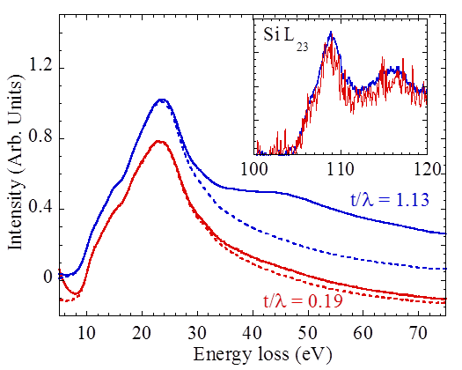

(a)

(b)

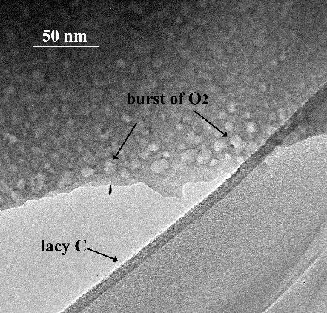 Fig. S2 TEM image of decomposed Li4SiO4 particle.

Fig. S3. A cartoon showing the ejection of Li+ ions from the irradiated Li4SiO4 particle.

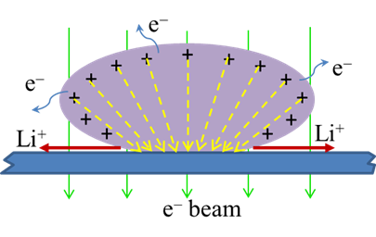

1. Time-dependent EELS

The full set of time dependent EELS of Li K-edge is given in Fig. S.4. The intensity of Li K-edge decreases rapidly. Spectra No. 110 to No. 115 are plotted in a separate graph.

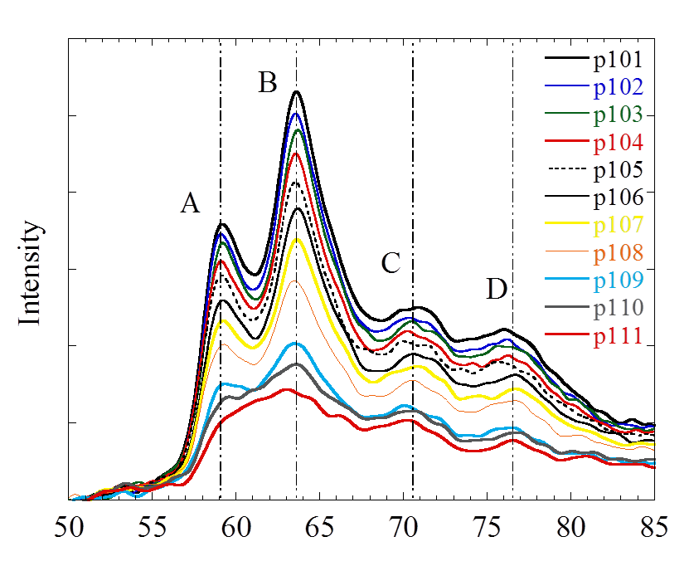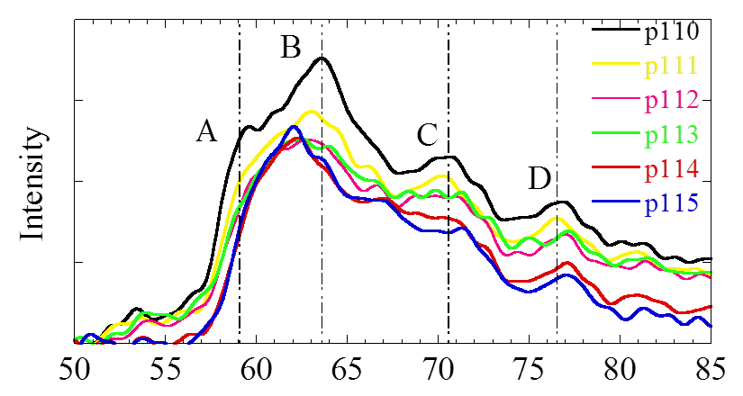

Fig. S4. A full set of time-dependent Li K-edge EELS recorded from the lithiated am-C under Setup I (Fig. 1a in the paper). The spectra were labeled by their sequence of acquisition. Note: both p110 and p111are respectively the same spectra in both panels. Vertical lines are guides.

1. Assignment of Li K-edge EELS in lithiated am-C

The assignment of Li K-edge EELS in lithiated am-C was obtained by comparing its spectrum with the reference Li K-edge EEKS (spectrum was reproduced from [S6]) and momentum transfer dependent inelastic x-ray scattering spectra of LiC6 (reproduced from [S7]), which are plotted in Fig. S5. Although it is still unknown where the Li goes in the disordered carbons, the intercalated Li could either insert between layers of graphite segments [S8, S9] or “coat” both sides of graphene sheets [S10], since disordered carbons show short-range resemblance to graphite or graphene [S11]. Since EELS is more sensitive to the local structure around the absorbing atom, rather than the long-range order structure, the K-edge of the remaining Li can be compared with the Li K-edge of LiC6. Since LiC6 has a layered structure, in which the C atoms form honeycombs directly above and below one another and the Li atoms intercalate between adjacent C sheets and are centered between honeycombs above and below [S12], its Li K-edge EELS is strongly orientation-dependent, on two directions of the momentum transfer [S7, S13]. In disordered carbons, however, the graphite-like or graphene-like segments are randomly orientated. Therefore, the simulations, using code FEFF [S14], were the average of all directions, and the result is also plotted in Fig. S5. Both experiments [S6, S7] and calculation show a single-peak structure, while it is two-peak structure in Li2O. This assignment has also been confirmed by the comparisons with other previous experimental [S13, S15] and theoretical [S16] results in LiC6, and they also fit very well.

Fig. S5. Comparison of Li K-edge from the Li – C component with the experimental data of Li K-edge EELS in LiC6 and calculation.



References:

[S1] Jiang, N.; Qiu, J.; Ellison, A.; Silcox, J. Fundamentals of High-Energy Electron-Irradiation-Induced Modifications in Silicate Glasses. Phys. Rev. B **2003**, 68, 064207.

[S2] Jiang, N.; Silcox, J. Electron irradiation induced phase decomposition in alkaline earth multi-component oxide glass. J. Appl. Phys. **2002**, 92, 2310.

[S3] Jiang, N.; Wu, B.; Qiu, J.; Spence, J. C. H. Precipitation of nano crystals in glasses by electron irradiation: an alternative path to form glass-ceramics? Appl. Phys. Lett. **2007**, 90, 161909.

[S4] Jiang, N. Damage Mechanisms in Electron Microscopy of Insulating Materials. J. Phys. D: Appl. Phys. **2013**, 46, 305502 (10pp).

[S5] Goldstein, J. I.; Newbury, D. E.; Echlin, P.; Joy, D. C.; Fiori, C.; Lifshin, E. Scanning Electron Microscopy and X-ray Microanalysis, (Plenum Press, New York, 1981), pp53-122.

[S6] Wang, F., Graetz, J., Moreno, M. S., Ma, C., Wu, L., Volkov, V., Zhu, Y: Chemical distribution and bonding of lithium in intercalated graphite: identiﬁcation with optimized electron energy loss spectroscopy. ACS Nano **5**, 1190-1197 (2011).

[S7] Schulke, W., Gabriel, K.-J., Berthold, A., Schulte-Schrcpping, H.: Interlayer states of LiC6 investigated by inelastic X-ray scattering spectroscopy (IXSS) using Li-core excitation. Solid State Communications **79**, 657-660 (1991).

[S8] Sato, K.; Noguchi, M.; Demachi, A.; Oki, N.; Endo, M. A mechanism of lithium storage in disordered carbons. Science **264**, 556-558 (1994).

[S9] Stevens, D. A.; Dahn, J. R. The mechanism of lithium and sodium insertion in carbon materials. J. Electrochemical Society **148**, A803-A811 (2001).

[S10] Dahn, J. R.; Zheng, T.; Liu, Y.; Xue, J. S. Mechanisms for Lithium Insertion in Carbonaceous Materials. Science **270**, 590-593 (1995).

[S11] Claye, A.; Fischer, J. E. Short-range Order in Disordered Carbons: Where does the Li Go. Electrochimica Acta **45**, 107-120 (1999).

[S12] Kganyago, K. R.; Ngoepe, P. E. Structural and electronic properties of lithium intercalated graphite LiC6. Phys. Rev. B **68**, 205111 (2003).

[S13] Balasubramanian, M.; Johnson, C. S.; Cross, J. O.; Seidler, G. T.; Fister, T. T.; Stern, E. A., Hamner, C.; Mariager, S. O. Fine structure and chemical shifts in nonresonant inelastic X-ray scattering from Li-intercalated graphite. Appl. Phys. Lett. **91**, 031904 (2007).

[S14] A. L. Ankudinov, B. Ravel, J. J. Rehr, and S. D. Conradson: Real space multiple scattering calculation and interpretation of X-ray absorption near edge structure. Phys. Rev. B 58, 7565(1998).

[S15] Grunes, L. A.; Gates, I. P.; Ritskn, J. J.; Mele, E. J.; DiVincenzo, D. P.; Preil, M. E.; Fischer, J. E. Valence and core electronic excitations in LiC6. Phys. Rev. B **28**, 6681 (1983).

[S16] Titantaha, J. T.; Lamoena, D.; Schowalterb, M.; Rosenauerb, A. Density-functional theory calculations of the electron energy-loss near-edge structure of Li-intercalated graphite. Carbon **47**, 2501-2510 (2009).