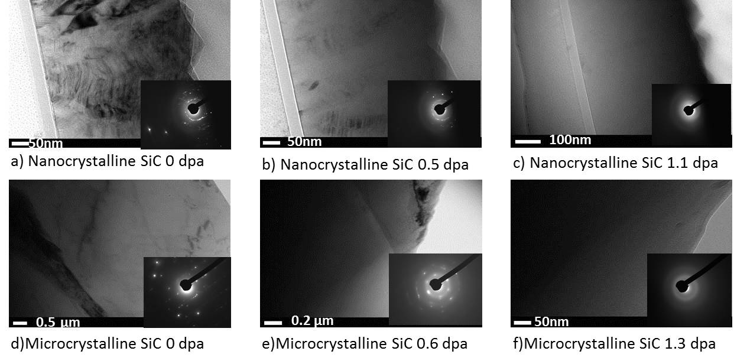
FIG S1: Bright field images for (a-c) nanocrystalline SiC and (d-f) microcrystalline SiC corresponding to the diffraction patterns examined in figure 2 of the main text. These diffraction patterns are included in the insets of the respective bright field image.

