Fig. 1. ¹H NMR spectrum of polymer in the chloroform solution.

Fig. 2. ¹H NMR spectrum of polymer in the DMSO solution.

Fig.3. ¹³C NMR spectra of polymer.

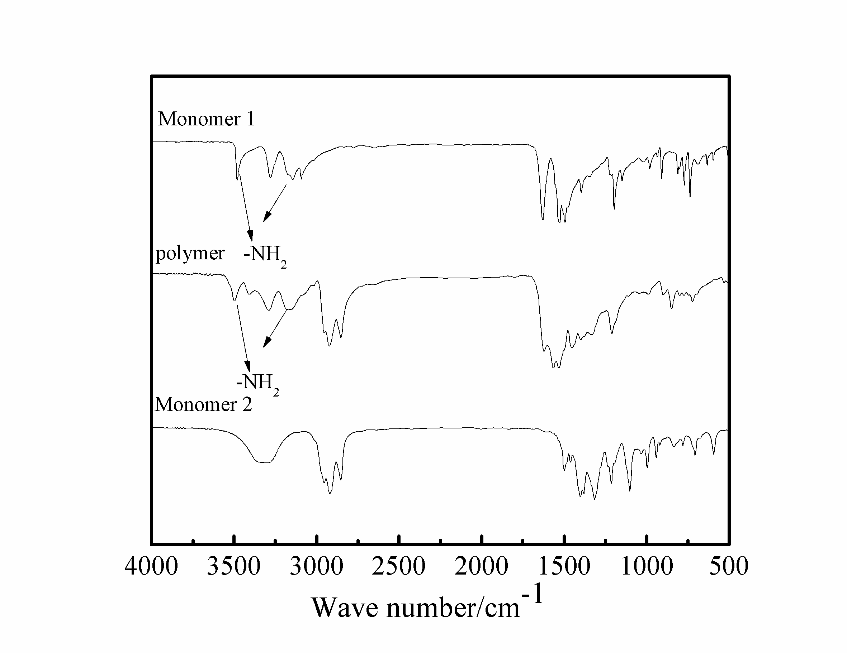

Fig.4 FT–IR spectra of the monomers and polymers. (a)monomer 1;(b)monomer 2;(c) polymer.

