Supporting Information

Static and dynamic hydrophobicity of alumina-based porous ceramics
impregnated with fluorinated oil

Yuta Tsuruki¹, Munetoshi Sakai², Toshihiro Isobe¹, Sachiko Matsushita¹, Akira Nakajima*^{1, 2}

1. PIV system
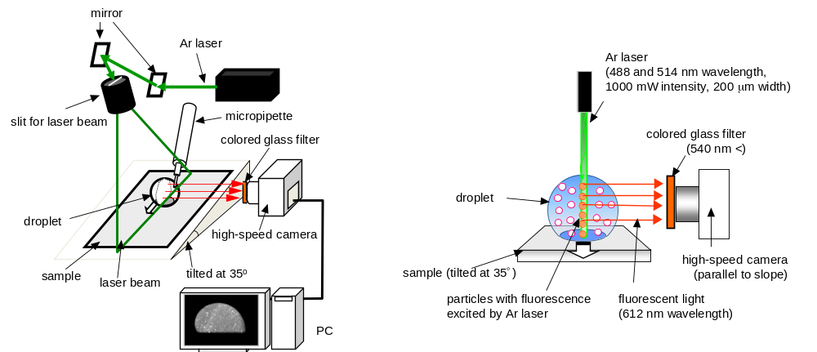
Figure S-1. Schematic illustration of PIV system.
For PIV analysis, the water droplet contained 0.06 mass% fluorescent particles (test fluid). Using a microsyringe, a 20-μL test fluid droplet was prepared on the sample surface inclined at 35°. A sheet-shaped laser beam was emitted vertically to the droplet and was set to the center of droplet during sliding. A dynamic image of the fluorescent light emitted from the particles was taken using a high-speed camera. For this study, we estimated the velocity vectors on each meshed cell region of about 136 × 136 μm² in the entire dynamic image of sliding droplets using time separation of ca. 0.33 ms. Pattern matching for PIV analysis was performed if a correlation factor of 0.65 or greater was found.

2. Droplet control by external electric field
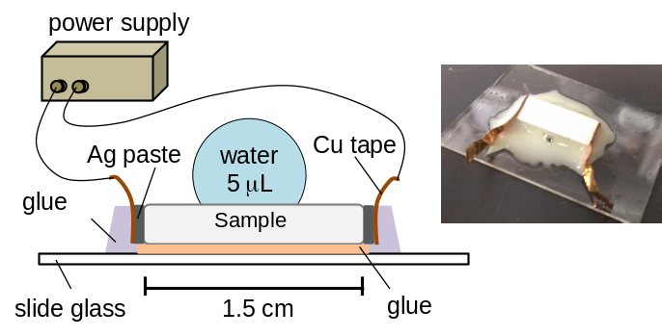

Figure S-2. Schematic illustration and photograph of a sample assembly.

3. Visualization of internal fluidity of water droplets sliding on SLBC surfaces

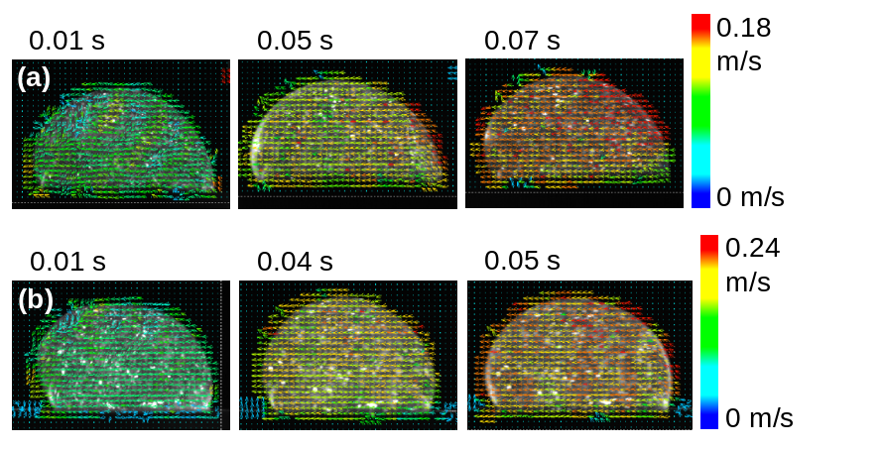

Figure S-3 Practical internal velocity distribution images of a water droplets sliding on sample surfaces: (a) alumina-based porous ceramics fired at 750 °C and impregnated with fluorinated oil (A-f) and (b) alumina-based porous ceramics fired at 750 ºC, treated in hot-water treatment for 4 h, and impregnated with fluorinated oil (R-f). Although the entire velocity increases gradually concomitantly with increasing time, the color inside of the droplet was almost uniform. Its heterogeneity was slight. When rolling elements exist in the fluidity motion, the velocity in the vicinity of droplet circumference becomes great and the resultant color difference becomes remarkable. This figure suggests that slipping is the dominant mechanism for the internal fluidity of the moving droplets.

4. Droplet height change during sliding

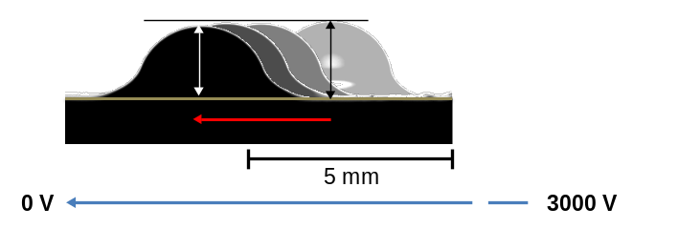
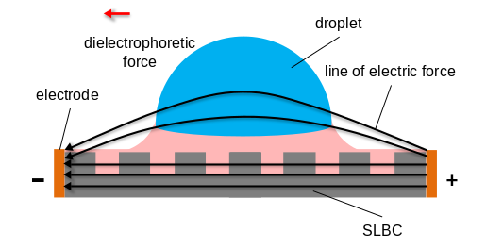

Figure S-4. Change of droplet height under an electric field. Sequential photographs were taken every 5 s. Slightly decreased height is observable during the droplet motion. Because the lines of electric force are not straight between electrodes, but rather curved at the higher position, once the droplet moves from the center position where the electric field is even, dielectrophoretic force might contribute to the droplet motion.

5. Relation between droplet velocity and sliding time

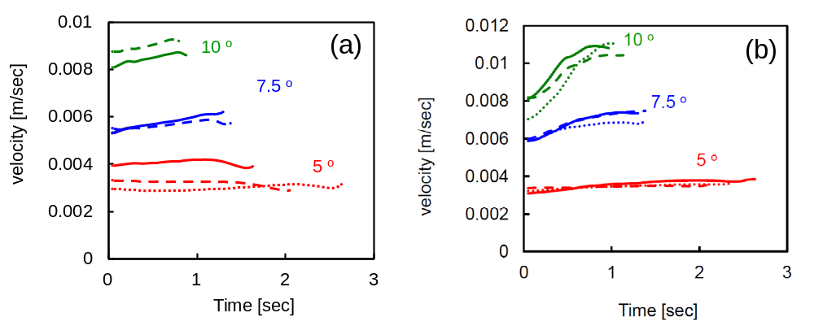

Figure S-5. Relation between droplet velocity and sliding time on the solid–liquid bulk composite (R-f): (a) 3 μL and (b) 10 μL. Measurements were repeated 2–3 times for each condition. Average values were used for plotting Fig. 11.

