Electronic Supplementary Information (ESI)

Synthesis of Tungsten Oxide Nanoparticles using a Hydrothermal Method at Ambient Pressure
Majid Ahmadi¹, Reza Younesi² and Maxime J-F Guinel^{1, 3}
¹Department of Physics, College of Natural Sciences, University of Puerto Rico, PO Box 70377, San Juan, PR 00936-8377, U.S.A.
²Department of Energy Conversion and Storage, Technical University of Denmark, Frederiksborgvej 399, P.O. Box 49, 4000 Roskilde, Denmark.
³Department of Chemistry, College of Natural Sciences, University of Puerto Rico, PO Box 70377, San Juan, PR 00936-8377, U.S.A.

Figure S1. (a) XRD recorded from two TNPs and TNPs annealed at 300ºC for two hours. The upper diffractogram is shifted up by 2,000 counts. (b) Schematic of the orthorhombic tungstite unit cell which transforms to the monoclinic tungsten oxide unit cell by dehydration, upon annealing.
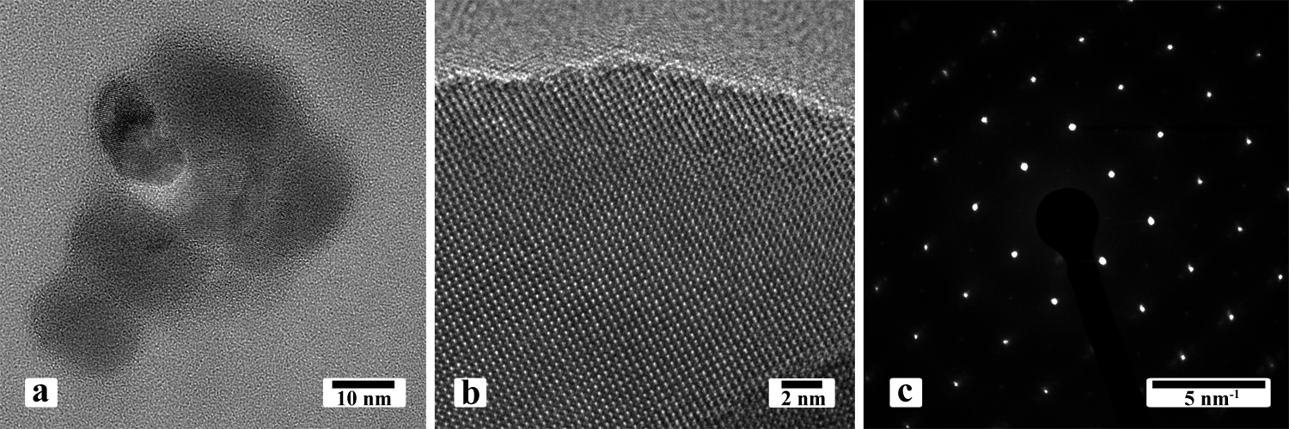
Figure S2. (a) TEM and (b) HRTEM images and (c) corresponding SAED pattern recorded from WNPs (TNPs heat treated at 500ºC) indexed to monoclinic WO₃.
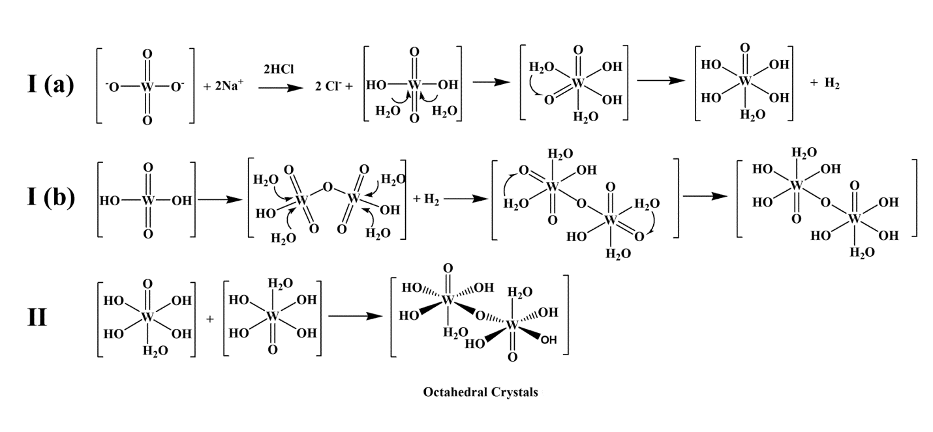
Figure S3. Proposed mechanisms with two steps; I (protonation of tungstate ions) and II (dimerization and crystallization of tungstite) yielding tungstite (WO₃.H₂O).

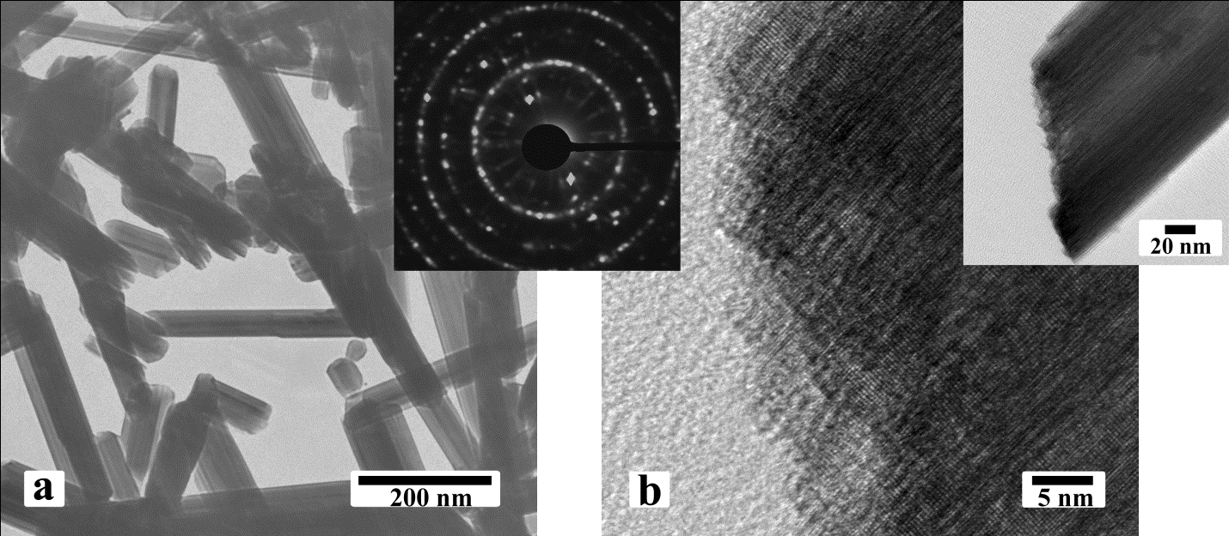
Figure S4. TEM (a, b and its inset) images showing tungstite nanorods obtained with the presence of 5mM sulfate ions. The growth direction was found to be in <111>.The inset is the corresponding tungstite orthorhombic SAED pattern.

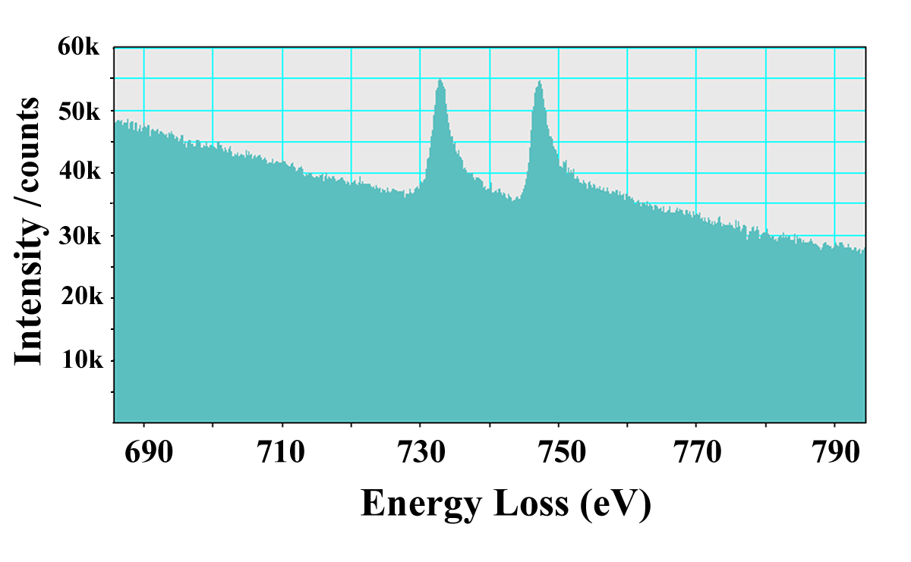
Figure S5. EELS showing the Cs-M_{4,5} edge recorded from TNPs obtained with the presence of 10mM Cs⁺ ions.
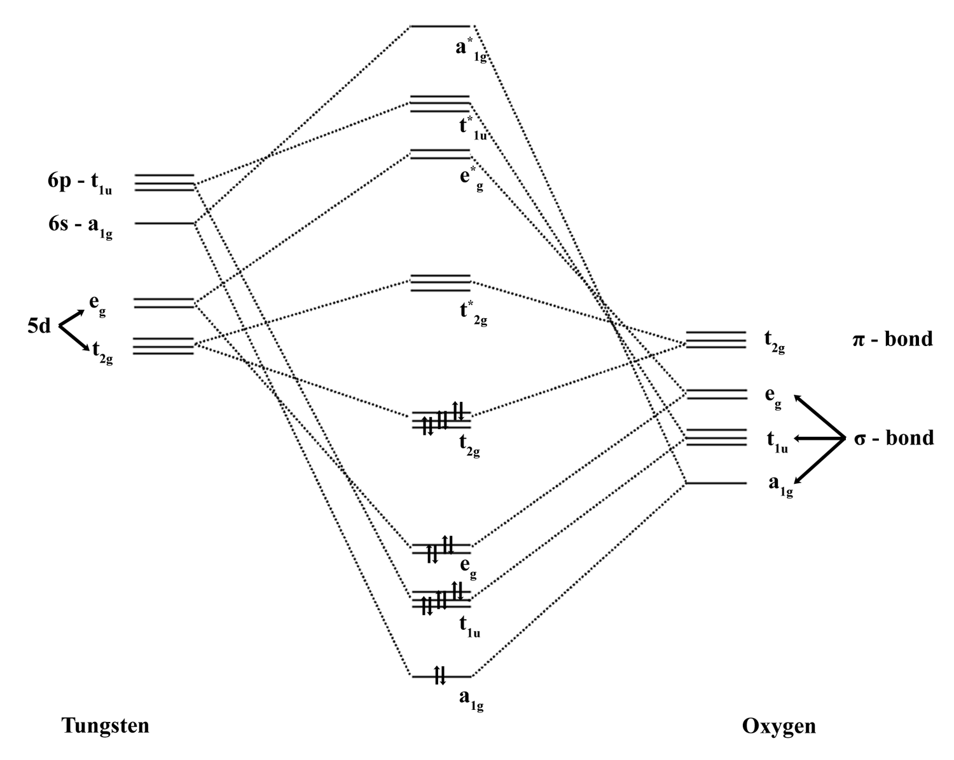
Figure S6. Molecular orbital diagram for WO₃.

Corresponding author: maxime.guinel@upr.edu

