Supporting information

Facile synthesis of the SiO₂/Au hybrid microspheres for excellent catalytic performance

Xin-Hui Liu, ª Bin-Bin Ding,^{b} Yan-Zhu,ª Tai-Ya Wang,ª Bi-cui Chen,ª Yong Shao, ^{a ,}* Ming-Qi Chen,^{b} Pan Zheng,^{b} Yu-Ling Zhao,ª Hai-sheng Qian^{b,}∗

ª Department of Chemistry, College of Chemistry and Life Sciences, Zhejiang Normal University, Jinhua 321004, P. R. China.
^{b} Department of Medical Materials and Rehabilitation Engineering, School of Medical Engineering, Hefei University of Technology, Hefei 230009, P. R. China.

The preparation of Ag(NH₃)₂⁺ solution. In a typical process, 0.1 mmol NaCl was added to 1 mL 0.1 M AgNO₃ solution and white precipitate was formed. Then 2 mL ammonium hydroxide was added to form clear solution.

Fig. S1. XRD patterns of the as-prepared SiO₂/Ag hybrid microspheres obtained from 0.25g amorphous silica and 3mL [Ag(NH₃)₂]⁺ solution at 180 ºC for 24h.

Table S1 Element composition of the as-prepared SiO₂/Au microspheres from XPS analyses.

Name | Atomic%
Au4f | 0.46
Si2p | 32.01
C1s | 11.66
O1s | 55.86
Total | 100

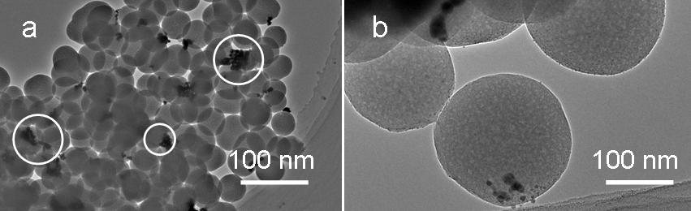
Fig. S2. TEM images of the silica/Au hybrid microspheres obtained from 0.05 g prepared SiO₂/Ag microspheres and then 1 mL 1 % (wt %) in aqueous solution when the other condition was kept at the same.

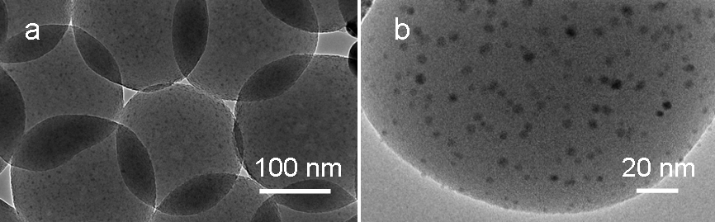
Fig. S3. (a,b) TEM images of the silica/Au hybrid microspheres obtained after eight successive cycles of the catalytic reduction to 4-AP finished.

 Corresponding author. Tel.: +86-579-82282269; fax: +86-579-82282269. E-mail address: yshao@zjnu.cn (Prof. Shao Y); shqian@hfut.edu.cn (Prof. Qian HS)

