Phase transformation in relaxor - ferroelectric single crystal [Pb(Sc_{1/2}Nb_{1/2})O₃]_{0.58} -[PbTiO₃]_{0.42}

S.V. Rajasekaran¹, S. N. Achary², S. J. Patwe², R.Jayavel³, G. Mangamma⁴, A.K. Tyagi⁴

¹Department of Physics, Govt. Arts College, Dharmapuri, India 636705
²Chemistry Division, Bhabha Atomic Research Centre, Mumbai, India 400085
³Crystal Growth Centre, Anna University, Chennai, India 600025
⁴Surface and Nano science division, Material Science group, IGCAR, Kalpakam, India

Supplementary Information

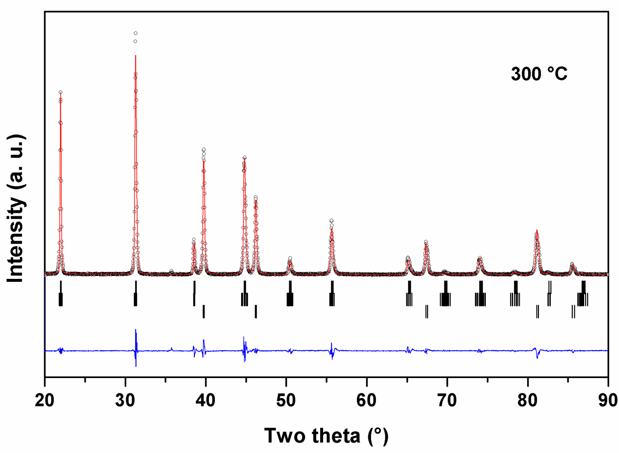

Refinement plots of the powder XRD data of PSN-42PT recorded at 300°C.
Tetragonal (P4mm): a = 4.0407(3), c = 4.0461(3) Å, V = 66.06(1) Å³
Monoclinic (Pm): a = 4.0441(2), b = 4.0212(3), c = 4.0731(6) Å, β = 90.02(1)°, V = 66.24(1) Å³

