S1 synthetic method for low-T phase CsPbBr_{x}I_{3–x}, CsSnI₃, and FAPbI₃

CsPbI_{x}Br_{3–x} nanowire synthesis
A total of 460 mg PbI₂ (99.999%) was dissolved in 1 mL anhydrous dimethylformide (DMF), stirred at 70°C overnight before further use. The PbI₂ solution was spin coated onto O₂ plasma-treated glass substrates at 3,000 rpm for 60 s, then annealed at 100°C for 15 min. The PbI₂ film was carefully dipped into a glass vial with a mixed solution of 0.4 mL 8 mg/ml CsI (99.999%)/methanol (anhydrous 99.8%), 1 ml 8 mg/CsBr (99.999%)/methanol (anhydrous 99.8%), and 0.8 ml methanol (anhydrous 99.8%). The PbI₂ side was facing up during the reaction. The reaction was carried out at room temperature for approximately 12 h with the glass vial sealed with a plastic cap, then the substrate was taken out to wash in anhydrous isopropanol for 30 s. The sample was dried under 50°C for 5 min. The whole growth process took place within a N₂-filled glovebox. (All of the chemicals were purchased from Sigma-Aldrich unless otherwise stated.)

CsSnI₃ nano-/microwire synthesis
SnI₂ was deposited on the substrates and was left to react with a saturated CsI solution (anhydrous 2-propanol). Reactions proceeded in an argon-filled glovebox with an oxygen level of <0.1 ppm and a H₂O level of <0.1 ppm. Specifically, saturated solutions of CsI (99.999%, anhydrous beads) in anhydrous 2-propanol (99.5%) was prepared in the glovebox. A small SnI₂ (99.999%, ultra-dry, Alfa Aesar) particle (~10 mg) was then directly put on the clean substrates, and the substrate was carefully immersed in a clean 20 mL vial (Kimble, #FS74504-20) with 2 mL CsI/2-propanol. The reaction went for roughly 12 h at room temperature with the vial carefully capped. The substrate was taken out to wash in anhydrous isopropanol for 30 s. The sample was dried under 50°C for 5 min.

Low-T phase FAPbI₃ nano-/microwire synthesis
FAPbI₃ synthesis is modified based on Reference 1. 100 mg/mol lead acetate (Pb(ac)₂) in methanol was drop casted on O₂ plasma-treated glass substrates. The film was annealed in air at 120°C for 1h. The substrate was then dipped in a clean 20 mL vial (Kimble, #FS74504-20) with 20 mg/ml FAI/2-propanol. The reaction was carried out at 75°C inside a glovebox for about 12 h. Then the as-synthesized yellow film was taken out and rinsed with anhydrous isopropanol for 30 s. Low-T phase FAPbI₃ nanowires were formed when the reaction was carried out at room temperature.

S2 structural and optical characterization methods

X-ray diffraction (XRD)
The XRD pattern was acquired by using a Bruker AXS D8 Advance diffractometer equipped with a lynxeye detector, which used Cu Kα radiation.

Electron microscopy characterization
Scanning electron microscope (SEM) images were acquired using a JEOL JSM-6340F field emission SEM. The SEM energy dispersive x-ray spectroscopy was carried out using a FEI Quanta 3D FEG/FIB SEM (FEG/FIB). The TEM images and selected area electron diffraction patterns were acquired by a FEI Titan microscope at the National Center for Electron Microscope.

Photoluminescence (PL) spectra
PL measurements were performed using an OBIS 375 nm LX 50 mW Laser (the intensity of the incident beam was 1 mW) with emission collected via a Nikon A1 microscope and a multimode optical fiber coupled to a liquid-nitrogen-cooled Si charge-coupled device (CCD).

In situ optical imaging and Raman
The low-T phase perovskites were transferred on flat Si or quartz substrates. An optical microscope coupled with a CCD camera (Zeiss AxioCam MRc 5) was connected to a heating stage (INSTEC), which allowed Ar flow during the whole process. Under the exposure of white light from the built-in microscope lamp, the in situ optical images were taken over a quartz window every few seconds using the Zeiss AxioCam, which has a maximum 2584 × 1936 pixel density per image. The fastest frame rate at a maximum pixel density is about 3 s per image. One frame per second is possible with a lower pixel density setting. For in situ imaging, we recorded the optical images of FAPbI₃ microwires when the stage temperature was increased to a specific set value. Note that the relatively fast phase propagation makes it difficult to measure the phase propagation rate before reaching the targeted constant temperature. The phase propagation rate is calculated using the average temperature during the ramp-up process.

In situ Raman spectroscopy was performed with a Jobin-Yvon LabRAM HR confocal microscope with a 100X (0.55 N.A) objective. A 632.8 nm He-Ne laser (10–40 mW) was focused onto the perovskite crystals, and the Raman-scattered photons were dispersed by a 1800 g/cm diffraction grating and collected by a CCD spectrometer. The output power of the excitation source was adjusted by neutral density filters (normally ND2~ND3). For each temperature, the sample was equilibrated for 5 min after the stage reached the set temperature. Typical collections times ranged from 10–30 s. The confocal PL spectra were acquired on the same setup with a 532 nm laser. The laser beam size was ~300 nm × 300 nm.

Reference
1. Y. Fu, H. Zhu, A.W. Schrader, D. Liang, Q. Ding, P. Joshi, L. Hwang, X.Y. Zhu, S. Jin, Nanowire lasers of formamidinium lead halide perovskites and their stabilized alloys with improved stability. Nano Lett. 16(2), 1000 (2016).

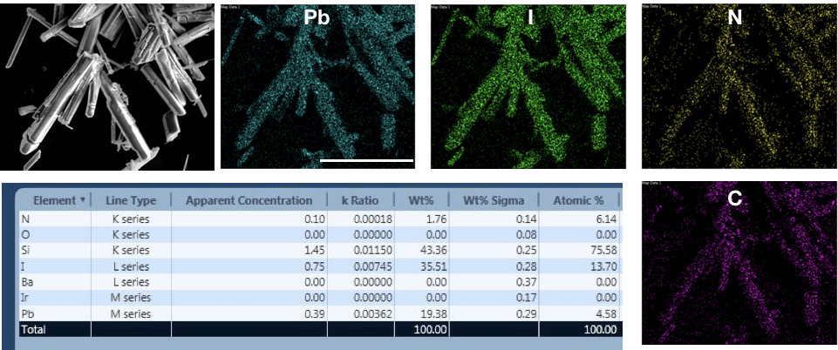

Figure S1. Scanning electron microscope-energy dispersive x-ray spectroscopy characterization of as-synthesized low-T phase FAPbI₃. The scale bar is 25 μm.

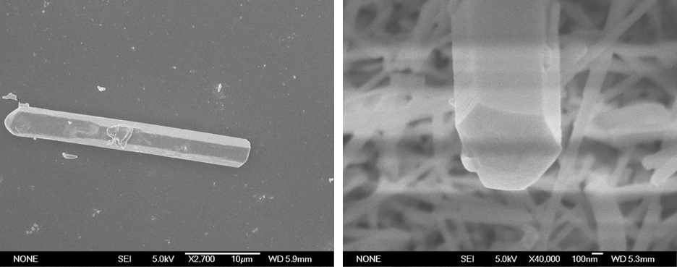

Figure S2. Scanning electron microscope image of a typical FAPbI₃ microwire on Si substrate. The wire on the right shows their typical hexagonal cross-section.

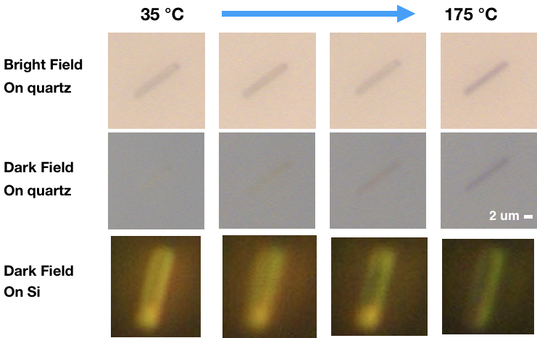

Figure S3. In situ evolution of optical images along with thermally induced phase transition. The optical contrast can be obviously distinguished from the low-T phase to high-T phase of FAPbI₃ on Si or quartz.

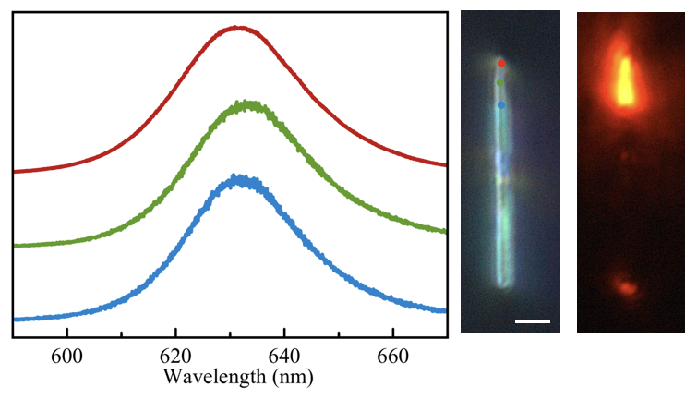

Figure S4. Confocal photoluminescence (PL) spectra of a low-T/high-T CsPbBr_{x}I_{3–x} nanowire heterojunction. The composition is close to CsPbIBr₂ based on the PL emission peak. The PL spectra of blue, green, and red correspond to PL emission of the spots (blue, green, red) in the optical image. The scale bar is 2 um.

Figure S5. The time series of optical dark-field images of FAPbI₃ perovskite phase evolution at different temperature range. (top) 157~163°C, (middle) 158~161°C, and (bottom) 168~176°C. Each frame is about 3 s. The scale bar is 5 μm.

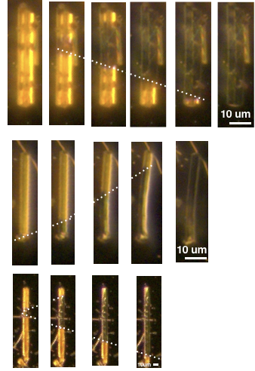

Figure S6. The time series of optical dark-field images of CsSnI₃ perovskite phase evolution. (top) 160.1–161.2°C, (middle) 163.2~164.5°C, and (bottom) 162.5~168.8°C . Each frame is 3~4 s. The scale bar is 10 μm.

