Supplementary Materials
Table S1
Descriptive and Reliability Statistics on the Measures of Loneliness, Distress, and Emotion Regulation
Measure | M | SD | Range | Cronbach’s α
UCLA Loneliness Scale  Total scale score | 23.49 | 5.77 | 10-39 | .89
Depression Anxiety Stress Scales-21  Total scale score | 20.13 | 14.05 | 0-62 | .95
Emotion Regulation Questionnaire
Cognitive reappraisal | 28.08 | 6.91 | 6-42 | .89
Expressive suppression | 14.36 | 5.37 | 4-28 | .81
Behavioral Emotion Regulation Questionnaire
Seeking distraction | 12.30 | 3.36 | 4-20 | .79
Withdrawal | 11.18 | 4.18 | 4-20 | .89
Actively approaching | 11.78 | 3.52 | 4-20 | .87
Seeking social support | 11.72 | 4.11 | 4-20 | .89
Ignoring | 9.60 | 3.66 | 4-20 | .84
Cognitive Emotion Regulation Questionnaire-Short
Self-blame | 5.97 | 1.96 | 2-10 | .73
Acceptance | 7.13 | 1.86 | 2-10 | .81
Rumination | 6.79 | 1.81 | 2-10 | .62
Catastrophising | 5.38 | 2.07 | 2-10 | .83
Other-blame | 4.18 | 1.65 | 2-10 | .77

Table S2
Pearson Correlation Matrix for the Demographic, Loneliness, Psychological Distress, and Emotion Regulation Variables.
Variable | 1 | 2 | 3 | 4 | 5 | 6 | 7 | 8 | 9 | 10 | 11 | 12 | 13 | 14 | 15 | 16
1. Age | -
2. Genderª | -.11** | -
3. UCLA-LS total score | .01 | .03 | -
4. DASS-21 total score | .02 | .10* | .50*** | -
5. ERQ Cognitive reappraisal | .04 | -.04 | -.33*** | -.31*** | -
6. ERQ Expressive suppression | .04 | -.06 | .43*** | .29*** | .01 | -
7. BERQ Seeking distraction | -.00 | -.05 | -.10* | -.01 | .29*** | .11** | -
8. BERQ Withdrawal | -.01 | .11* | .52*** | .52*** | -.24*** | .45*** | .04 | -
9. BERQ Actively approaching | .03 | -.06 | -.36*** | -.29*** | .45*** | -.24*** | .33*** | -.32*** | -
10. BERQ Seeking social support | -.01 | .07 | -.41*** | -.18*** | .18*** | -.42*** | .20*** | -.34*** | .41*** | -
11. BERQ Ignoring | .01 | .08 | .32*** | .34*** | -.10* | .56*** | .33*** | .53*** | -.18*** | -.28*** | -
12. CERQ-S Self-blame | .04 | .04 | .33*** | .35*** | -.12** | .27*** | .09* | .33*** | -.12** | -.08 | .26*** | -
13. CERQ-S Acceptance | .01 | -.05 | -.11** | -.06 | .21*** | .02 | .27*** | -.03 | .28*** | .12** | .03 | .19*** | -
14. CERQ-S Rumination | -.05 | .11** | .11* | .21*** | .08 | -.02 | .14*** | .12** | .11** | .26*** | .04 | .37*** | .40*** | -
15. CERQ-S Catastrophising | .05 | .13** | .33*** | .43*** | -.27*** | .14*** | -.05 | .36*** | -.26*** | .08 | .21*** | .43*** | -.01 | .39*** | -
16. CERQ-S Other-blame | .01 | .04 | .07 | .18*** | -.10* | .03 | .13** | .08 | -.01 | .15*** | .13*** | .05 | .02 | .20*** | .44*** | -
Note. ***p<.001. **p<.01. *p<.05. Gender was coded 0 = male, 1 = female. ª = point-biserial correlation as variable is dichotomous. UCLA-LS = UCLA Loneliness Scale. DASS-21 = Depression Anxiety Stress Scales-21. ERQ = Emotion Regulation Questionnaire. BERQ = Behavioral Emotion Regulation Questionnaire. CERQ-S = Cognitive Emotion Regulation Questionnaire-Short.
Table S3
Fit Index Values for the Tested Latent Profile Analysis Solutions
Number of profiles | AIC | BIC | CLC | KIC | AWE | Entropy
1 | 23165.010 | 23287.271 | 23111.010 | 23196.010 | 23547.533 | 1.000
2 | 22076.193 | 22263.951 | 21991.842 | 22122.193 | 22665.061 | 0.824
3 | 21812.884 | 22066.139 | 21698.444 | 21873.884 | 22607.834 | 0.780
4 | 21559.581 | 21878.333 | 21415.178 | 21635.581 | 22560.488 | 0.798
5 | 21384.549 | 21768.798 | 21210.192 | 21475.549 | 22591.404 | 0.822
6 | 21278.315 | 21728.062 | 21073.932 | 21384.315 | 22691.192 | 0.808
7 | 21195.923 | 21711.167 | 20961.530 | 21316.923 | 22814.804 | 0.803
8 | 21172.416 | 21753.156 | 20908.016 | 21308.416 | 22997.297 | 0.800
9 | 21162.686 | 21808.924 | 20868.292 | 21313.686 | 23193.556 | 0.803
10 | 21090.003 | 21801.738 | 20765.614 | 21256.003 | 23326.862 | 0.805
Note. AIC = Akaike Information Criterion. BIC = Bayesian Information Criterion. CLC = Classification Likelihood Criterion. KIC = Kullback Information Criterion. AWE = Appropriate Weight of Evidence Criterion.

Figure S1
The Process Model of Emotion Regulation
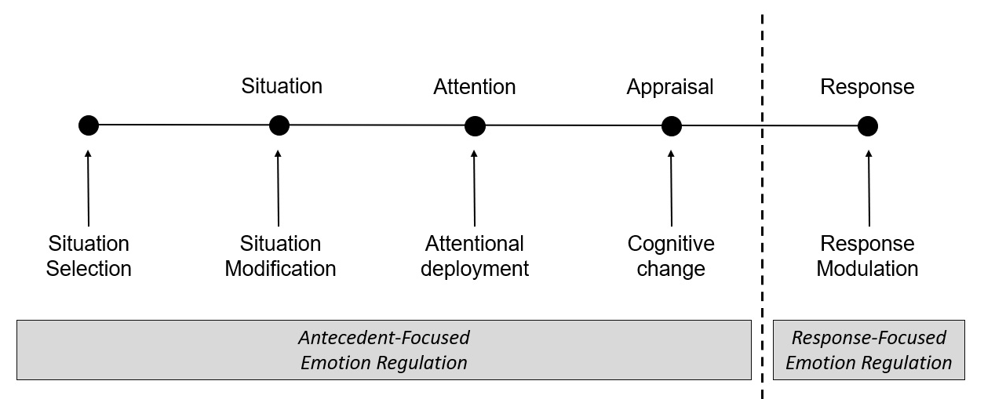
Note. The process model of emotion regulation (Gross, 2015) specifies that emotions are generated across a four-stage situation-attention-appraisal-response sequence. The situation stage represents an emotion-inducing stimulus (i.e., a snake is in the room); at the attention stage one focuses attention on the stimulus (e.g., noticing the snake); at the appraisal stage one appraises what the stimulus is and what it means for one’s goals (e.g., this is a dangerous snake that is bad for my goal of staying alive); and at the response stage, based on that appraisal, an emotional response might result (e.g., fear). The process model specifies that different types of emotion regulation strategies can be activated at various stages in this emotion generation process, in an effort to try to change the trajectory of the emotion. At the situation stage, one might alter what situations they are exposed to (situation selection) or modify the nature of the situation (situation modification); at the attention stage one might alter what aspects of the situation they are directing their attention to (attentional deployment); at the appraisal stage one might try to change how they are evaluating the situation (cognitive change); and at the response stage, once the emotion is more fully developed, one might try to alter the manifestation of the emotion (response modulation). Because some of these strategy categories are activated before the emotion has fully formed, the process model also makes a broad distinction between antecedent-focused emotion regulation strategies (situation selection/modification, attentional deployment, cognitive change) and response-focused emotion regulation strategies (response modulation). Most research in this area has contrasted two strategies from these categories, cognitive reappraisal (a cognitive change strategy) and expressive suppression (a response modulation strategy), finding that cognitive reappraisal is typically associated with better long-term outcomes than expressive suppression (Gross, 2015).
Figure S2
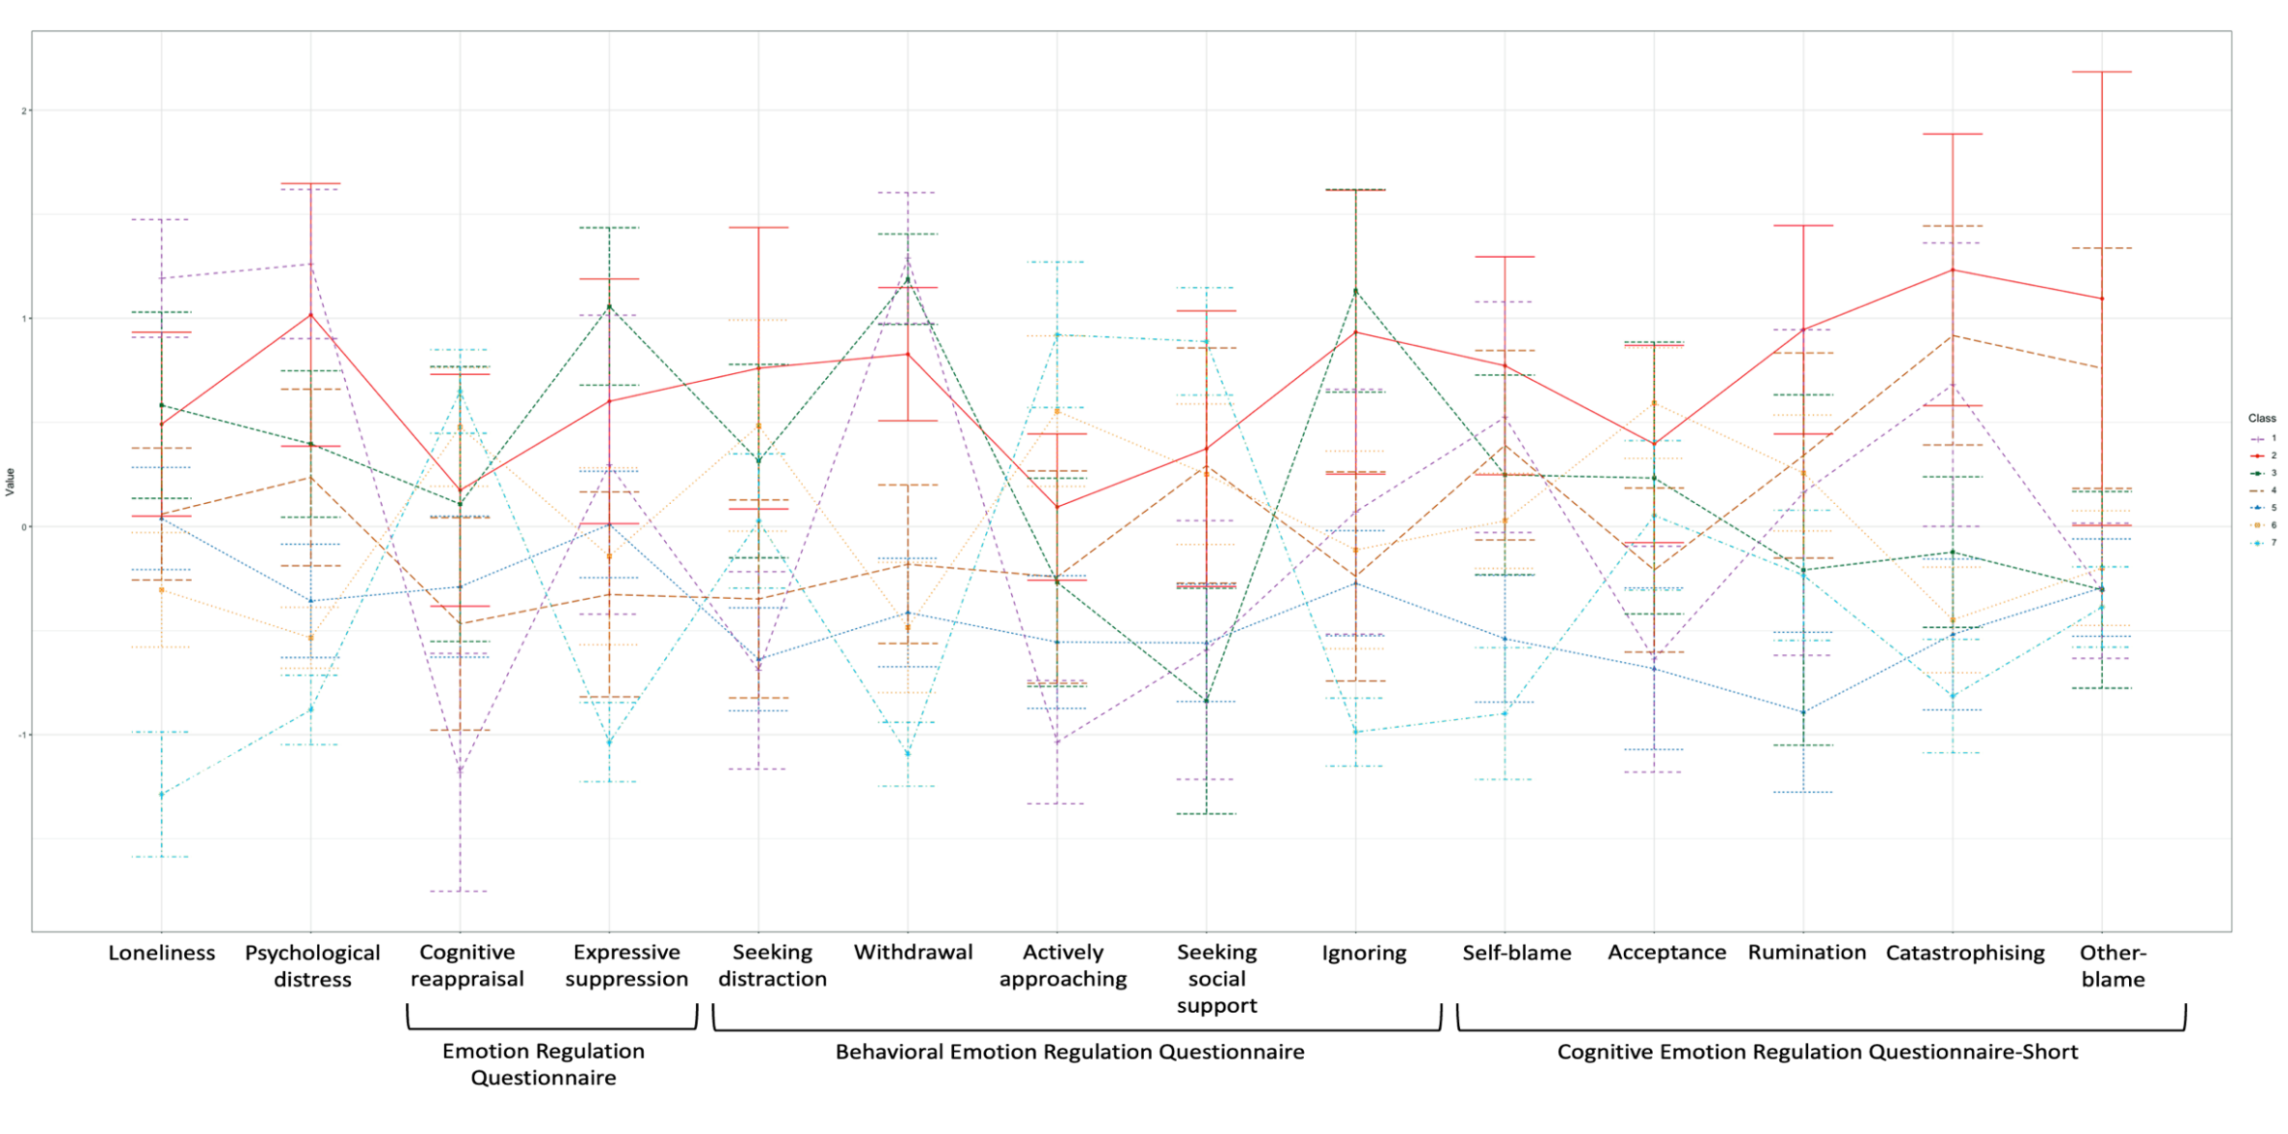
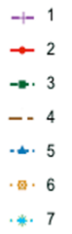
Latent Profile Analysis: 7-Profile Solution with 95% Confidence Interval Error Bars.
-1
0
1
2
Profile
Z-score
Note. Z-score of 0 = the average for the sample; z-score of 1 is 1SD above mean; -1 is 1SD below mean.

