Appendix 1
Study 1 Supplementary Materials
  - University of Bimboola Paradigm Stimuli

Condition 1 – In Person
Condition 2 – Online Synchronous

Condition 3 – Online Asynchronous

  - Parallel Mediation Results

H2: Social Identification Processes Explain the Link Between Isolating Transitions and Loneliness
We conducted a parallel mediation including group membership continuity, new group memberships and identification with the new group as mediators in the relationship between isolation and loneliness. For this analysis, the direct effect of isolation condition on loneliness was not significant, b = 0.10, SE = 0.07, p = .145, 95% CI [-0.03, 0.2] and the total effect was significant, b = 0.28, SE = 0.08, p = .001, 95% CI [0.12, 0.45]. The indirect effect of membership continuity (H2a) was not significant, b = 0.01, SE = 0.01, 95% CI [-0.01, 0.04], the indirect effect of new group memberships (H2b) was significant b = 0.06, SE = 0.03, 95% CI [0.01, 0.12], and the indirect effect of social identification was significant b = 0.12, SE = 0.04, 95% CI [0.05, 0.21]. Thus, consistent with H2b and H2c, there was a significant indirect effect of new group memberships and social identification in the relationship between isolation level during life transition and loneliness. However, inconsistent with H2a group membership continuity did not have a significant indirect effect in this parallel model.
Further analyses revealed that it was the inclusion of social identification as a university student in the model that nullified the significant effect of group membership continuity.

Appendix 2
Study 2 Supplementary Materials
  - Moving to Bimboola Paradigm Stimuli

Introductory Information

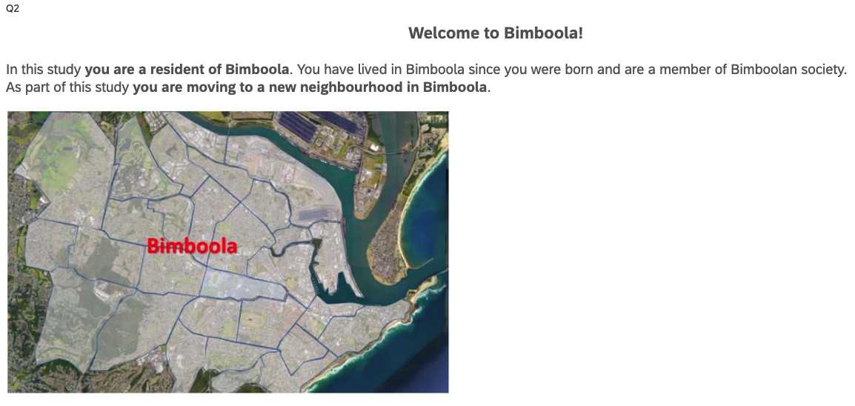
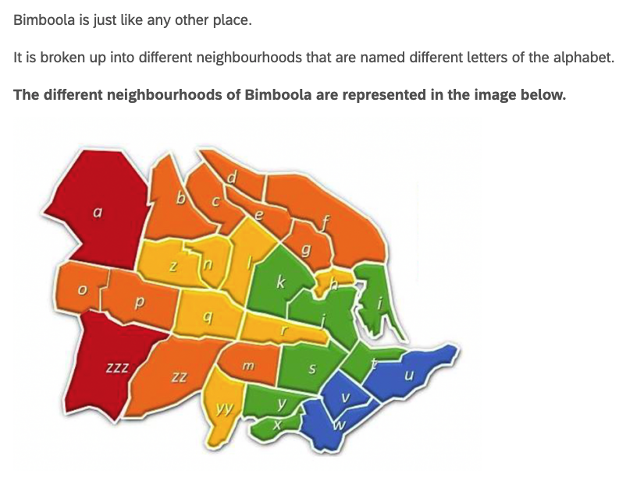
Condition Text
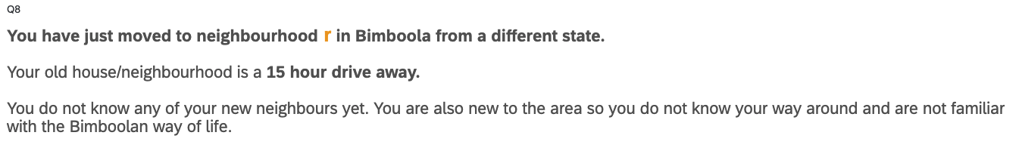
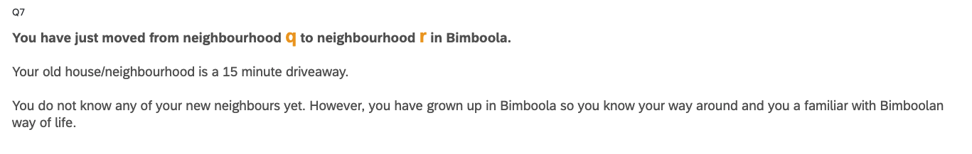

Decision Stimuli
Appendix 2
Study 2 Supplementary Materials
  - Parallel Mediation Results

H2: Social Identification Processes Explain the Link Between Isolating Transitions and Loneliness
We conducted a parallel mediation including group membership continuity, new group memberships and identification with the new group as mediators in the relationship between isolation and loneliness. For this analysis, the direct effect of isolation condition on loneliness was not significant, b = -0.07, SE = 0.11, p = .507, 95% CI [-0.28, 0.14] and the total effect was marginally significant, b = 0.22, SE = 0.13, p = .084, 95% CI [-0.03, 0.48]. The indirect effect of membership continuity (H2a) was significant, b = 0.08, SE = 0.10, 95% CI [0.10, 0.49], the indirect effect of new group memberships (H2b) was not significant b = 0.01, SE = 0.04, 95% CI [-0.06, 0.09], and the indirect effect of social identification was significant b = 0.20, SE = 0.06, 95% CI [0.08, 0.33]. Thus, consistent with H2a and H2c, there was a significant indirect effect of continuity of group memberships and social identification in the relationship between isolation level during life transition and loneliness. However, inconsistent with H2b new group memberships did not have a significant indirect effect in this parallel model.

Appendix 3
Study 3 Supplementary Materials
  - Mobility Data

SS1: Figure comparing the Google mobility changes in Victoria, New South Wales, and all of Australia; the figures includes the time points of data collection at Wave 1 and Wave 2, as well as the Victoria lockdown

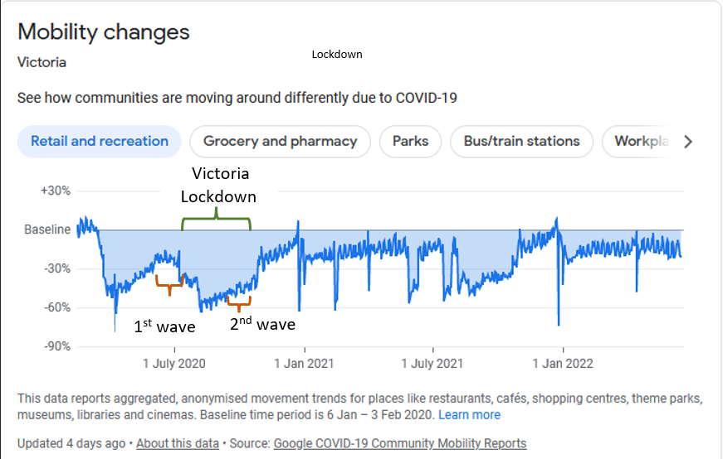
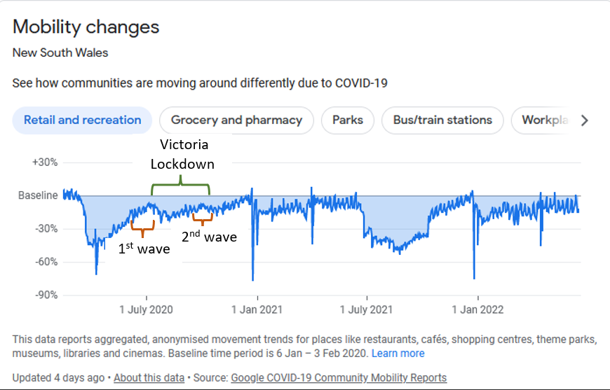

  - Measures of Control Variables

Age

What is your age?

Sex

What is your sex?
▢ Male
▢ Female

▢ Other

Individual weekly income

What is your individual WEEKLY income after income tax?

▢ Negative income

▢ Nil income

▢ $1 - $149 per week

▢ $150 - $299 per week

▢ $300 - $399 per week

▢ $400 - $499 per week

▢ $500 - $649 per week

▢ $650 - $799 per week

▢ $800 - $999 per week

▢ $1,000 - $1,249 per week

▢ $1,250 - $1,499 per week

▢ $1,500 - $1,749 per week

▢ $1,750 - $1,999 per week

▢ $2,000 - $2,999 per week

▢ $3,000 or more

Select the percentage that best describes how often you do the following behaviours.
 |  |  | 0% |  |  |  | Percentage of time |  |  |  |  | 100%
 |  | 0 |  | 10 | 20 | 30 |  | 40 | 50 | 60 | 70 |  | 80 | 90 | 100
Interacted with friends, family, or colleagues via the internet (e.g., Zoom, Skype, online platforms)

  - Confirmatory Factor Analyses
A confirmatory factor analyses (CFA) tested whether loneliness, group maintenance and new group memberships were valid latent variables. Three models were compared: one with a single latent variable, a second model with three latent variables (loading Wave 1 and Wave 2 items in the same latent variable), and a third model with six latent variables (one per variable and wave).
The first model with all items across both waves of loneliness, group maintenance and new group memberships loading on a single latent factor had a poor fit, χ 2(135) = 20,294.09, p < .001, CFI = .32, RMSEA = .252 (.249 to .255), SRMR = .230. The second model, in which the items at Waves 1 and 2 loaded on the respective latent factor of loneliness, group maintenance and new group memberships fit the data better (χ2 difference (3) = 12,181.21, p < .001) but nonetheless showed poor fit per most indices (χ 2(132) = 8,112.88, p < .001, CFI = .73, RMSEA = .161 (.158 to .164), SRMR = .09). The third CFA model, in which the items at Waves 1 and 2 loaded on separate latent factors of their respective variables fit significantly better (χ2 difference (12) = 7,278.44, p < .001) and was a good fitting model (χ2 (120) = 834.44, p < .001, CFI = .98, RMSEA = .050 (.047 to .054), SRMR = .04). Therefore, in the following SEM, Waves 1 and 2 of loneliness, group maintenance and new group memberships are a respective latent factor. Supplementary Table 1 shows the factor loadings for each of the items.

Supplementary Table 1: Confirmatory Factor Analyses
Variable | Item | Standardized Factor Loading | SE | p value
Loneliness W1
 | How often do you feel that you lack companionship? | 0.857 | 0.01 | <.001
 | How often do you feel left out? | 0.898 | 0.01 | <.001
 | How often do you feel isolated from others? | 0.906 | 0.01 | <.001
Loneliness W2
 | How often do you feel that you lack companionship? | 0.872 | 0.01 | <.001
 | How often do you feel left out? | 0.897 | 0.01 | <.001
 | How often do you feel isolated from others? | 0.909 | 0.01 | <.001
Continuity of group membership W1
 | I still belong to the same groups I was a member of before COVID-19 | 0.715 | 0.01 | <.001
 | I still join in the same group activities as before COVID-19 | 0.618 | 0.02 | <.001
 | I continue to have strong ties with the same groups as before COVID-19 | 0.977 | 0.01 | <.001
Continuity of group membership W2
 | I still belong to the same groups I was a member of before COVID-19 | 0.763 | 0.01 | <.001
 | I still join in the same group activities as before COVID-19 | 0.717 | 0.01 | <.001
 | I continue to have strong ties with the same groups as before COVID-19 | 0.987 | 0.01 | <.001
New group memberships W1
 | I have joined one or more new groups | 0.951 | 0.00 | <.001
 | I have joined in the activities of new groups | 0.968 | 0.00 | <.001
 | I have strong ties with one or more new groups | 0.911 | 0.00 | <.001
New group memberships W2
 | I have joined one or more new groups | 0.951 | 0.00 | <.001
 | I have joined in the activities of new groups | 0.961 | 0.00 | <.001
 | I have strong ties with one or more new groups | 0.944 | 0.00 | <.001

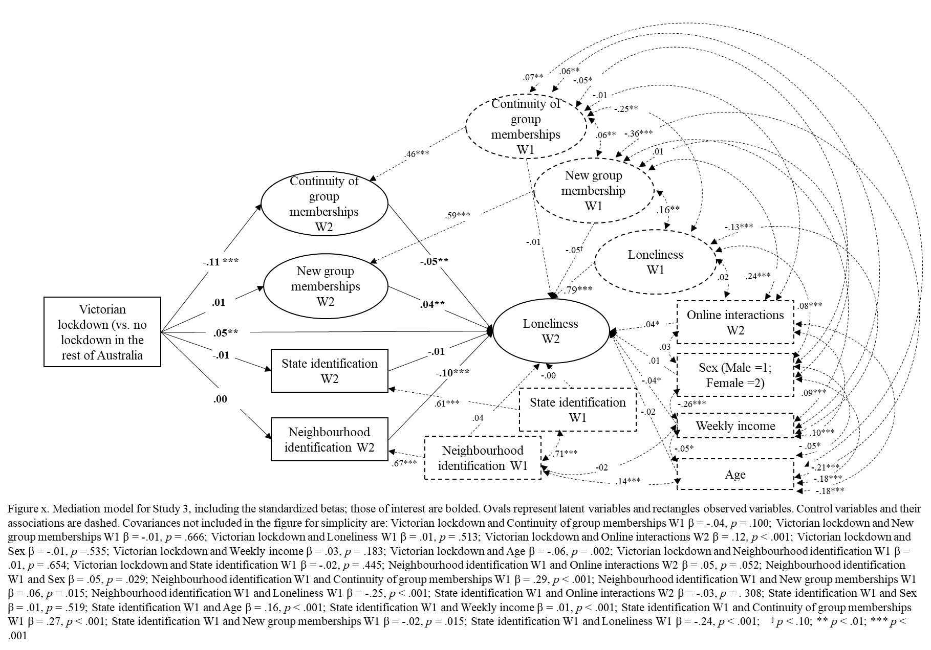
3.3. Detailed results for SEM
The complete SEM model is presented in Supplementary Figure 1 along with all control variables and covariances.

