**Supplementary Information**

**Thibaut**

Food List

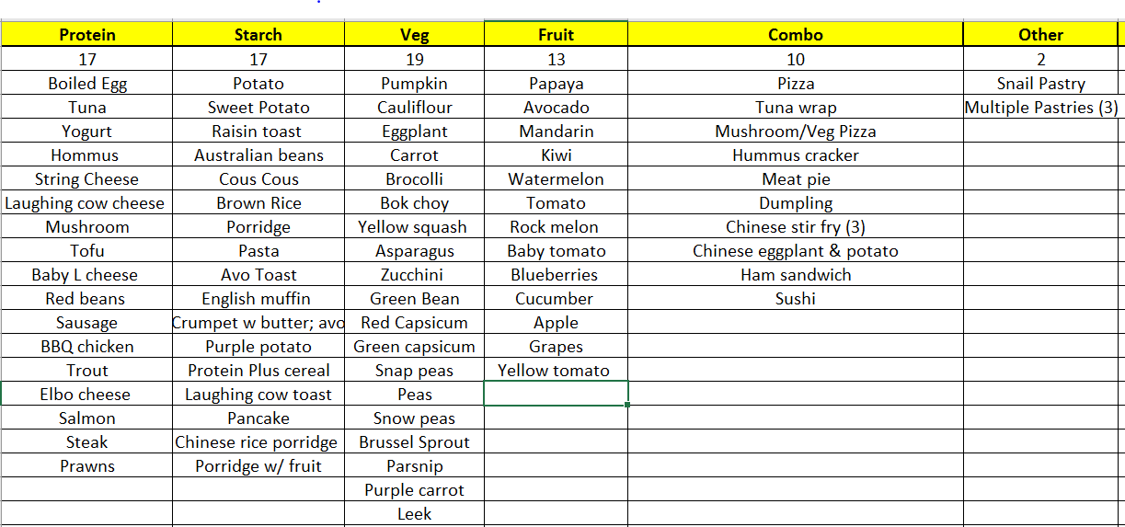

**Shay**

Food List Initial

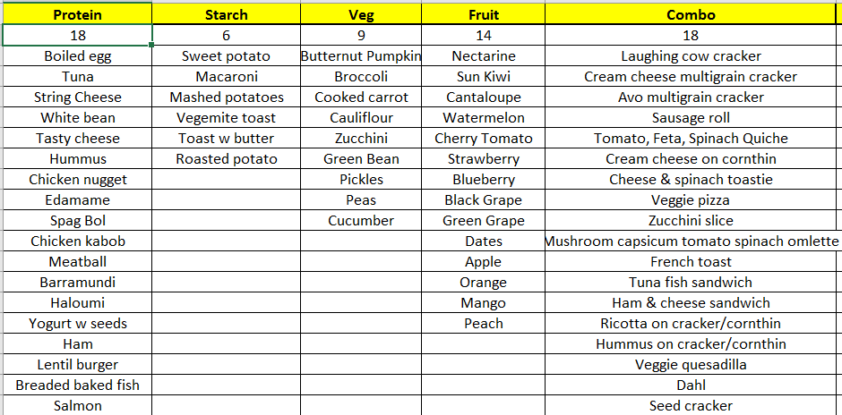

Food List Follow-up

