Appendix A - Contingency Variation Task (CVT)

Participants received the following instructions:
"Someone has told you that free snacks can be won from our vending machines by tilting them to the left or to the right. Use the Left and Right keys to tilt left and right. Find out which direction releases the most snacks, and try to win as many snacks as you can!" Following these instruction, the CVT consisted of two phases, which were repeated over six blocks:
- Keypresses to earn reinforcers: Across six blocks, pressing "left" (L) and "right" (R) on a "vending machine" led to earning two different snacks (snacks A and B, presented as pictures). Within each block, each snack was rewarded on either a high, or a low action-outcome contingency. On average one in four (high contingency), or one in 12 (low contingency) keypresses were followed by the delivery of a reward). Participant L / R responses were recorded. The duration for each block was 60 seconds. Snack allocation to L vs. R keypresses, and to high vs. low contingency, was counterbalanced across blocks.
- Rating of contingency (not used as an outcome in the current study): At the conclusion of each block, knowledge of contingency was rated: participants were asked to rate how likely the vending machine was to deliver each of the two snacks: "How effective was tilting the machine to get Snack A?" and "How effective was tilting the machine to get Snack B?" These were rated on a scale of 1 to 7, with 1 representing "not at all effective" and 7 representing "very effective".

Pictorial representations

Figure 1. Pictures of snacks used as outcomes.
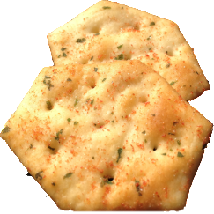
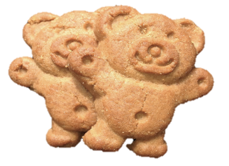

M&Ms BBQ Shapes Tiny Teddies

Figure 2. Representation of the "vending machine".

L - tilting left R - tilting right

