Supplimental Material
Appendix A.
Table: Characteristics of Referrals to Crisis Resolution Home Treatment Team
Category | n | % of total
All | 1645 | 100
Gender | n
Male | 695 | 42
Female | 950 | 58
Age (yrs)
18-24 | 300 | 18
25-34 | 389 | 24
35-44 | 326 | 20
45-54 | 245 | 15
55-65 | 254 | 15
65+ | 131 | 8
Sector
CSE | 694 | 42
CSW | 647 | 39
Douglas | 204 | 12
Other | 106 | 7
Diagnosis
Depressive Disorder | 374 | 22
Personality Disorder | 354 | 22
Schizophrenia | 262 | 16
Bipolar Affective Disorder | 227 | 14
Anxiety Disorder | 186 | 11
Acute psychotic episode | 47 | 3
Psychotic Depression | 19 | 1
Other | 176 | 11
Referral Source
CMHT/Liaison | 978 | 59
GP | 667 | 41
Referral Reason
Prevent hospital admission | 667 | 40
Acute relapse | 469 | 29
Crisis management | 282 | 17
Early discharge | 227 | 14

CSW=City South West, CSE=City South East, CMHT=Community Mental Health Team.

Appendix B.
Figure 2: Impact of Crisis Resolution Home Treatment on Symptoms and Functioning
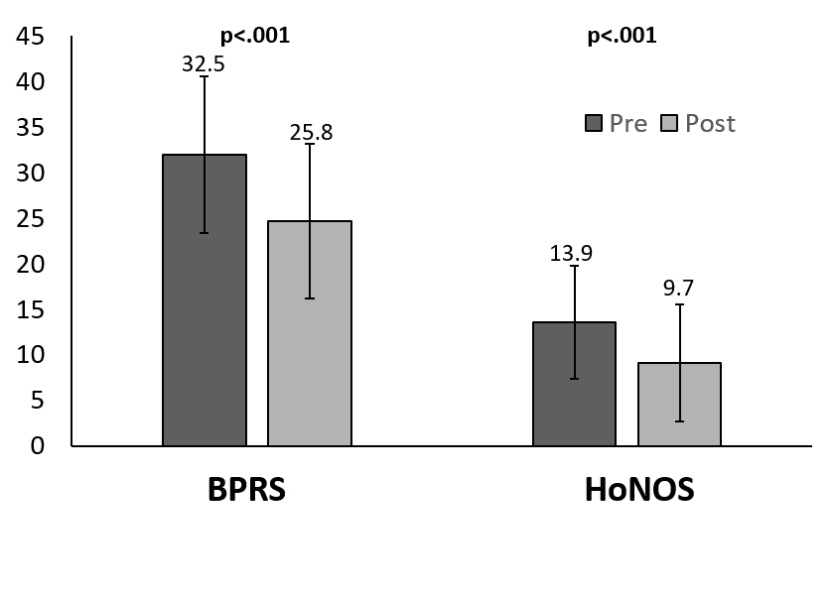
Figure 2: Impact of Crisis Resolution Home Treatment on Symptoms and Functioning. The Figure shows mean BPRS and HoNOS scores before and after treatment by the CRHTT. Error bars show standard deviation from the mean. BPRS= Brief Psychiatric Rating Scale (Intensity of Psychiatric Symptoms). HoNOS=Health of the Nation Outcomes Scale (Health Outcomes/Overall Functioning). CRCRHTT = Crisis Resolution Home Based Treatment Team.

Appendix C.
Table: Results of the Client Satisfaction Questionnaire (CSQ-8)

n=180
Point on Likert Scale | Very Negative | Negative | Positive | Very Positive
Question | n(%) | n(%) | n(%) | n(%)
1. How would you rate the quality of service you received? | 0 (0) | 2(1) | 37(21) | 141(78)
2. Did you get the kind of  service you wanted? | 1(0.5) | 4(2) | 55(35) | 120(67)
3. To what extent has our  service met your needs? | 0(0) | 10(5) | 65(37) | 105(58)
4. If a friend were in need of similar help would you recommend our service to them? | 1(0.5) | 0(0) | 34(19) | 144(80.5)
5. How satisfied were you with the  amount of help you received? | 1(0.5) | 4(2) | 43(24) | 131(73.5)
6. Have the services you received  helped you deal more effectively  with your problems? | 0(0) | 4(2) | 50(28) | 125(70)
7. In an overall, general sense  how satisfied are you with the  service you received? | 2(1) | 5(2.5) | 31(17.5) | 141(79)
8. If you were to seek help again,  would you come back to this team? | 0(0) | 3(1.5) | 32(18) | 144(80.5)

Table: Results of the Client Satisfaction Questionnaire (CSQ-8): Median scores for all questions on the likert scale were “Very Positive”. The majority of service users who responded chose very positive for each question asked.

