Supplementary material:
Appendix 1: BST Clinical Examination
The Basic Specialist Training (BST) clinical examination by College of Psychiatrists of Ireland (CPsychI) ensures a national standard in the assessment of clinical skills and competencies for psychiatric trainees and is used as an entry criterion for higher specialist training ⁵. Trainees must have at least 12 months experience of BST with a satisfactory outcome at BST 1st year Annual Review of Progress (ARP) and must have passed all written components of Membership of Royal College of Psychiatrists (MRCPsych) exam. The clinical exam consists of two components: Clinical Formulation and Management Examination (CFME) and Objective Structured Clinical Examination (OSCE). During CFME all candidates watch two videos of interaction between a psychiatrist and a patient. This is followed by 20 minutes of interview by a panel of two examiners. The questions pertain to mental state findings, differential diagnosis, and management options. There are 12 stations in OSCE which focus on four core domains: communication skills, physical examination, prescribing skills, and risk assessment. The candidates need to pass both the CFME and at least 8/12 OSCE stations with a pass in all four core domains. All candidates have four attempts to pass the exam and all components must be completed within 2 years of successful completion of BST.
Appendix 2: Topic Guide
For Examiners:
- How was your experience of assessing communication skills virtually?
- What attributes do you think are important for good virtual communication skills?
- What difference did you notice in marking face-to-face vs online?
- Was there any difference in the assessment of CFME vs OSCE online? What is the difference compared to face-to-face examination if you have assessed BST exam before?
- What is your opinion on the positioning of camera? How much of the candidate’s image do you think should appear in the camera? E.g., face/shoulders/arms?
- How did you assess nonverbal communication e.g., facial expressions, tone of voice, empathy and rapport, and hand gestures?
- Did you encounter any technology issues, and did they make any impact on assessing the communication skills e.g., a delay in voice?
For Trainees:
- How was your experience of demonstrating your communication skills during online examination?
- How did you adapt to different types of patients when communicating via screen?
- Did you experience any difference when compared with face-to-face exam e.g., higher or lower anxiety levels, communication via screen (for trainees who have had a previous sitting in face-to-face exam)?
- Was there any difference in the assessment of CFME vs OSCE online?
- What is your opinion on the positioning of camera? How much of your image you think should appear in the camera (e.g., face/shoulders/arms) for effective communication?
- Did you encounter any technology issues, and did they make any impact on demonstrating the communication skills and rapport building e.g., a delay in voice?
- How did you feel about the presence of patient and examiner on the same screen? Did you feel compelled to make eye contact with the examiner or just focused on the patient?
- Did you have written task opened in front of you throughout the interview? Would you like to comment on how should that be presented?
Audit Trail

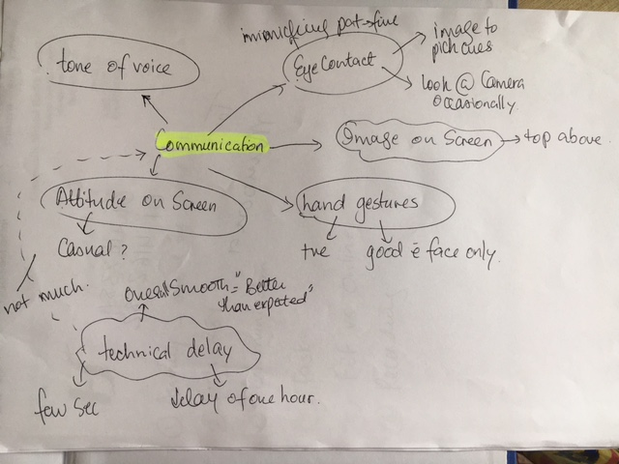
Figure 3: Initial Themes

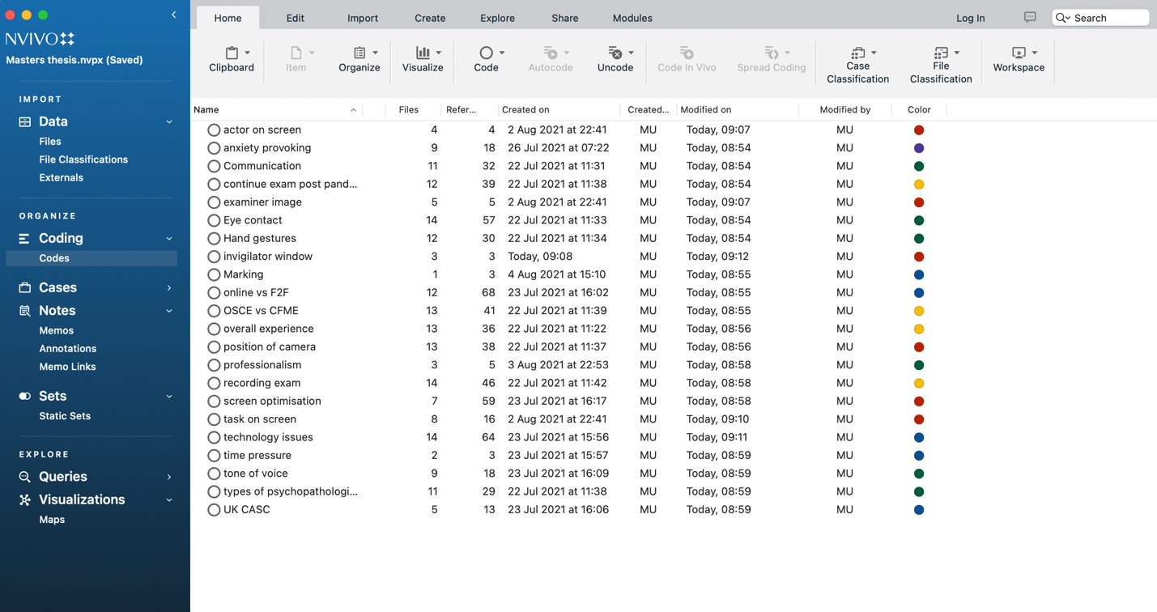
Figure 4: NVivo coding

